
CZ2307
THINKING SCIENCE ON COMPUTER

Project




Done By : Fok Han Yew, Marcus (U021778R)
Li Yiu Ming (U021748A)
Loh Hui Sze, Josephine (U021754A)
Oh Wee Lee (U021752E)
Tan Li Sa, Vicky (U021750H)
Group : 7

Page Numbers
- Aim ----------------------------------------------------------------------------- 3 of 25
- Introduction -------------------------------------------------------------- 3 of 25
- Description Of The Project ----------------------------------------- 4 of 25
- Description Of The Model -------------------------------------------- 4 of 25
- Description Of The Simulation Program ----------------------- 6 of 25
- Results Of Simulation And Their Interpretation ----------- 8 of 25
- Proposed Solutions ------------------------------------------------------ 14 of 25
- Conclusion ------------------------------------------------------------------ 15 of 25
- References ------------------------------------------------------------------- 16 of 25

APPENDIX 1 Individual Reports -------------------------------------- 17 of 25
APPENDIX 2 Survey Form ----------------------------------------------- 21 of 25
APPENDIX 3 Results Collected From Survey ------------------- 22 of 25

- Aim

The aim of this project is to study the effects of the number of traffic lights on the flow of traffic. We will also study the effects of human curiosity on the traffic condition.

- Introduction

Driving in Singapore is a hassle, especially in a congested traffic. The baseline to the congested traffic may be due to high volume of vehicles during the peak hours. As we have limited land area, Singapore Government had implemented various policies such as the Certificate of Entitlement (COE), Electronic Road Pricing (ERP), off-peak car scheme, private car rental scheme and park and ride scheme, etc. However, as the numbers of vehicles grow, Singapore still faces serious road traffic congestion problems. On some major roads, the condition can be so bad that their speeds are 10 km/h or less, (slower than a bicycle). The consequences include reduced work and leisure time, increased air pollution, stress, fuel consumption, health problems, and discomfort. Furthermore, congestions slow down the movement of goods and services, hence adding to the cost of products and reducing the competitiveness of business.

We believe that there are several other contributing factors to the ongoing traffic conditions in Singapore. In this project we have identified two main factors that contributed to the traffic conditions by conducting survey at various areas in Singapore.

- Description Of Project

Our model consists of three stretches of road, namely Road 0, 1 and 2. Road 0 does not have any traffic light, Road 1 consists of only one traffic light, and Road 2 consists of three traffic lights.

The effects of human curiosity are also examined in the model through the placement of activities (Fun Fair) present along the road. By using such representation, it will enable us to effectively study their effect on the flow of traffic.

- Descriptions Of Traffic Model

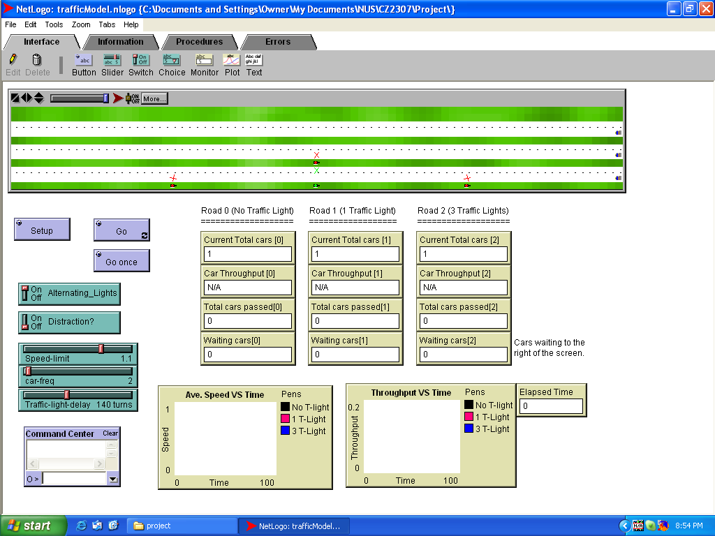
1
2
3
4
5
6
7
8

- The Setup button initializes the model. The three stretches of road created are namely Road 0, Road 1 and Road 2. These three roads will represent three different road conditions whereby Road 0 will have no traffic light, Road 1 will have one traffic light and Road 2 will have three traffic lights. Initially, one car will appear on the right side of each stretch of road.
- The Go button starts the movement of cars continuously. The first car on each stretch of road will move off. Subsequent cars will have to wait for the counter to reach the interval time specified by the car-freq slider before being created.
- The Go once button is basically a Go button whereby the program will only run for 1 elapse time. This allows the users to view the simulation at a slower pace.
- The Alternating_Lights button is a switch which allows users to choose whether to have alternate red lights between the three traffic lights in Road 2.
- The Distraction? button is a switch which allows users to choose whether to have the presence of distraction (Fun Fair) along each stretch of roads.
- There are 3 variables assigned to the sliders so that their values can be manipulated without changes to the coding. These variables are namely:
  - Speed Limit
  - Car Frequency
  - Traffic Light Delay
- There are 4 monitors created for each road to achieve numerical results from running the simulations at real time. These monitors are namely:
  - Current Total Cars (Number of cars that appear on the screen)
  - Car Throughput (Number of cars passed over elapsed time)
  - Total Car Passed (Number of cars that passed through the road)
  - Waiting Cars (Number of cars waiting to appear on right side of the screen)
- There are 2 graphs created to display the results graphically. These graphs are namely:
  - Average Speed vs. Time
  - Car Throughput vs. Time
- Description Of The Simulation Program

We have come up with 4 simulation programs.

Elapsed time used = 2000 sec

- Simulation 1

Aim: Determination of the rate of traffic flow for road with different number of traffic lights.
- The traffic lights would change at different time intervals for each road.
- The traffic light will change only after an elapsed time of more than 150sec.
- The presence of distraction is absent on all the roads.
- The speed limit set for this experiment is 1.0.
- After an elapsed time of 2 sec, a new car is generated.
Parameter Used
Alternating light = ON
Distraction = OFF
Speed limit = 1.0
Car frequency = 2
Traffic delay = 150

- Simulation 2

Aim: Determination of the rate of traffic flow for road with presence of distraction
- The traffic lights would change at different time intervals for each road.
- The traffic light will change only after elapsed time of more than 150.
- The presence of distraction is present on all the roads.
- The speed limit set for this experiment is 1.0
- After an elapsed time of 2 sec, a new car is generated.
Parameter Used
Alternating light = ON
Distraction = ON
Speed limit = 1.0
Car frequency = 2
Traffic delay = 150

- Simulation 3

Aim: To determine the total number of cars that pass through the road with respect to the car frequency. And the effect of different setting of the traffic lights on the traffic
- The traffic lights would change at different time intervals for each road.
- The traffic light will change only after elapsed time of more than 150.
- The presence of distraction is absent on all the roads.
- The speed limit set for this experiment is 1.0
- Elapsed time for a new car is alternated at intervals of 2.
Parameter Used
Alternating light = ON
Distraction = OFF
Speed limit = 1.0
Car frequency = 2 – 20 (alternate of 2)
Traffic delay = 150

- Simulation 4

Aim: Determination of the rate of traffic flow for road without the presence of alternating traffic light.
- The traffic lights would change at different time intervals for each road.
- All the traffic light will change simultaneously only after elapsed time of more than 150.
- The presence of distraction is absent on all the roads.
- The speed limit set for this experiment is 1.0
- Elapsed time for a new car is alternated at intervals of 2.
Parameter
Alternating light = OFF
Distraction = OFF
Speed limit = 1.0
Car frequency = 2 – 20 (alternate of 2)
Traffic delay = 150

- Results Of Simulation And Their Interpretation

- Simulation 1
Table 1: Data Collected For No. Of Cars For Each Road
Road No. | Number of car
0 | 327
1 | 177
2 | 50
Chart:
With reference to Graph 1, it was observed that Road 0, which has no traffic lights has the most number of cars passing through; therefore the traffic flow is high. While on Road 2, which has the most number of traffic lights, has the least number of cars passing through, traffic flow is the lowest. Hence number of cars which would pass through is inversely proportional to the number of traffic lights, i.e., roads with a high number of traffic lights would only allow a smaller number of cars to pass through.

Therefore, in order to have a smooth flow of traffic on the roads, it would be ideal if there are no traffic lights. However, this is not feasible in reality; therefore the best solution would be to reduce the number of traffic lights on the road as much as possible.

- Simulation 2

Table 2: Comparison of no. of cars passed through with and without distraction.
Road No. | No of Cars  (Absence of Distraction) | No. of Cars  (Presence of Distraction) | Percentage Change (%)
0 | 327 | 95 | 55
1 | 177 | 57 | 51
2 | 50 | 36 | 16

Chart:
With reference to Graph 2 above, it was observed that with the presence of distraction on the road, the traffic flow for the roads would be lower as compared to the roads without any distraction.

From the data obtained, the percentage change in the traffic flow when there is presence of distraction was determined. It was observed that the presence of distraction had little effect on the road with the most number of traffic lights as the percentage change was the least, only 16%. While the roads with least number of traffic lights had the highest percentage change in the presence of the distraction, hence the traffic flow is highly affected.

- Simulation 3

Table 3: Data Collected for the Effect of Intervals of Cars on Traffic Flow at Different Traffic Light Delay
Frequency of Car Generated | Elapsed Time of 150 |  |  | Elapsed Time of 100
Frequency of Car Generated | Road 0 | Road 1 | Road 2 | Road 0 | Road 1 | Road 2
2 | 327 | 177 | 50 | 327 | 202 | 74
4 | 327 | 177 | 50 | 327 | 199 | 73
6 | 280 | 166 | 48 | 280 | 192 | 73
8 | 218 | 155 | 47 | 218 | 189 | 72
10 | 179 | 148 | 48 | 179 | 176 | 72
12 | 151 | 140 | 48 | 151 | 150 | 72
14 | 131 | 123 | 48 | 131 | 131 | 72
16 | 116 | 109 | 48 | 116 | 116 | 72
18 | 104 | 98 | 48 | 104 | 104 | 72
20 | 94 | 89 | 48 | 94 | 94 | 71

Chart:
The general trend observed was that when the number of car generated decreases, the number of cars passing through road also decreases. As observed in Graph 3 where there is only one traffic light in Road 1, the flow of traffic is almost the same as the traffic flow for Road 0, which does not have any traffic light. Whereas in Road 2 where there are three traffic lights, there were no observable effects of the car generated w.r.t elapsed time on the flow of traffic as the flow of traffic was restricted by the traffic lights.

Chart:
As the traffic light delay decreased, it was observed that more cars were able to pass through the road (table). Based on Graph 4, it was observed that at a lower traffic light delay, the number of cars passing through Road 0 and 1 are the same. Hence if the number of traffic lights is minimal, it would have minimum or no effect on the traffic flow which is similar to roads without any traffic lights.

- Simulation 4

Table 4: Data Collected for the Number Of Cars When the Traffic Lights are Changed Simultaneously
Frequency | Elapsed Time of 150
Frequency | Total No. of Cars |  |  | % increase in total cars passed on Road 2 compared to Simulation 3
Frequency | Road 0 | Road 1 | Road 2
2 | 327 | 177 | 159 | 218.00
4 | 327 | 177 | 159 | 218.00
6 | 280 | 166 | 145 | 202.08
8 | 218 | 155 | 125 | 165.96
10 | 179 | 148 | 113 | 135.42
12 | 151 | 140 | 104 | 116.67
14 | 131 | 123 | 97 | 102.08
16 | 116 | 109 | 92 | 91.67
18 | 104 | 98 | 88 | 83.33
20 | 94 | 89 | 82 | 70.83

Chart:

To compare the effect of traffic flow with and without the presence of alternating traffic lights, we need to compare the above Graph 5 with that of Graph 3 of Simulation 3. From the two graphs, we can clearly see the difference of the car flow for Road 2 with three traffic lights positioned. As the number of traffic lights for this road is the highest therefore the effect of alternating light will be the greatest for it. We observe an increase of car flow for this road when there is no alternating traffic light as compared to the slower car flow with alternating traffic light. In fact, we observed that the car flow for Road 2 with three traffic lights is quite close to that of the Road 1 with only one traffic light. Although it is slightly slower than Road 1, but the fact that it has increase a great deal from the previous experiment shows that alternating traffic light actually slows down the traffic flow.

Therefore in order to have a smooth flow of traffic on the roads, it would be ideal if the traffic light that is present has no alternating schedules. However, this is not feasible in reality; therefore the best solution again would be to reduce the number of traffic lights on the road as much as possible.

- Proposed Solutions

Upon detailed analysis of our results, our group has come out with several suggestions.

Firstly, number of traffic lights can be reduced by building overhead bridges and underpasses. According to our simulation results, a reduction of 2 traffic lights per road can increase the car flow by about 300%.

Secondly, we also found that alternating light in Road 2 actually slow down the traffic. Therefore, in area whereby several traffic lights are lined up in series, alternating red light frequency should be removed. Our results show that in the absence of alternating lights, there is an increment of at least 70% and maximum of 218% for road with high car frequency. Ultimately, fuzzy logic traffic light system should be used whereby it is able to detect the traffic conditions and optimize the traffic light frequency accordingly.

Thirdly, traffic light delay has a significant effect of the traffic flow. We found that by decreasing the traffic light delay, the traffic flow will increase by at about 10% for Road 1 and about 50% for Road 2.

- Conclusion

In this project, we have conducted a survey to help us identify the two main causes of traffic congestion. The two main caused are found to be i) the number of traffic lights and ii) the presence of activities (fun fair) at the roadside. A traffic model showing this phenomenon was then done using the NetLogo program. This model allows us to study the impact of different parameters on the flow of traffic.

In addition, we had also run 4 simulations on the model to help us see how the presence of traffic lights and presence of activities such as a fun fair along the roadside would contribute to traffic congestions. The results were discussed and solutions were proposed based on our results.

We can therefore conclude that the aims of this project are achieved.

- References

- Understanding traffic light system:
http://www.angelfire.com/sc/sumeet/ense621OOAD.html
- Other project done by other study groups:
http://www.di.fc.ul.pt/~mal/community/extraffic.htm
- Background for Fuzzy Logic Traffic Light:
http://www.doc.ic.ac.uk/~nd/surprise_96/journal/vol4/sbaa/report.traff.html
- Large Scale Traffic Study Done by Auckland:
http://www.aucklandcity.govt.nz/news/releases/20031003.asp
APPENDIX 1 Individual Reports

- Fok Han Yew, Marcus

Personal Effort:

I have brainstormed on possible topics for the project and come out with the idea of conducting a survey to further enhance the accuracy of the ideas. Then I helped in coding of the Netlogo model and numerical experiments. I also did the sorting of data for the survey done and helped in troubleshooting of the main interface for the Netlogo model.

Individual Thoughts:

By doing this project, I have found out that the genuine effect of numbers of traffic lights on the flow of traffic in Singapore. Also I am able to see the outcome of reducing traffic lights on the flow of traffic. I had also fully understood the effective usage of Netlogo. It really helps a lot in creating and running any daily phenomenon that ones need to found out. Otherwise, it would have been a far longer and tedious process. However, this program might be modified to be slightly more users friendly, especially in the area of errors reporting that can suggest alternative programming language.

- Li Yiu Ming, Ryan

Personal Effort:

I had participated in the brainstorming and involved in the initial stage of how this model should be coded. And, I was heavily involved in the running of the program and simulation running. I conducted internet searches for relevant information on other traffic light model. I also helped to conduct the survey in the central area of Singapore. Finally, I did part of the report write up.

Individual Thoughts:

As Singapore continue to develop, having smooth traffic is vital to both citizens and businesses. This model enables us to look to into a few aspects of causes for traffic congestion. I personally feel that this model is able to reflect actually the scenario that is experience by any drivers. This model shows the importance of adequate number traffic lights and traffic light frequency. It also shows us how traffic is slow down by distractions.

Although this is a successful traffic model, there is still room of improvement which can make this model how more useful. Overall, this project gave me an insight on the power of computer simulation and it is usefulness in our every day life.

- Loh Hui Sze, Josephine

Personal Effort:

I have participated in the brainstorming of possible topics for the project and after finalizing the topic, I also played a part in suggesting what to include in the model. I am also involved in conducting the survey at the northern area of Singapore. I also helped in suggesting what simulations to run for the program. Finally,I did the overall edition and compilation of the project.

Individual Thoughts:

After doing this project, I have come to realize the impact of traffic lights on traffic. Though I knew waiting at the traffic lights is a very annoying thing but I did not realize that it could slowly led to heavy traffic jams! I am also amazed with how the Netlogo program can work. I never knew that it could reflect the real situation so well! The work done for collection of data was greatly reduced with the help of this Netlogo model. Overall, I feel that our project is quite successful because we were able to obtain the data from the program and hence came up with some solutions for the traffic congestion in Singapore. However, I also feel that it would be good if the Netlogo program could be made more user friendly in terms of having clearer description of commands in the primitive dictionary and giving alternative program language in the error reporting section so as assist those who are not so good in program language.

- Oh Wee Lee

Personal Effort:

I have brainstormed on possible ideas for the project during the discussion and contributed to the aim and introduction of the written report. I also helped in conducting the survey in the western part of Singapore. My main task in the written report is to write the description of traffic model. I have also contributed in the coding of the Netlogo program and I have written the contents in the information tab of the Netlogo program.

Individual Thoughts:

Traffic congestion is an ongoing problem found in many countries over the world. I think that there is no exact solution to solve the problem completely but we can explore ways of reducing traffic congestion. I think one of the best ways to study traffic condition is to create a realistic computer simulation that can allow us to study the causes of traffic congestion. In our traffic model, we have simulated the traffic conditions and this has enabled us to identify and study the causes of traffic congestion. This traffic model simulation is terrific as it can easily be customized to study different traffic situations. In our project, I think that the survey on the motorists is necessary as it can effectively identify the two main causes of traffic congestion. From our traffic model, I think there is a lot more room for improvement where we can make the traffic simulation more realistic and more detailed. I think that we can also include more variables in our program to widen our analysis. On the whole, I think that our traffic model is quite successful in simulating the traffic condition which helps us to explore some possible solutions for the traffic congestion problem.

- Tan Li Sa, Vicky

Personal Effort:

I had contributed in brain storming for topics for this project. Upon deciding on the topics, we had to conduct a survey in order to narrow down the scope of our topic. Hence, I had conducted the survey based on the eastern area of Singapore. Once we had run the stimulations for the program, I had helped in consolidating the data and interpreted the results for discussion. I had also helped in coding and debugging the Netlogo program.

Individual Thoughts:

Singapore has one of the best traffic systems in the world; however traffic jams still occur during certain time of the day. One of the many reasons was the high number of traffic lights that we seem to find on a same stretch of road. This is seemed to have slowed down the flow of traffic whenever there is a high traffic flow. The model was successful in simulating the rate of traffic flow when the number of traffic lights was high as well as the slowing down of the traffic due to driver’s curiosity of the things that had happened on the road. With simulation that epic the real life situation, we were able to identify the solutions to the problems. Hence I feel that our project was a success
APPENDIX 2 Survey Form

National University of Singapore
Faculty of Science
Survey

Age: □18 to 25 Gender: □ Male □ Female
□26 to 30
□31 to 35 Time: AM / PM
□36 to 40
□41 to 55 Location:________________
□above 55

Hello! We are a group of students from the NUS, working on a project on reasons behind traffic congestion. Your opinions will be of invaluable use to us. Hence, we greatly appreciate it if you could spare us some time to answer the following questions.

Q1. How often do you drive?

□Daily
□Once to thrice a week
□Weekly
□less than a once a week

Q2. On average, how long do u drive?

Daily
□less than an hour
□an hour to two
Weekly
□less than 5 hours
□ 5 hours and above
□Others. Pls specify____________________

Q3. Overall, what is the rating you will give to the reasons for traffic congestion.
(please circle the appropriate rating: 1…Least agreed, 5..Most agreed)

Road hogging | 1 | 2 | 3 | 4 | 5
Too many traffic lights | 1 | 2 | 3 | 4 | 5
Heavy vehicles | 1 | 2 | 3 | 4 | 5
Pedestrians jaywalking | 1 | 2 | 3 | 4 | 5
Narrow road | 1 | 2 | 3 | 4 | 5
Poor road condition | 1 | 2 | 3 | 4 | 5
Poor lighting | 1 | 2 | 3 | 4 | 5
Too many bus stops | 1 | 2 | 3 | 4 | 5
Vehicles breakdown | 1 | 2 | 3 | 4 | 5

Others. Pls specify:______________________________________________________________
________________________________________________________________________________

~~~The End~~~
Thank you for your time and co-operation for helping us to complete this survey.
APPENDIX 3 Results Collected From Survey

A total number of 50 drivers in various part of Singapore were surveyed. In order to make the survey’s results more accurate, we carry out the survey in several area of Singapore as shown below :

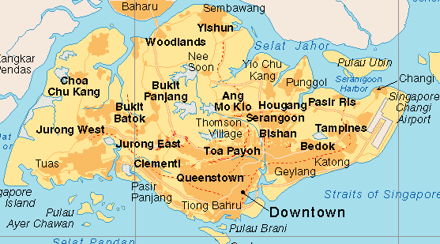
Town area; Orchard & City hall.
Number of driver: 25
East area; Bedok & Tampines.
Number of driver: 25
North area; Yishun & Woodlands.
Number of driver: 25
West area; Jurong East & Bukit Batok.
Number of driver: 25

The results of the survey were then tabulated and graphed for easy analyzing;

Q1. How often do you drive?

Frequency | No. | Percentage
Daily | 29 | 58%
Once to thrice a week | 12 | 24%
Weekly | 5 | 10%
Less than once a week | 4 | 8%

Q2. On average, how long do u drive?

Frequency | Duration | No. | Percentage
Daily | less than an hour | 26 | 52%
Daily | an hour to two | 15 | 30%
Weekly | Less than 5 hours | 13 | 26%
Weekly | 5 hours and above | 21 | 42%
Weekly | others | 16 | 32%

Q3. Overall, what is the rating you will give to the reasons for traffic congestion.( please circle the appropriate rating: 1 Least agreed, 5 Most agreed)

Reasons | 1 | 1 | 2 | 2 | 3 | 3 | 4 | 4 | 5 | 5
Road hogging | 15 | 30% | 12 | 24% | 10 | 20% | 7 | 14% | 6 | 12%
Too many traffic lights | 6 | 12% | 8 | 16% | 9 | 18% | 13 | 26% | 14 | 28%
Heavy vehicles | 12 | 24% | 10 | 20% | 13 | 26% | 7 | 14% | 8 | 16%
Pedestrians Jaywalking | 14 | 28% | 10 | 20% | 9 | 18% | 9 | 18% | 8 | 16%
Narrow road | 12 | 24% | 11 | 22% | 15 | 30% | 6 | 12% | 6 | 12%
Poor road condition | 11 | 22% | 13 | 26% | 11 | 22% | 8 | 16% | 7 | 14%
Poor lighting | 14 | 28% | 9 | 18% | 12 | 24% | 9 | 18% | 6 | 12%
Too many bus stops | 13 | 26% | 13 | 26% | 11 | 22% | 6 | 12% | 7 | 14%
Vehicles breakdown | 5 | 10% | 6 | 12% | 10 | 20% | 15 | 30% | 14 | 28%

From the above graph, we observed two main peaks in the higher rating of 4 and 5. And this corresponds to the reasons of “Too many traffic lights” as well as “Vehicles breakdown”.

On top of that, the other reasons that the group of drivers had chosen surveyed were:
- accidents by the road side causes other cars to slow down
- incidents occurring by the side of the road

Therefore to study the effects of these reasons, our group decided to do a traffic model based on the above mentioned reasons in order to justify the surveyed results.

