AI

Introduction to
Artificial Intelligence
Unit One – Searching:
Depth First vs Breadth First

September 2007

Developed by Shane Torbert
with help from Randy Latimer
under the direction of Jerry Berry

Thomas Jefferson High School for Science and Technology

Fairfax County Public Schools, Fairfax, Virginia

Copyright Information

These materials are copyright © 2007 by the author; additional contributions from Randy Latimer. All rights not explicitly granted below are reserved.

You are encouraged to reproduce these materials in whole or in part for use within your educational institution provided appropriate credit is given. You may distribute these materials to other institutions or representatives thereof only if the entire work is transferred in its complete, unaltered form, either as the original Microsoft Word files or as an original, high quality printout.

Ruby version 1.8.6 can be found at http://www.ruby-lang.org/en/
Downloads for Ruby are at http://www.ruby-lang.org/en/downloads/
The Vim editor can be found at http://www.vim.org/download.php.
Free FCPS AI course content, with software and materials, is available.

You may alter these materials to suit your needs and distribute these altered materials within your educational institution provided that appropriate credit is given and that the nature of your changes is clearly indicated. You may not distribute altered versions of these materials to any other institution.

If you have any questions about this agreement please e-mail mr@torbert.com.
AI Instruction Plan—Unit One
Section One – Introduction to Ruby, Generating Neighbors | Page
Lab00: Introduction to Ruby, ladder_intro.rb . . . . . . . . . . . . . . . . . . . . . . . . . . | One-4 to 13
Lab01: Generating Neighbors, ladder_random.rb. . . . . . . . . . . . . . . . . . . . . . . | One-14 to
Section Two – Depth First Search DFS
Lab02: Recursive DFS, ladder_dfs.rb.. . . . . . . . . . . . . . . . . . . . . . . . . . . . . . . . | Four- __to __
Lab03: Iterative Deepening, ladder_dfsid.rb. . . . . . . . . . . . . . . . . . . . . . . . . . . | Four- __ to __
Section Three – Breadth First Search
Lab04: Queue-based Breadth First Search, ladder_bfs.rb. . . . . . . . . . . . . . . . | Four- __ to __
Discussion
Solving problems by searching: Simple Search (see Norvig text, Ch. 3)
A problem can be defined by four components:
Initial state: A state that the agent starts in. For example, I'm in Arad trying to get to Bucharest.
Successor function: Given a particular state x, In(Arad), a successor function returns a set of <action, successor> ordered pairs, where each action is legal in state x and each successor is a state that is reached by applying the action. Example, the successor function for the state In(Arad) generates the states In(Timisoara), In(Sibiu), In(Zerind). This initial state and successor function define the state space, the set of all states reachable from the initial state. A path in the state space is a sequence of states connected by a sequence of actions.
Goal test: A condition determining whether a particular state is a goal state. For example, traveling from Arad to Bucharest, the goal state is In(Bucharest).
Path cost: A funtion that assigns a numeric cost to a path. The path costs in the Roumanian map below are the distances between cities. The path cost for traveling from Arad to Bucharest could be the total distance for the particular route taken.

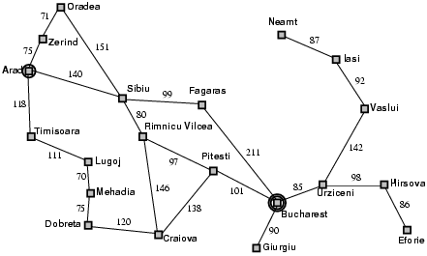

Simple search can be defined as follows:
Given:
Initial state
Successor(state) = {<action,state>,….}
Goal(state) = true or false
Find
Path from initial state to a goal state

Example problems (see Norvig Ch. 3)
Toy problems
Vacuum world
States: The agent is in one of two locations, 2 cells, each cell may or may not contain dirt and may or may not contain the agent (4 possible states for each cell). For 2 cells there are 2 x 2^2 = 8 possible states.
Initial state: Any state can be an initial state.
Successor function: Generates the legal states that result from trying the three actions (Left – move left, Right – move right, and Suck – pick up dirt).
Goal test: are all the squares (the two initial cells) clean.

8-puzzle
States: Specify the location of each of the eight tiles and the blank tile in one of the nine squares.
Initial state: Any state can be an initial state.
Successor function: Generates the legal states that result from trying the four actions (blank moving Left, Right, Up, Down).
Goal test: Does the particular state match the goal configuration.
Path cost: could be the number of steps in the path to reach the goal.

8-queens
States: Any arrangement of 0 to 8 queens on the board.
Initial state: No queens on the board.
Successor function: Add a queen to an empty square.
Goal test: 8 queens on the board, none attacked.

Word ladder
States: A dictionary of words.
Initial state: Any one word from the dictionary.
Successor function: Generate another word, also contained in the dictionary, by changing only one letter, keeping the length of the word the same, and not repeating a word already used - (Change-One-Letter)
Goal test: Is the new word generated the same as the goal word (some word also in the dictionary, but different from the initial word).

Lab00
Word Ladder pt. 1
Objective
Introduction to Ruby programming and the initial word ladder programming problem.
Background
Information on Ruby is available at http://www.ruby-lang.org/en/. Also see Programming Ruby, The Pragmatic Programmer's Guide, http://phrogz.net/ProgrammingRuby/,
or here: http://www.ruby-doc.org/docs/ProgrammingRuby/ , Try Ruby, http://tryruby.hobix.com/ .

Specification
Filename ladder_shell.rb. Enter the source code shown below, then run with ruby ladder_shell.rb. Complete the program so that only valid next words are allowed. A next word is valid if it changes only one letter, is in the dictionary, and has not already been used.
1: # Torbert, 8.22.2007
2:
3: $words = File.read(“words.txt”).chomp.split
4:
5: puts
6: while true
7: print “What word to start with? “
8: current = gets.chomp
9: break if $words.include? current
10: end
11:
12: ladder = Array.new
13: ladder << current
14: for k in 1..5 do
15: puts
16: puts “Current Ladder: #{ladder.inspect}”
17: print “Next word? “
18: current = gets.chomp
19: ladder << current
20: end
21:
22: puts
23: puts “Ladder:”
24: for k in 1..5 do
25: puts “#{k+1}. #{ladder[k]}”
26: end
27: puts
28:
29: outfile = File.open(“puzzle.txt”, “w”)
30: outfile.puts ladder[0]
31: outfile.puts ladder[-1]
32: outfile.close

Line 3: $words is a global variable (begins with $). Ruby reads the entire text file of words with only one line of code. The class is File, and read is a method from this class. chomp and split store the words from the file into an array. $words is the name of this array.
Line 5: puts is “put string”. With no string to write, this is printing a blank line.
Lines 6-10: A while loop in Ruby. Parentheses for the loop test are optional. The loop needs the end.
Line 8: gets is “get string” from the keyboard. chomp removes the end-of-line marker from the enter key. The word typed is stored in the variable current.
Line 9: include? is a method in class Array that returns true/false – boolean - if the argument – current - is in the array object $words. Parentheses for the argument are optional - $words.include?(current) is also okay to use.

Line 12: Creating a new array object called ladder. Another way to do this is: ladder = [] Note that in Ruby the size and type of the the array are not predetermined.

Line 13: Adding an element – current – into the array ladder. This is an array of strings – words.

Lines 14-20: A for loop in Ruby. The range 1..5 is inclusive. With 3 dots the second value is not included: 1...6 would be the numbers 1 through 5.
Line 16: With #{ } the value of the ladder array is inserted into the string for puts, and the current ladder array is printed each iteration of the loop.
Lines 17-19: Another word is read in from the keyboard, stripped of the end-of-line character, and stored at the end of the array.
Lines 23-26: Printing the contents of the ladder array using a for loop. The indexes are 0 through 5 – six elements or words in the array.
Line 25: #{ } values are inserted into the print string. The index+1 and the corresponding array value for index are printed, one per line. puts adds an end-of-line.
Lines 29-31: Using class File and the open method to open a new file to write to. Using outfile.puts writes to this file. ladder[0] is the first element, and ladder[-1] is the last element of the array.
Line 32: Close the file in order to save the results of lines 29-31.
This program is run through a terminal window. Open two terminal windows, one to edit the file and the other to run the file. To run a Ruby file, use ruby filename.rb.
Save your Ruby file each time you make changes before running.
Test Data
Go to www.tjhsst.edu/compsci/ai
Discussion
Using terminals to edit and run your program
Normally use two terminals when developing your programs. In one terminal run an editor such as vim. Use the other terminal to run your program. This allows you to make re-edits and re-runs simply.
Sample screenshot of vim editor with a portion of the program file for ladder_shell.rb:
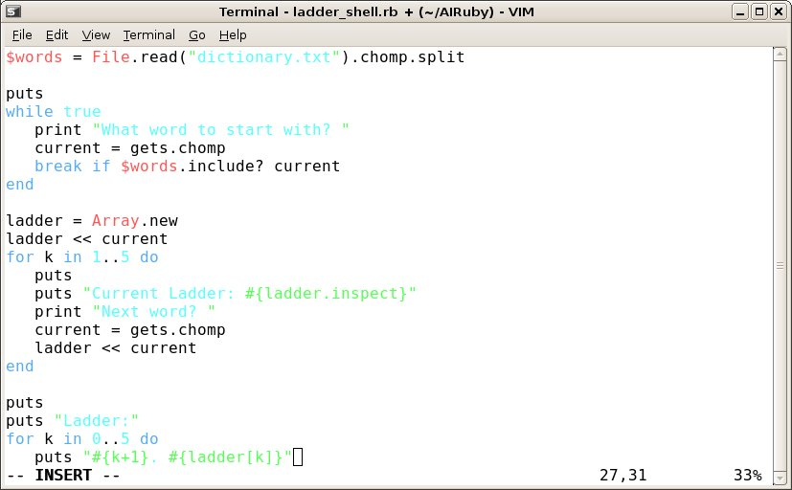
Sample screenshot of running your program in another terminal window:
(to run this program use: ruby ladder_shell.rb)
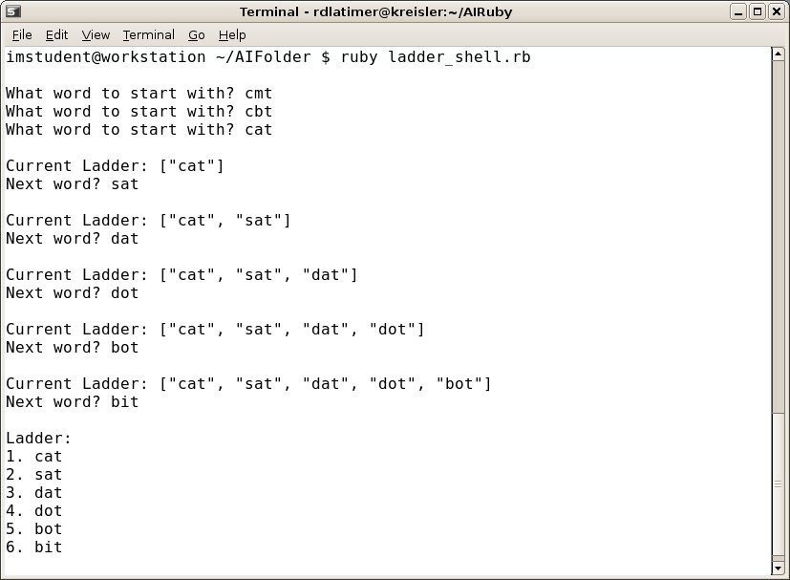

For debugging, use another terminal to step through your program with interactive ruby: irb
You can enter single lines of ruby code and evaluate these separate lines interactively with the program irb.
Sample screenshot of using irb. Ruby evaluates each line of code you enter, as you type in the code.
Exit irb with the command exit:
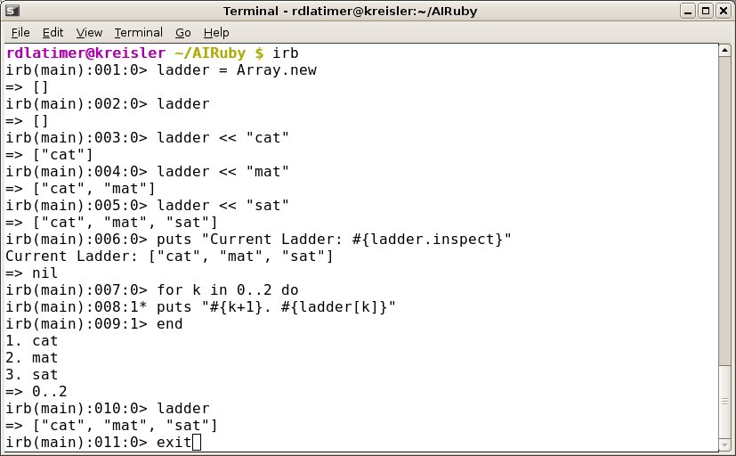

Exercises
Lab00, experimenting with Ruby
Use irb to evaluate/run these lines of code – or enter the lines in a file such as test.rb and run with ruby test.rb from a terminal (These exercises are from Learning Ruby by M. Fitzgerald, O'Reilly press)
1) puts “Hello “ + “World!”
puts “Hello “ << “World!”
puts “Hello world” * 5

5.times {print “Hello world”}
puts “Hello” * 3 + “ World”

hi = “Hello world”
puts hi

hi = “Hello “
who = “World”
puts hi + who

puts “Hello #{who}”

puts “Hello, #{ARGV[0]}” This one's special – grabs the first argument
off the command line: ruby test.txt World

Formatting a string:

hi = “Hello %s”
puts hi % “world”
puts hi % “people”
puts hi % “universe”

%s, %s % [“Hello”, “World”]

sprintf(“Hello, %s”, “World”) - formats a string

2) Getting input from the terminal.

print “Who do you want to say hello to? “
hello = gets
puts “Hello “ + hello

3) Methods – define your own methods using def/end
def hello
puts “Hello world”
end

hello # => Hello world

def repeat (word, times)
puts word * times
end

5) Classes
class Hello
def initialize(name)
@name = name # @name is an instance variable
end

def say_hello
puts “Hello “ + @name + “!”
end
end

hi = Hello.new( “World”)
hi.say_hello # => “Hello World!”

4) Using the each method to print all the elements in an array.

[“Hello “, “world”].each {|e| print e}

blocks:

mid_atlantic = [ “Maryland”, “Virginia”, “North Carolina”]
mid_atlantic.each do | element |
puts element
end

same as: mid_atlantic.each { | element | puts element }

5) GUI programming with the Tk toolkit. (see http://www.tcl.tk)

require 'tk'
hello = TkRoot.new

TkLabel.new(hello) do

text "\n Hello World! \n"

pack

end

Tk.mainloop

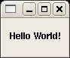
6) Conditionals: if/end if/else/end if/elsif/.../else/end

if a == 10 && b == 27 && c == 43 && d == -14
print sum = a + b + c + d
end

7) Type conversions: 13.to_s, “123”.to_i, 97.to_c

8) Loops
i = 0
notes = [ “quarter”, “half”, “whole”, “sixteenth”, “rest”]
puts notes.size # or notes.length
temp = []

while i < notes.size do # the do is optional
temp << notes[i].capitalize
i += 1
end

temp.sort!
notes.replace(temp)
p notes # => [“half”, “quarter”, “rest”, “sixteenth”, “whole”]

temp = 98.3
begin
print “Your temperature is “ + temp.to_s + “ degrees”
temp += 0.1
end while temp < 98.6

Using break

while i < notes.size
temp << notes[i].capitalize
break if temp[i] = “quarter”
i += 1
end

Unless and Until

unless land == “de”
dog = “dog”
else
dog = “Hund”
end

weight = 150
until weight == 200 do
puts “Weight: “ + weight.to_s
weight += 5
end

weight = 150
begin
puts “Weight: “ + weight.to_s
weight += 5
end until weight == 200

loop

loop do
print “Type something: “
line = gets
break if line =~ /q|Q/
puts line
end

for
for i in 1..12
print “2 X “ + i.to_s + “ = “, i * 2, “\n”
end

for i in 1..12
for j in 1..12
print i_to_s + “ X “ + j.to_s + “ = “, j * i, “\n”
end
end

times and upto

10.times { |i| print i, “ “}

1.upto(10) {|i| print i, “ “}

1.upto(12) {|i| print “2 X “ + i.to_s + “ = “, i * 2, “\n”}

1.upto(12) {|i| 1.upto(12) {|j| print i.to_s + “X” + j.to_s + “ = “, j * i, “\n”}}

downto

5.downto(1) {|i| print i, “ “ }

def timer(start)
puts “Minutes: “ + start.to_s
start_time = Time.now
puts start_time.strftime(“Start to_time: %I:%M:%S %p”)
start.downto(1) {|i| sleep 60}
end_time = Time.now
print end_time.strftime(“Elapsed time: %I:%M:%S %p”)
end

Arrays
months = Array.new
months.empty? => true
months = Array.new (12) or Array 12 (no parens are necessary for the argument)
months.size => 12
months.length => 12

puts months.inspect => prints the values looking like an array
or p months

[nil, nil, nil, nil, nil, nil, nil, nil, nil, nil, nil, nil]

month = Array.new(12, “month”)

["month", "month", "month", "month", "month", "month", "month", "month", "month", "month", "month", "month"]

month.clear => []
month.empty? => true

num = Array.new(10) { |e| e = e * 2} => [0,2,4,6,8,10,12,14,16,18]

month_abbrv = Array[“jan”, “feb”, “mar”, “apr”]
or month_abbrv = [“jan”, “feb”, “mar”, “apr”]

digits = Array(0..9) => [1,2,3, etc ]

months = %w[January February March April etc] => [“January”, “February”, “March”, etc]

months[0] => “January” etc

months.at(0) => “January

months[-1] => last element in the array
months[-2] => second to last, etc

or months.first
months.last
months.first 2

months.index “March” => 2
months[0,3] => months 0 , 1, 2
months[0..3] months[0...3] Two dots – include last index, Three dots – don't include

months.slice(0..2) months.slice(0...2)
months.include?(“January”) => true

Concatenation

q1= %w[ January February March ]
q2 =%w[ April May June ]
q3=%w[ July August September ]
q4=%w[ October November December ]

half1 = q1 + q2
half2 = q3 + q4
yr = half1 + half2

<< also concatenates

yrs = [1999]
yrs << 2000 => [1999, 2000]

yrs << 2001 << 2002 << 2003 => [1999, 2000, 2001, 2002, 2003]

last_part = q3.concat(q4)

Set operations
& intersection
- difference
| union

uniq! removes duplicates

Stacks and Queues
.pop
.push operate on the end of the array

.shift
.unshift operate on the front of the array

Deleting elements
months.delete(“january”)
months.delete_at(11)

Arrays and Blocks
months.each {|e| print e.capitalize + “ “}
month.map {|e| e.capitalize + “ 2007” } => returns an array [“Jan 2007”, “Feb 2007”, etc]

Uninformed search strategies

Basic search algorithm
Keep variable successors of unexplored states
Initialize with the initial state
Pop state off fringe
If it’s a goal state, we’re done
Else generate all its successor states and put them in successors.
[how?]
Repeat

Depth first search (stack data structure)
Expand from the top of the stack – the deepest unexpanded node.
Place successor nodes on the top of the stack. These nodes are also the first to be removed.
Breadth first search (queue data structure)
Expand from the front of the stack – the deepest unexpanded node.
Place successor nodes at the end of the queue (not the front, as in a stack)
The next nodes expanded are on the front of the queue.
Iterative deepening
Depth first search to a fixed depth.
If no solution is found, this depth is increased and depth first search is begun again.
Initially set the depth to 1. If no solution, perform depth first search to a depth of 2. If no solution, perform the depth first search to a depth of 3, etc.

(image is from http://www.comp.lancs.ac.uk/computing/research/aai-aied/people/paulb/old243prolog/section3_6.html

Depth first search – expand the deepest unexpanded node.

Example:
Place the initial node A on the stack.
Remove node A and expand to find A's neighbors. Put these on the stack.
Remove node B and expand to find B's neighbors (E and F). Put these on the stack.
Remove node E and expand to find E's neighbors (J,K and L). Put these on the stack.
Remove node J and expand – no new neighbors.
Remove node K and expand to find K's neighbors (S, T, and N). Put these on the stack.
Remove nodes S, T, and N in turn, no new neighbors.
Remove node L. STOP because this is the goal node.

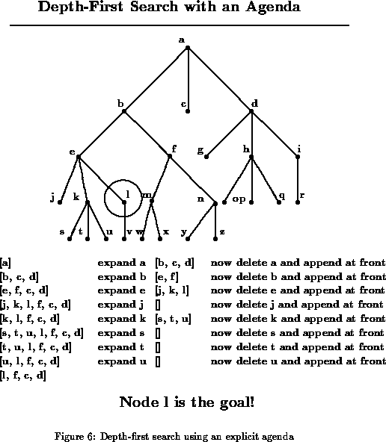
Breadth first search -expand the shallowest unexpanded node.

Example from above, using breadth first search.

Place initial node A on the queue.
Remove node A and expand to (B, C, and D). Place these on the queue.
Remove node B and expand to (E and F). Put these on the queue.
Remove node C and expand – No neighbors.
Remove node D and expand to (G, H, and I). Place these on the queue.
Remove node E and expand to (J, K, and L). Place these on the queue.
Remove node F and expand to (M and N). Place on the queue.
Remove node G, no neighbors. Remove node H and place neighbors O, P, and Q on the queue.
Remove node I and place neighbor R on the queue.
Remove node J – no neighbors. Remove node K, place neighbors S, T, U on the queue.
Remove node L and STOP. This is the goal node.

[A]
[B C D]
[C D E F]
[E F G H I]
[F G H I J K L]
[G H I J K L M N]
[I J K L M N O P Q]
[J K L M N O P Q R]
[L M N O P Q R S T U]

Lisp to Ruby

Lisp (Common Lisp) clisp Ruby irb or ruby file.rb
(setq tools '(hammer screwdriver))  tools => (hammer screwdriver)  (cons 'pliers tools)  (PLIERS HAMMER SCREWDRIVER)  tools => (HAMMER SCREWDRIVER)  (setq tools (cons 'pliers tools))  (setq tools (append '(saw wrench) tools)) =>  (saw wrench pliers hammer screwdriver)  (length tools) => 5  (reverse tools) => (screwdriver hammer etc...)  (car tools) => saw  (first tools)  (last tools) => (screwdriver) | tools = %w[hammer screwdriver]  tools => [“hammer”, “screwdriver”]  tools + [“pliers”] =>  [“hammer”, “screwdriver”, “pliers”]  tools => [“hammer”, “screwdriver”]  tools << “pliers”  tools.concat([“saw”,”wrench”]) OR  tools.concat(%w[saw wrench])  tools.length  tools.reverse  tools.first OR tools[0]  tools.last OR [tools.last]  tools[-1]
(defun rotate-left (lst)  (append (cdr lst) (list (car lst))  )  )  (rotate-left tools) | def rotate_left lst  tools[1..-1] << tools[0]  end  OR  def rotate_left lst  return tools[1..-1] << tools[0]  end  rotate_left tools
(defun rotate-right (lst)  (append (last lst)  (reverse (cdr (reverse lst)))  )  ) | def rotate_right lst  [lst.last] + lst.reverse[1..-1].reverse  end  OR  def rotate_right lst def rotate_right lst  [lst.last] + lst[0..-2] lst[0..-2].unshift(lst.last)  end end  OR  def rotate_right lst  return lst[0..-2].unshift(lst.last)  end  letters = %w[a b c d e]  rotate_right letters => [“e”, “a”, “b”, “c”, “d”]

Common Lisp clisp Ruby irb or ruby file.rb
(defun palindrome (lst)  (append lst (reverse lst))) | def palindrome lst def palindrome lst  lst + lst.reverse return lst + lst.reverse  end end
(defun f-to-c (temp)  (- (/ (+ temp 40)  1.8)  40)  )  (f-to-c 212) => 100.0 | def f_to_c temp  (temp + 40)/1.8 - 40 =>return(temp + 40)/1.8-40  end  f_to_c 212 => 100.0
(defun palindromep (lst)  (equal lst (reverse lst))) | def palindromep lst  lst.eql?(lst.reverse) =>return lst.eql?(lst.reverse)  end  x = %w[a b c d c b a]  palindromep x => true

RECURSION

Common Lisp clisp Ruby irb or ruby file.rb
(expt 10 3) => 1000  (expt 10 3.5) => 3162.2776 | 10**3 => 1000  10**3.5 => 3162.27766016838
(defun myexpt (base power)  (expt-aux base power 1)  )  (defun expt-aux (base power result)  (cond ((zerop power) result)  (t (expt-aux base (- power 1)  (* result base)))) | def myexpt(base, power)  exp_aux(base, power, 1)  end  def expt_aux(base, power, result)  if power == 0  result => return result  else  expt_aux(base, power-1, result*base)  end  end  OR return expt_aux(base, power-1, result*base)

Counting all the atoms (non-lists) in embedded lists

Common Lisp Ruby
(defun count-atoms(l)  (count-atoms1 l 0))  (defun count-atoms1 (l count)  (cond ((null l) count)  ((atom l) (+ count 1))  (t (count-atoms1 (cdr l)  (count-atoms1 (car l)  count))))  (count-atoms '(1 (2 (3 4 (5)))) => 5 | def count_atoms lst  count_atoms1 lst 0  end  def count_atoms1(lst, count)  if lst==[]  return count  elsif not lst.kind_of?(Array)  return count + 1  else  return count_atoms1(lst[1..-1],  count_atoms1(lst[0],count)  end  end  puts count_atoms([1,[2,[3,4,[5]]]]) => 5

More bizarre example using Lisp apply and mapcar
and Ruby collect (same as map in Ruby)

(defun count-atoms (lst)  (cond ((null lst) 0)  ((atom lst) 1)  (t (apply '+  (mapcar 'count-atoms lst)))))  (count-atoms '(1 (2 (3 5) 4))) => 5 | def plus lst  sum=0  lst.each {|e| sum += e}  sum  end  def count_atoms lst  if lst==[]  0  elsif not lst.kind_of?(Array)  1  else  plus lst.collect {|e| count_atoms e}  end  end  p count_atoms([1,[2,[3,5]],4]) => 5

These Lisp examples were tested in clisp and Allegro CL - Allegro CL Free Express Edition
http://www.franz.com/downloads/#AllegroCL_Download

