AI2 February 20, 2009

- Sobels edge detection: program file, comments (well commented), images* for various thresholds – 300...900 for example, highest pixel value, number of pixels over various thresholds. (late)

- Preliminary floodfill exercises: floodfillTester.pgm and floodfillTester2.pgm (late)

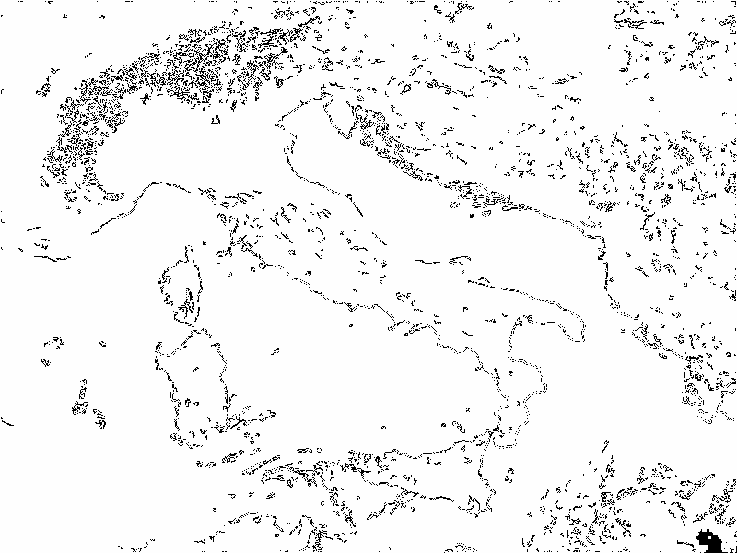
- Write an image inverter function/method/procedure: pixels with 255 → 0, otherwise make the pixel value 255. You'll get images such as (save our black ink in the printer): (late)

- Canny Edge Detection 1 – show various high/low threshold combinations of the canny edge detection. You can choose various combinations as examples.

- Canny Atan preliminary exercise – validate your atan angle measurement is working correctly using test images triangleSmall2.ppm, triangle2Small1.ppm, hexagonSmall1.ppm – choose 1 of the triangles and the hexagon as test images.
- Canny atan application – verify that your edge detection with the atan technique sharpens the edge of your non-atan version.
Without (thicker edge) With atan (sharper edge)
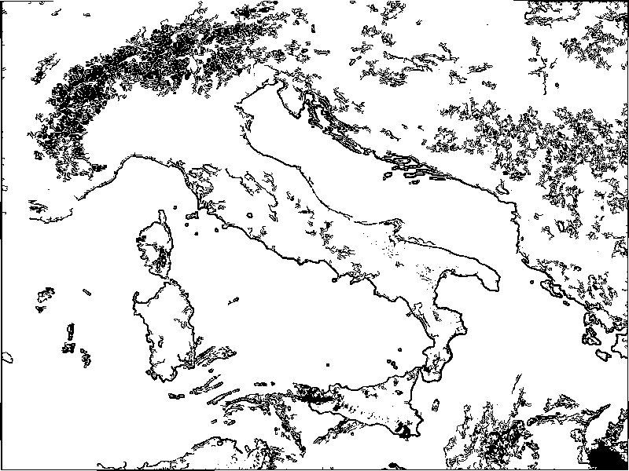
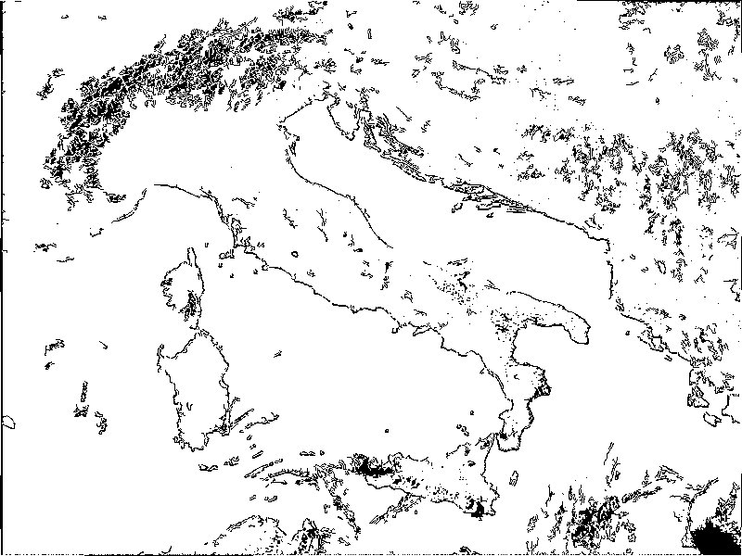

- Circle finding preliminary exerices. Use Circle.ppm and atan to find the approximate center of the circle. Use atan for the normals to the circle's curve.
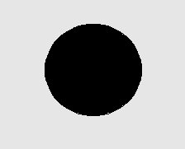

Using these normals, highlight the approximate center of the circle.

This version rounds the angles of gradY and gradX to the nearest 45 degrees:

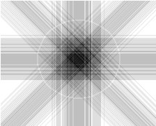

See CirclePreliminary output

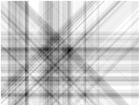
- Use another test image with circle(s) and show the approximation of the center(s) of the circle(s). For example, here’s a sample face image, trying to locate the eyes.


