Canny Edge Detection Demo 1
This demo uses a 4-neighborhood (N,S,E,W)

1. High threshold 800, low threshold 500 There are 137 pixel locations with connected regions – where pixels above the threshold 800 are connected to pixels above the threshold 500.
Solo pixels above threshold 800 are left off of this list.

List of counts: [6, 15, 5, 14, 6, 7, 7, 22, 8, 20, 6, 11, 7, 7, 12, 28, 9, 9, 8, 4, 14, 7, 17, 6, 10, 15, 9, 9, 8, 12, 6, 9, 7, 12, 11, 10, 30, 10, 21, 17, 10, 8, 13, 10, 11, 25, 11, 5, 20, 24, 10, 11, 26, 27, 12, 15, 9, 17, 19, 8, 7, 7, 12, 13, 9, 9, 8, 25, 11, 22, 31, 26, 106, 27, 22, 7, 14, 26, 8, 52, 29, 11, 9, 5, 14, 14, 11, 34, 67, 59, 64, 56, 14, 89, 41, 20, 13, 14, 9, 74, 188, 34, 49, 31, 77, 5, 7, 27, 17, 11, 20, 35, 17, 8, 13, 29, 37, 14, 15, 29, 14, 10, 31, 10, 32, 24, 5, 8, 4, 21, 10, 20, 14, 24, 15, 7, 12]

High threshold:800, low: 500, number of regions:137

Average connected count=20.109489
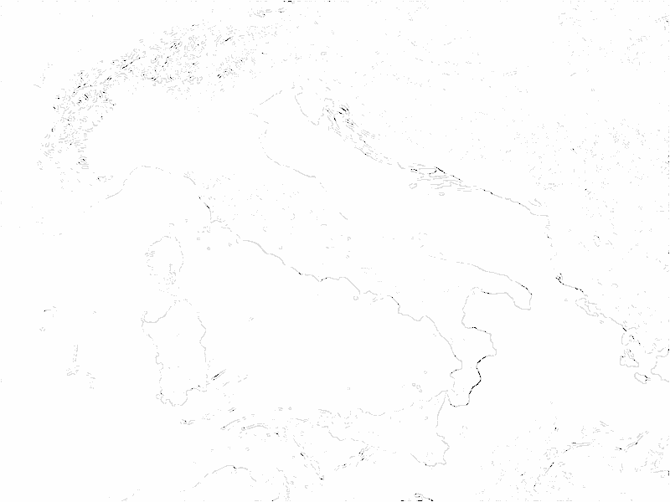



- Example with High threshold 700 and low threshold 400.

There are 324 pixel locations with connected regions – where pixels above the threshold 700 are connected to pixels above the threshold 400.
Solo pixels above threshold 700 are left off of this list.

List of counts: [7, 25, 7, 6, 3, 7, 43, 28, 65, 14, 15, 15, 28, 13, 12, 24, 13, 15, 14, 23, 28, 23, 46, 34, 13, 13, 17, 26, 29, 19, 39, 13, 10, 5, 9, 43, 17, 28, 17, 29, 18, 11, 9, 28, 21, 63, 6, 10, 36, 19, 12, 95, 56, 12, 28, 21, 14, 9, 12, 15, 33, 9, 16, 12, 10, 19, 12, 26, 37, 26, 82, 6, 18, 26, 32, 19, 15, 27, 30, 23, 21, 18, 81, 42, 9, 23, 44, 14, 12, 25, 28, 43, 139, 25, 46, 18, 27, 12, 9, 16, 7, 16, 24, 16, 9, 10, 17, 95, 87, 34, 21, 21, 43, 46, 52, 18, 30, 37, 16, 25, 19, 33, 14, 69, 23, 16, 82, 10, 27, 36, 18, 54, 52, 25, 8, 17, 26, 13, 25, 23, 26, 38, 14, 29, 8, 70, 25, 9, 31, 18, 55, 7, 29, 14, 6, 4, 6, 31, 12, 61, 26, 10, 8, 8, 10, 64, 8, 11, 15, 11, 16, 3, 33, 19, 6, 21, 5, 39, 11, 336, 27, 58, 7, 28, 35, 4, 92, 8, 12, 62, 43, 17, 57, 9, 28, 41, 14, 87, 22, 81, 5, 16, 17, 21, 21, 16, 111, 41, 20, 9, 15, 52, 6, 28, 335, 33, 260, 19, 137, 10, 12, 18, 372, 25, 25, 35, 24, 15, 71, 21, 80, 8, 74, 415, 17, 42, 108, 11, 11, 17, 19, 13, 29, 25, 19, 9, 22, 29, 128, 23, 68, 55, 29, 80, 12, 63, 98, 21, 18, 12, 13, 19, 23, 71, 97, 16, 106, 17, 17, 33, 38, 15, 15, 35, 50, 34, 108, 18, 13, 18, 10, 12, 47, 17, 26, 40, 65, 25, 22, 88, 61, 44, 16, 27, 139, 9, 40, 20, 31, 6, 43, 23, 17, 103, 11, 9, 19, 14, 37, 30, 42, 4, 21, 6, 14, 19, 16, 29, 14, 16, 88, 19, 7, 9]

High threshold:700, low: 400, number of regions:324
Average connected count=33.996914
