Example Run of Left click/Right click version, density = .6

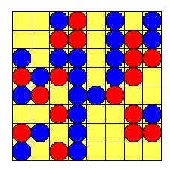

agent with color #FF0000 added to patch at row 6, col 6
agent with color #0000FF added to patch at row 7, col 0
agent with color #FF0000 added to patch at row 3, col 0
agent with color #FF0000 added to patch at row 6, col 7
agent with color #0000FF added to patch at row 2, col 0
...

agent with color #0000FF added to patch at row 2, col 2
agent with color #0000FF added to patch at row 7, col 3
agent with color #0000FF added to patch at row 1, col 7
agent with color #0000FF added to patch at row 2, col 3
agent with color #FF0000 added to patch at row 1, col 2
agent with color #0000FF added to patch at row 3, col 3
11 uncontented agents

checking agent 0 at r 6 c 6, color=#FF0000, contented=True
checking agent 1 at r 7 c 0, color=#0000FF, contented=True
checking agent 2 at r 3 c 0, color=#FF0000, contented=False
Moving 1 uncontented agent
moving agent at r 3 c 0 to patch at r 2 c 1
right mouse button clicked
Moving agent #2
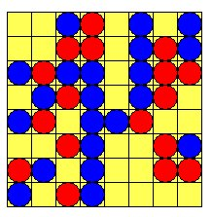
checking agent 3 at r 6 c 7, color=#FF0000, contented=True
checking agent 4 at r 2 c 0, color=#0000FF, contented=True
checking agent 5 at r 5 c 3, color=#0000FF, contented=True
checking agent 6 at r 4 c 0, color=#0000FF, contented=True
checking agent 7 at r 5 c 2, color=#FF0000, contented=False
Moving 1 uncontented agent
moving agent at r 5 c 2 to patch at r 7 c 1
right mouse button clicked
Moving agent #7
checking agent 8 at r 2 c 7, color=#FF0000, contented=True
checking agent 9 at r 4 c 4, color=#0000FF, contented=True
checking agent 10 at r 1 c 3, color=#FF0000, contented=True
checking agent 11 at r 3 c 2, color=#FF0000, contented=False
Moving 1 uncontented agent
moving agent at r 3 c 2 to patch at r 1 c 0

