Canny Cirlce finder Preliminary Exercise

- Use the image CircleSmall.ppm. Highlight the edges and verify your atan is correctly showing the normals to the curve at various points.
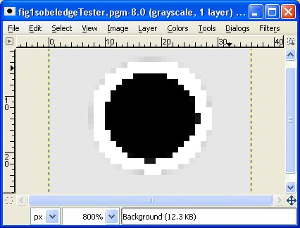

checking pixel at index 193, row 5, col13, color=257
->Row=5, col=13, color=257, gradX=-313, gradY=605, atan2=2.048232, angle=117.355028

->Row=5, col=13, color=257, gradX=-313, gradY=605, atan2=2.048232, angle=117.355028

->Row=5, col=12, color=256, gradX=-274, gradY=450, atan2=2.117726, angle=121.336771

->Row=6, col=13, color=257, gradX=-305, gradY=545, atan2=2.081005, angle=119.232817

->Row=5, col=14, color=257, gradX=-274, gradY=660, atan2=1.964296, angle=112.545855

etc. (YOU DON'T HAVE TO SHOW THE ENTIRE OUTPUT)

- Using the normals to the curve, approximate the location (highlight) the center of the circle. For example: (this version rounds the gradY, gradX angles to the nearest 45 degrees.)

