Constraint Solvers : Lab 1
AI Pt 2, Spring 2009

Solve a map coloring problem using three colors ['red', 'green', 'blue']
Find all the combinations of assigning one of these colors to each territory.
Constraint: No territory can have the same color as any of its neighbors.

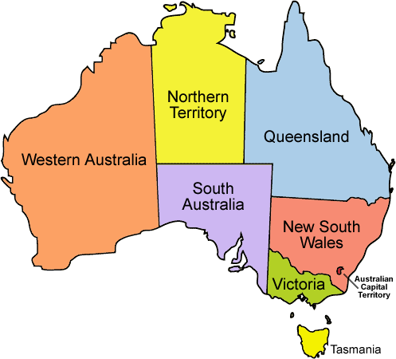
See the website: http://academics.tjhsst.edu/compsci/ai/csp/

- Download australia.csv
This file contains a list of territories and neighbors for each territory.

"SA","WA"
"SA","NT"
"SA","Q"
"SA","NSW"
"SA","V"
"NT","Q"
"NT","WA"
"NSW","Q"
"NSW","V"
"T"

Your goal at first is to convert this file into a Python dictionary structure storing the territories as keys and the neighbors for each territory as the values associated with each key.

{'WA': ['SA', 'NT'], 'Q': ['SA', 'NT', 'NSW'], 'T': [], 'V': ['SA', 'NSW'], 'SA': ['WA', 'NT', 'Q', 'NSW', 'V'],
'NT': ['Q', 'WA', 'SA'], 'NSW': ['Q', 'V', 'SA']}

- This section of code is a preliminary start

infile=open('australia.csv')
filelist=infile.read() # with end of lines includes
print "filelist=%s" % filelist
lines=filelist.split('\n') # take out the end of lines
lines=lines[:-1]
print "file by lines: %s" % lines

Generates this list of the territories:
['"SA","WA"', '"SA","NT"', '"SA","Q"', '"SA","NSW"', '"SA","V"', '"NT","Q"', '"NT","WA"', '"NSW","Q"', '"NSW","V"', '"T"']

- Suggested next step:
use .split(',') for each of these list values and temp[1:-1] to convert '"SA"' to 'SA'
in order to end up with this list:
[['SA', 'WA'], ['SA', 'NT'], ['SA', 'Q'], ['SA', 'NSW'], ['SA', 'V'], ['NT', 'Q'], ['NT', 'WA'],
['NSW', 'Q'], ['NSW', 'V'], ['T', '']]

- Use the list above to create the dictionary of key values and neighbors that is needed for the program

