Constraint Solvers : Lab 1 Step 2, writing the “check” method
AI Pt 2, Spring 2009

Solve a map coloring problem using three colors ['red', 'green', 'blue']
Find all the combinations of assigning one of these colors to each territory.
Constraint: No territory can have the same color as any of its neighbors.

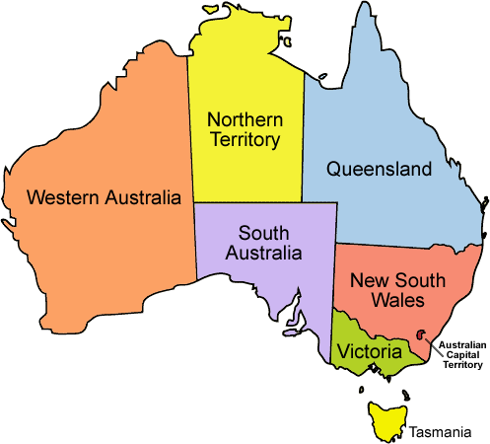
See the website: http://academics.tjhsst.edu/compsci/ai/csp/

Step 2
- Use your solution to Step 1, which finds the correct neighbor dictionary:
Neighbors dictionary second pass:
{'WA': ['SA', 'NT'], 'Q': ['SA', 'NT', 'NSW'], 'T': [], 'V': ['SA', 'NSW'],
'SA': ['WA', 'NT', 'Q', 'NSW', 'V'], 'NT': ['Q', 'WA', 'SA'], 'NSW': ['Q', 'V', 'SA']}

- Write a "check" function that has parameters (neighborlist, colorlist)
and returns True or False whether a particular colorlist is a correct solution

For example, here are sample solutions that may or may not be correct.
Okay
test1={'WA': 'blue', 'Q': 'blue', 'T': 'blue', 'V': 'blue', 'SA': 'green', 'NT': 'red', 'NSW': 'red'}

Not Okay
test2={'WA': 'green', 'Q': 'green', 'T': 'green', 'V': 'green', 'SA': 'red', 'NT': 'red', 'NSW': 'blue'}

SA (red) has neighbor NT (red not ok)

- Suggested starter file:

def check(neighborlist,colorlist):
# neighbor cannot be assigned same color

return True

infile=open('australia.csv')
filelist=infile.read() # with end of lines includes
print "filelist=%s" % filelist
lines=filelist.split('\n') # take out the end of lines
lines=lines[:-1]
print "file by lines: %s" % lines

colors=['red','green','blue']

# Okay
test1={'WA': 'blue', 'Q': 'blue', 'T': 'blue', 'V': 'blue', 'SA': 'green', 'NT': 'red', 'NSW': 'red'}
print "Test1=%s" % check(neighbors,test1)

# Not Okay
test2={'WA': 'blue', 'Q': 'green', 'T': 'blue', 'V': 'red', 'SA': 'green', 'NT': 'blue', 'NSW': 'red'}

# WA (blue) has neighbors SA (green ok), NT (blue not ok),
# VA (red) has neighbors SA (green ok), NSW (red not ok)
# SA (green) has neighbor Q (green not ok)
print "Test2=%s" % check(neighbors,test2)

# Okay
test3={'WA': 'green', 'Q': 'green', 'T': 'green', 'V': 'green', 'SA': 'red', 'NT': 'blue', 'NSW': 'blue'}
print "Test3=%s" % check(neighbors,test3)

test4={'WA': 'green', 'Q': 'green', 'T': 'green', 'V': 'green', 'SA': 'red', 'NT': 'red', 'NSW': 'blue'}
# SA (red) has neighbor NT (red not ok)
print "Test4=%s" % check(neighbors,test4)

test5={'WA': 'red', 'Q': 'red', 'T': 'blue', 'V': 'red', 'SA': 'green', 'NT': 'blue', 'NSW': 'blue'}
print "Test5=%s" % check(neighbors,test5)

