Constraint Solvers : Lab 1 Step 3, Writing the recursive brute force method
AI Pt 2, Spring 2009

Solve a map coloring problem using three colors ['red', 'green', 'blue']
Find all the combinations of assigning one of these colors to each territory.
Constraint: No territory can have the same color as any of its neighbors.

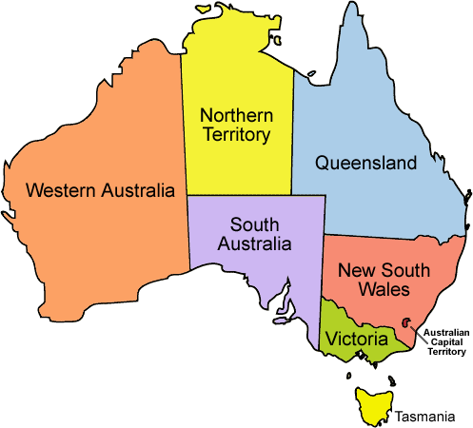
See the website: http://academics.tjhsst.edu/compsci/ai/csp/

Step 3
- In Step 1 you've read the csv file and converted this to a Python dictionary with territories as keys and an associated list of the neighbors for each territory:
{'WA': ['SA', 'NT'], 'Q': ['SA', 'NT', 'NSW'], 'T': [], 'V': ['SA', 'NSW'],
'SA': ['WA', 'NT', 'Q', 'NSW', 'V'], 'NT': ['Q', 'WA', 'SA'], 'NSW': ['Q', 'V', 'SA']}

- In Step 2, you've written a "check" function that has parameters (neighborlist, colorlist)
and returns True or False whether a particular colorlist is a correct solution:
Okay
test1={'WA': 'blue', 'Q': 'blue', 'T': 'blue', 'V': 'blue', 'SA': 'green', 'NT': 'red', 'NSW': 'red'}
Not Okay
test2={'WA': 'green', 'Q': 'green', 'T': 'green', 'V': 'green', 'SA': 'red', 'NT': 'red', 'NSW': 'blue'}

SA (red) has neighbor NT (red not ok)

- Step 3 begins with a simplified australia.csv file, only the three territories NT, WA, SA

"SA","WA"
"SA","NT"
"NT","WA"

Here's a brute force solution using a series of nested loops, one loop for each territory.

def printSolutions(neighborlist,colors):
colorchoices={}
territory=[]
for el in neighbors:
territory.append(el)
for Territory0color in colors:
colorchoices[territory[0]]=Territory0color
for Territory1color in colors:
colorchoices[territory[1]]=Territory1color
for Territory2color in colors:
colorchoices[territory[2]]=Territory2color
if check(neighbors,colorchoices):
print "Colorchoices: OKAY Color=%s" % colorchoices
else:
print "Colorchoices: NOT okay Color=%s" % colorchoices
del(colorchoices[territory[2]]) # These deletes may not be necessary
del(colorchoices[territory[1]])
del(colorchoices[territory[0]])

Output:

#Colorchoices: NOT okay Color={'SA': 'red', 'NT': 'red', 'WA': 'red'}
#Colorchoices: NOT okay Color={'SA': 'red', 'NT': 'red', 'WA': 'green'}
#Colorchoices: NOT okay Color={'SA': 'red', 'NT': 'red', 'WA': 'blue'}
#Colorchoices: NOT okay Color={'SA': 'red', 'NT': 'green', 'WA': 'red'}
#Colorchoices: NOT okay Color={'SA': 'red', 'NT': 'green', 'WA': 'green'}
#Colorchoices: OKAY Color={'SA': 'red', 'NT': 'green', 'WA': 'blue'}
#Colorchoices: NOT okay Color={'SA': 'red', 'NT': 'blue', 'WA': 'red'}
#Colorchoices: OKAY Color={'SA': 'red', 'NT': 'blue', 'WA': 'green'}
#Colorchoices: NOT okay Color={'SA': 'red', 'NT': 'blue', 'WA': 'blue'}

. . .

A disadvantage of this solution is that you need one loop for each territory. Write a version using recursion that is not specific to a particular number of territories, but works on any number of territories. It will work on our original australia.csv file with 7 territories.

