Constraint Solvers : Lab 2, AUS example
Forward checking with Degree heuristic and Minimum remaining values
AI Pt 2, Spring 2009

Solve a map coloring problem using three colors ['red', 'green', 'blue']
Find all the combinations of assigning one of these colors to each territory.
Constraint: No territory can have the same color as any of its neighbors.

See the website: http://academics.tjhsst.edu/compsci/ai/csp/

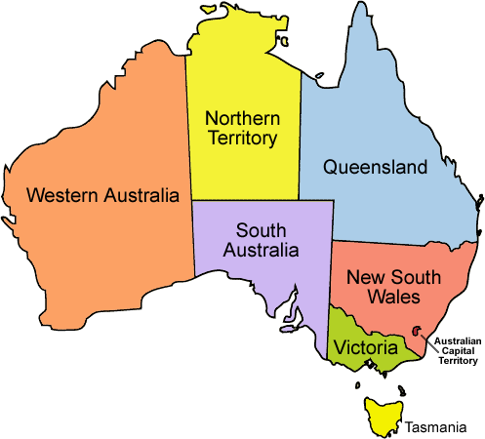

- Sort the list of states, largest # of neighbors first

Neighbors dictionary second pass: {'WA': ['SA', 'NT'], 'Q': ['SA', 'NT', 'NSW'], 'T': [], 'V': ['SA', 'NSW'], 'SA': ['WA', 'NT', 'Q', 'NSW', 'V'], 'NT': ['Q', 'WA', 'SA'], 'NSW': ['Q', 'V', 'SA']}

List of territories, largest # of neighbors first

Territories sorted by number least number of color choices and most number of neighbors

# of choices=['SA', 'Q', 'NT', 'NSW', 'WA', 'V', 'T']

Assign SA color red ← pick the first territory off of the sorted list

Coloring SA red limits its neighbors to two colors, green and blue:
Territory Q has colorchoices ['green', 'blue']
Territory NT has colorchoices ['green', 'blue']
Territory NSW has colorchoices ['green', 'blue']
Territory WA has colorchoices ['green', 'blue']
Territory V has colorchoices ['green', 'blue']
Territory T has no neighbors, so has all three color choices:['red', 'green', 'blue']

2. Use MINIMUM REMAINING VALUES and the DEGREE HEURISTIC to pick one of these states having the most uncolored neighbors and the least number of color choices

States sorted by # of color choices and most neighbors:
['Q', 'NT', 'NSW', 'WA', 'V', 'T']

Assigning Q color green ← pick first in sorted list. Q has the combination of least color choices and most uncolored neighbors

Coloring Q green places limitations on the color choices of its neighbors (NT and NSW):
Territory NT has colorchoices ['blue']
Territory NSW has colorchoices ['blue']
Territory WA has colorchoices ['green', 'blue']
Territory V has colorchoices ['green', 'blue']
Territory T has colorchoices ['red', 'green', 'blue']

NT and NSW each have one uncolored neighbor and one color choice:

3. Use MINIMUM REMAINING VALUES and the DEGREE HEURISTIC to pick one of these states having the most uncolored neighbors and the least number of color choices

['NT', 'NSW', 'V', 'WA', 'T']

Assign NT color blue ← choose either NT or NSW to color next

Territory NSW has colorchoices ['blue']
Territory V has colorchoices ['green', 'blue']
Territory WA has colorchoices ['green']
Territory T has colorchoices ['red', 'green', 'blue']

NSW and WA each have one color option left, WA has 0 uncolored neighbors, NSW has one uncolored neighbor. NSW is ranked higher priority to color next

4. Use MINIMUM REMAINING VALUES and the DEGREE HEURISTIC to pick one of these states having the most uncolored neighbors and the least number of color choices
['NSW', 'WA', 'V', 'T']
Assign NSW color blue ← color NSW, the first in the list

Territory WA has colorchoices ['green']
Territory V has colorchoices ['green']
Territory T has colorchoices ['red', 'green', 'blue'

WA and V are ranked evenly, each have 0 uncolored neighbors and 1 color choice

5. Sort by minimum number of color choices and maximum number of uncolored neighbors
['WA', 'V', 'T']

Assign WA color green

Territory V has colorchoices ['green']
Territory T has colorchoices ['red', 'green', 'blue']

Sort territories by number of color options again:

['V', 'T']

Assign V color green

At this point an answer list is generated, T can have any of the colors, it has no neighbors.

{'WA': 'green', 'Q': 'green', 'T': 'red', 'V': 'green', 'SA': 'red', 'NT': 'blue', 'NSW': 'blue'}

