Constraint Solvers : Lab 2, Step 1 - Sorting
Degree heuristic, Minimum remaining values, Forward checking
AI Pt 2, Spring 2009

Solve a map coloring problem using three colors ['red', 'green', 'blue']
Find all the combinations of assigning one of these colors to each territory.
Constraint: No territory can have the same color as any of its neighbors.

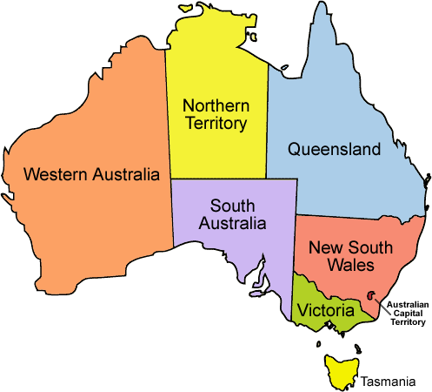
See the website: http://academics.tjhsst.edu/compsci/ai/csp/

- Step 1 – write a sort method, insertion sort for example.

sorting this list of territories, largest # of neighbors first,
{'WA': ['SA', 'NT'], 'Q': ['SA', 'NT', 'NSW'], 'T': [], 'V': ['SA', 'NSW'], 'SA': ['WA', 'NT', 'Q', 'NSW', 'V'], 'NT': ['Q', 'WA', 'SA'], 'NSW': ['Q', 'V', 'SA']}
sortedneighborlist=['WA']
in insert, sorted neighbors=['WA']
in insert, sorted neighbors=['Q', 'WA']
in insert, sorted neighbors=['Q', 'WA', 'T']
in insert, sorted neighbors=['Q', 'WA', 'V', 'T']
in insert, sorted neighbors=['SA', 'Q', 'WA', 'V', 'T']
in insert, sorted neighbors=['SA', 'Q', 'NT', 'WA', 'V', 'T']

def insert(sortedneighbors, territory,neighbors):
. . .
sortedneighbors.append(territory)
. . .
return sortedneighbors

- This section of code is a preliminary start

