Constraint Solvers : Lab 2, Step 2
Forward checking with Degree heuristic
AI Pt 2, Spring 2009

Solve a map coloring problem using three colors ['red', 'green', 'blue']
Find all the combinations of assigning one of these colors to each territory.
Constraint: No territory can have the same color as any of its neighbors.

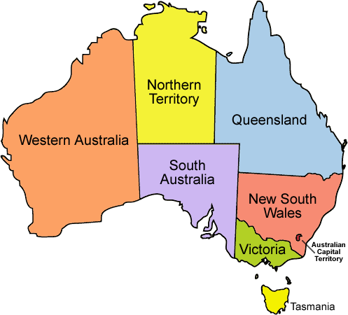
See the website: http://academics.tjhsst.edu/compsci/ai/csp/

- Use your sort method from Step 1 to prioritize the order in which you choose a territory to color. For example, in the map above, you'd want to start with South Australia because it has the most neighbors. Choosing a color for SA will constrain the choices of the most amount of other territories.

sorting this list of territories, largest # of neighbors first,
{'WA': ['SA', 'NT'], 'Q': ['SA', 'NT', 'NSW'], 'T': [], 'V': ['SA', 'NSW'], 'SA': ['WA', 'NT', 'Q', 'NSW', 'V'], 'NT': ['Q', 'WA', 'SA'], 'NSW': ['Q', 'V', 'SA']}

sorted by neighbors=['SA', 'Q', 'NT', 'WA', 'V', 'T']

- Verify that this process solves the puzzle more quickly than your brute force method from Lab1. For example, putting a counter in the recursive coloring methods leads to:

(brute force) count1=3280 (degree heuristic) count2=52

3. Try this out on the larger data base file of US states.

