Constraint Solvers : Lab 2, Step 3
Forward checking with Degree heuristic and Minimum remaining values
AI Pt 2, Spring 2009

Solve a map coloring problem using three colors ['red', 'green', 'blue']
Find all the combinations of assigning one of these colors to each territory.
Constraint: No territory can have the same color as any of its neighbors.

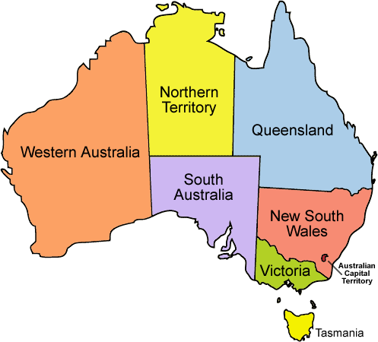
See the website: http://academics.tjhsst.edu/compsci/ai/csp/

- Use your solutions to Steps 1 and 2 in combination with the minimum remaining values heuristic. Make your first choice with the degree heuristic, and then prioritize your next territory to pick by those with the fewest color options
- Write another sort method that prioritizes by the territories with the least color options as first in the sorted list. Here's an example portion of a trace:

Assigning SA color red (USING DEGREE HEURISTIC)

colorstochoose list={'WA': ['green', 'blue'], 'Q': ['green', 'blue'], 'T': ['red', 'green', 'blue'],
'V': ['green', 'blue'], 'NT': ['green', 'blue'], 'NSW': ['green', 'blue']}

territories sorted by # of choices=['WA', 'Q', 'V', 'NT', 'NSW', 'T']

Assigning WA color green (USING MINIMUM REMAINING VALUES)

colorstochoose list={'Q': ['green', 'blue'], 'NSW': ['green', 'blue'], 'NT': ['blue'],
'T': ['red', 'green', 'blue'], 'V': ['green', 'blue']}

territories sorted by # of choices=['NT', 'Q', 'NSW', 'V', 'T']

Assigning NT color blue

colorstochoose list={'Q': ['green'], 'V': ['green', 'blue'], 'T': ['red', 'green', 'blue'],
'NSW': ['green', 'blue']}

territories sorted by # of choices=['Q', 'V', 'NSW', 'T']

Assigning Q color green

colorstochoose list={'NSW': ['blue'], 'T': ['red', 'green', 'blue'], 'V': ['green', 'blue']}

territories sorted by # of choices=['NSW', 'V', 'T']

Assigning NSW color blue

colorstochoose list={'T': ['red', 'green', 'blue'], 'V': ['green']}
territories sorted by # of choices=['V', 'T']

Assigning V color green

colorstochoose list={'T': ['red', 'green', 'blue']}
territories sorted by # of choices=['T']

Assigning T color red

OKAY Color={'WA': 'green', 'Q': 'green', 'T': 'red', 'V': 'green', 'SA': 'red', 'NT': 'blue', 'NSW': 'blue'}

