Constraint Solvers : Lab 2, Step 3, Another example
Forward checking with Degree heuristic and Minimum remaining values
AI Pt 2, Spring 2009

Solve a map coloring problem using three colors ['red', 'green', 'blue']
Find all the combinations of assigning one of these colors to each territory.
Constraint: No territory can have the same color as any of its neighbors.

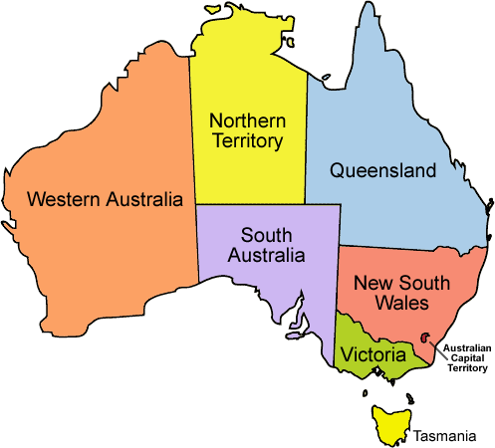
See the website: http://academics.tjhsst.edu/compsci/ai/csp/

- Use your solutions to Steps 1 and 2 in combination with the minimum remaining values heuristic. Make your first choice with the degree heuristic, and then prioritize your next territory to pick by those with the fewest color options
- Write another sort method that prioritizes by the territories with the least color options as first in the sorted list. Here's an example portion of a trace:

sorting the list of territories, largest # of neighbors first
SORTING THE 7 TERRITORIES USING INSERTION SORT:
in insert, sorted neighbors=[]
in insert, sorted neighbors=['WA']
in insert, sorted neighbors=['Q', 'WA']
in insert, sorted neighbors=['Q', 'WA', 'T']
in insert, sorted neighbors=['Q', 'WA', 'V', 'T']
in insert, sorted neighbors=['SA', 'Q', 'WA', 'V', 'T']
in insert, sorted neighbors=['SA', 'Q', 'NT', 'WA', 'V', 'T']
Neighbors sorted ['SA', 'Q', 'NT', 'NSW', 'WA', 'V', 'T'] ← SA has the most neighbors (5)

Color={'SA': 'red'} ← USING THE DEGREE HEURISTIC, color first the territory with max
neighbors
By coloring SA red, you've limited the 5 neighbors, each cannot be red:
Territory Q has colorchoices ['green', 'blue']
Territory NT has colorchoices ['green', 'blue']
Territory NSW has colorchoices ['green', 'blue']
Territory WA has colorchoices ['green', 'blue']
Territory V has colorchoices ['green', 'blue']

Territory T, 0 neighbors, has 3 choices:
Territory T has colorchoices ['red', 'green', 'blue']

Create a sorted list ordered with territories with minimum choices in the front:
Territories sorted by # of choices=['WA', 'Q', 'V', 'NT', 'NSW', 'T']

Assigning WA color green ← pick the first off this sorted list

The remaining uncolored neighbor of WA – NT – is now constrained to blue:
Territory Q has colorchoices ['green', 'blue']
Territory V has colorchoices ['green', 'blue']
Territory NT has colorchoices ['blue']
Territory NSW has colorchoices ['green', 'blue']
Territory T has colorchoices ['red', 'green', 'blue']

Sort the territories by number of color choices, minimum first:
Territories sorted by # of choices=['NT', 'Q', 'NSW', 'V', 'T']

Assigning NT color blue ← pick the first off this sorted list

NT's one remaining neighbor – Q – is constrained to a single color choice:
Territory Q has colorchoices ['green']
Territory NSW has colorchoices ['green', 'blue']
Territory V has colorchoices ['green', 'blue']
Territory T has colorchoices ['red', 'green', 'blue']

Sort by number of color choices:
Territories sorted by # of choices=['Q', 'V', 'NSW', 'T']

Assigning Q color green ← pick the first off the list

Sort by color choices:
Territory V has colorchoices ['green', 'blue'],
Territory NSW has colorchoices ['blue']
Territory T has colorchoices ['red', 'green', 'blue']

Territories sorted by # of choices=['NSW', 'V', 'T']

Assigning NSW color blue ← color the first off the list

Remaing color choices:
Territory V has colorchoices ['green']
Territory T has colorchoices ['red', 'green', 'blue']
Sort by color choices:
territories sorted by # of choices=['V', 'T']
Assigning V color green ← Color first on sorted list. 'T' can be any color
R4ByColorChoices...Territory T has colorchoices ['red', 'green', 'blue']
R4ByColorChoices: colorstochoose list={'T': ['red', 'green', 'blue']}
R4ByColorChoices: territories sorted by # of choices=['T']
R4ByColorChoices: assigning T color red
R4ByColorChoices:OKAY Color={'WA': 'green', 'Q': 'green', 'T': 'red', 'V': 'green', 'SA': 'red', 'NT': 'blue', 'NSW': 'blue'}
count1=0 count2=0 count3=0 count4=9
neighborlist={'WA': ['SA', 'NT'], 'Q': ['SA', 'NT', 'NSW'], 'T': [], 'V': ['SA', 'NSW'], 'SA': ['WA', 'NT', 'Q', 'NSW', 'V'], 'NT': ['Q', 'WA', 'SA'], 'NSW': ['Q', 'V', 'SA']}
colorlist (7 states)=[{'WA': 'green', 'Q': 'green', 'T': 'red', 'V': 'green', 'SA': 'red', 'NT': 'blue', 'NSW': 'blue'}, {'WA': 'green', 'Q': 'green', 'T': 'red', 'V': 'green', 'SA': 'red', 'NT': 'blue', 'NSW': 'blue'}]
1 top neighbors, 6 lower neighbors, 7 territories
colors used=['red', 'green', 'blue']

Assigning SA color red (USING DEGREE HEURISTIC)

colorstochoose list={'WA': ['green', 'blue'], 'Q': ['green', 'blue'], 'T': ['red', 'green', 'blue'],
'V': ['green', 'blue'], 'NT': ['green', 'blue'], 'NSW': ['green', 'blue']}

territories sorted by # of choices=['WA', 'Q', 'V', 'NT', 'NSW', 'T']

Assigning WA color green (USING MINIMUM REMAINING VALUES)

colorstochoose list={'Q': ['green', 'blue'], 'NSW': ['green', 'blue'], 'NT': ['blue'],
'T': ['red', 'green', 'blue'], 'V': ['green', 'blue']}

territories sorted by # of choices=['NT', 'Q', 'NSW', 'V', 'T']

Assigning NT color blue

colorstochoose list={'Q': ['green'], 'V': ['green', 'blue'], 'T': ['red', 'green', 'blue'],
'NSW': ['green', 'blue']}

territories sorted by # of choices=['Q', 'V', 'NSW', 'T']

Assigning Q color green

colorstochoose list={'NSW': ['blue'], 'T': ['red', 'green', 'blue'], 'V': ['green', 'blue']}

territories sorted by # of choices=['NSW', 'V', 'T']

Assigning NSW color blue

colorstochoose list={'T': ['red', 'green', 'blue'], 'V': ['green']}
territories sorted by # of choices=['V', 'T']

Assigning V color green

colorstochoose list={'T': ['red', 'green', 'blue']}
territories sorted by # of choices=['T']

Assigning T color red

OKAY Color={'WA': 'green', 'Q': 'green', 'T': 'red', 'V': 'green', 'SA': 'red', 'NT': 'blue', 'NSW': 'blue'}

