Constraint Solvers : Lab 2, US example
Forward checking with Degree heuristic and Minimum remaining values
AI Pt 2, Spring 2009

Solve a map coloring problem using three colors ['red', 'green', 'blue']
Find all the combinations of assigning one of these colors to each territory.
Constraint: No territory can have the same color as any of its neighbors.

See the website: http://academics.tjhsst.edu/compsci/ai/csp/

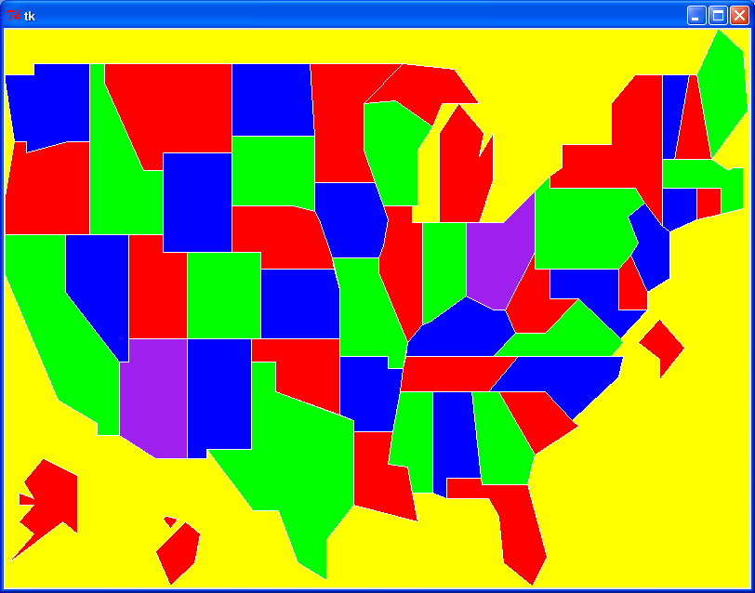

- Sort the list of states, largest # of neighbors first

Neighbor count sorted –
(TN and MO have 8 neighbors; KY has 7, WY, NE, PA, VA, CO, AR, IA, ID, OK, SD have 6, etc)
['TN', 'MO', 'KY', 'WY', 'NE', 'PA', 'VA', 'CO', 'AR', 'IA', 'ID', 'OK', 'SD', 'WV', 'NY', 'NV', 'IL', 'GA', 'MA', 'MD', 'OH', 'UT', 'WI', 'NM', 'TX', 'NC', 'AL', 'IN', 'AZ', 'MN', 'KS', 'MT', 'MS', 'OR', 'DE', 'NH', 'NJ', 'LA', 'ND', 'CA', 'VT', 'CT', 'MI', 'WA', 'DC', 'FL', 'RI', 'SC', 'ME', 'HI', 'AK']

Color={'TN': 'red'} ← USING THE DEGREE HEURISTIC, color first the territory with max
neighbors
By coloring TN red, you've limited the 8 neighbors, each cannot be red:
MO has colorchoices ['green', 'blue', 'purple']
KY has colorchoices ['green', 'blue', 'purple']
VA has colorchoices ['green', 'blue', 'purple']
AR has colorchoices ['green', 'blue', 'purple']
GA has colorchoices ['green', 'blue', 'purple']
NC has colorchoices ['green', 'blue', 'purple']
AL has colorchoices ['green', 'blue', 'purple']
MS has colorchoices ['green', 'blue', 'purple']

2. Use MINIMUM REMAINING VALUES and the DEGREE HEURISTIC to pick one of these states having the most uncolored neighbors and the least number of color choices

States sorted by # of color choices and most neighbors
['MO', 'KY', 'VA', 'AR', 'GA', 'NC', 'AL', 'MS', 'WY', 'NE', 'PA', 'CO', 'IA', 'OK', 'ID', 'SD', 'WV', 'NY', 'NV', 'IL', 'MD', 'MA', 'OH', 'UT', 'WI', 'NM', 'TX', 'IN', 'AZ', 'MN', 'KS', 'MT', 'OR', 'DE', 'NH', 'NJ', 'LA', 'ND', 'CA', 'VT', 'CT', 'MI', 'WA', 'DC', 'FL', 'RI', 'SC', 'ME', 'HI', 'AK']

Pick MO to color next, it has three color choices and 7 uncolored neighbors

MO color green ← pick the first off this sorted list

Neighbors of both TN and MO now have only two color choices

KY has colorchoices ['blue', 'purple']
AR has colorchoices ['blue', 'purple']

3. Use MINIMUM REMAINING VALUES and the DEGREE HEURISTIC to pick one of these states having the most uncolored neighbors and the least number of color choices

States sorted by # of color choices and most neighbors
['KY', 'AR', 'NE', 'VA', 'IA', 'OK', 'IL', 'GA', 'NC', 'AL', 'KS', 'MS', 'WY', 'PA', 'CO', 'ID', 'SD', 'WV', 'NY', 'NV', 'MA', 'MD', 'OH', 'UT', 'WI', 'NM', 'TX', 'IN', 'AZ', 'MN', 'MT', 'OR', 'DE', 'NH', 'NJ', 'LA', 'ND', 'CA', 'VT', 'CT', 'MI', 'WA', 'DC', 'FL', 'RI', 'SC', 'ME', 'HI', 'AK']

Assign KY color blue ← pick the first off this sorted list

4. Use MINIMUM REMAINING VALUES and the DEGREE HEURISTIC to pick one of these states having the most uncolored neighbors and the least number of color choices

['VA', 'AR', 'IL', 'NE', 'IA', 'OK', 'WV', 'GA', 'OH', 'NC', 'AL', 'IN', 'KS', 'MS', 'WY', 'PA', 'CO', 'ID', 'SD', 'NY', 'NV', 'MA', 'MD', 'UT', 'WI', 'NM', 'TX', 'AZ', 'MN', 'MT', 'OR', 'DE', 'NH', 'NJ', 'LA', 'ND', 'CA', 'VT', 'CT', 'MI', 'WA', 'DC', 'FL', 'RI', 'SC', 'ME', 'HI', 'AK']

Assign VA color green

5. Sort by minimum number of color choices and maximum number of uncolored neighbors=
['AR', 'WV', 'IL', 'NC', 'NE', 'IA', 'OK', 'GA', 'MD', 'OH', 'AL', 'IN', 'KS', 'MS', 'DC', 'WY', 'PA', 'CO', 'ID', 'SD', 'NY', 'NV', 'MA', 'UT', 'WI', 'NM', 'TX', 'AZ', 'MN', 'MT', 'OR', 'DE', 'NH', 'NJ', 'LA', 'ND', 'CA', 'VT', 'CT', 'MI', 'WA', 'FL', 'RI', 'SC', 'ME', 'HI', 'AK']

Assign AR color blue

