Constraint Solvers : Lab 3, US coloring
Forward checking with Degree heuristic and Minimum remaining values
AI Pt 2, Spring 2009

Solve a map coloring problem using four colors ['red', 'green', 'blue', 'purple'] for example
Find all the combinations of assigning one of these colors to each territory.
Constraint: No territory can have the same color as any of its neighbors.

See the website: http://academics.tjhsst.edu/compsci/ai/csp/

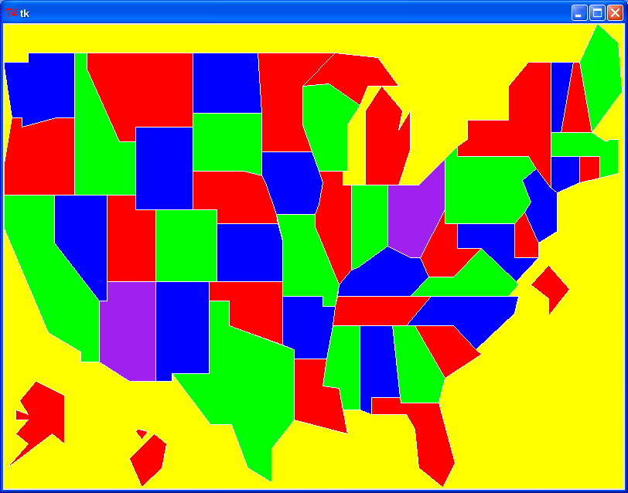

- Write a program to read in unitedstates.csv with colors This file is on our website
http://academics.tjhsst.edu/compsci/ai/csp/unitedstates.csv

An example shell starter program is listed below and is also on our class website
http://www.tjhsst.edu/~rlatimer/ai2008Pt2/assignmentsConstraint.html

This shell program colors only one state – Ohio. You need to color all of the states.

- Adjust your Lab 2 program so that it outputs only one solution or a list of several solutions.

In the recursive method you'll need to stop after one or several solutions by returning a value such as True/False or an answerlist that may have a solution or be an empty list:

if check(neighborlist,colorchoices):
print "OKAY color=%s" % colorchoices
return True
else:
return False

OR something like

if len(sortedneighborlist)==0:
if check(neighborlist,colorchoices):
print "OKAY Colorchoices=%s" % colorchoices
answerlist.append(colorchoices)
return answerlist
else:
. . .
answer = recursivecall(. . .)

- Find several solutions with different colors for the US map.
- As an extension, try to color the more detailed US map,
stateVisibilityBorders.csv
http://academics.tjhsst.edu/compsci/ai/csp/stateVisibilityBorders.csv

EXAMPLE STARTER PROGRAM THAT READS pentagonSample.csv AND COLORS ONE PENTAGON
(COLORS ONLY ONE PENTAGON - “PENTAGON1”)

see http://www.tjhsst.edu/~rlatimer/ai2008Pt2/assignmentsConstraint.html

from Tkinter import *
from sys import exit
from random import choice

# OR LIKE THIS: colors="red green blue purple".split()
colors=["red", "green", "blue", "purple"]

Color={'PENTAGON1': 'green'} # THIS VERSION IS ONLY COLORING ONE POLYGON

w,h=800,600
minX=0
minY=0
maxX=160
maxY=100
root=Tk()
canvas=Canvas(root,width=w,height=h,bg="yellow")
canvas.pack()

# read the polygon

filelines=open("pentagonSample.csv").read().split('\n')#[1:-1]
print "filelines=%s" % filelines
filelines=filelines[1:-1] # remove the first and last lines
print "filelines=%s" % filelines
polygonlocations={}
for i in range(0,5): # 5 lines of data point for PENTAGON1
line=filelines[i]
linedata=line.split(',')
print "%d: %s" % (i,linedata)
polygonname = linedata[0]
xloc = linedata[1]
yloc = linedata[2]
# or: polygonname,xloc,yloc=line.split(',')
print "shape=%s, xloc=%s, yloc=%s" % (polygonname,xloc,yloc)
if polygonname not in polygonlocations:
polygonlocations[polygonname]=[]
xloc=float(xloc)
yloc=float(yloc)
polygonlocations[polygonname].append((xloc,yloc))

print "Final polygonlocations=%s" % polygonlocations
col={}

# assign colors

for polygon in polygonlocations:
col[polygon]=Color[polygon]

# draw map

for polygon in polygonlocations:
xy=[]
for (x,y) in polygonlocations[polygon]:
xy.append((w*(x-minX)/(maxX-minX),h-h*(y-minY)/(maxY-minY)))
canvas.create_polygon(xy,fill=col[polygon],outline="white")

root.bind('<q>', lambda e: exit(0))
root.mainloop()

