Sudoku
AI Pt 2, Spring 2009

Solve a sudoku problem using nine “colors” ['1', '2', '3', '4','5','6', '7', '8', '9']
Constraint: There are nine “sections” in which all the squares within the section are considered neighbors, so they each need a different “color” - number. Also, additional neighbors of each square are the other squares in the same row and the squares in the same column. No square can have the same “color” - number - as any of its neighbors.

See the website: http://academics.tjhsst.edu/compsci/ai/csp/

This sample puzzle is from http://www.websudoku.com, Easy level
Partially solved version
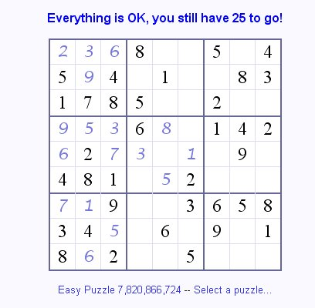
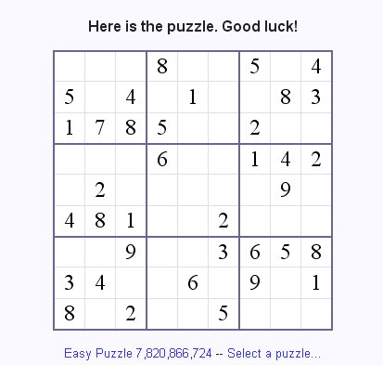
1. Example representation for the partially solved puzzle on the right:
2,3,6,8,-1,-1,5,-1,4
5,9,4,-1,1,-1,-1,8,3
1,7,8,5,-1,-1,2,-1,-1
9,5,3,6,8,-1,1,4,2
6,2,7,-1,-1,-1,-1,9,-1
4,8,1,-1,-1,2,-1,-1,-1
7,1,9,-1,-1,3,6,5,8
3,4,5,-1,6,-1,9,-1,1
8,6,2,-1,-1,5,-1,-1,-1

Blank squares are represented as -1

Example representation for data structures :

2. The entire puzzle list:
sudokulist=[2, 3, 6, 8, -1, -1, 5, -1, 4, 5, 9, 4, -1, 1, -1, -1, 8, 3, 1, 7, 8, 5, -1, -1, 2, -1, -1, 9, 5, 3, 6, 8, -1, 1, 4, 2, 6, 2, 7, -1, -1, -1, -1, 9, -1, 4, 8, 1, -1, -1, 2, -1, -1, -1, 7, 1, 9, -1, -1, 3, 6, 5, 8, 3, 4, 5, -1, 6, -1, 9, -1, 1, 8, 6, 2, -1, -1, 5, -1, -1, -1]
3. The indexes initially having a color – number – assigned

colorlist (indexes currently assigned a color) ={0: 2, 1: 3, 2: 6, 3: 8, 6: 5, 8: 4, 9: 5, 10: 9, 11: 4, 13: 1, 16: 8, 17: 3, 18: 1, 19: 7, 20: 8, 21: 5, 24: 2, 27: 9, 28: 5, 29: 3, 30: 6, 31: 8, 33: 1, 34: 4, 35: 2, 36: 6, 37: 2, 38: 7, 43: 9, 45: 4, 46: 8, 47: 1, 50: 2, 54: 7, 55: 1, 56: 9, 59: 3, 60: 6, 61: 5, 62: 8, 63: 3, 64: 4, 65: 5, 67: 6, 69: 9, 71: 1, 72: 8, 73: 6, 74: 2, 77: 5}

4. The indexes corresponding to the nine regions:
regionindexes={0: [0, 1, 2, 9, 10, 11, 18, 19, 20], 1: [3, 4, 5, 12, 13, 14, 21, 22, 23], 2: [6, 7, 8, 15, 16, 17, 24, 25, 26], 3: [27, 28, 29, 36, 37, 38, 45, 46, 47], 4: [30, 31, 32, 39, 40, 41, 48, 49, 50], 5: [33, 34, 35, 42, 43, 44, 51, 52, 53], 6: [54, 55, 56, 63, 64, 65, 72, 73, 74], 7: [57, 58, 59, 66, 67, 68, 75, 76, 77], 8: [60, 61, 62, 69, 70, 71, 78, 79, 80]}

5. The neighbors of each index (square) 0 .. 80 (81 squares)

neighborlist={0: [1, 2, 9, 10, 11, 18, 19, 20, 27, 36, 45, 54, 63, 72, 3, 4, 5, 6, 7, 8], 1: [0, 2, 9, 10, 11, 18, 19, 20, 28, 37, 46, 55, 64, 73, 3, 4, 5, 6, 7, 8], 2: [0, 1, 9, 10, 11, 18, 19, 20, 29, 38, 47, 56, 65, 74, 3, 4, 5, 6, 7, 8], 3: [4, 5, 12, 13, 14, 21, 22, 23, 30, 39, 48, 57, 66, 75, 0, 1, 2, 6, 7, 8], . . .
. . . 77: [57, 58, 59, 66, 67, 68, 75, 76, 5, 14, 23, 32, 41, 50, 72, 73, 74, 78, 79, 80], 78: [60, 61, 62, 69, 70, 71, 79, 80, 6, 15, 24, 33, 42, 51, 72, 73, 74, 75, 76, 77], 79: [60, 61, 62, 69, 70, 71, 78, 80, 7, 16, 25, 34, 43, 52, 72, 73, 74, 75, 76, 77], 80: [60, 61, 62, 69, 70, 71, 78, 79, 8, 17, 26, 35, 44, 53, 72, 73, 74, 75, 76, 77]}

6. List of the “filtered” color choices - those colors (numbers) available to each unsassigned index

filtered color choices={4: ['7', '9'], 5: ['7', '9'], 7: ['1', '7'], 12: ['2', '7'], 14: ['6', '7'], 15: ['7'], 22: ['3', '4', '9'], 23: ['4', '6', '9'], 25: ['6'], 26: ['6', '9'], 32: ['7'], 39: ['1', '3', '4'], 40: ['3', '4', '5'], 41: ['1', '4'], 42: ['3', '8'], 44: ['5'], 48: ['3', '7', '9'], 49: ['3', '5', '7', '9'], 51: ['3', '7'], 52: ['3', '6', '7'], 53: ['5', '6', '7'], 57: ['2', '4'], 58: ['2', '4'], 66: ['2', '7'], 68: ['7', '8'], 70: ['2', '7'], 75: ['1', '4', '7', '9'], 76: ['4', '7', '9'], 78: ['3', '4', '7'], 79: ['3', '7'], 80: ['7']}

For example, index 4 (next to the numeral 8) has color choices 7 and 9. Index 7 (between the 5 and 4) has color choices 1 and 7.

