Neural Netorks: Perceptron and XOR Lab 1
http://www.iiit.net/~vikram/nn_intro.html

The Perceptron
This is a very simple model and consists of a single `trainable' neuron. Trainable means that its threshold and input weights are modifiable. Inputs are presented to the neuron and each input has a desired output (determined by us). If the neuron doesn't give the desired output, then it has made a mistake. To rectify this, its threshold and/or input weights must be changed. How this change is to be calculated is determined by the learning algorithm.
The output of the perceptron is constrained to boolean values - (true,false), (1,0), (1,-1) or whatever. This is not a limitation because if the output of the perceptron were to be the input for something else, then the output edge could be made to have a weight. Then the output would be dependant on this weight.
The perceptron looks like -
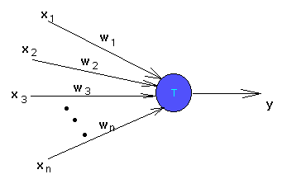
x1, x2, ..., xn are inputs. These could be real numbers or boolean values depending on the problem.
- y is the output and is boolean.
- w1, w2, ..., wn are weights of the edges and are real valued.
- T is the threshold and is real valued.
The output y is 1 if the net input which is
w1 x1 + w2 x2 + ... + wn xn
is greater than the threshold T. Otherwise the output is zero.
The idea is that we should be able to train this perceptron to respond to certain inputs with certain desired outputs. After the training period, it should be able to give reasonable outputs for any kind of input. If it wasn't trained for that input, then it should try to find the best possible output depending on how it was trained.
So during the training period we will present the perceptron with inputs one at a time and see what output it gives. If the output is wrong, we will tell it that it has made a mistake. It should then change its weights and/or threshold properly to avoid making the same mistake later.
Note that the model of the perceptron normally given is slightly different from the one pictured here. Usually, the inputs are not directly fed to the trainable neuron but are modified by some "preprocessing units". These units could be arbitrarily complex, meaning that they could modify the inputs in any way. These units have been deliberately eliminated from our picture, because it would be helpful to know what can be achieved by just a single trainable neuron, without all its "powerful friends".
To understand the kinds of things that can be done using a perceptron, we shall see a rather simple example of its use - Compute the logical operations "and", "or", "not" of some given boolean variables.
Computing "and": There are n inputs, each either a 0 or 1. To compute the logical "and" of these n inputs, the output should be 1 if and only if all the inputs are 1. This can easily be achieved by setting the threshold of the perceptron to n. The weights of all edges are 1. The net input can be n only if all the inputs are active.
Computing "or": It is also simple to see that if the threshold is set to 1, then the output will be 1 if atleast one input is active. The perceptron in this case acts as the logical "or".
Computing "not": The logical "not" is a little tricky, but can be done. In this case, there is only one boolean input. Let the weight of the edge be -1, so that the input which is either 0 or 1 becomes 0 or -1. Set the threshold to 0. If the input is 0, the threshold is reached and the output is 1. If the input is -1, the threshold is not reached and the output is 0.

The XOR Problem
There are problems which cannot be solved by any perceptron. Infact there are more such problems than problems which can be solved using perceptrons. The most often quoted example is the XOR problem - build a perceptron which takes 2 boolean inputs and outputs the XOR of them. What we want is a perceptron which will output 1 if the two inputs are different and 0 otherwise.
Input | Desired Output
--------|----------------
0 0 | 0
0 1 | 1
1 0 | 1
1 1 | 0
Consider the following perceptron as an attempt to solve the problem -
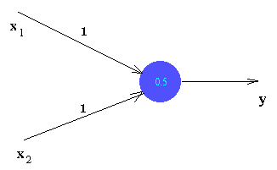
If the inputs are both 0, then net input is 0 which is less than the threshold (0.5). So the output is 0 - desired output.
If one of the inputs is 0 and the other is 1, then the net input is 1. This is above threshold, and so the output 1 is obtained.
But the given perceptron fails for the last case. To see that no perceptron can be built to solve the problem, try to build one yourself.

