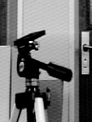
ASCII PPM and PGM image formats

Fig1.pgm (black and white, grayscale image)

P2
# CREATOR: XV Version 3.10a Rev: 12/29/94 (PNG patch 1.2)
97 128
255
45 45 49 57 65 65 61 85 125 138 121 117 117 121 121 121 117
109 146 215 219 219 223 206 182 190 194 194 190 194 198 198 198 202
198 194 190 190 194 198 198 202 202 202 198 198 194 194 194 194 198
198 198 198 198 194 194 194 198 198 198 202 198 198 194 190 194 194
194 198 198 190 190 210 215 215 210 206 170 146 146 142 130 65 45
40 45 49 61 53 36 16 28 28 61 121 142 53 53 53 57 69
65 65 85 125 130 125 121 121 121 117 117 113 105 142 215 223 223

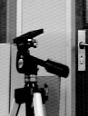
. . .

Fig2.ppm (saved as a “color” image with rgb pixel components)
P3
# CREATOR: GIMP PNM Filter Version 1.1
97 128
255
45 45 45 45 45 45 49 49 49 57 57 57 65 65 65
65 65 65 61 61 61 85 85 85 125 125 125 138 138 138
121 121 121 117 117 117 117 117 117 121 121 121
121 121 121 121 121 121 117 117 117 109 109 109
146
146
146
215
215
215
Fig2.ppm (this is an actual color image)
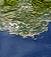

P3
# CREATOR: GIMP PNM Filter Version 1.1
71 79
255
115 126 70 141 150 93 167 171 110 182 187 121
158 170 98 92 112 41 39 64 6 40 62
. . .

Fig2.pgm (black and white, grayscale vers.)
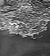

P2
# CREATOR: GIMP PNM Filter Version 1.1
71 79
255
120 144 166 181 162 103 54 53 74 112 149 133
99 67 64 123 183 184 144 131 110 102
. . .

Assignment part 1: convert this “color” ppm image to grayscale pgm format

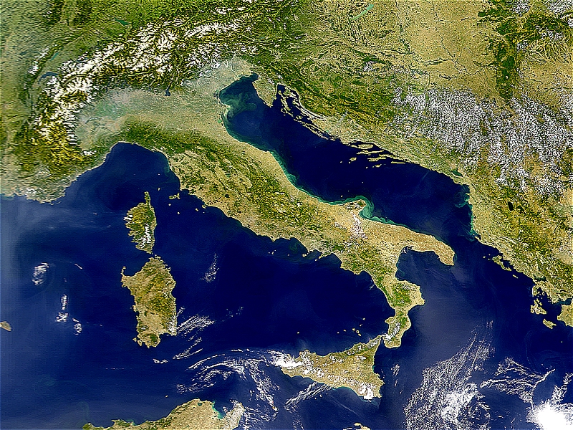

We're eventually going to use a process of edge detection to get this image such as this (see fig1):

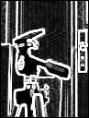

Explanation of PGM and PPM image file format

Use GIMP to view image files and for saving image files in various formats.

Common image formats are GIF and JPEG.
For reading image data, two other formats, PGM and PPM are also used.
PGM - grey scale images (one value per pixel)
PPM - color images (three values, red green blue - rgb, per pixel)

At the top of the image file is a code for the particular format:
P2 - PGM grey scale image, stored in ASCII, one value per pixel
P3 - PPM color image, stored in ASCII, 3 values rgb per pixel
P5 - PGM grey scal image stored in binary (compressed) format
P6 - PPM color image stored in binary (compressed) format

Here's the first few lines of fig1.pgm. This image file is a grey scale
image in P2 format. The second line, beginning with #, is a comment.
Comment lines begin with the symbol "#". The next two numbers specify
the width and height (#cols and #rows) of the image. The next number,
255, is the highest pixel value in the array.
Below the 255 are the pixel values in ASCII format.

P2 <-- Image format type
# CREATOR: XV Version 3.10a Rev: 12/29/94 (PNG patch 1.2) <-- Comment
97 128 <-- 97 columns (width) and 128 rows (height) of image
255 <-- Max pixel value
45 45 49 57 65 65 61 85 125 138 121 117 117 121 121 121 117
109 146 215 219 219 223 206 182 190 194 194 190 194 198 198 198 202
198 194 190 190 194 198 198 202 202 202 198 198 194 194 194 194 198
198 198 198 198 194 194 194 198 198 198 202 198 198 194 190 194 194
194 198 198 190 190 210 215 215 210 206 170 146 146 142 130 65 45
40 45 49 61 53 36 16 28 28 61 121 142 53 53 53 57 69
. . .

Here's the same file in PPM (color) format. Note the 3 values per
pixel. Since the rgb values are the same for each pixel, this would
still be a grey scale image.

P3 <-- Image format type
# CREATOR: XV Version 3.10a Rev: 12/29/94 (PNG patch 1.2) <-- Comment
291 384 <-- 291 columns (width) and 384 rows (height) of image
255 <-- Max pixel value
45 45 45 45 45 45 49 49 49 57 57 57 65 65 65 85 85
85 121 121 121 . . .

P2 and P3 modes are stored in ASCII format, readable by an editor.
These take up alot of space. The binary versions, P5 and P6, take
less space, but they must be read in binary form.

