Othello/Reversi Lab

Name ___________________________

- Hand in the code of your heuristic(s) with good and detailed explanations
- Describe in detail how your heuristic(s) chooses moves.
- What moves – and why – would your heuristic pick (pick at least 3 or 4 of these examples)

A. B.
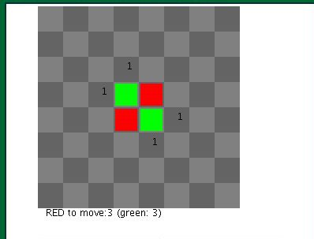
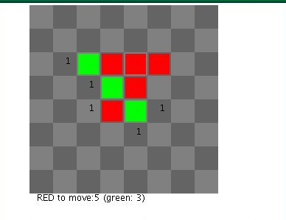

C. D.
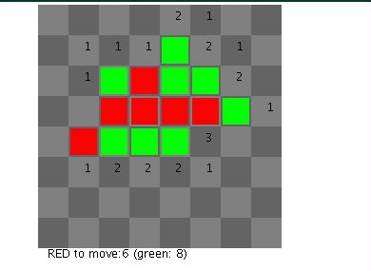
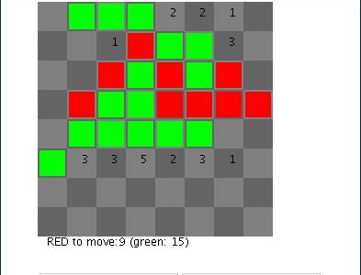

E. F.
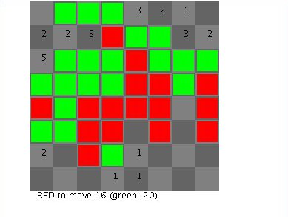
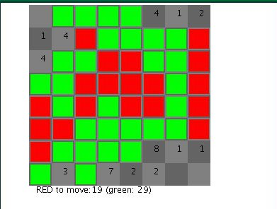

G.
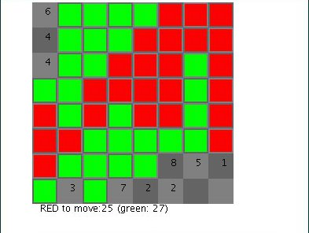

- Does your program use recursion and/or alpha beta pruning at all? (not a requirement) If yes, explain in some detail how.

- Run your program against 5 (hopefully 5) other strategies from siggisim. You can use jrandom and jlowest as example strategies to compete against. List below details of your winning percentages for each of your example rounds against various strategies.

- Put your .py and .pyc files in my dropbox: ~rdlatimer/dropbox/AI2010/ You can also put a copy of this document if you'd like.

Running the pyc strategies from the Siggi site
siggisim.com/ai

- Go to Siggi's site of pyc strategies from last year's AI course.
Download, for example, siggi.pyc to your directory

- These pyc files were created with an older version of Python. This needs to be updated.
  - Use the hexadecimal editor 'okteta' to update the compiled pyc file siggi.pyc
  - Type in 'okteta' and load siggi.pyc
  - Change the first byte of information from 'B3' to 'D1' and save

- Run the referee: python othello_referee.py
and choose, for example, siggi and jrandom as strategies to play the round

- Run your strategy(ies) against siggi.pyc and other strategies from this site.
Keep a list of how your strategy(ies) does against other strategies on this site.
Try at least 5 other strategies to play against.

