TJHSST Computer Systems Techlab 2005-2006

V Multiagent modeling, Social Complexity, Artificial Life, Algorithm optimization

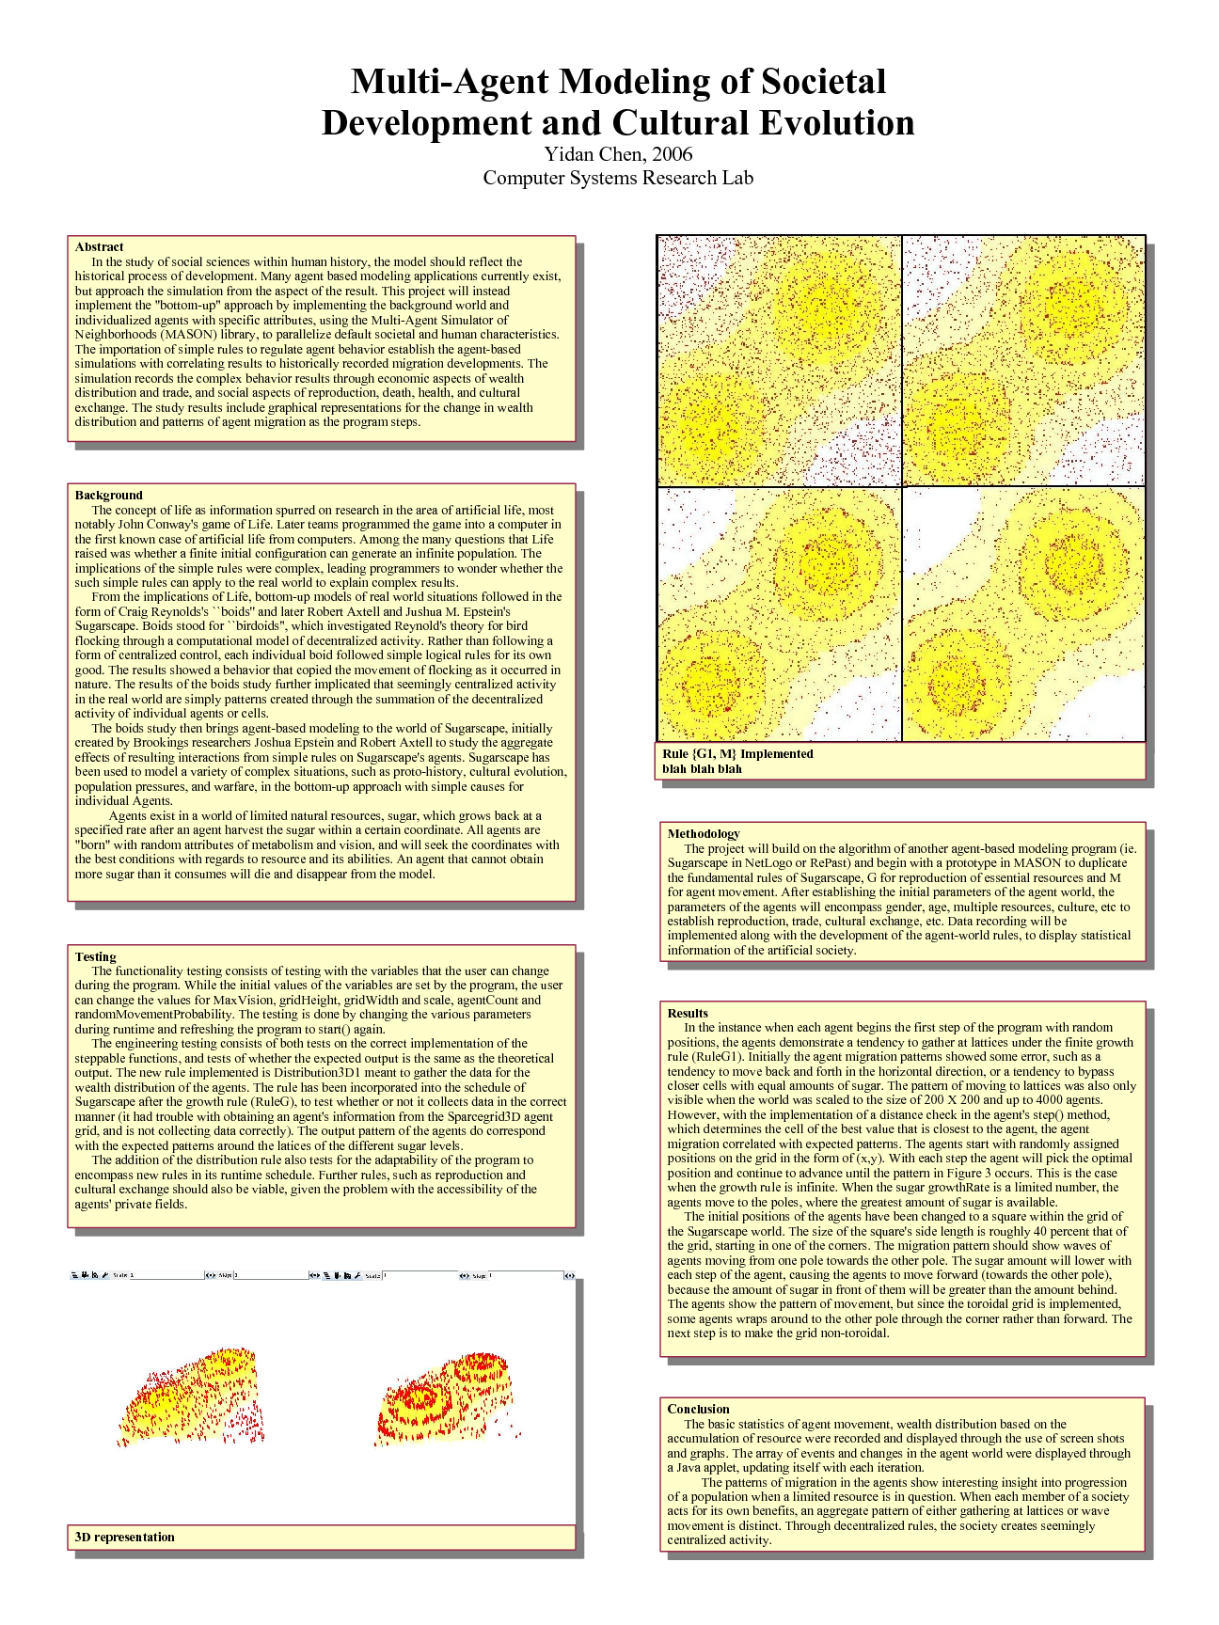
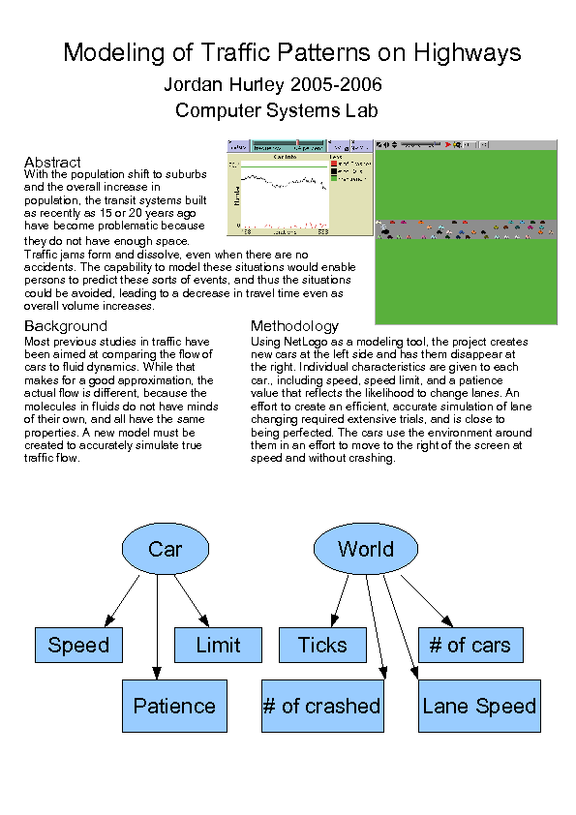

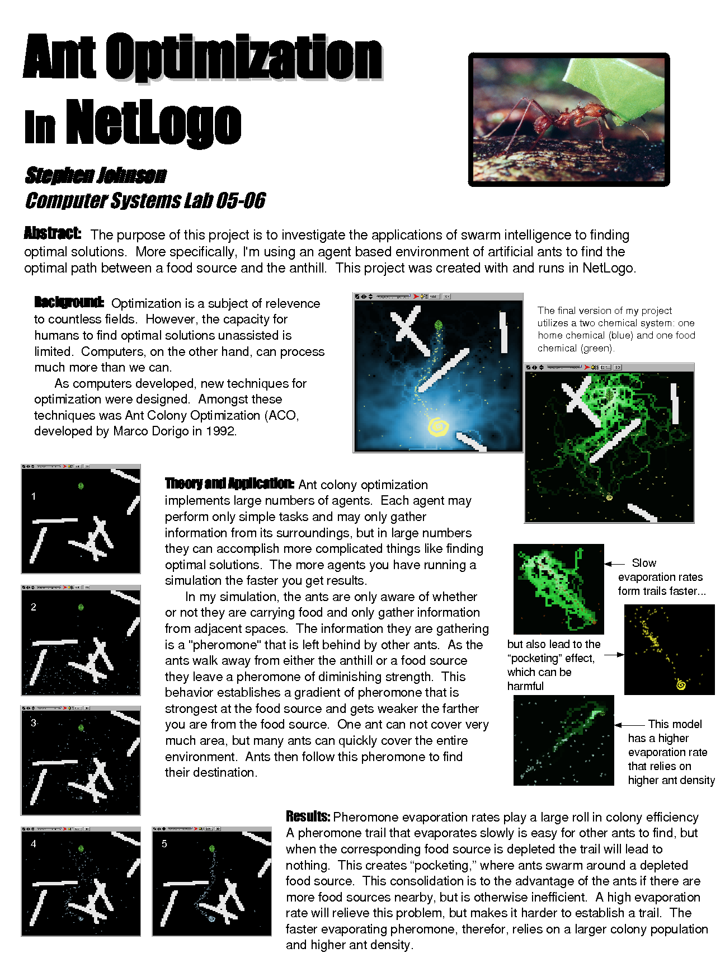

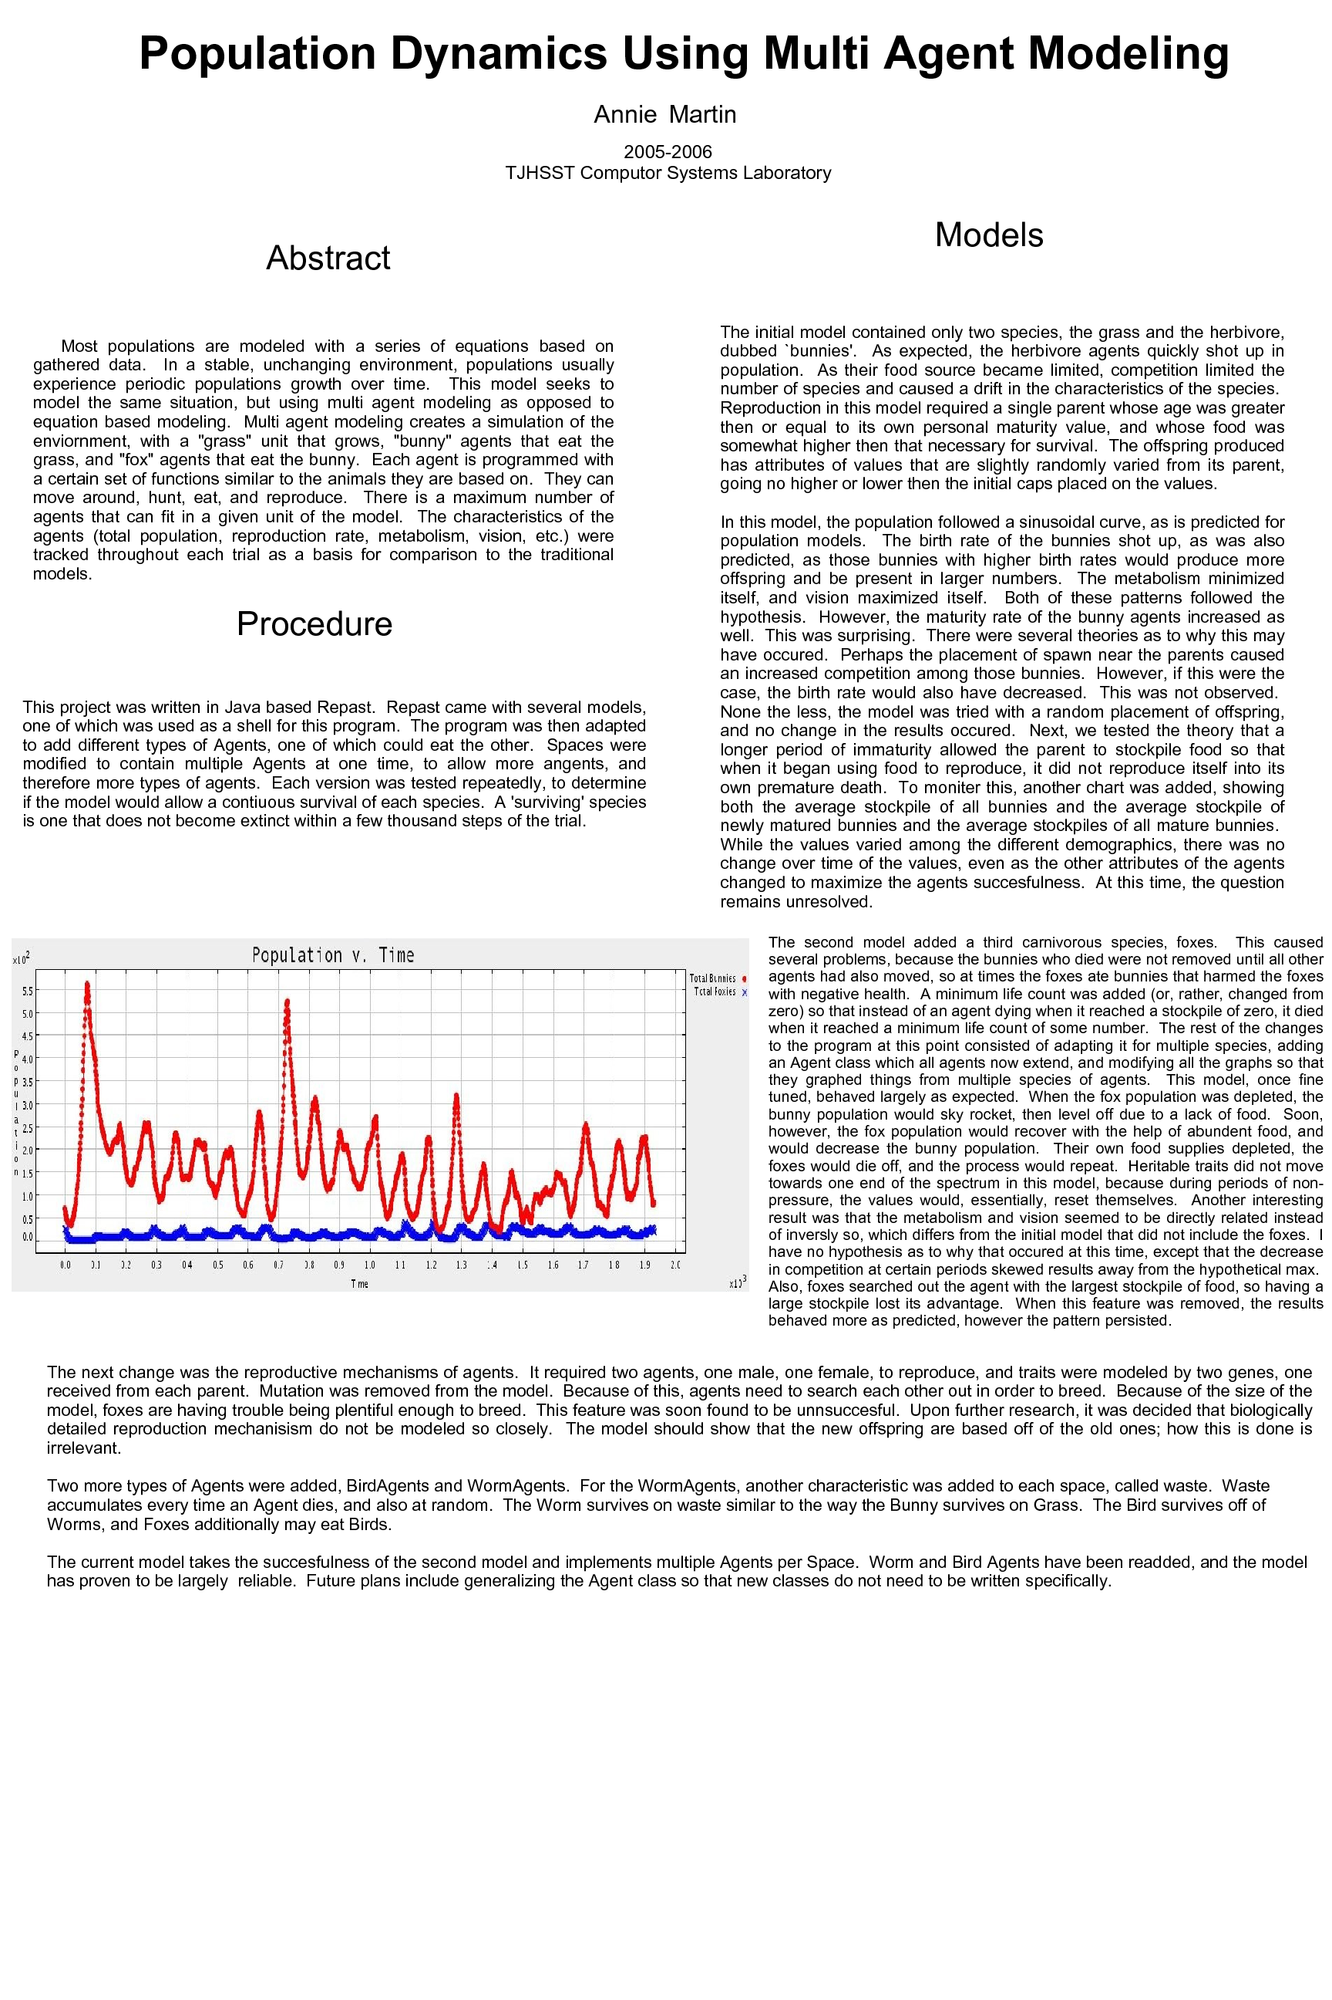
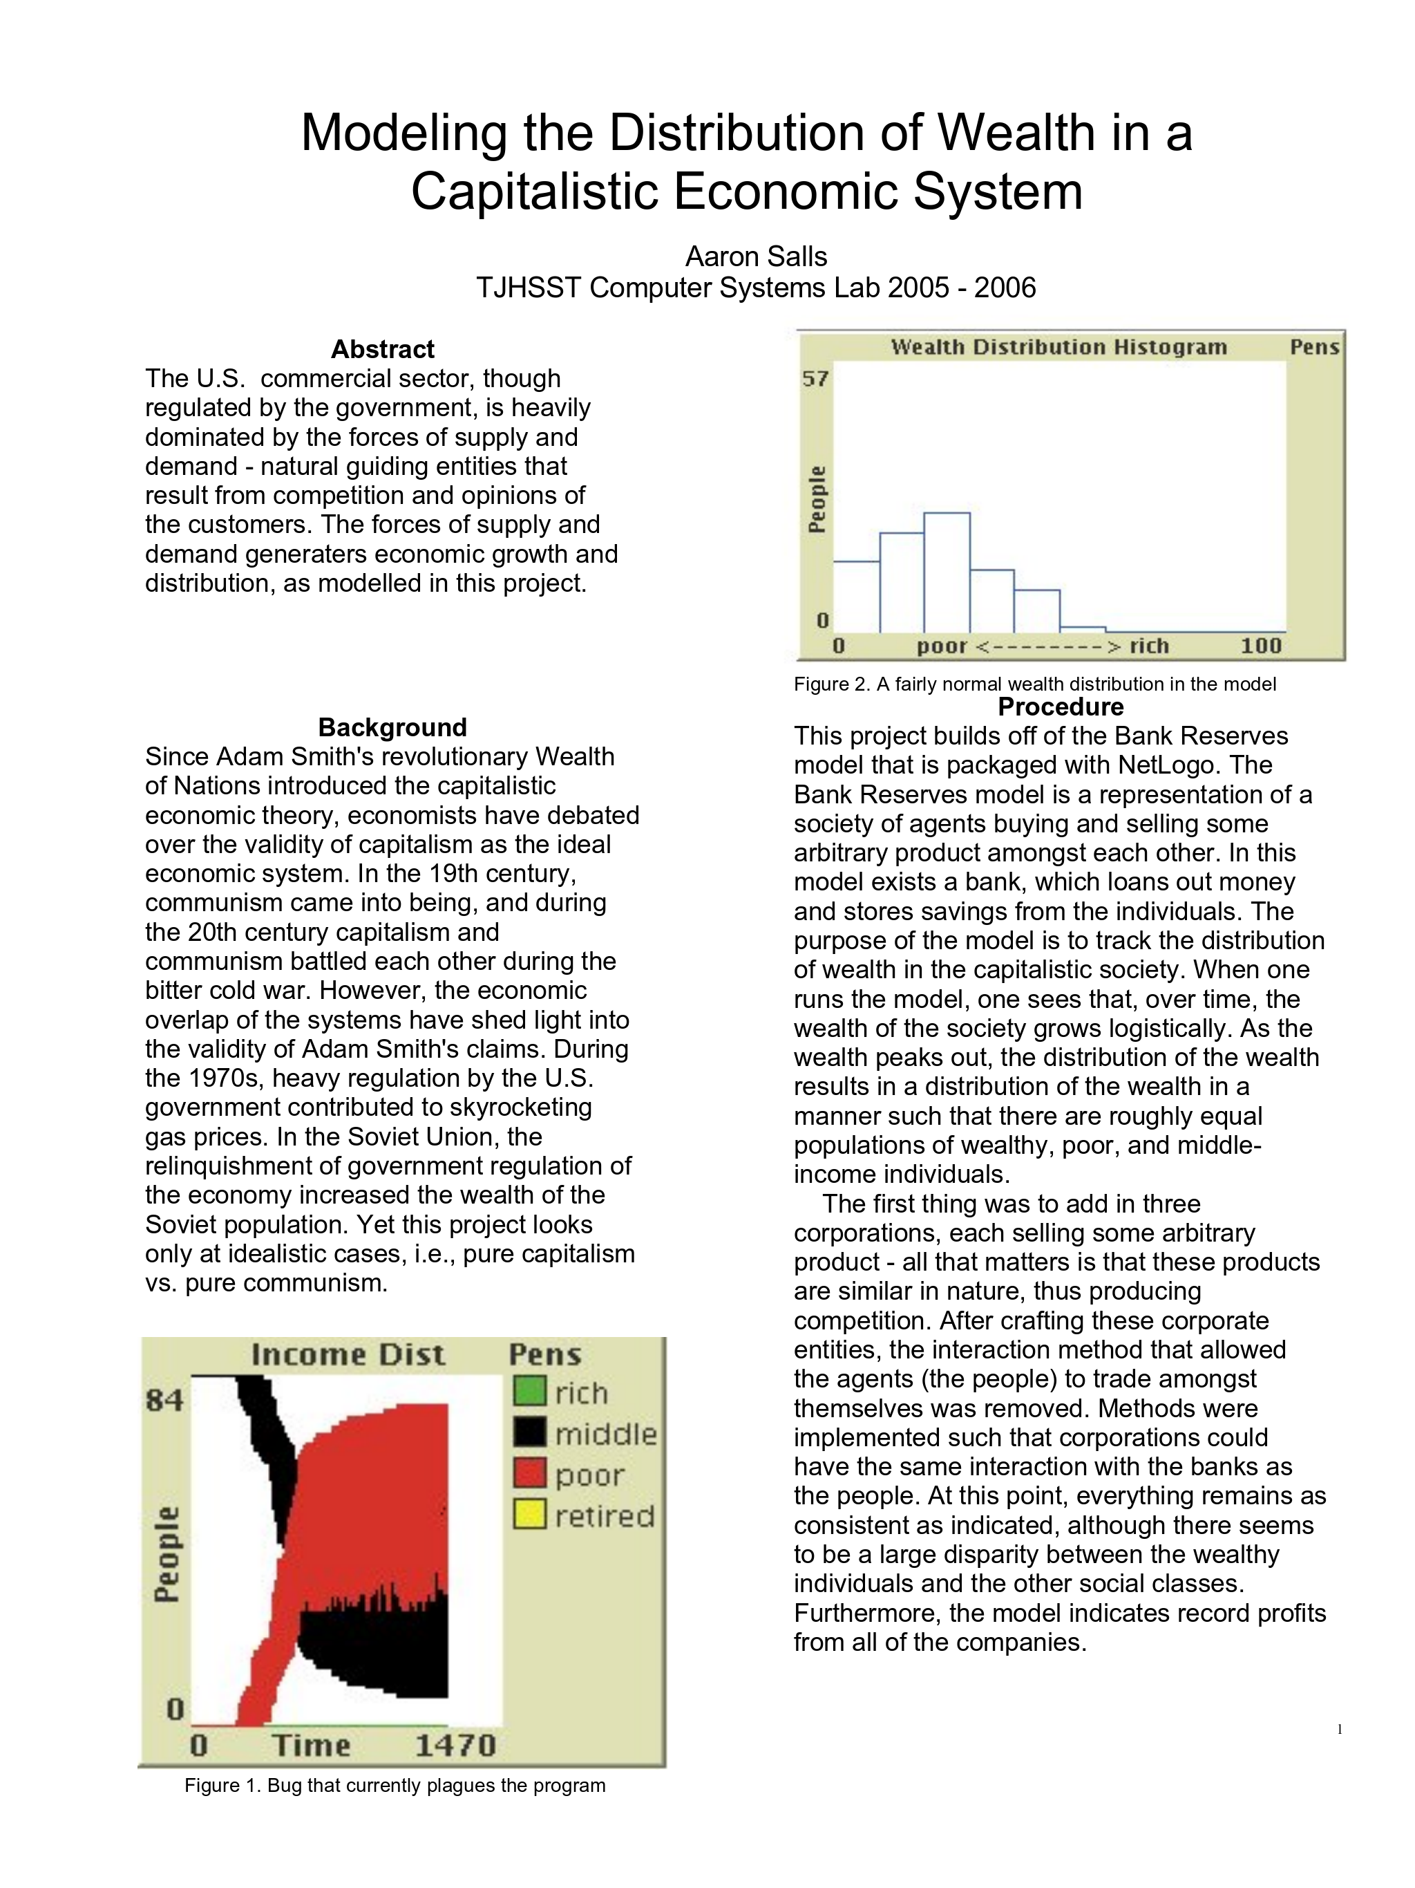
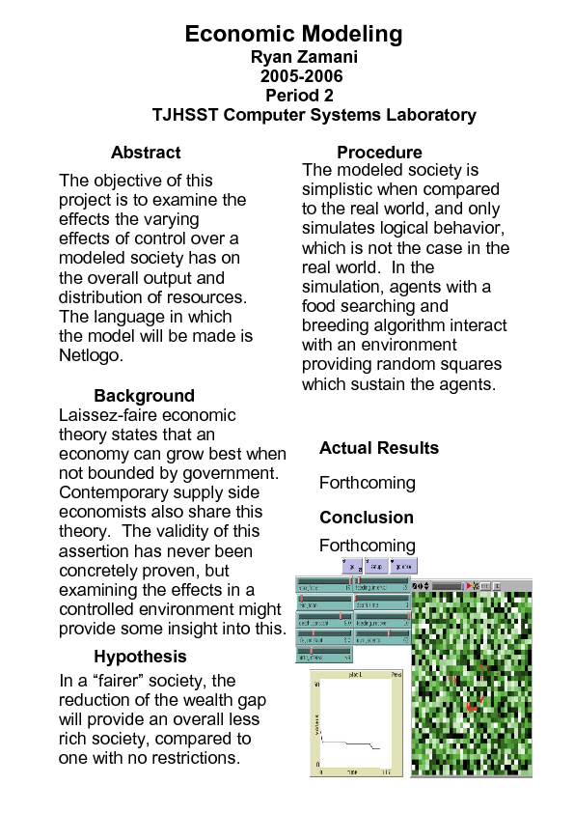

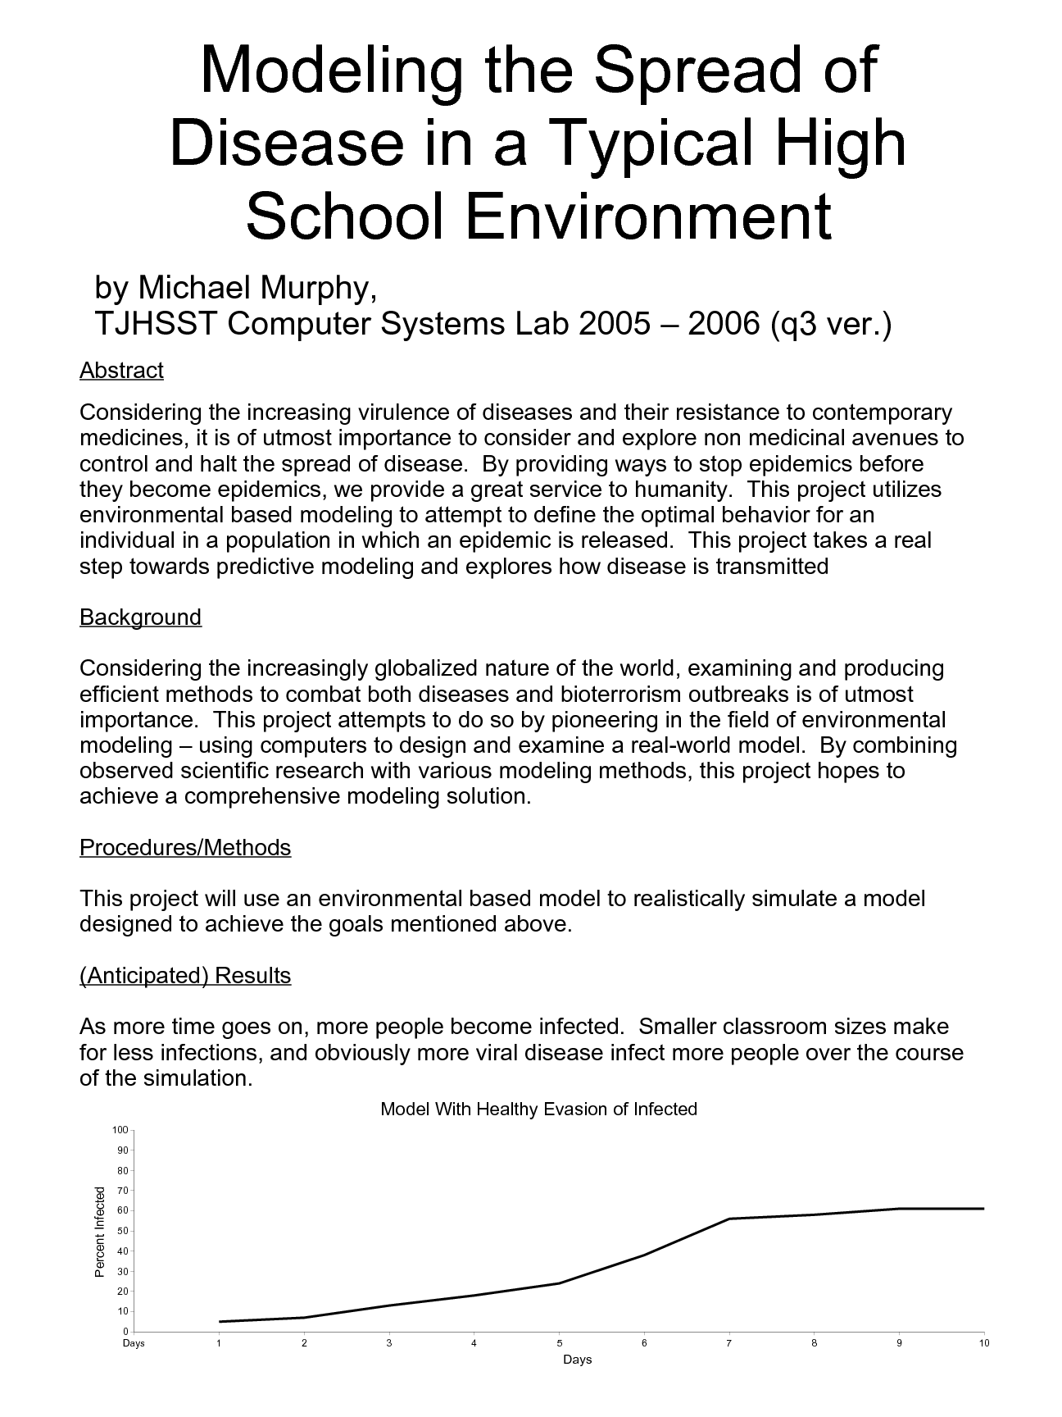
Title: Modeling of NP Complete Problems

Student: Long Ouyang

Title: Development of a Strategic Space Based Game in NetLogo that Uses and Tracks Dozens of Different Turtle Breeds

Student: Ryan Logue

Title: Simulation of Traffic Patterns and Optimizing Traffic Lights

Student: Gregg Tabot

Background:

Description:

Title: Multiagent Modeling of Civil Violence and Disobedience

Student: Ravi Udeshi

Background:

Description:

VI HCI - Human Computer Interaction

Title: Multimedia Workstation

Student: Alfie Parthum

Title: An Implementation of an Efficient User Interface for the Generation of Statistical Marketing Media

Student: Dan Tran

