TJHSST Computer Systems Techlab 2005-2006

VII Natural Language Processing

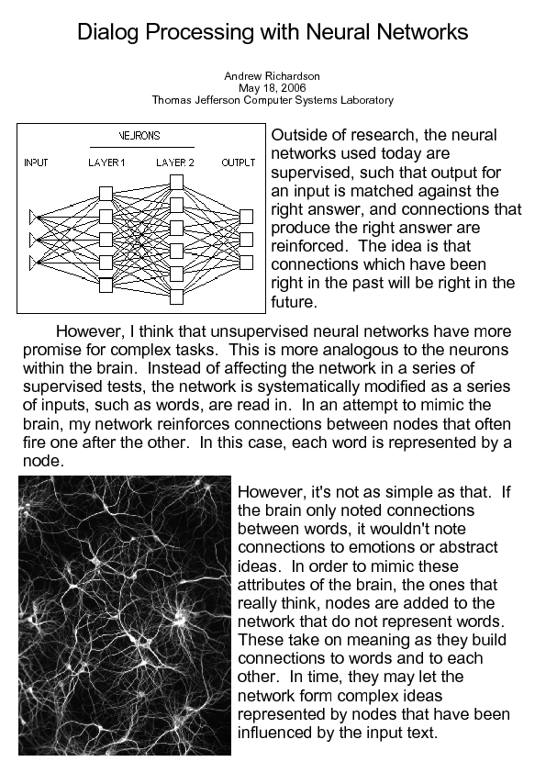

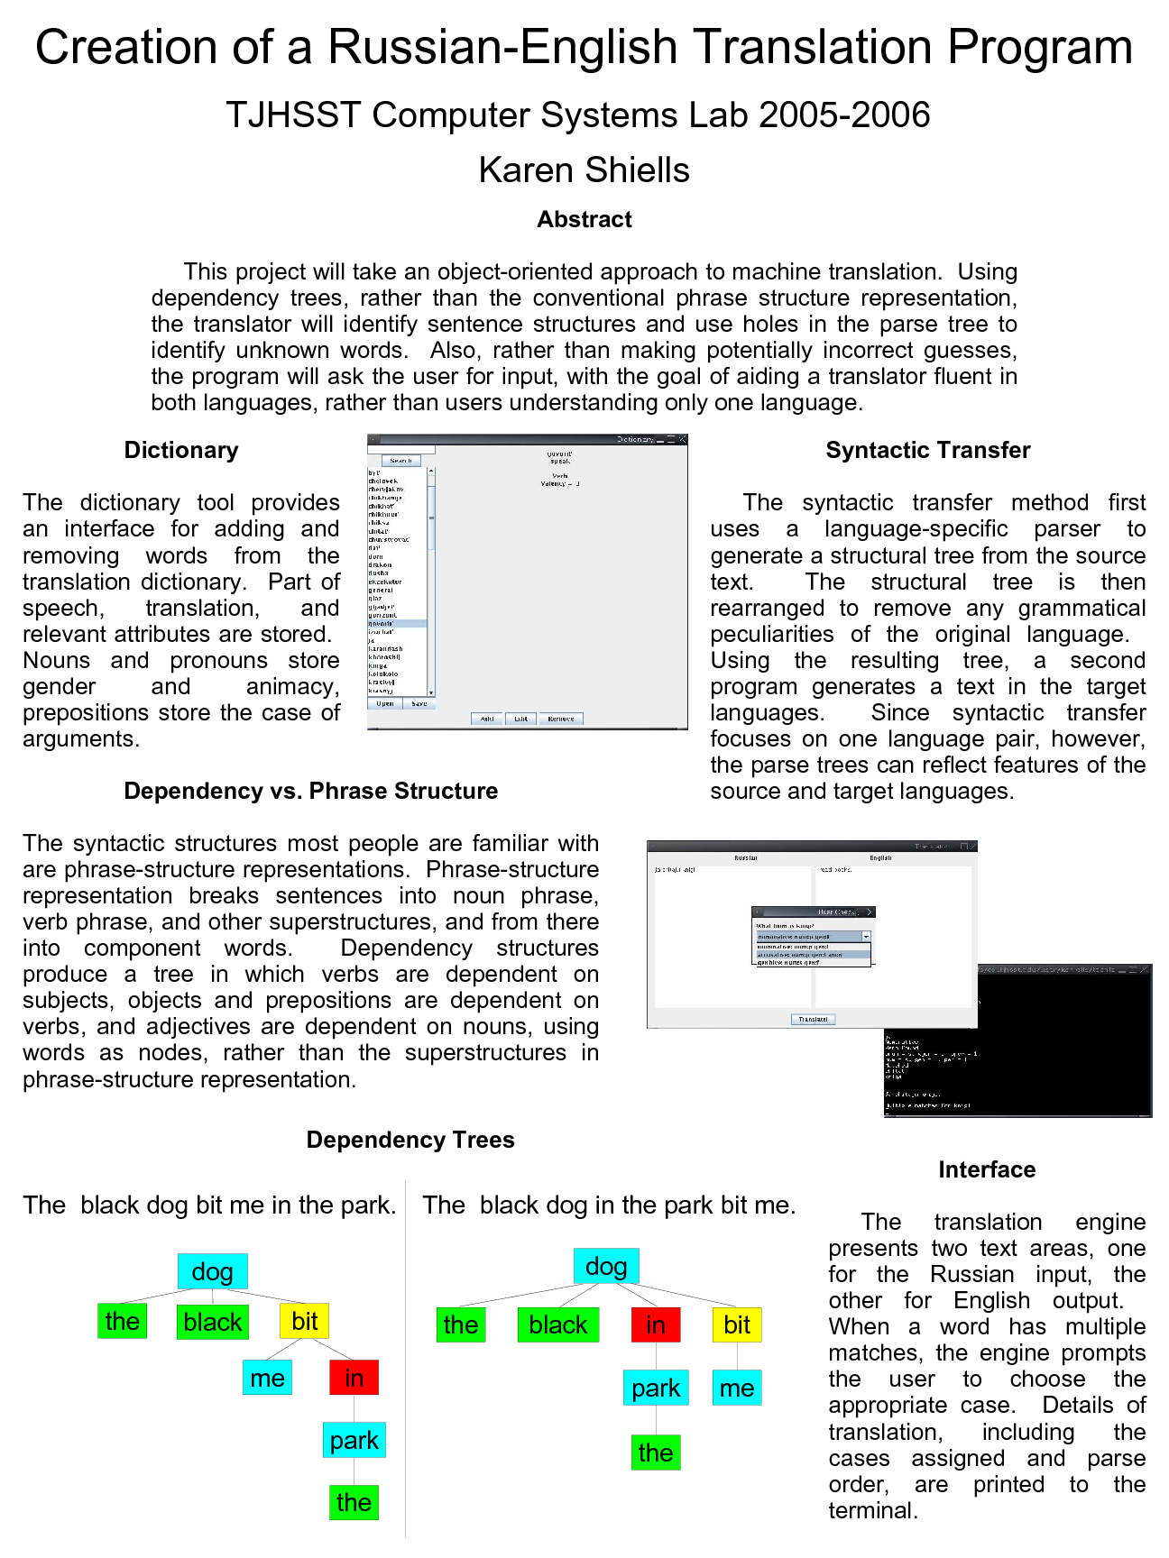
IX Computer Languages, Interprers, Compilers

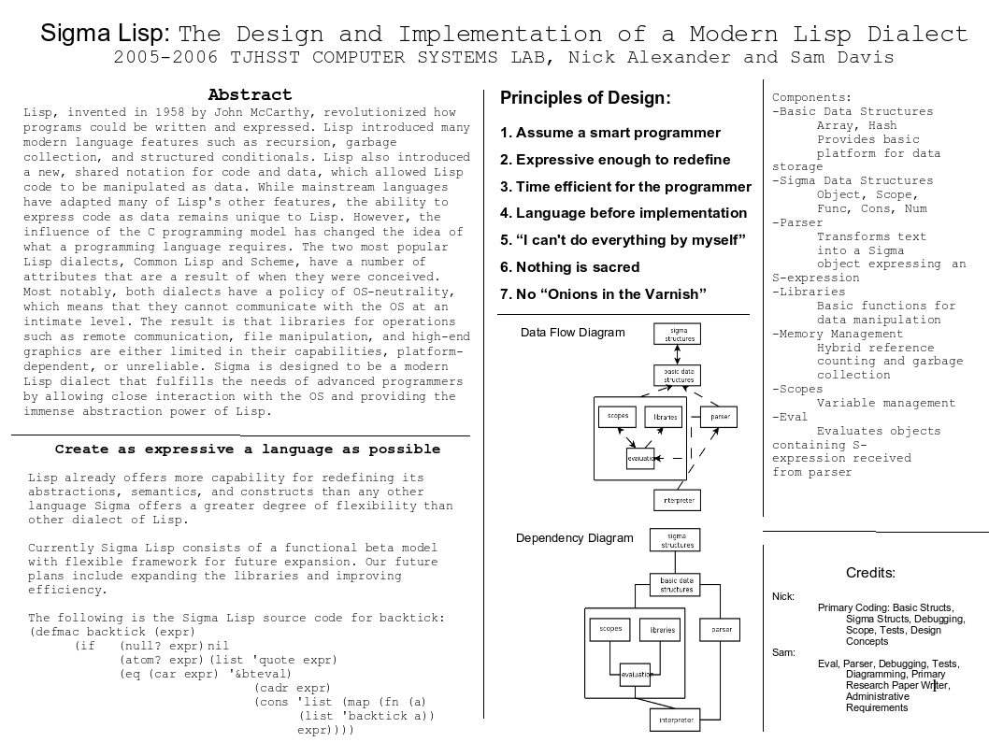

X Computer Graphics

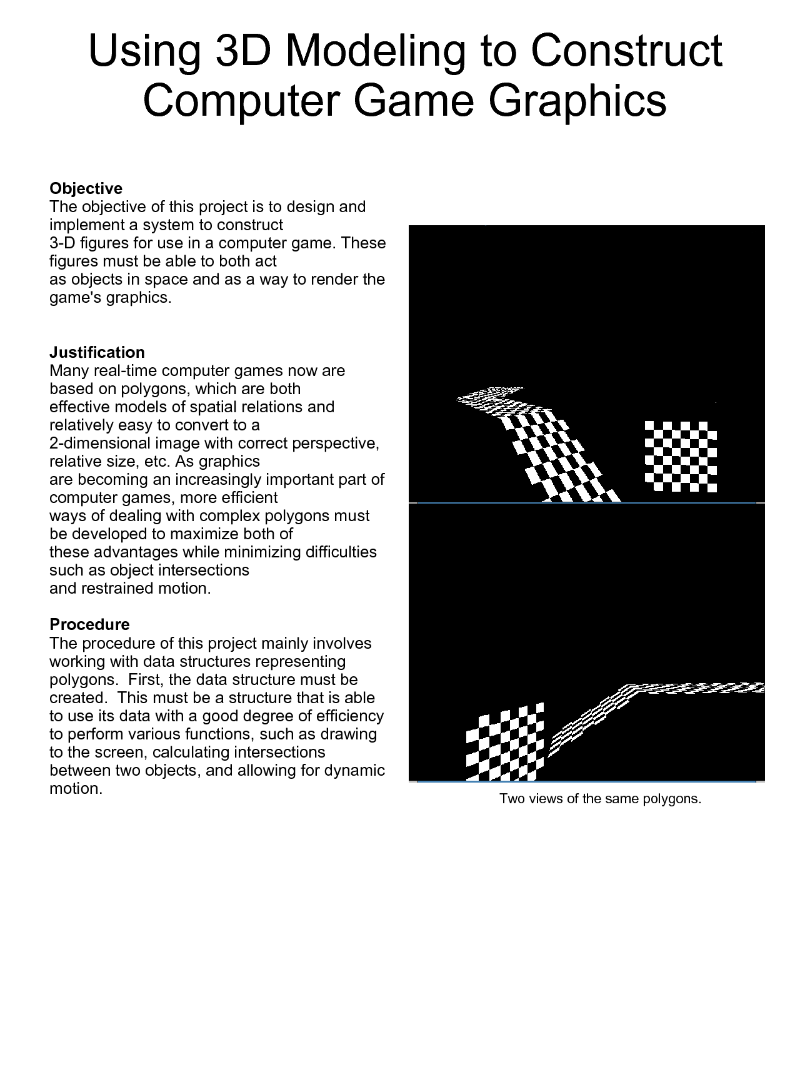
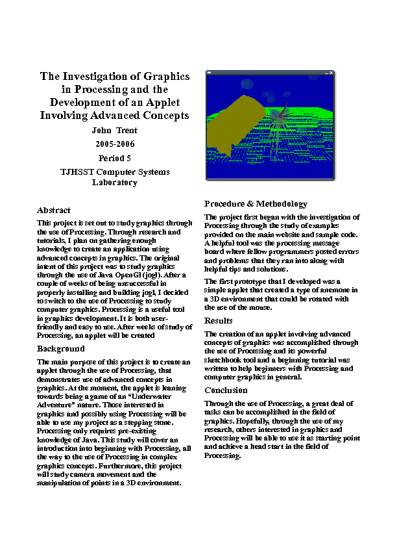

XI Artificial Intelligence and Machine Learning

Title: Genetic Algorithms in Machine Learning

Student: Calvin Hayes

Title: Artificial Learning Through Pattern Recognition

Student: Arvind Ravichandran

Title: A Better Algorithm for GO

Student: Justin Park

XII Software Engineering, Object Oriented programming techniques

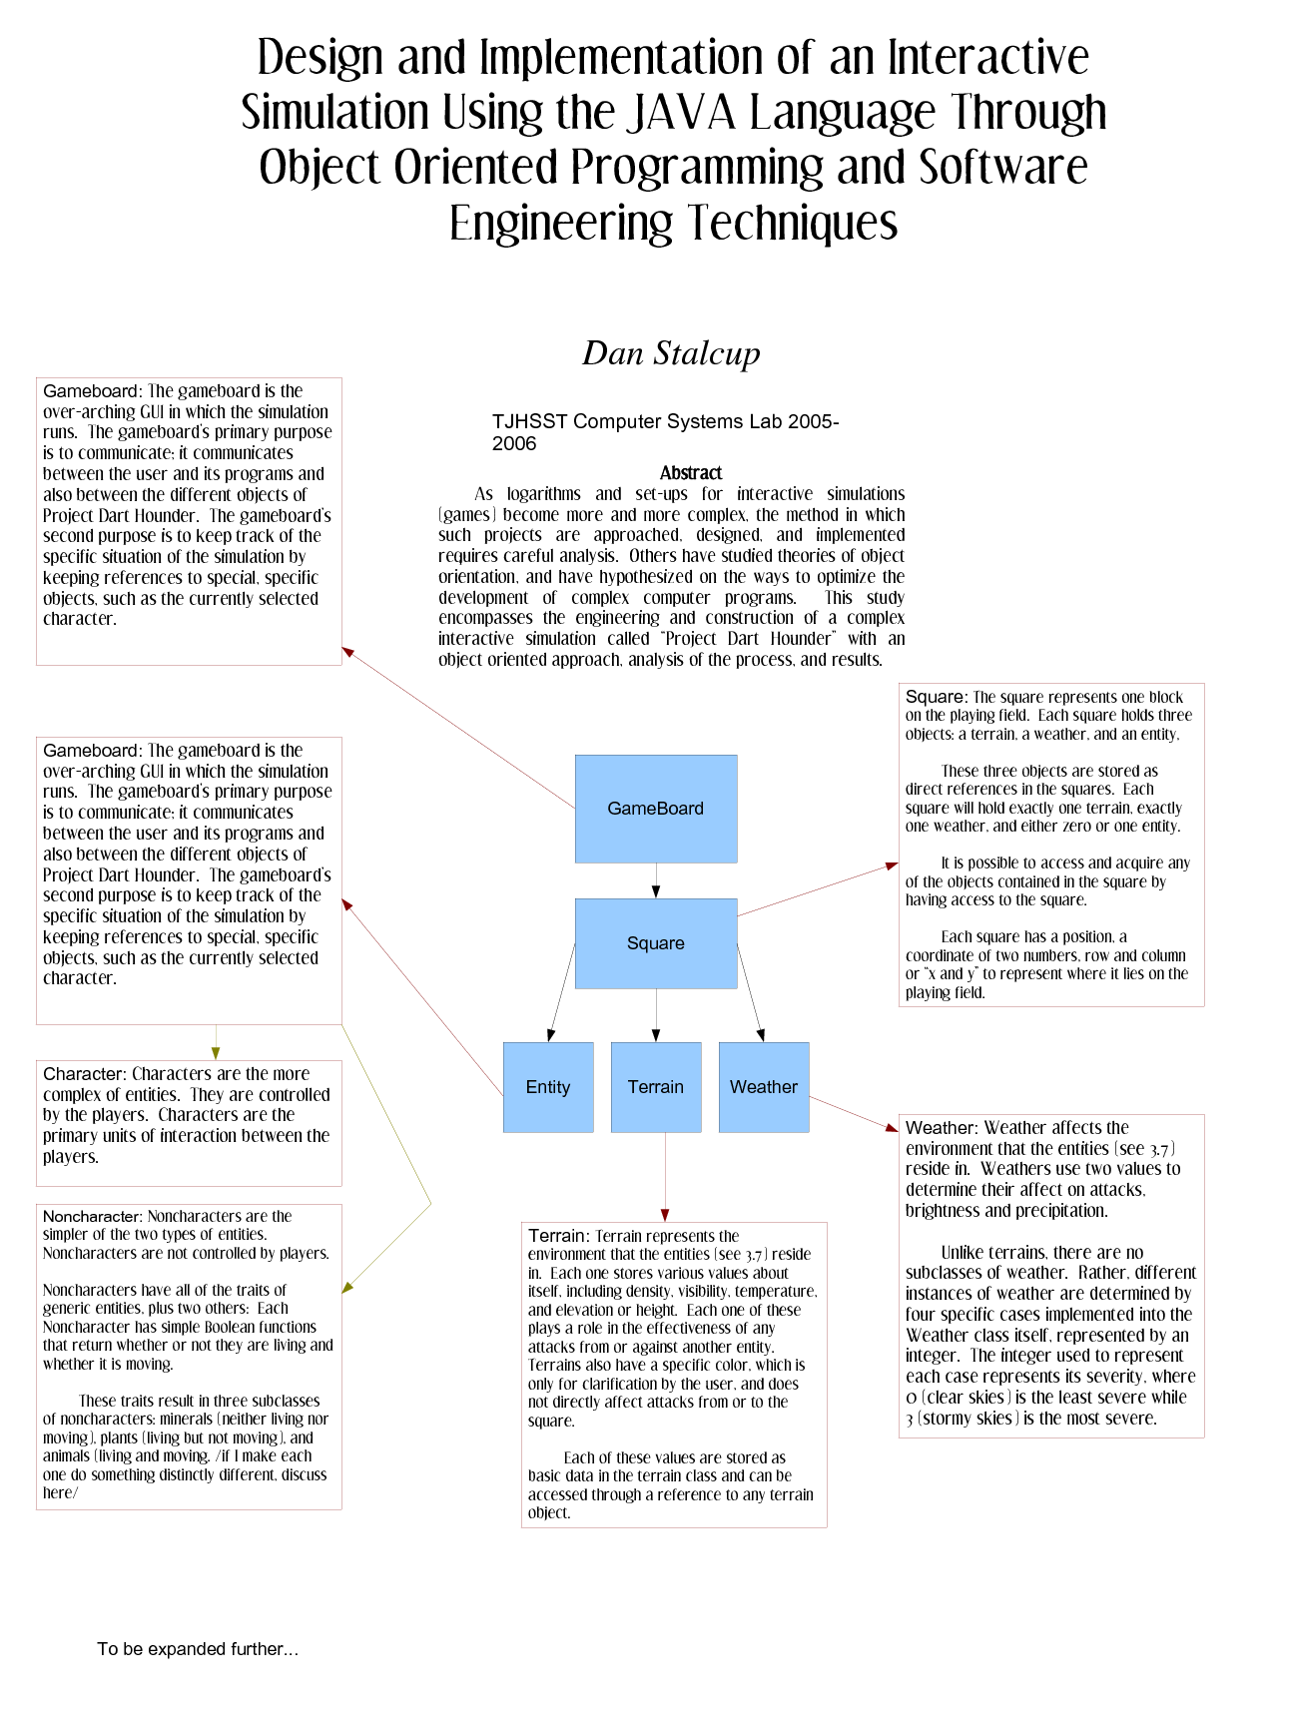
XIII Database Design

