Cardinal Forest Elementary 2012, Spring semester, CSI program
Fred Allard, Randy Latimer, and the students in CSI at Cardinal Forest

K-6
We are working with several basic types of programming environments. The first is block sliding, tiles representing code statements. In this category for this study are Scratch (MIT), Snap (Berkeley), and Etoys (Squeakland and Smalltalk). The next category is typed in languages with user interfaces adapted for education. Here we are using Kojo (written in Scala), RoboMind, Greenfoot (Java), and and possibly Python based environments. The third category of programming language we are using is those with a browser based interface. In this category we use Snap (Berkeley) and WeScheme (Scheme). A fourth category we investigate are agent based domains characterized by grid worlds with one to many agents interacting through successive generations. Agent based domains in this research are Greenfoot (Java), NetLogo (Logo), and AgentSheets (for purchase). The fifth category of language focus is robotic applications. Here we look at Lego Mindstorms (for purchase) and RoboMind (simulated robot). Also are educational initiatives with developing curricula currently active, for example Bootstrap (WeScheme), Etoys, and Greenfoot.

We chose initially to begin with block sliding environments in order to minimize typing skills needed to complete the blocks of code and program scripts. Age groups where keyboard typing and reading and spelling of words is an issue (K-1) may continue to focus more in the block sliding world through much of our program. Older age groups (3/4-6) will move on into typed in languages and agent based formats. Certain 'in-between' age groups (1,2) can vary with implementations, block sliding vs typed in.

Turtle geometry patterns are used as a start for developing the idea of algorithms. Drawing regular polygon shapes such as a triangle, square, pentagon, hexagon and octagon involve certain basic procedural concepts. A first category of concepts are those used to clear the screen, position the “turtle” drawing sprite, and set initial pen conditions such as pen up or down and the color of the pen. Positioning the turtle at (0,0) leads into discussions of the basics of coordinate geometry – x and y axis and coordinate points. Scratch and Snap set pen up or down using blocks specific for penup and pendown. Etoys sets the condition of pen down as true or false necessitating topics of boolean concepts

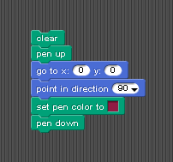

Fig 1a: Starter blocks in Snap Fig 1b: Snap, start position of the 'turtle' sprite

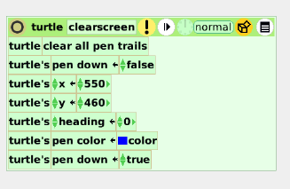
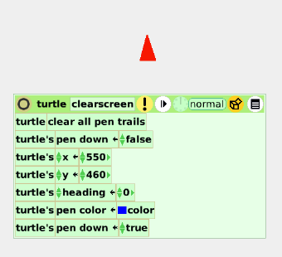

Fig 2a: starting blocks Etoys
Fig 2b: Sample turtle “sprite”

Note that in the Etoys version, a procedural block is created automatically and is named by the user as 'clearscreen' in this case. The creation of a procedural block can be done in Snap but not in Scratch.

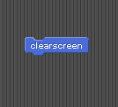
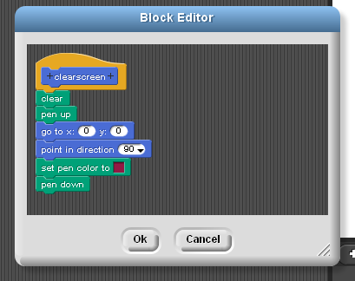

Fig 3a: Defining a procedural block in Snap Fig. 3B: a defined block, Snap

Drawing involves the basic movements of moving a particular number of 'steps' and turning a specified number of degrees in a clockwise or counterclockwise direction. The patterns of regular polygons with multiple repeated blocks quickly suggests the use of loops. Scratch uses a repeat <numtimes> loop block in which the uses must type in the number of times to repeat a particular seiries or sequences of blocks..
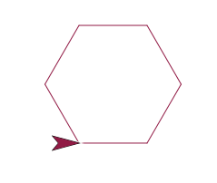
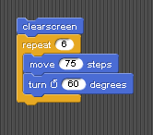
Fig 4a,b : Block algorithm to draw a hexagon, Snap
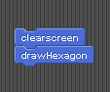
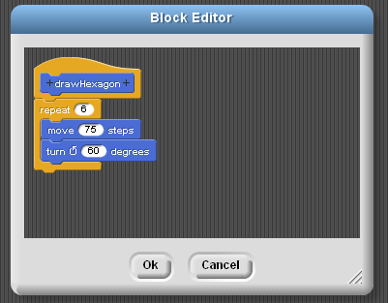

Fig 5a: Defining a drawHexagon procedure, Snap Fig. 5B: Using newly defined
blocks in Snap

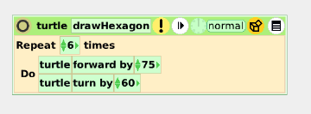
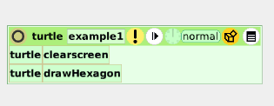

Fig. 6a: draw hexagon in Etoys Fig 6b: make a procedure script to run
this example

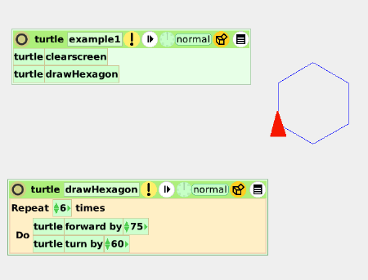
Fig 6c: Running the example 1 in Etoys

Within the world of turtle geometry and drawing regular polygons this set of basic commands allows drawings of regular polygons of various colors, sizes, and number of sides. Also the drawing of circles is simulated with many sided polygons. We have used pen commands for clearing the screen, setting the pen color, and the state of the pen (up/down). We use move forward and turning commands for drawing, and we use repeat blocks to loop through similar actions needed to draw the entire figure.

Topics for discussion involve:
  - the geometry of polygons
  - names of polygons: triangle, square, pentagon, hexagon, octagon
  - how the number of sides affects the degree measures of the interior and exterior angles.
  - Interior, exterior angles and relation to number of sides
  - Simulating of a circle with a polygon with increasing numbers of sides
  - “move” ← length of sides, “turn” ← exterior angle
  - looping: repeat n times ← number of sides
Extensions to the drawHexagon algorithm can allow investigations of nested loops. Here we draw a hexagon, turn a certain number of degrees, and draw another hexagon. If we turn 18 degrees, we repeat this 20 times with an outer loop. Note that 18 x 20 = 360 degrees for a complete rotation.

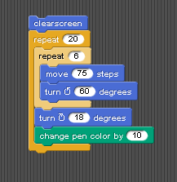
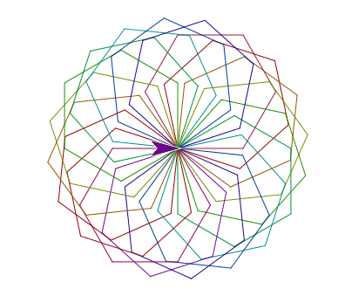
Fig 6a: In Snap, the inner loop draws the Fig. 6B: picture from Snap version,
hexagon with sides = 75. The note the pen color changes
outer loop 'spins' the hexagon 18 degrees with each iteration
each iteration.

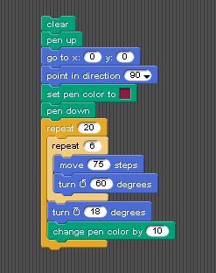
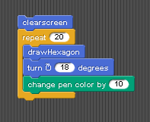

Fig 7a: Snap version with no defined blocks Fig 7b: Snap version with defined blocks

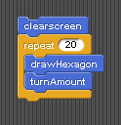
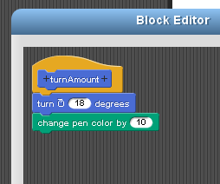

Fig 7c: Snap version with turnAmount block Fig 7d: 'turnAmount' block definition

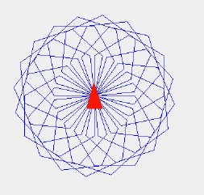

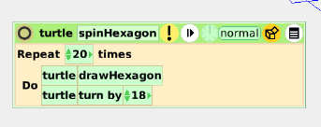
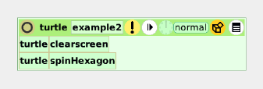
Fig 8a-c: Etoys blocks to spin hexagon

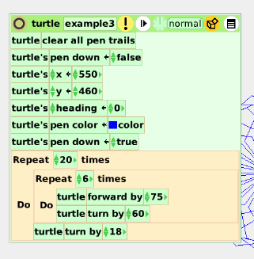

Fig 8d: Etoys version with no defined blocks (scripts in Etoys)

The concept of variables can be a next important step in abstraction of algorithms. For example we can set the starting side length of a square to be 5 and draw consecutive squares with an increasing the sidelength by 5 each iteration.

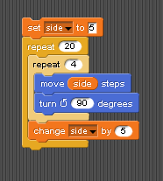
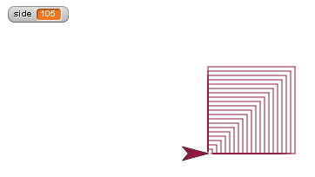

Fig. 9A: Snap, global variable for sidelength Fig. 9B: Note final value of global side

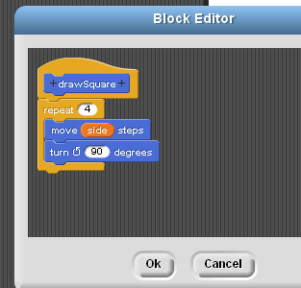
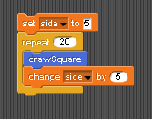

Fig. 10A,B: Block defined using global side

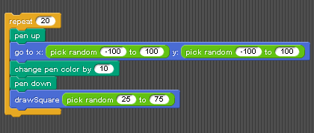

Fig. 11 A: draw Square block with input for sidelength

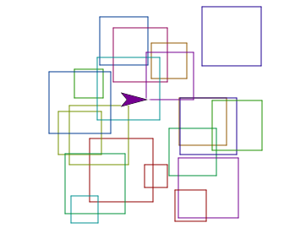
Fig. 11B: random size squares at random locations, using drawSquare with input

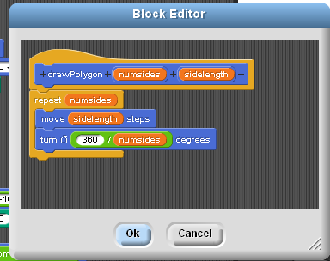

Fig. 12A: drawPolygon (Snap) with inputs for number of sides and sidelength

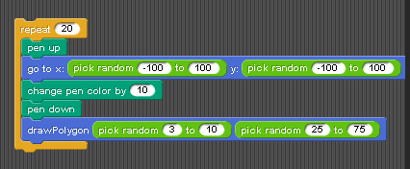

Fig. 12B: Drawing random polygons at random locations

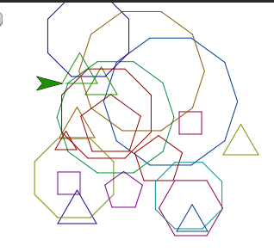

Fig.. 12C: Random Polygons using drawPolygon with 2 inputs, number of sides and sidelength

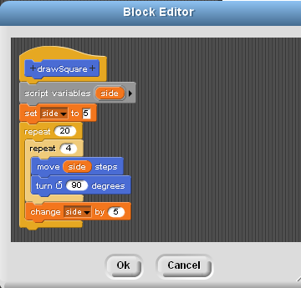

Fig 13: Local variable side (Snap)

- January/February, Block sliding/tiles languages
Scratch and Etoys
http://www.tjhsst.edu/~rlatimer/cardinalforest/ScratchProjects/CSI2012/ProjectsFeb2012.html

Scratch (MIT):
http://scratch.mit.edu/
Etoys (Squeak and Smalltalk, Alan Kay, Viewpoints Research Inst)
http://www.squeakland.org/
http://vpri.org/

Turtle geometry: pen, movement, looping commands
Clear screen, pen up, pen down, move __ steps, turn __ degrees
Repeat __ times

Drawing regular polygons:
General algorithm:

Repeat numberOfTimes
move size
turn angle

where:
numberOfTimes → number of sides of the polygon
size → length of the side
angle → exterior (outside) angle = 360/numberOfSides

Also includes:
Polygon exercise sheet
Handwritten pseudocode w.orksheet for algorithms
Learning the names of figures: triangle, square, rectangle, pentagon, hexagon, octagon
Drawing a 'circle' as a many sided regular polygon where the outside (exterior) angle
gets small
Patterns: less number of sides → larger angle turn
Learning user interfaces: mouse use, left/right click, keyboard use, finding menus
Saving and loading programs at specific server locations for the lab
“When key pressed” commands to draw different shapes
“Quizzes”/Challenges where the exercise is not all written out for the student
Creative 'make up your own' patterns with different colors and shapes

- Introduction of using variables:
Scratch version
http://www.tjhsst.edu/~rlatimer/cardinalforest/ScratchProjects/CSI2012/Feb29-2012/ProjectsFeb29-2012.html

Make a variable for side length
Also:
Use of 'broadcast” in Scratch for sending messages to run particular scripts.
for example: drawSquare and clearscreen
Patterns of variable length squares
Sensing the environment

Etoys version of using variables
http://www.tjhsst.edu/~rlatimer/cardinalforest/ScratchProjects/CSI2012/Feb29-2012/etoys/ProjectsEToysFeb29-2012.html

- Browser based interface and typed in languages, March 2012

WeScheme, Bootstrap, Racket (Scheme):
http://www.wescheme.org/
http://www.bootstrapworld.org/
http://racket-lang.org/

Drawing shapes with Scheme
Using WeScheme's built in animation clock
UFO landing
Flying chicken

- Snap (Berkeley), block sliding language, March/April 2012

Browser based programming and enhanced Scratch capabilities
http://snap.berkeley.edu/run
http://byob.berkeley.edu/

http://www.tjhsst.edu/~rlatimer/cardinalforest/ScratchProjects/CSI2012/Feb29-2012/snap/ProjectsSnapFeb29-2012.html

Expanded version of Scratch
Defining of procedures (blocks) with inputs
Expanded loops, operators, variables, lists
Functional programming capabilities
Recursion

Exercises include defining new blocks to
draw square, triangle, pentagon, hexagon, octagon,
circle
draw spiral patterns
recursive fractal patterns
use of recursive algorithms for looping
Random numbers
Sensing the environment

- RoboMind, April/May 2012
http://www.robomind.net/en/index.html

http://www.tjhsst.edu/~rlatimer/cardinalforest/ScratchProjects/CSI2012/Feb29-2012/robomind/ProjectsRobomindApril19-2012.html

Driving a robot around various and variable map landscapes
Painting patterns with forward, back, turning right/left, paint white and paint black
Writing programs with text.
Use of 'remote control' feature to practice writing programs
Capturing beacons
Sensing walls, obstacles, environment
Using AI to drive through obstacles/mazes and to find beacons

- Kojo programming interfaces (from Scala), May 2012
http://www.kogics.net/sf:kojo

http://www.tjhsst.edu/~rlatimer/cardinalforest/ScratchProjects/CSI2012/Feb29-2012/kojo/ProjectsKojoMay3-2012.html

Turtle geometry and graphics using typed in programs

- Greenfoot – Java based agent worlds (we didn't make it to Greenfoot this school year)
http://www.tjhsst.edu/~rlatimer/cardinalforest/ScratchProjects/CSI2012/Feb29-2012/greenfoot/ProjectsGreenfootApril19-2012.html

- more to come

