Installing Java, jGrasp, and JKarel at Home

You need to install two different programs, Java and jGrasp. You need to download and unzip a file from the TJ website. Finally, you will need to set a classpath in jGrasp.

1. Turn off your virus protection software.

2. Download and install Java JDK 7 Update 25 from http://java.sun.com/j2se/downloads.html Let it install in the default directory.

3. Download and install jGrasp. Begin at http://www.eng.auburn.edu/grasp/ Click on Downloads. Fill out the little form. Choose the version that is correct for your system. Let it install in the default directory.

4. Next, download the students’ shell code from TJ's website at http://academics.tjhsst.edu/compsci/CSweb/index.html
After unzipping, you will see six folders, Setup Files, Unit1, Unit2, Unit3, Unit4, and Unit5.

5. In jGrasp, under the menu Settings|Path-Classpath|Workspace, click on the "Classpath" tab. Click on “New” and browse to your "Setup Files" folder. Click on karel2_c.jar. Click on OK. Click on "New" and browse to your "Setup Files" folder. Click on xercesImpl.jar. Click on OK, Apply, OK.
1
2

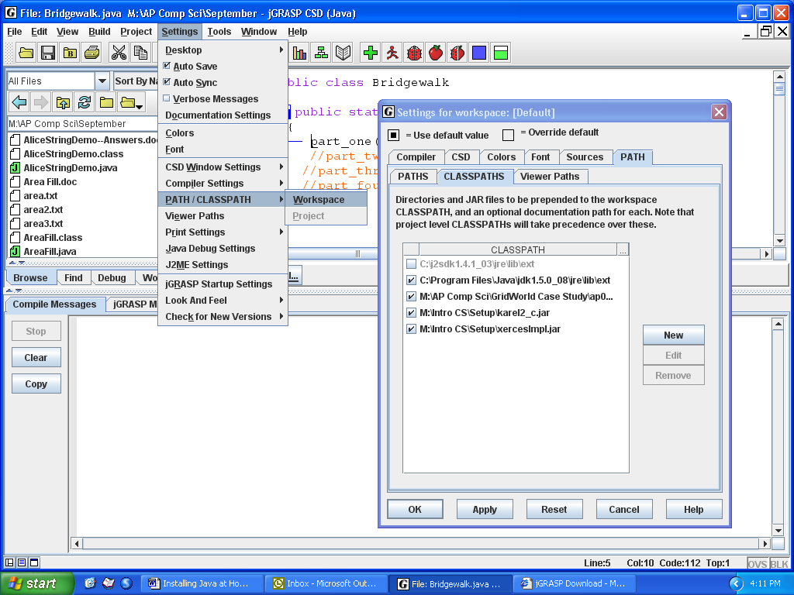

4

3

2

5

- Compile and run a karel program. If you have any errors, make a note of them and talk to your teacher.

