FCPS
Java
Packets

Unit One – fcpsKarel Programming

July 2015

Developed by Shane Torbert
Answer Key by Marion Billington
under the direction of Gerry Berry

Thomas Jefferson High School for Science and Technology

Fairfax County Public Schools

Fairfax, Virginia

Contributing Authors
The author is grateful for additional contributions from Marion Billington, Charles Brewer, Margie Cross, Cathy Eagen, Anne Little, John Mitchell, John Myers, Steve Rose, John Totten, Ankur Shah, and Greg W. Price.

The students' supporting web site, including all materials, can be found at http://academics.tjhsst.edu/compsci/
The teacher's FCPS Computer Science CD is available from Stephen Rose at srose@fcps.edu

Acknowledgements
Many of the lessons in Unit 1 were inspired by Karel++: A Gentle Introduction to the Art of Object-Oriented Programming by Bergin, J., Stehlik, M., Roberts, J., and Pattis, R.

License Information
This work is licensed under the Creative Commons Attribution-Noncommercial-No Derivative Works 2.5 License. To view a copy of this license, visit http://creativecommons.org/licenses/by-nc-nd/2.5/ or send a letter to Creative Commons, 543 Howard Street, 5th Floor, San Francisco, California, 94105, USA.

You are free:

* to Share -- to copy, distribute, display, and perform the work

Under the following conditions:

* Attribution. You must attribute the work in the manner specified by the author or licensor.
* Noncommercial. You may not use this work for commercial purposes.
* No Derivative Works. You may not alter, transform, or build upon this work.
* For any reuse or distribution, you must make clear to others the license terms of this work.
* Any of these conditions can be waived if you get permission from the copyright holder, smtorbert@fcps.edu

You are free to alter and distribute these materials within your educational institution provided that appropriate credit is given and that the nature of your changes is clearly indicated. As stipulated above, you may not distribute altered versions of these materials to any other institution. If you have any questions about this agreement please e-mail smtorbert@fcps.edu
Java Instruction Plan—Unit One
Section One – Classes and Objects | Page
Lab00: Hello Robot . . . . . . . . . . . . . . . . . . . . . . . . . . . . . . . . . . . . . . . . . . . . . . | 4
Lab01: Students and Books . . . . . . . . . . . . . . . . . . . . . . . . . . . . . . . . . . . . . . . . | 7
Lab02: Escape the Maze . . . . . . . . . . . . . . . . . . . . . . . . . . . . . . . . . . . . . . . . . . | 10
Section Two – Inheritance and Methods
Lab03: Climb Every Mountain. . . . . . . . . . . . . . . . . . . . . . . . . . . . . . . . . . . . . | 14
Lab04: Take the Field. . . . . . . . . . . . . . . . . . . . . . . . . . . . . . . . . . . . . . . . . . . | 16
Lab05: Shuttle Run . . . . . . . . . . . . . . . . . . . . . . . . . . . . . . . . . . . . . . . . . . . . . . | 21
Lab06: A Half-Dozen Tasks . . . . . . . . . . . . . . . . . . . . . . . . . . . . . . . . . . . . . . . | 24
Section Three – Algorithms and Polymorphism
Lab07: Exploration . . . . . . . . . . . . . . . . . . . . . . . . . . . . . . . . . . . . . . . . . . . . . . | 26
Lab08: Hurdle Racing . . . . . . . . . . . . . . . . . . . . . . . . . . . . . . . . . . . . . . . . . . . . | 29
Lab09: Shifting Piles . . . . . . . . . . . . . . . . . . . . . . . . . . . . . . . . . . . . . . . . . . . . . | 31
Lab10: Maze Escaping . . . . . . . . . . . . . . . . . . . . . . . . . . . . . . . . . . . . . . . . . . . | 34
Section Four – Abstract Classes and Interfaces
Lab11: Your ID Number . . . . . . . . . . . . . . . . . . . . . . . . . . . . . . . . . . . . . . . . . . | 37
Lab12: Harvesting and Carpeting . . . . . . . . . . . . . . . . . . . . . . . . . . . . . . . . . . . | 39
Lab13: Project: An Original Karel Lab . . . . . . . . . . . . . . . . . . . . . . . . . . . . . | 41
Lab14: Synchronized Swimming . . . . . . . . . . . . . . . . . . . . . . . . . . . . . . . . . . . | 43
Lab15: Dancing Robots . . . . . . . . . . . . . . . . . . . . . . . . . . . . . . . . . . . . . . . . . . | 44
Lab16: Shifty Robots . . . . . . . . . . . . . . . . . . . . . . . . . . . . . . . . . . . . . . . . . . . . | 46
Lab17: Republicans and Democrats . . . . . . . . . . . . . . . . . . . . . . . . . . . . . . . . . . | 48
Section Five – Return, break, and continue
Lab18: Treasure Hunt . . . . . . . . . . . . . . . . . . . . . . . . . . . . . . . . . . . . . . . . . . . . | 51
Lab19: Yellow Brick Road . . . . . . . . . . . . . . . . . . . . . . . . . . . . . . . . . . . . . . . . | 52
Appendix
LabXX: Recursion. . . . . . . . . . . . . . . . . . . . . . . . . . . . . . . . . . . . . . . . . . . . . . . | 55
Arrays . . . . . . . . . . . . . . . . . . . . . . . . . . . . . . . . . . . . . . . . . . . . . . . . . . . . . . . . | 58
Lab YY: Seeking the Beeper, Part II. . . . . . . . . . . . . . . . . . . . . . . . . . . . . . . . . . | 59
Glossary. . . . . . . . . . . . . . . . . . . . . . . . . . . . . . . . . . . . . . . . . . . . . . . . . . . . . . . | 60
Discussion
File Management
Java requires you to organize your files carefully. Most students make a personal CS folder, which might be on a network drive, a hard drive, or a removable drive. Inside CS, copy Setup_files and the Unit folders. Then inside Unit1, do all your Unit1 work. Do not create subfolders inside Unit1. Ask your teacher how to do this on your school’s system. Here is a typical directory structure, as seen from jGrasp:
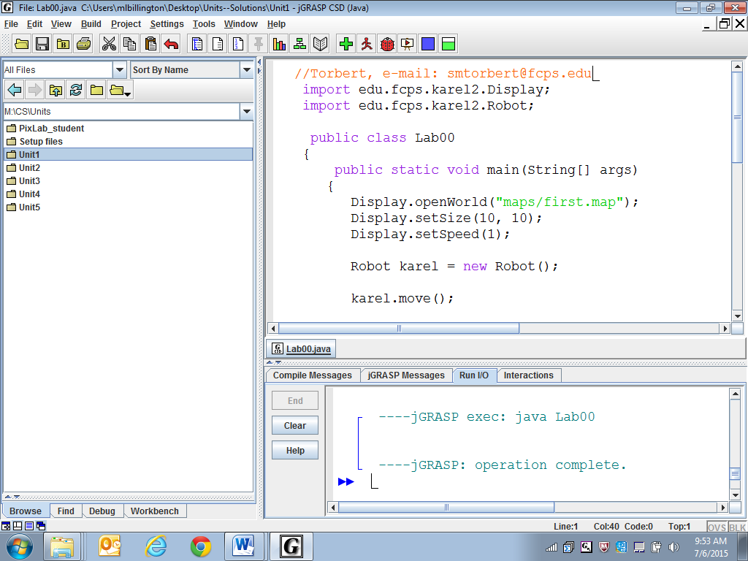
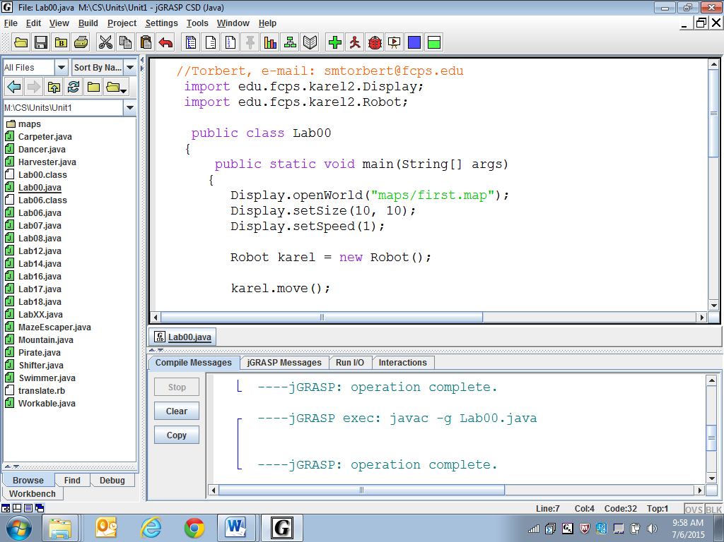

Source code is the Java program you write. Running a Java program is a two-step process: compiling and then running. Compiling is the translation of the source code into a lower-level code called bytecode. Compiling also checks for some kinds of errors, which is helpful. If the program successfully compiles, then you run the bytecode and see what happens. If you edit your source code, and you do not re-compile, then you are running the old bytecode. Accordingly, every time you make a change, you must re-compile in order to create an updated bytecode.

The two-step structure was adopted in order to accommodate different kinds of computers connected by the World Wide Web. The bytecode is sent over the internet, which is then run on the local system. The result is that Java is portable, or platform independent, because you can compile once and run anywhere. The alternative structure, which is used by C++ and other languages, is to produce compiled code directly for each type of computer. This second kind of code has an advantage in that it runs faster than the Java kind of code.

source code
bytecode
compile
run
run
Java, and object-oriented programming, can be difficult (but fun) to learn. Unit 1 uses karel robots and maps to introduce the concepts of object-oriented programming.
Windows
UNIX
Mac
run

Why do we use the name “karel”? According to Karel++: A Gentle Introduction to the Art of Object-Oriented Programming by Joseph Bergin, Mark Stehlik, Jim Roberts, and Richard Pattis:
The name "karel" is used in recognition of the Czechoslovakian dramatist Karel Čapek, who popularized the word robot in his play R.U.R. (Rossum’s Universal Robots). The word robot is derived from the Czech word robota, meaning forced labor.
Lab00
Hello Robot
Objective
Classes, objects, and sending Robot commands. Program structure.
Background
Ask your teacher about the text editor and Java environment you will be using. A nice text editor for a beginning student is jGRASP, available for free from Auburn University.
Specification
Go to File, New, Java file. Enter the source code shown below.
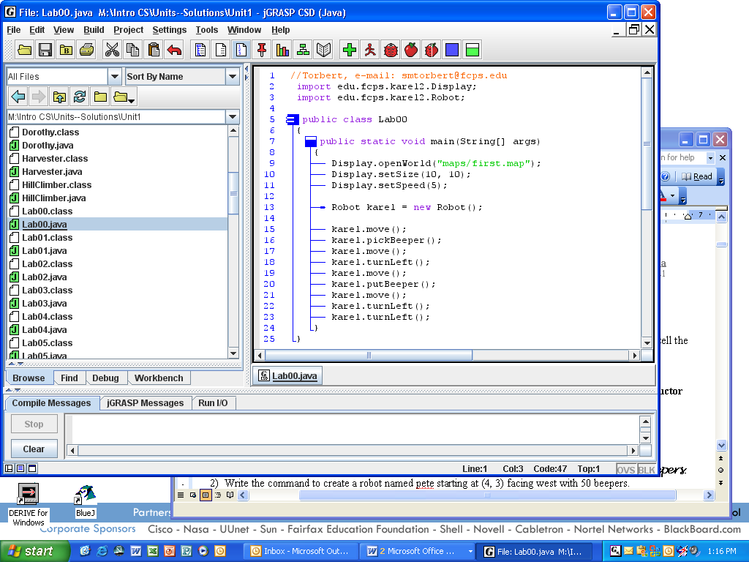
Line 1: This line states the programmer's name and date, beginning with //. The // starts a comment line, which is not compiled into bytecode; it is ignored.
Line 2: The import keyword makes classes in other packages accessible.

Line 5: A class (in Java) is a container for code. This class is public, not private.

Line 6: Left curly brace begins the class.

Line 7: All applications have a main method. The statements execute in order.

Line 8: Left curly brace begins main.

Line 9: openWorld is a class method in the Display class.

Line 12: The compiler ignores whitespace.

Line 13: Our object named karel is an instance of the Robot class. We have instantiated a Robot object from the Robot class.

Line 15: move is an instance method in every Robot object.

Lines 24 and 25: Right curly brace ends main and another right curly brace ends class Lab00. When you click CSD, the braces are all indented properly and the blue lines are generated.

Go to Save As. . . and save it as Lab00 (the file name must exactly match the class name) in the Unit1 folder. CSD. Compile and fix any errors. Run. You will see a map and a robot accomplishing its task, like this:
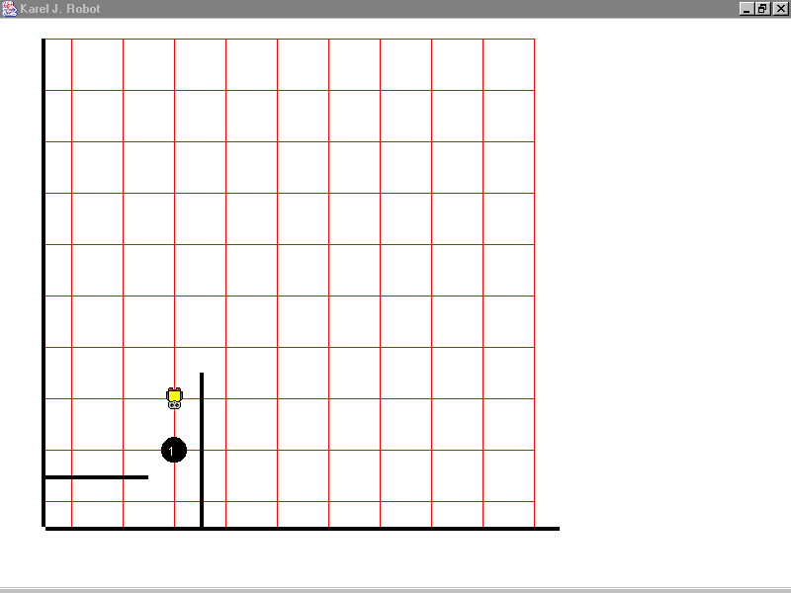
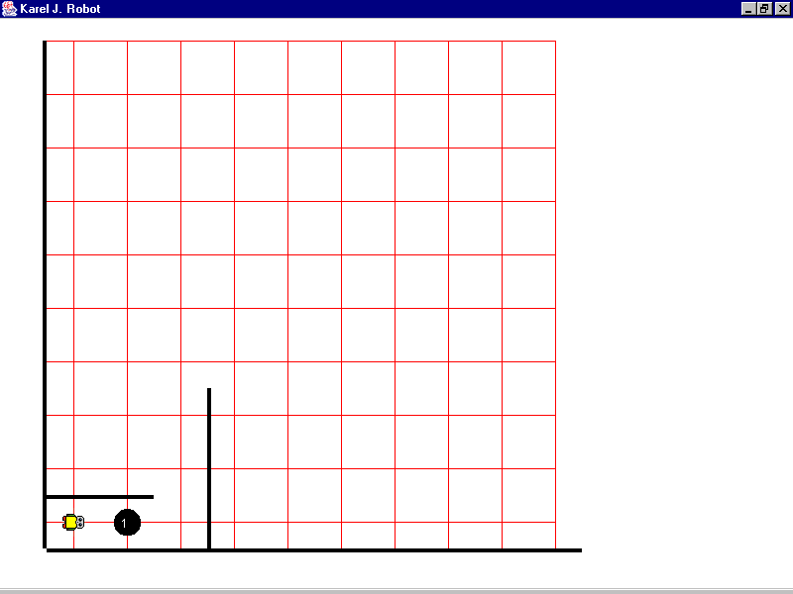
Sample Run
Unit1Lab00.jar

Start: End:
Exercises
Lab00
A Robot object’s default initial conditions are to start at (1, 1) facing east with zero beepers. If you don’t want the default settings, you may specify the x-coordinate, y-coordinate, direction, and number of beepers. For instance:
Robot ophelia = new Robot(); //calls the default constructor
Robot horatio = new Robot(5, 4, Display.SOUTH, 37); //calls the 4-arg constructor
1) What does ophelia know? What does horatio know? What do both robots know?

2) Write the command to create a robot named pete starting at (4, 3) facing west with 50 beepers.

3) Complete the main method to have lisa move one block, put down a beeper, then move another block. Since we have not set-up a specific map, the default robot-map will be used. The default map is empty except for the two infinite-length walls on the southern and western edges.
public static void main (String[] args)
{
Robot lisa = new Robot(7, 7, Display.SOUTH, 15);

}

4) Complete the main method to have martha move forward five blocks and “hand-off” her beeper to george. Have george move forward two blocks and put the beeper down.
public static void main (String args[])
{
Robot martha = new Robot(1, 1, Display.NORTH, 1);
Robot george = new Robot(1, 6, Display.EAST, 0);

}

5) Question #3 has no Display.openWorld. In that case, what map is used?
Discussion
Java Applications
Java applications, or programs, require a specific structure. An application is a class with a main method, which is the entry point for running the code. When the program runs, the computer executes the commands in main, one after another. Java uses matching curly braces to indicate blocks of code. Finally, the class name must match the filename (as you already know), so that the code below must be saved as LabXX.java.

public class LabXX
{
public static void main(String[] args)
{

}
}

Note: If you do not define main your program cannot run. If you did define main but the header does not say precisely:
public static void main(String[] args)

your program will still give an error, “not found: main”.

When you click the jGrasp "compile" button, you are actually running a separate program called javac. (This program was written by Sun, now owned by Oracle, and is part of the j2sdk installation.) The compiler first checks the LabXX.java code for syntax errors. Then it imports all the import files, looking first in the current folder (which is our Unit1), then in the external import locations, then the automatic import locations. All this source code is translated into bytecode and saved as LabXX.class. The bytecode is a comparatively small file, so that it can travel quickly over the internet.

When you click on a Java applet in a web browser, or on the jGrasp "run" button, you are actually running a separate program called java . (This program was written by Sun, now owned by Oracle, and is part of the jre installation.) The "run" button calls the main method in the application and executes the commands.

The write-compile-run process is illustrated below.

You write and save your Java source code. | javac LabXX.java | Java creates  the bytecode | java LabXX.class
LabXX.java | compile | LabXX.class | run | Look at the output, see if it is  what you wanted.
fix the syntax
errors
fix the run-time errors
Lab01
Students and Books
Objective
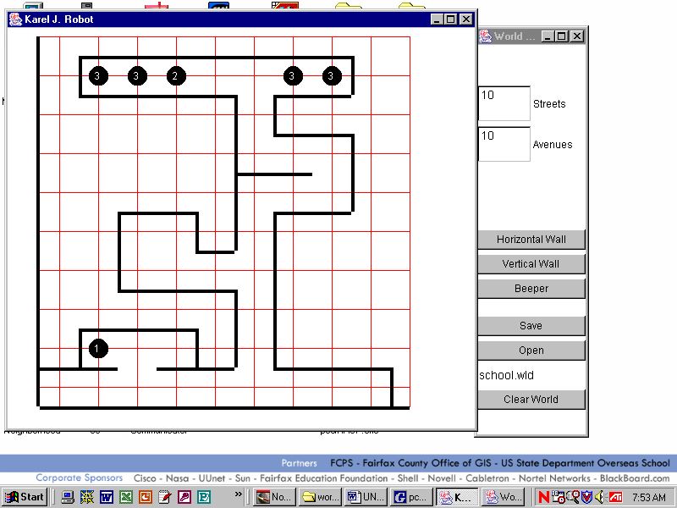
Program structure. Display commands. Robot commands.
Background
Maps are mapped according to the Cartesian coordinate system. The corner at the bottom-left of the graphics window is (1, 1).
Maps create the context for solving robot problems. Pre-defined maps are stored in the folder Unit1\maps
An identifier is the name of a class, an object, or a method. An identifier can be any unique sequence of numbers, letters, and the underscore character “_”. An identifier cannot begin with a number. An identifier cannot be a Java keyword, like class. Identifiers are case-sensitive, so lisa is not the same as Lisa. As a convention, only class names begin with an uppercase letter. Methods, objects, and variables by convention begin with a lowercase letter. Constant values, such as EAST, are written in ALL CAPS.
The word instantiate means to create an instance of a class—an object. Java instantiates an object with the new keyword.

The object “knows” how to do things in its methods. We can call or invoke a method, or send a message to a robot object, by using dot-notation. For instance, a robot named pete will move forward with the call pete.move();. The identifier “pete”, before the dot, is the name of an object and the identifier “move”, after the dot, is the name of a method. All methods in Java are marked by parentheses, which sometimes are empty and sometimes have values. The pete object will attempt to follow the calls in its move method.
Specification
Create Unit1\Lab01.java with the “school” map at size 10x10. Instantiate two Robot objects, one named lisa using the default constructor and the other named pete starting at (4, 5) facing south with zero beepers. Have lisa pick up the “book” from the math office and bring it to pete. Have pete take the book to the storage room and place it on the pile that currently has only two books. Then have pete step away from the pile.
Sample Run
Unit1Lab0.jar
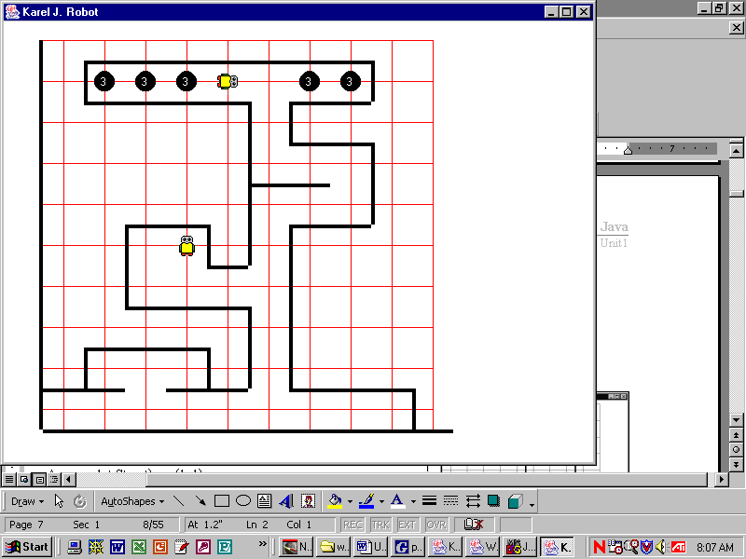
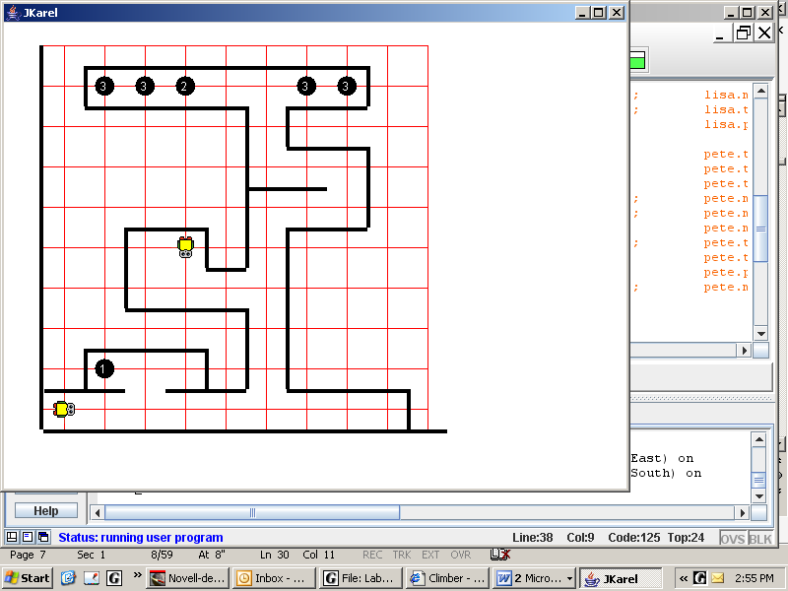

start: end:

Exercises
Lab01
- An API is a document that lists all relevant information about each class. Consult the "Unit1 API" found at https://academics.tjhsst.edu/compsci/CSweb/index.html
  - Fields store an object’s private information about its state. List all the fields of the Robot class:

  - What methods in Robot have we used so far?

  - What methods in Display have we used so far?

2) Circle the identifiers that will compile. Put a star by the identifiers that by convention identify a class.
mrsAdams | mr.chips | class | r2_d2 | c-3po | Hal9000 | 7_of_9
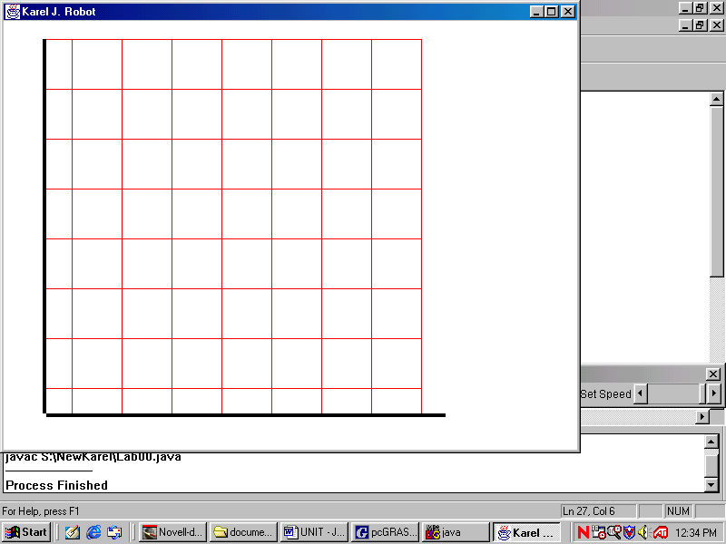
3) Mark the following points A(1, 1), B(6, 7), C(5, 2), D(3, 8), E(8, 1) on the robot-map shown.
4) What has the size of this robot-map been set to?

5) Give the command to set that size.

6) Lisa is a teacher at the local high school. She needs to store some books in the storage room downstairs. Lisa takes the books from the math office to the student lounge, where eager students wait to help their teachers. Lisa gives the books to pete, who cheerfully stores the books on the smallest pile.

Identify the nouns in the story above:

Identify the verbs in the story above:

7) In objected oriented programming, nouns turn into __________.

8) In objected oriented programming, verbs turn into _____ _________.

9) Our Lab01 program modeled a story about students and books in terms of robots and beepers. Write another similar story that could have been modeled in terms of robots and beepers.

10) In terms of your new classes, what should be the fields (private data) of each class?

11) Thinking about your new classes, what behaviors would it be useful to have?

Discussion
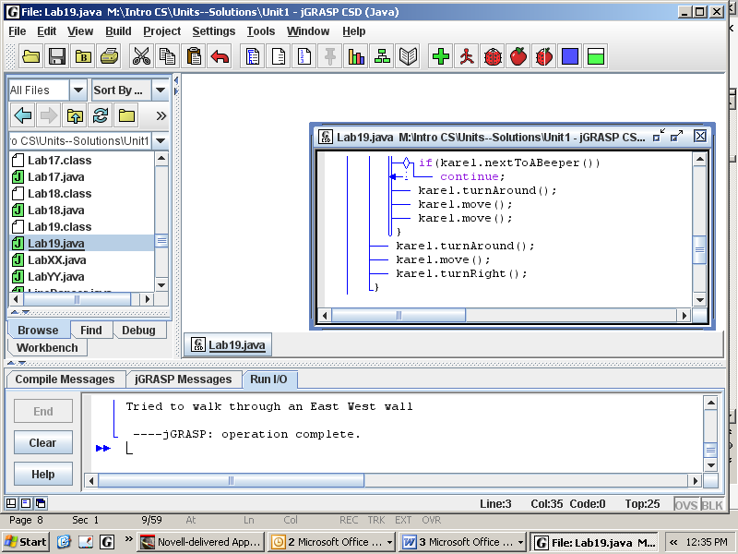
Errors
A Java compiler checks your work for errors whenever you compile a program. For instance, if you misspell Robot as Robt in your source code, you will receive a lexical error message because Robt is undefined. The compiler can’t understand that you meant to say Robot but spelled it incorrectly. (The error message will tell you on which line your error occurs; use the Line Numbering button to help you locate the exact line.)
CSD Line Numbers
A second kind of error is a syntax error, meaning that it breaks the rules of forming valid commands in Java. It is like making a grammatical error in English.
A third kind of error can occur when the program runs. If your code tells a robot to walk through a wall, pick up a beeper that isn’t there, or place a beeper that it doesn’t have, then a runtime error will occur. Your run-time environment generates an error message saying why the program crashed.
A fourth kind of error occurs when your program executes all the commands, but doesn’t accomplish the required task. Such logic errors are not the program’s fault. They are the programmer’s fault, usually due to unclear thinking. You’ll be spending a lot of time correcting logic errors.
Please get in the habit of generating CSD and compiling after you write a few lines of code. That way, you know that any syntax errors are in the last few lines that you wrote.
To help correct logic errors, you might try to comment out parts of the code. That way you can check portions of the code by itself. The commented out portions will turn orange (in jGrasp), and the compiler ignores those lines. You can either use // at the beginning of each line, or you can use /* to start a block of code and */ to end it. In jGrasp, you can highlight some code and press Ctrl-/. That’s nice.
Using Lab01, create these errors and write down what error messages, if any, they generate.

common errors | CSD error messages | compiler error | run-time error
omit a semicolon

put in an illegal semicolon, say after public static void main(String[] args);
omit a }

lexical error in “SSSSchool”

pass the wrong number of arguments, e.g. new Robot (4, 5, Display.SOUTH);
forget to import edu.fcps.karel2.Display;

Finally, comment out the lisa Robot and all lisa’s commands. What happens to pete?

The process of finding errors and correcting them is called “debugging” and the errors themselves are called “bugs.” In 1951, Grace Hopper, who would eventually rise to the rank of Rear Admiral in the United States Navy, discovered the first computer “bug.” It was a real moth that died in the circuitry. Hopper pasted the moth into her UNIVAC logbook and started to call all her programming errors “bugs.”
Lab02
Escape the Maze
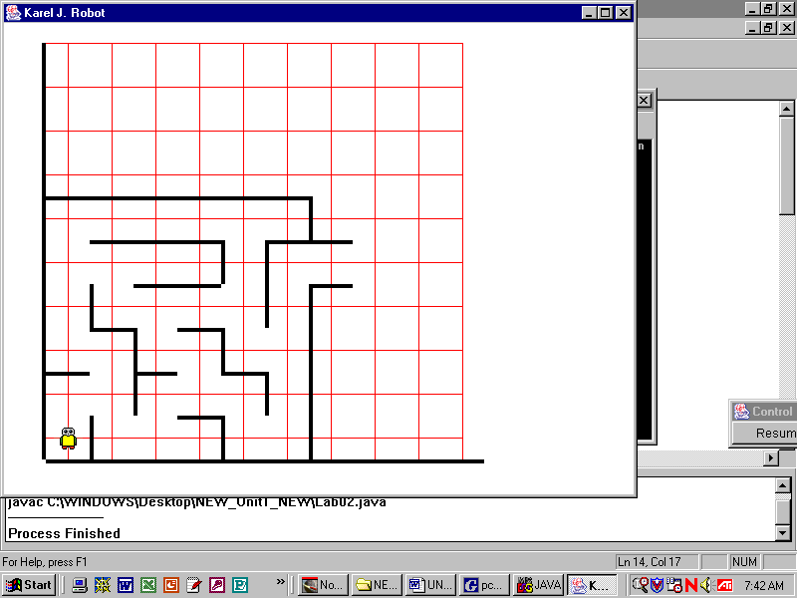
Objective
Inheritance. Defining instance methods.
Background
You may have noticed that Robots don't know how to turn right. In object oriented programming, it is common practice not to change the classes that are given to you. Instead, you extend Robot and define the new class which will have the power to turn right. Study the structure of Athlete, especially lines 14 to 24. In these instance methods, we “teach” Athlete how to turn around and how to turn right. (We will talk about lines 6 to 13 later.)
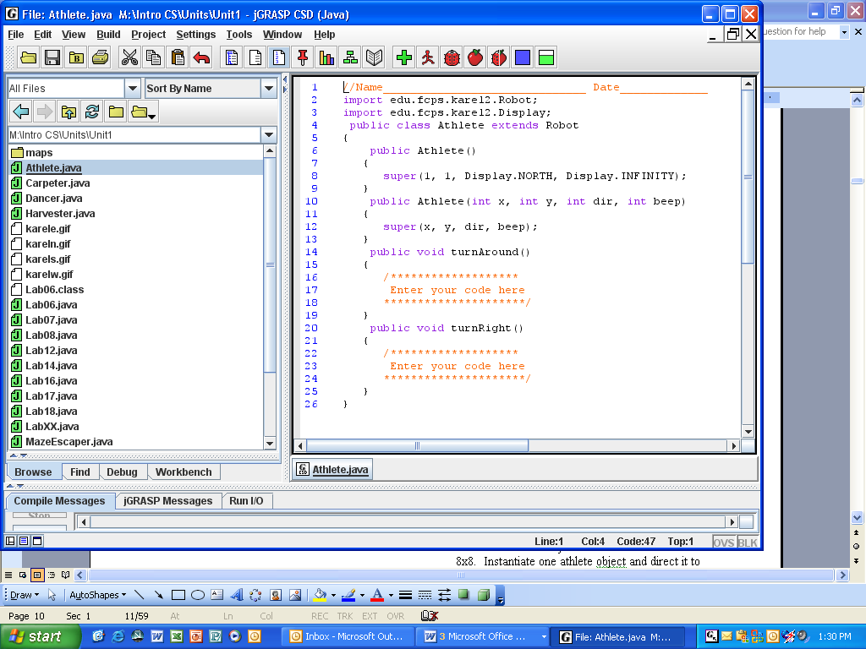
The keyword extends means that an athlete isa robot. "Isa" means that the Athlete class inherits the behaviors and attributes of the Robot class; the methods from Robot do not have to be re-written. We can use turnLeft in our definition of turnRight and turnAround, and any athlete object can use any robot method. When you write methods in Athlete, think of programming an Athlete in general, not of programming any specific athlete object.

Athlete is a general resource class that will be useful in a wide range of applications. The application called Lab02, which has the main method, will use the Athlete class. We sometimes say that Lab02 hasa athlete.
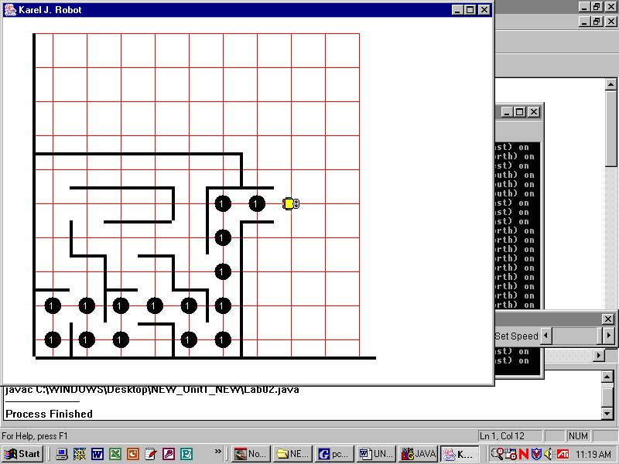
Specification
Create Unit1\Athlete.java as given above. Implement the methods turnRight and turnAround, then compile. Do not run Athlete.
Create Unit1\Lab02.java with “maze” map at size 8x8. Instantiate one athlete object and direct it to escape the maze. Leave a trail of beepers to mark the path. By default, athletes begin with an infinite number of beepers.
Sample Run ,
Unit1Lab02.jar
Extension
Write a putAndMove method in Athlete then use it in Lab02.

Exercises
Lab02
Examine the robot-map shown. Let Athlete maria = new Athlete();
1. Write the commands to put one beeper at the indicated location.

- Use a different path from your answer from Question #1. Write the commands to put one beeper at the indicated location

3. Lab01 used three classes, Lab01, Display, and Robot. Label the boxes (it’s called a UML diagram), showing the class relationships. Label the arrows with “hasa.”

4. Lab02 involved four classes, Lab02, Display, Robot, and Athlete. Label the boxes in the UML diagram, showing the class relationships. Label the arrows with “isa” or “hasa.”

Discussion
Resources vs. Drivers
In Lab01 you wrote one class while in Lab02 you wrote two classes, a driver class and a resource class. The driver class contained the main method while the resource class contained the code for Athlete. Using a different terminology, we could say that the driver class is the client and the resource class is the server. The client sends messages or commands while the server knows how to respond to those messages. Notice also that the driver class did not have to be instantiated to be used. The driver class had a static main method, which contained code that just lies around, waiting to be used. We could just run the main method. In contrast, the resource class did have to be instantiated (using the new keyword) as an object. Then the client could send messages to that object, the server, directing the object to perform some task.
Discussion
Class Types vs. Primitive Types
A data type specifies how the different kinds of data, e.g., numbers, or words, or Robots, are stored and manipulated. (This is a big topic in computer science. Here we just introduce the topic.) Classes define complex types since they encapsulate data and methods, i.e., an object’s data and methods are private and wrapped up inside the object. Objects are accessed by references, which act like little pointers. The code Robot karel = new Robot(); does three things: creates a reference (karel), instantiates an object (new Robot()), and assigns (the "=" sign) the reference to point to the object. You should imagine the reference pointing to object, like this:
Robot karel = new Robot(); |  | karel |  |  | OBJECT
Two or more references can point to a single object. You will see this in later labs.
In Java, some built-in data types are not complex, but are simpler, called primitive data types. Three of Java’s primitive data types are int for integers, double for decimal numbers, and boolean for true-false.
Primitive data types are not accessed by reference. Instead, the data is stored directly in memory spaces called variables. A type declaration assigns a name to a memory space, and often assigns a value, e.g.:
int sum;
sum
total | 0
int total = 0;

We may say that these two statements declare sum and total. Here are five more declarations:
int x = 5;
x | 5
y | 5
d |  | 579 | 2
answer | true
result | true
int y = x;
double d = 5.79;
boolean answer = true;
boolean result = answer;

The eight declarations on this page create a reference to a Robot object, seven different variables, and assign values to six of those variables.
The constructor method public Athlete(int x, int y, int dir, int beep) creates four memory spaces for integers, but does not assign values. The values are assigned when the actual values are passed to the constructor method by a call to the constructor such as:

Athlete ariadne = new Athlete(1, 2, Display.EAST, 10);

Discussion
Constructors
Lab02 instantiated an athlete at (1, 1, north, infinity) with the call Athlete karel = new Athlete(); That call executed lines 6-9 in the Athlete class below, which is one of Athlete's constructors. A constructor method is a method that creates an object and initializes its private data. Initializing the private data is done in this case by the super command which specifies this athlete's x-position, y-position, direction, and beepers.
The no-arg (or default) constructor is easy to call, but isn't flexible. It always instantiates an object in the default state, which in the case of an Athlete is 1, 1, north, and infinity. It would be nice to be more flexible, so that we could specify an Athlete at different positions, directions, and numbers of beepers. We can do so by writing a constructor with arguments.

Lines 10 through 13 contain the code for the 4-arg constructor, because in line 10, the (int x, int y, int dir, int beep) creates room for 4 values. The 4-arg constructor is hard to call, but is flexible because it allows the programmer to instantiate an athlete in any state.

Java allows us to write as many constructors as we want, each instantiating objects in slightly different states. You know from Lab01 (and from page One-5) that Robot also has two varieties of constructors.
Object
Item
Robot
Athlete

In Java, a subclass inherits fields and methods, but not constructors. The subclass constructor needs an explicit call, which is the super command, to the superclass’s constructor. The super command calls the constructor of the class above the current class. Thus, Athlete’s super calls Robot’s constructor. Robot also has a super method, which calls the constructor of the class above it, which happens to be Item (you only know this because it is in the API). Item calls the constructor of Object. Eventually, all the supers in the hierarchy instantiate all the pieces that make an Athlete object.

There are several rules regarding constructors. First, the name of the constructor method must match the name of the class, i.e. Athlete on lines 6 and 10 must match Athlete on line 4. Second, constructors are not labeled with a keyword, such as void or static. Third, the call to super, including the number and types of arguments, must find the corresponding constructor in the class in the hierarchy above it. For example, the Athlete’s super(1,1,Display.NORTH,Display.INFINITY) must find a corresponding 4-arg constructor method public Robot(int x, int y, int dir, int beep). If the compiler is unable to find the corresponding constructors in the class above, it reports an error, "constructor not found."

If you choose not to write a constructor, then Java automatically generates a hidden no-arg constructor for you! This is very nice but it is also confusing to beginners, because it appears there is no constructor at all. If you do write a constructor with arguments, then you should, as a general rule, also define a no-argument constructor, just in case the chain of super constructors needs it later. Notice that we follow this rule with the Climber class in Lab03, giving Climber two varieties of constructors.
Lab03
Climb Every Mountain
Objective
Constructors are special methods that create an object and initialize its private data, often by the super command.

Background
A Climber is a specialized Athlete. A climber climbs mountains and finds treasure. Climbers always start at the bottom facing north with one beeper, but we want climbers to be able to begin at any given x-position. In order to specify the starting x-position, the Climber class will define a 1-arg constructor as well as a default constructor. How do these two constructors work?
Object
Item
Robot
Athlete
Climber

1 public class Climber extends Athlete
2 {
3 public Climber()
4 {
5 super();
6 }
7 public Climber(int x)
8 {
9 super(x, 1, Display.NORTH, 1);
10 }
11 public void climbUpRight()
12 {
13 //pseudocode: tL, m, m, tR, m
14 }
//You must define three other instance methods.

We might instantiate a climber with Climber tenzing = new Climber(100);. Note that we pass one argument to Climber's one-arg constructor. Climber's own super (on line 9) passes four arguments to Athlete’s 4-arg constructor. Athlete's constructor passes those four to Robot, and so on up to Object.

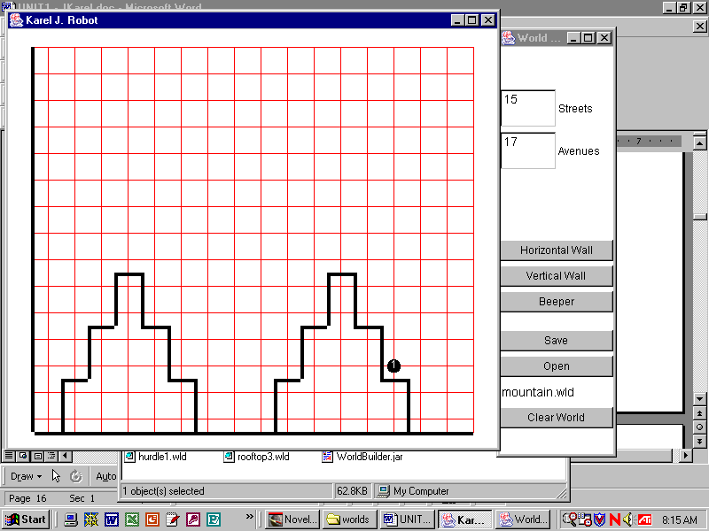
The Climber's instance methods all have to do with climbing the mountain. Each
method should work for one step only. Plan how you will teach the climber to climb up one step, going to the right.

Specification
Consult the Unit 1 API to find out what methods the Climber class needs to know.

Create Unit1\Climber.java. Implement the methods in the Climber class, then compile.

Create Unit1\Lab03.java with “mountain” map at size 16 x 16. Instantiate two climbers starting at x-coordinate 8. Put down the beeper, which is the "base camp." Staying together as much as possible, bring the treasure back to “base camp.”
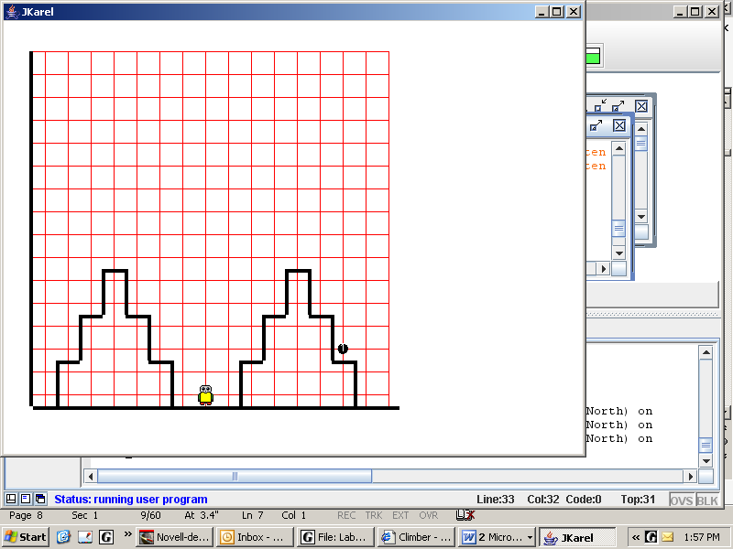
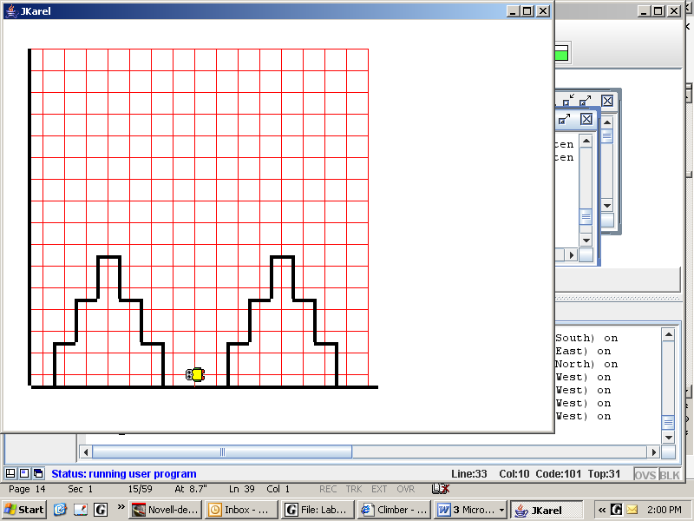
Sample Run
Unit1Lab03.jar

start: end:
Exercises
Lab03
1. Notice which class Elf inherits from. Write a default constructor for Elf. All elves begin at (1, 90), face south, and carry an unlimited supply of beepers.
public class Elf extends Robot
{

2. Notice which class Spartan extends. Write a constructor for Spartan that takes two arguments specifying the position to start on. All Spartans face east with one beeper.
public class Spartan extends Athlete
{

3. Write a second constructor for Spartan. This constructor is a default constructor. It instantiates a Spartan in an Athlete's default state.

Discussion
Passing Arguments
We said above that we might instantiate a climber with Climber tenzing = new Climber(100);. The number 100, inside parentheses, is called an actual argument. The program then goes to the method’s code, sees the public Climber(int x), creates room for the x, and assigns the 100 to the x. The variable x is called the formal argument. Whenever the x is used after that, its value will be 100. Similarly, when the call to super(100, 1, Display.NORTH, 1) is executed, then those four integers are passed up to Athlete. There, the x is 100, the y is 1, the dir is Display.NORTH, and the beep is 1. The four actual arguments must match up with the four formal arguments, or the class will not compile. Whenever we write or call a method, we need to think about the method’s arguments, both their type and their number.
x | 100
x | 100
y | 1
dir | 3
beep | 1
maria
ATHLETE
arg

In the next lab, we will be passing objects as arguments with takeTheField(maria); The computer then goes to the method’s code, sees public static void takeTheField(Athlete arg), and creates and assigns a new reference. Because Java objects are referenced, what gets passed is the reference, meaning that maria and arg point to the same object. In effect, the athlete has two names. Commands invoked on arg affect the same object to which maria points.
Lab04
Take the Field
Objective
Class methods vs. Instance methods
Background
A class method conveniently stores code that is accessible to anyone, without first creating an object (the class "knows"). Mathematical formulas, such as those in the Math class, are examples of class methods. Often class methods control the environments for other objects. You have already seen Display.setSize and Display.openWorld. All class methods are marked by the keyword static. Class methods are usually placed before the main method, but they don’t have to be.
An instance method is a method written in a class that must be instantiated (the object “knows”) before being used. Every Athlete should know how to turnRight. Therefore, turning right is appropriately defined as an instance method within the Athlete class--the object knows. In contrast, taking the field is something that is specific to this lab only. Therefore, taking the field is appropriately defined as a class method within the Lab04 class--the class knows. All the athletes in Lab04 will go from the locker room (Point A) to the field (Point B) by executing the code in the class method takeTheField.
public class Lab04
{
public static void takeTheField(Athlete arg)
{
arg.move();
arg.move();
arg.move();
arg.move();
arg.turnRight();
arg.move();
arg.move();
}
public static void main(String[] args)
{ //You must define main.

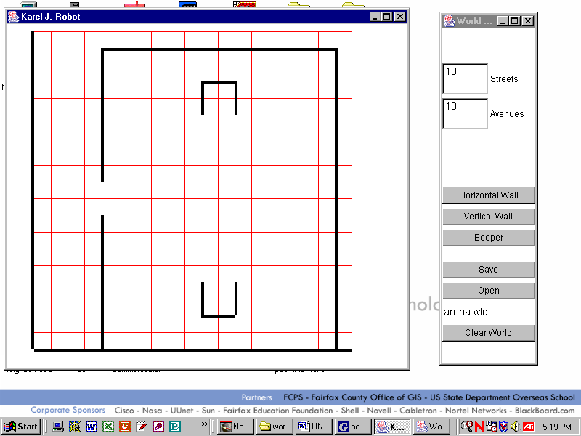
A
B

We can use this class method with any athlete object by passing the object. For instance, if we have athletes maria and gary defined in main, we can tell each to take the field with the commands:
takeTheField(maria);
takeTheField(gary);

Notice that we do NOT say maria.takeTheField(). This is because takeTheField is not part of an Athlete object. It is "known" by the Lab04 class. We call takeTheField and pass the object to the argument arg, which points to whatever Athlete has been passed; first maria, then gary.
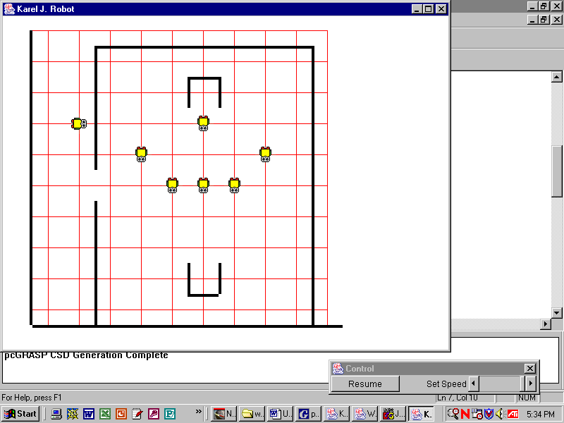
Specification
Create Unit1\Lab04.java with “arena” map at size 10x10. Create six athletes starting in the locker room; use the default constructor. Create one object with the 4-arg constructor to put the coach at the side of the field. Have your team get positioned for the start of the game as shown
.
Sample Run
Unit1Lab04.jar
Exercises, Part 1
Lab04
class NewLab

main()
karel
josie

Robot
public class NewLab
{
Athlete
public static void main(String[] args)
{
Robot karel = new Robot();
Athlete josie = new Athlete();
class Lab04
takeTheField(Athlete arg)

main()
gary
maria

//Assume each command below is inserted here.
}
}
Explain what is wrong with each command shown below.

1. karel.turnRight();

2. karel.putBeeper();

3. maria.pickBeeper();

4. josie.turnLeft();
josie.move();

5. josie.takeTheField();

6. takeTheField(josie);

7. Lab04.takeTheField(karel);

8. Lab04.takeTheField(josie, karel);

9. Lab04.takeTheField(Athlete arg);

Exercises, Part 2
Lab04
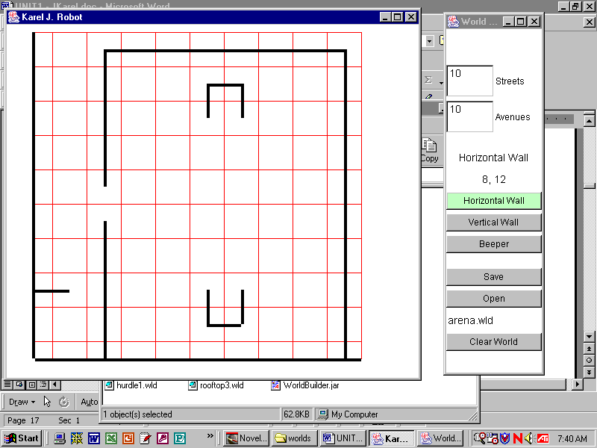
Examine the robot-map shown. Note that this is not exactly the same arena map from Lab04. Our facilities are being renovated and the construction crew has temporarily blocked off our normal passageway; there’s a horizontal wall north of (1, 2) that wasn’t there originally.

1. Describe how you would have to change your Lab04 application so that it would work in this map.

2. Write down the complete code of all methods that you changed, starting with the header for that method and including the entire method body.

3. Modular design is the practice of breaking larger problems into smaller, more manageable pieces. Explain how modular design helped us maintain our Lab04 program when the robot-map changed.

Look at the API for the Math class in the current version of Java. (In jGrasp, go to Help→Java API.)

- Which Math method doesn’t take any arguments? ______________________

- Name a Math method that takes two arguments. ______________________

- Why does it make sense that all the Math methods are marked static?
Discussion
Class Hierarchy
In the class hierarchy, or inheritance hierarchy, shown in the UML diagram at the right, we say:
 |  | Robot
 |  | Athlete
Climber |  |  |  | Racer
- Robot is the superclass of Athlete and Athlete is the subclass of Robot.
- Athlete is the superclass of Climber and Climber is the subclass of Athlete.
- Athlete is the superclass of Racer and Racer is the subclass of Athlete
Other names for a superclass are base class or parent class. Other names for a subclass are derived class or child class. Since a climber isa athlete and an athlete isa robot, we can also say that a climber isa robot. Likewise, since a racer isa athlete and an athlete isa robot, we can say that a racer isa robot. Not only do the subclasses inherit methods and fields, but they also inherit the name of the superclass.

1) For each attribute, circle the classes that must have that attribute.
A. Athletes have green feet. | Robot | Athlete | Climber | Racer
B. Climbers have blue scales. | Robot | Athlete | Climber | Racer
C. Robots have curly tails. | Robot | Athlete | Climber | Racer
D. Racers have sharp teeth. | Robot | Athlete | Climber | Racer

2) Given the declarations below, circle all the commands that are legal.
Robot karel = new Robot();
Athlete gary = new Athlete();
Climber lisa = new Climber();
Racer mary = new Racer(); // Racer defines jumpHurdle()
public static void runAway(Athlete arg)

karel.move(); | gary.move(); | lisa.move(); | mary.move();
karel.turnRight(); | gary.turnRight(); | lisa.turnRight(); | mary.turnRight();
karel.turnLeft(); | gary.turnLeft(); | lisa.turnLeft(); | mary.turnLeft();
karel.climbUpRight(); | gary.climbUpRight(); | lisa.climbUpRight(); | mary.climbUpRight();
karel.jumpHurdle(); | gary.jumpHurdle(), | lisa.jumpHurdle(); | mary.jumpHurdle();
karel.main(); | gary.setSize(); | lisa.openWorld(); | mary.pickUpBeeper();
karel.runAway(); | gary.runAway(); | lisa.runAway(); | mary.runAway();
runAway(karel); | runAway(gary); | runAway(lisa); | runAway(mary);

Discussion
Loops
We often want to repeat (or iterate, or loop) either one command or a sequence of commands. For instance:
karel.move();  karel.putBeeper();  karel.move();  karel.putBeeper();  karel.move();  karel.putBeeper();  karel.move();  karel.putBeeper();  karel.move();  karel.putBeeper();  karel.move();  karel.putBeeper(); | pete.pickBeeper();  pete.pickBeeper();  pete.pickBeeper();  pete.pickBeeper();  pete.pickBeeper();  pete.pickBeeper();  pete.pickBeeper();  pete.pickBeeper();  pete.pickBeeper();  pete.pickBeeper();
In the first example, we want to repeat moving and putting exactly 6 times. In the second example, we want to pick exactly 10 beepers. Since we know beforehand exactly how many times to iterate (definite iteration), we will use a for-loop. (We will study indefinite iteration, the while-loop, in Lab06.)

int k;  for(k=1; k<=6; k++)  {  karel.move();  karel.putBeeper();  } | int k;  for(k=1; k<=10; k++)  pete.pickBeeper();  This loop will cause pete to pick up a beeper ten times (once when k has each of the values 1, 2, 3, 4, 5, 6, 7, 8, 9 and 10).  Braces are optional if the process to be repeated consists of only a single command.
This loop will cause karel to move and put down a beeper six times (once when k has each of the values 1, 2, 3, 4, 5, and 6).

Each for-loop has three parts, where k begins, where k ends, and how k increases. The command k++ causes the value of the variable k to increase by one. If k was one, it is now two; if k was two, it is now three; and so on. (Plus-plus (++), the unary increment operator, gave us the name of the language C++.)
k | k <= 6
1 | true
2 | true
3 | true
4 | true
5 | true
6 | true
7 | false

The table to the right shows both the values that the integer variable k takes and the values that the boolean expression k <= 6 takes inside karel’s loop.

The boolean expression evaluates to false only when the value of k reaches seven. Since the loop continues until this condition is false, the value of k is seven when the loop stops. What is the value of k when pete’s loop stops?

The loop control variable, k, can actually be declared within the for-loop. The syntax of a for-loop that repeats n times can then be written as:
for(int k = 1; k <= n; k++)
{
}

The loop control variable, k, does not have to be k. You can name it anything that makes sense.

Lab05
Shuttle Run
4 public class Racer extends Athlete
5 {
6 public Racer(int y)
7 {
8 super(1, y, Display.EAST,
Display.INFINITY);
9 }
10 public void jumpRight()
11 {
//pseudocode: tL, m, tR, m, tR, m, tL
15 }
16 public void jumpLeft()
17 {

25 }
26 public void sprint(int n)
27 {
28 for(int k=1; k <= n; k++)
29 move();
30 }
31 public void put(int n)
32 {
33 __________________
34 __________________
35 }
36 public void pick(int n)
37 {
38 __________________
39 __________________
40 }
41 public void shuttle(int spaces,
int beepers)
41 {
42
43
Objective
for-loops.
Background
Racers always start on the left side at x=1, facing east with an infinite number of beepers, but they may begin on any y-coordinate. The Racer constructor with an argument that specifies the starting y-position is on lines 6-9.

Racers also improve upon the powers of Athletes and Robots. Racers will be able to move many steps at a time, pick up piles of beepers, and put down piles. These instance methods will use for-loops and pass a variable. One is done for you; complete the other two.

If pete is a Racer, then pete.sprint(100); will move pete way off the screen. How does the sprint method work?

Since three racers will complete the same task, which depends on the map that is used, this is a perfect place to define a class method. Let's call it runTheRace.

Specification
Consult the Unit 1 API for the methods that should be in the Racer class. Create Unit1\Racer.java. Implement the Racer class, then compile.

Create Unit1\Lab05.java with “shuttle” map at size 10x10. Create three racers to run the shuttle run. It’s not a race. Let one racer finish the task, then send each of the others. Use a class method. Each pile of beepers must be brought individually back to the racer’s starting point. At the end each racer must step away from the pile to confirm that all 15 beepers have been retrieved.

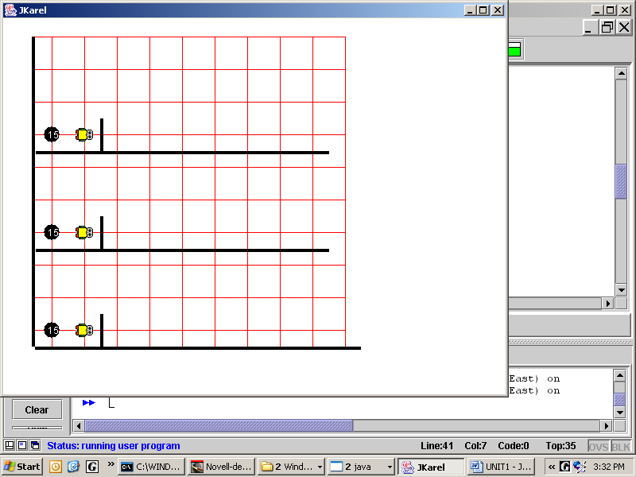
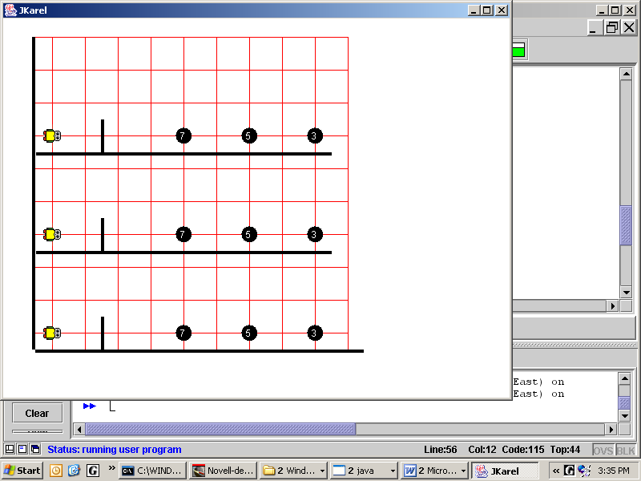
Sample Run
Unit1Lab05.jar
start: end:

Discussion
for-loop, while-loop, and if
Any for-loop can be re-written as a while-loop.
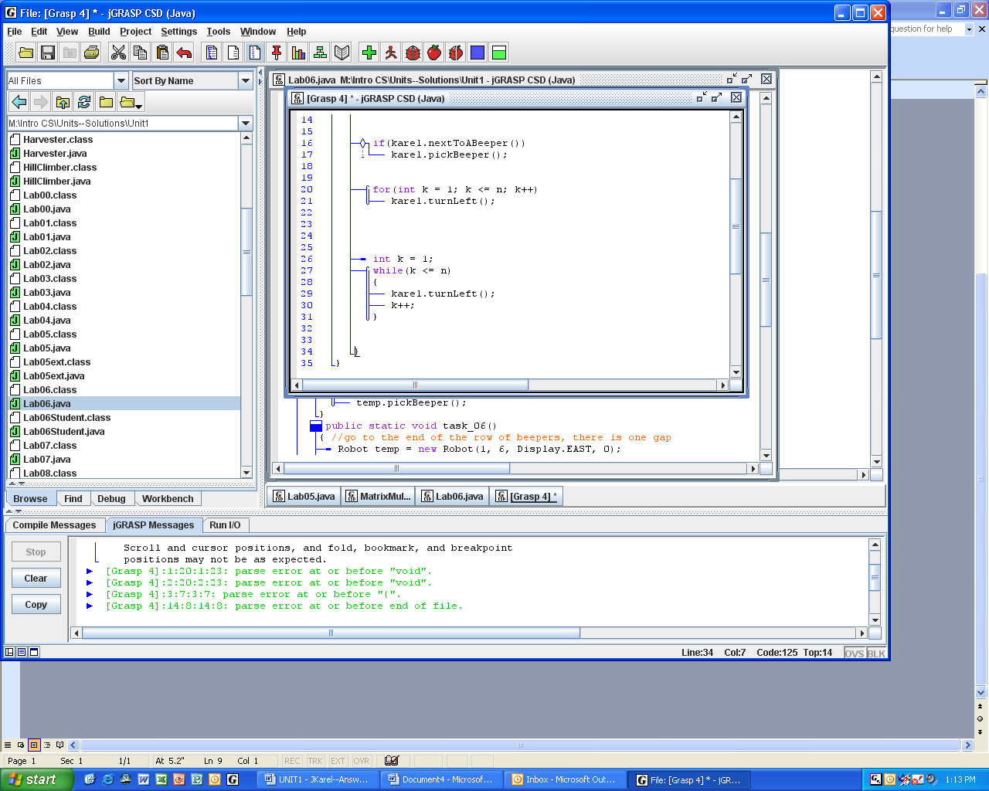
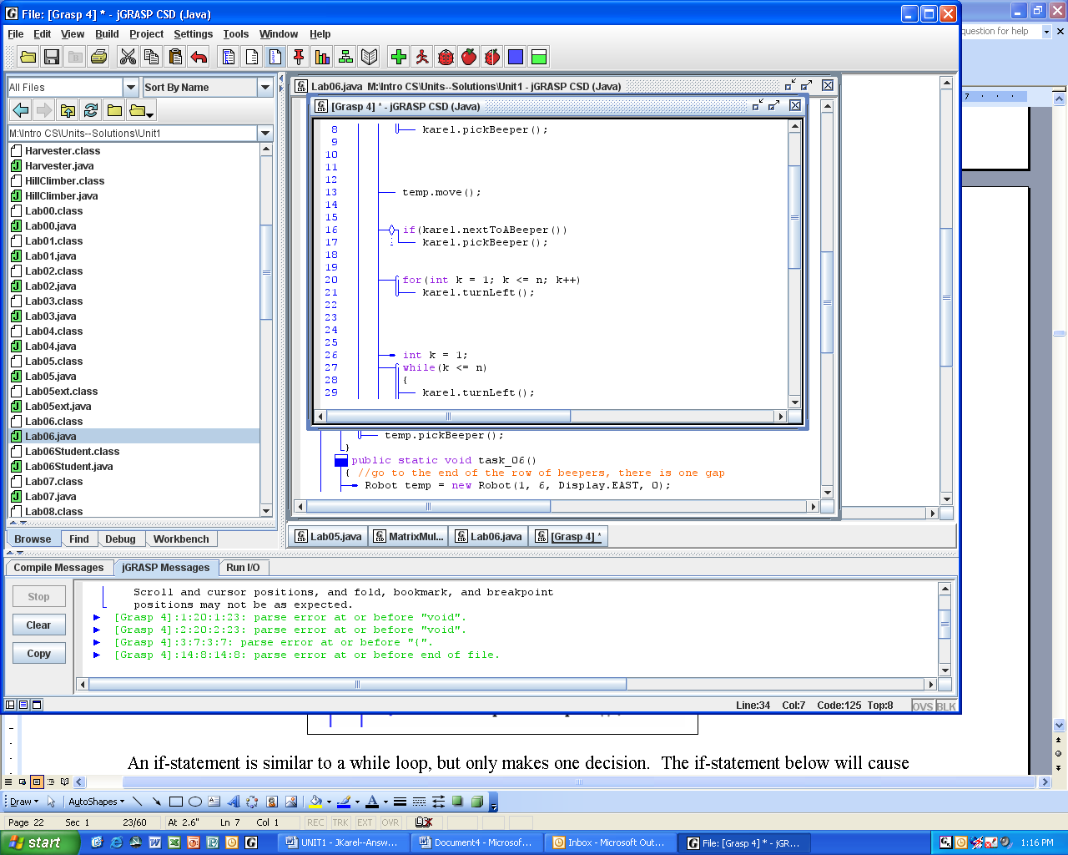

Both loops as written will try to make karel turn left for n times, no matter what. However, it has become conventional to use the for-loop for definite loops and the while-loop for indefinite loops, where you don’t know beforehand exactly how many times to loop.

The while-loop below is a better example of an indefinite loop, for we don’t know when it will stop. It keeps picking up a beeper as long as nextToABeeper is true. The result is to make a robot that is standing on top of a pile to pick up that entire pile of beepers.
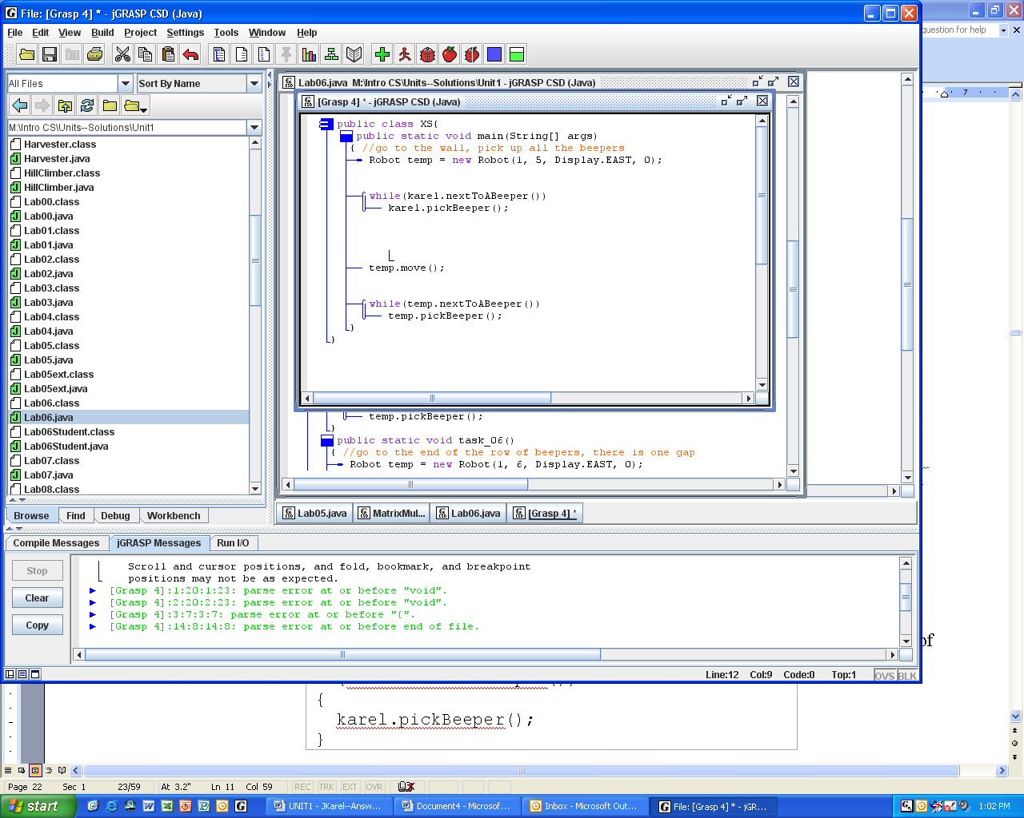

An if-statement is similar to a while-loop, but only makes one decision. The if-statement below will cause karel to pick up one beeper if he is currently standing on top of one. If karel is not currently standing on top of a beeper, the code just moves on. Thus, the if-statement acts as a guard to prevent the program from crashing in certain situations. In other words, an if-statement checks its condition only once.
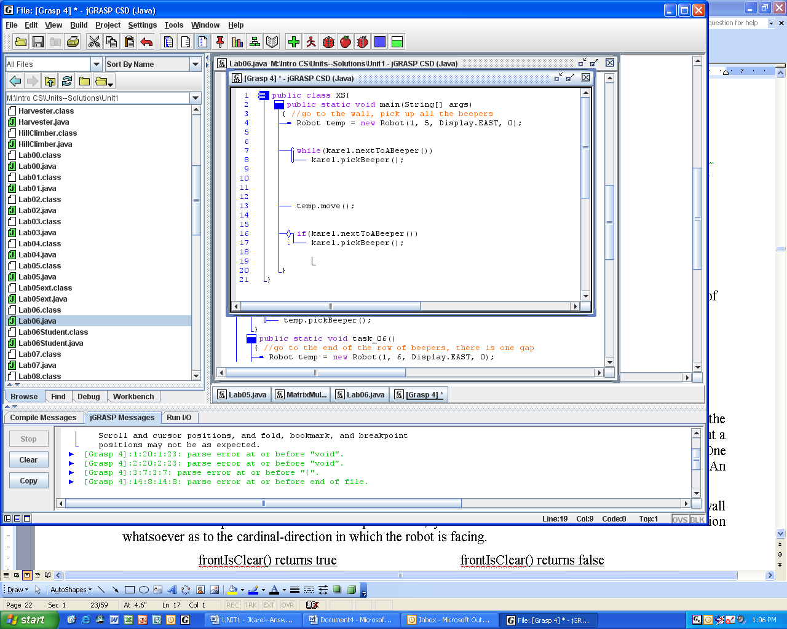

Warning
There is no such thing as an if-loop. Don’t say “if-loop,” say “if-statement.”

Java distinguishes between void methods and return methods. Void methods take action and change the situation, such as public void turnRight(). In contrast, return methods provide information about a robot’s situation. Since there are different kinds of information, return methods come in several varieties. One variety returns boolean values, either true or false. Think of booleans as answering yes-no questions. An example of a boolean method, used above, is public boolean nextToABeeper().
Another boolean method defined in the Robot class is frontIsClear. It determines whether or not a wall blocks a robot’s path. Look at the examples below; you can see that this method makes no distinction whatsoever as to the cardinal-direction in which the robot is facing.
frontIsClear() returns true frontIsClear() returns false
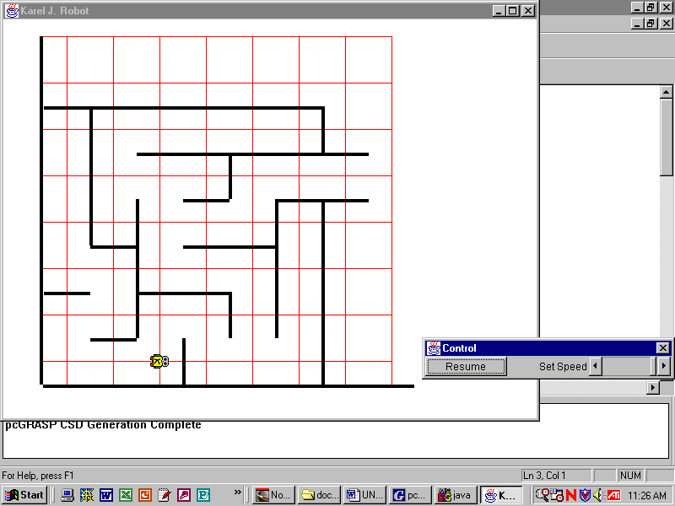
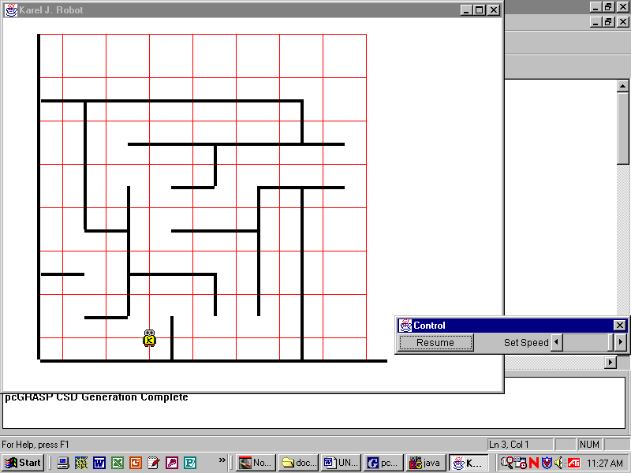
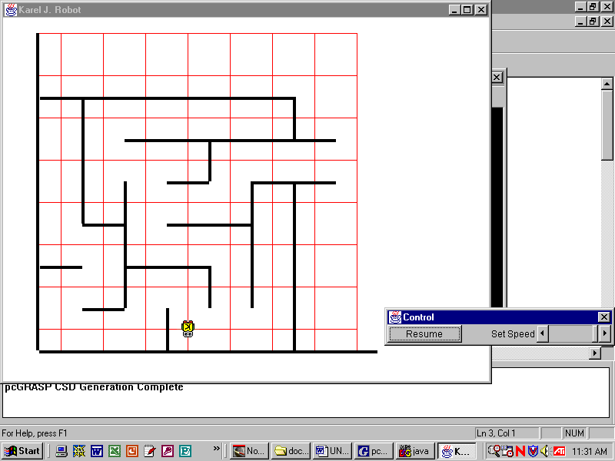
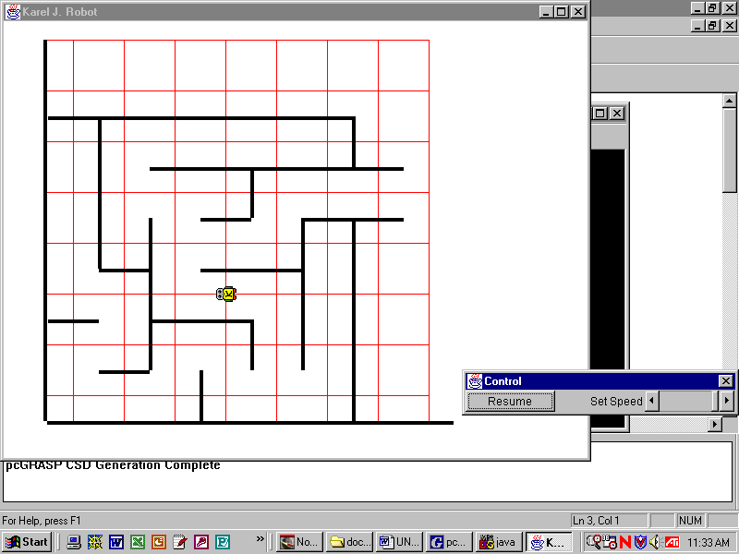

There is no method frontIsBlocked. However, there is the exclamation mark (!), called the not operator, and follows the rules not-true is false and not-false is true. The not operator goes in front of the whole expression, for example, !karel.frontIsClear(). We might read it as “not karel dot frontIsClear.”
Exercises
Booleans
Look at the Robot’s API to see what boolean methods might be helpful here.
1. Write the commands to force a Robot object named karel to face west no matter what direction it is initially facing. | 2. Write the commands to make an Athlete named ann to put down all her beepers.
3. Write the commands for Climber c to pick up a pile of beepers. | 4. Write the commands for Racer ray to stop moving when it is next to (on top of) another robot.
5) Given the declarations and the default map, indicate the boolean value of each statement.
Robot pete = new Robot(5, 1, Display.WEST, 37);
Robot lisa = new Robot(2, 6, Display.SOUTH, 0);
!pete.frontIsClear() | true | false
pete.hasBeepers() | true | false
!lisa.hasBeepers() | true | false
!pete.facingWest() | true | false
lisa.facingWest() | true | false
6) The logical AND (in Java) is the symbols &&. The logical OR (in Java) is the symbols||. Evaluate:
true && true | → |  |  | true || true | →
true && false | → |  |  | true || false | →
false && true | → |  |  | false || true | →
false && false | → |  |  | false || false | →
7) Extra Credit: make a truth table that shows that De Morgan’s Laws are true:
!(a && b) == !a || !b !(a || b) == !a && !b

Lab06
A Half-Dozen Tasks
Objective
while-loops and if-statements
Background
Row | Task
1 | Go to the end of the row of beepers.
2 | Go to the beeper.
3 | Go to the wall.
4 | Go to the wall, picking up all the beepers (max one beeper per pile).
5 | Go to the wall, picking up all the beepers.
6 | Go to the end of the row of beepers; there is one gap somewhere.
This lab instantiates 6 Robots to perform 6 different tasks. For convenience, we code each task as a class method. Each task uses one or more indefinite loops. Some tasks also use if-statements.

If temp (for temporary) is a Robot object, the solution to task number three is:
Before After
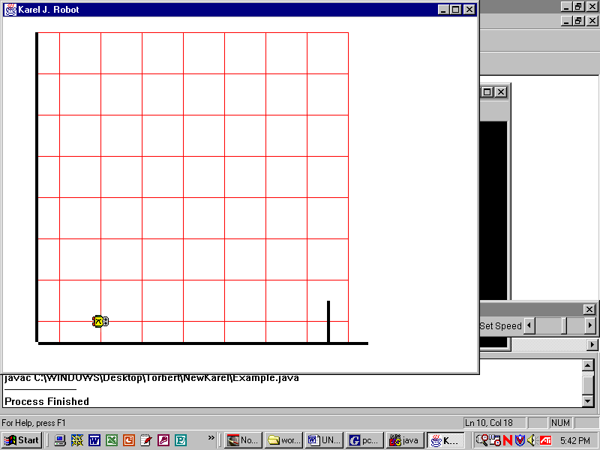
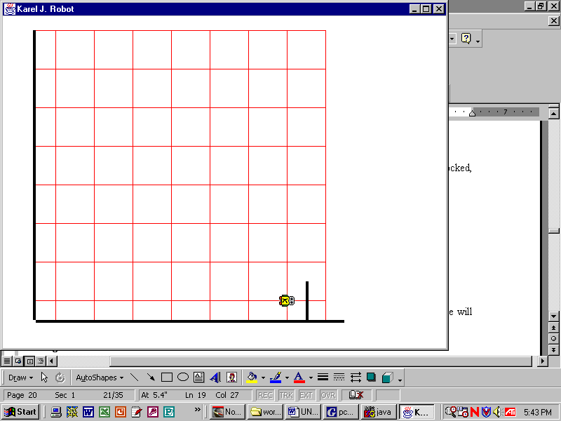
while(temp.frontIsClear())
{
temp.move();
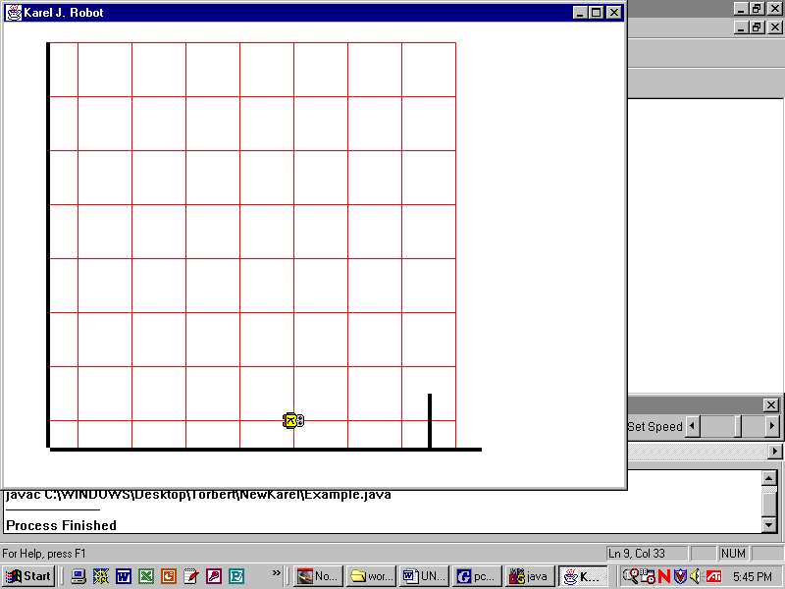
}

This loop will repeat an unknown number of times, as long as temp’s path is not blocked. The pictures show two such situations. Warning: if there is not a wall somewhere along the path then this segment of code will repeat forever; this is called an infinite loop and your program will never end.

This is the first lab in which your program must work correctly for many different robot-maps, all of which have the same basic structure. Thus, the name of the map will not be hard-coded:
Display.openWorld("maps/tasks1.map");
because your program cannot be fully tested with only the tasks1 map. Instead you must import the javax.swing.JOptionPane class and use the commands:
String filename = JOptionPane.showInputDialog("What robot map?");
Display.openWorld("maps/" + filename + ".map");
When your program runs, an input dialog box will open prompting you for the name of the map to use. Run your program three times, entering either “tasks1”, “tasks2”, or “tasks3”. Your program does not work unless it runs successfully for all three maps.

Specification
This is your first program that has shell code provided for you. Be sure to load Unit1\Lab06.java. Set the size to 10x10. Notice the 6 class methods, each instantiating a Robot object. Accomplish all six tasks. The same code must work with all three maps “tasks1”, “tasks2”, and “tasks3”.

Extensions
1. Modify task_04 and task_05 so that they count and print the number of beepers. Look at the code on the next page for a hint. In tasks1.map, task_04 will count 4 beepers and task_05 will count 11.
2. Create a valid robot-map for this lab using MapBuilder.jar and test your program with that map.
Sample Run Unit1Lab06.jar
Exercises
Lab06
int count = 0;
while(karel.nextToABeeper())
{
karel.pickBeeper();
count++;
}
System.out.println("Count is "+ count);
How can the robot keep count of its beepers? One way is to use an integer variable that starts at zero and increments every time. This code counts and prints the number of beepers in a pile.

Complete the methods below.
public static void task_07() //go to the beeper or the wall. Count and report the number of steps you took.
{

}
public static void task_08() //go until you are next to another robot, then put all your beepers down.
{

}
public static void task_09() //put down 5 different piles with 4 beepers in each pile. Use definite loops.
{

}
public static void task_10() //fill in gaps with a beeper. Stop when you reach a wall.
{

}
public static void task_11() //while there is a wall to your right, put down one beeper at each step
{

}
public static void task_12() //go until there is a wall to your right and you are standing on a beeper
{
1 2 3 4

}

Using MapBuilder.jar, make your own maps for tasks 7 through 12 above.
Lab07
Exploration
Objective
Polymorphism.
Background
In object oriented programming, if we set things up correctly, we can call the “same” methods, but by passing different subclass objects, we can get (slightly) different behaviors. This is a very powerful technique. As a real-world example, suppose the student council tells the students to wear their class colors during Homecoming. Every subclass of student, freshmen, sophomore, etc., acts on that command, but in its own way, meaning that freshmen know to wear red and sophomores white, and so on. That is polymorphic behavior.
To get polymorphic behavior in Java, we give commands to a reference, but pass subclass objects that actually perform those commands. Any time we have a superclass reference to a subclass object, we have the possibility of polymorphic behavior. Here is an example of a superclass reference (Robot) to a subclass object (Athlete): Robot karel = new Athlete();
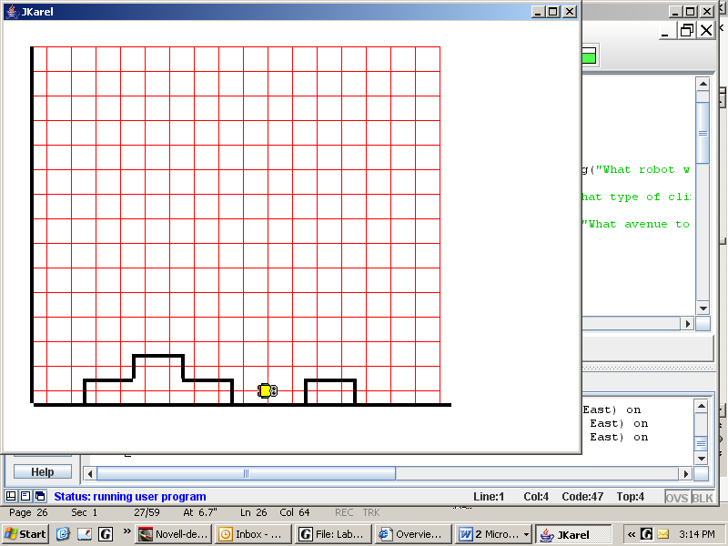
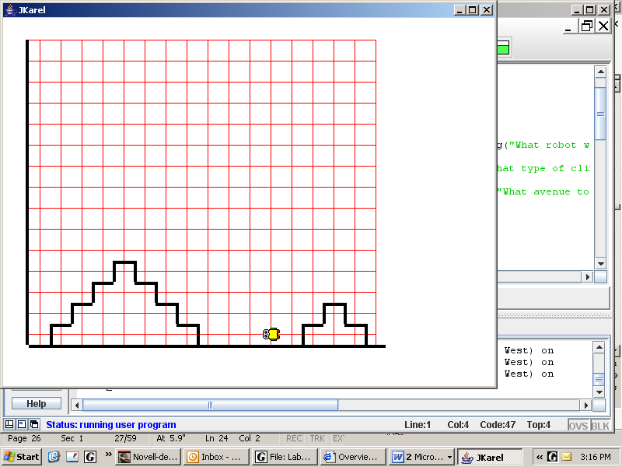
In this lab you are going to define two subclasses of Climber, one to climb hills and one to climb steps. Four instance methods (climbUpRight, etc.) in each subclass will override the four similar instance methods in Climber. We will be giving commands to the Climber reference, but objects of the Climber, HillClimber, and StepClimber classes will act
on those commands.
 |  | Climber
HillClimber |  |  |  | StepClimber
Let's study this simpler example:
Climber karel = new HillClimber();
karel.climbUpRight();
Which climbUpRight command will be followed, Climber’s or HillClimber’s? The answer is that Climber karel will execute climbUpRight as it is defined in the HillClimber class. karel “thinks” it is a Climber, but it behaves like a HillClimber. In the actual Lab07, we will call explore(Climber arg) and pass a HillClimber as an argument.
Specification
Load Mountain.java and study its method explore. Complete the Exercises on the next page.
Create Unit1\HillClimber.java and Unit1\StepClimber.java. Consult the Unit 1 API for more information regarding the HillClimber and StepClimber classes. Implement both the HillClimber and StepClimber classes. Recall that the actual arguments of the super in the HillClimber constructor must match the formal arguments accepted by the Climber constructor.
Load Unit1\Lab07.java. Compile and run. The application will prompt you, using the JOptionPane methods, to specify the map, the type of climber, and the x-coordinate starting position as follows:
mountain1, mountain2, mountain3 | Climber | 8
hill1, hill2, hill3 | HillClimber | 10
step1, step2, step3 | StepClimber | 12

Sample Run Unit1Lab07.jar
Exercises
Lab07
Looking at Unit1\Mountain.java, answer the following questions.
- Does Mountain contain class methods or instance methods? _________ How do you know?

- Explain the difference in syntax between explore(arg) and arg.move().

- How does explore know not to search the eastern mountain if the treasure was on the western one?

- Explain the purpose of the first arg.putBeeper() and last arg.pickBeeper() commands of explore.

- In explore_west, what is the variable n actually counting?

- How does the Climber know that it has reached the summit?

- If the treasure isn’t on the east summit, how do we know not to try to pick it up?

- Why can we use a for-loop going down the mountain when we needed a while-loop going up?

- How are we able to find base camp?

- Which specific method call(s) result in different behaviors, depending on the object?

- Does the steepness of the mountain change our code to go up and down? Why or why not?

- How can different types of objects make use of a single, common code?

Discussion
Polymorphism
The formal argument to the method Mountain.explore is a reference of type Climber. When an actual argument, either Climber, HillClimber, or StepClimber, is passed to Mountain.explore, a copy of the reference is made. This means that the formal argument, named arg, will point to the same object as the actual, anonymous, argument. In other words, we pass an object by reference:
public class Mountain
{
Climber object
anonymous
Climber arg
public static void explore(Climber arg)
{
//method definition here
}
}
public class Lab07
{
public static void main(String[] args)
{
Mountain.explore( new Climber(x) );
}
}
So far, strictly speaking, there has been no polymorphism involved. Now we get to:
public class Mountain
HillClimber object
anonymous
Climber arg
{
public static void explore(Climber arg)
{
//method definition here
}
}
public class Lab07
{
public static void main(String[] args)
{
Mountain.explore( new HillClimber(x) );
}
}
In this situation, the Climber reference arg will point to a subclass HillClimber object. Is a HillClimber a legal argument to the method explore? Yes, the compiler (in this case) allows a superclass reference to a subclass object. The compiler checks to see if the reference has access to the method. The computer at run-time actually runs the method’s code, whatever it may be. Therefore, when we give “the same” commands to arg, the subclass's methods are executed and we get polymorphic behavior from the code. climbUpRight is one of the polymorphic methods in this lab. Note we could pass a StepClimber to explore, but it would not pass the compiler to pass a Robot object, because Robot objects do not know how to climbUpRight.

Suppose the header were explore(Robot arg). In that case, the compiler does not allow the superclass reference to the subclass object. However, we can fix it if we cast the reference. See Discussion after Lab08.

Polymorphism works because the code calls a superclass’s method, but the subclass’s (overridden) method is the one that actually gets executed. It is the type of the object and not the type of the reference that determines the behavior. The algorithm in explore is the same, but the objects are slightly different--but not totally different, for the objects must stand in a superclass/subclass relationship. Polymorphism is also called dynamic method binding, or late binding.
Lab08
Hurdle Racing
Objective
Polymorphism. The if-else control structure.
Background
The hurdles shown below are all one-block tall hurdles. A beeper marks the finish line. An object of the Racer class can traverse that race course using this class method:
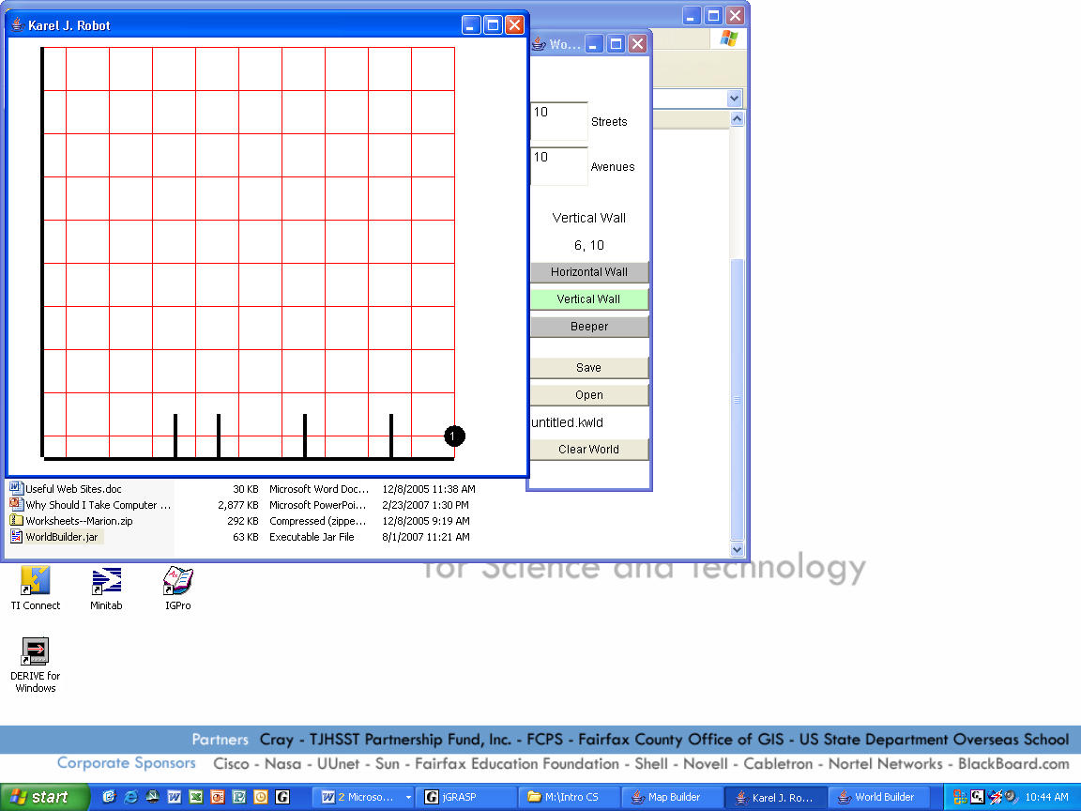

public static void race(Racer arg)
{
while(!arg.nextToABeeper())
if(arg.frontIsClear())
arg.move();
else
arg.jumpRight();
}

In English, the algorithm is: if there’s no hurdle, then move, otherwise jump over the hurdle. Keep going until you hit a beeper.
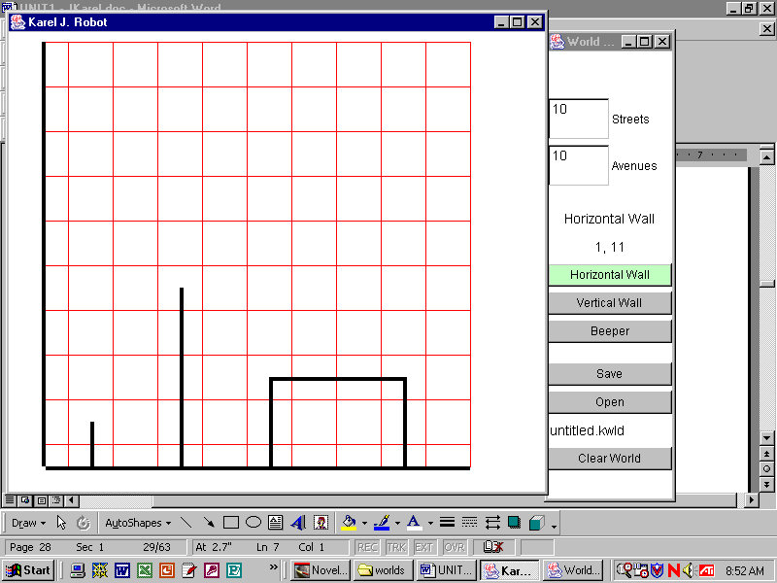
Now let's change the race-course so that instead of one-block tall hurdles we must jump over hurdles of any height. We do not change the algorithm above! The method arg.jumpRight is a perfectly good command—in the abstract—to jump hurdles of any height. All we need to do is to write our own jumpRight. In object-oriented programming we look around for a class that does approximately what we want (i.e. Racer) and the extend it. When we extend a class, we give the new class the powers that we really want—namely, how to jump hurdles of different heights.

What about jumping hurdles of differing widths? Again, our original algorithm still works! All we have to do is to write a new subclass that knows how to jump these new kinds of hurdles.
 |  | Racer
SteepleChaseRacer |  |  |  | BoxTopRacer

Each of the classes SteepleChaseRacer and BoxTopRacer will extend Racer and override jumpRight.

Specification
Consult the Unit 1 API for more information regarding the SteepleChaseRacer and BoxTopRacer classes.
Create Unit1\SteepleChaseRacer.java and Unit1\BoxTopRacer.java. Implement both the SteepleChaseRacer and BoxTopRacer classes as described above, then compile.

Load Unit1\Lab08.java. Compile and run. With maps “hurdle1”, “hurdle2”, and “hurdle3”, use an object of type Racer. With maps “steeple1”, “steeple2”, and “steeple3”, use a SteepleChaseRacer object. With maps “boxtop1”, “boxtop2”, and “boxtop3”, use a BoxTopRacer object.

Extension
Have the class method race accept a Robot argument, not a Racer argument. That is, change the header to be public static void race(Robot arg). Explain why the code won’t compile.

Sample Run Unit1Lab08.jar
Discussion
Casting
Polymorphic behavior is useful because the programmer can give one, general command to a superclass reference which is executed differently by each subclass. However, there sometimes is a glitch: if the superclass does not have access to a method, the code won't compile. Then it is the programmer's responsibility to cast the reference, thereby making the method available.
Robot turnLeft
Athlete turnRight
Racer jumpRight
For example, in the previous lab, the Robot superclass reference does not know how to jumpRight because jumpRight is a completely new method in Racer. Yet the programmer is sometimes forced to use the Robot reference to talk to the Racer objects. The way to do this is to cast the reference. Casting creates a new “larger” reference pointing to the entire object. Casting uncovers powers that you know are
already there, to which the compiler does not allow access. Casting changes the reference, never the object itself! Here is an example of a cast:
Racer arg2 = (Racer)arg;

Here is a real-world example (sort of): Clark Kent does not know how to fly. But if you call Clark Kent by his other name, then he does know how to fly. You have uncovered his hidden powers.
Study the code for the Knight (which moves like a knight in chess) subclass. Then we create a superclass reference to a subclass object:
public class Knight
extends Athlete
{
//a 4-arg constructor
public void turnLeft()
{
}
public void turnRight()
{
}
public void retreat()
{
}
}
Robot karel = new Knight(4,3,Display.NORTH,6);

Knight methods

Athlete methods
Robot methods
Robot reference karel

1. Is karel.turnLeft() a legal command at compile-time? _____ Why?

2. Which turnLeft is actually executed at run-time in Question #1, the Robot’s turnLeft or the Knight’s turnLeft? ____________ Why?

3. Is karel.turnRight() a legal command?_______ Why?

4. Cast the Robot karel reference to a Knight reference lancelot, then tell lancelot to retreat.

5. On the drawing above, draw a lancelot reference to the entire Knight object.
6. Is lancelot.retreat() now a legal command? ____ Why?

- Make the Extension to Lab08 work by casting the Robot reference. Explain what casting does.

Lab09
Shifting Piles
Objective
Algorithms. An algorithm is a sequence of steps, usually repeated, that eventually solves the problem.

Background
You’ll get very few hints on how to solve this problem. Your robot is standing on the first row at (1, 1) facing east with zero beepers. Each block between (1, 1) and (7, 1), inclusive, has a pile of beepers. One or more of these piles may contain zero beepers. It is possible that all of the piles contain zero beepers. It is guaranteed that each pile contains a finite number of beepers. Your task is to shift each pile one block to the right. The pile that started at (2, 1) should move to (3, 1), the pile that started at (3, 1) should move to (4, 1), etc.

(Each block on the second row, between (1, 2) and (7, 2), also contains piles of beepers, but they DO NOT NEED TO BE MOVED! They only serve as a reference, so that when your program runs, you can easily check whether it has run properly.)

Ask yourself the following questions:
1. What are the initial conditions of the problem?

2. What are the terminating conditions of the problem?

3. List the sub-tasks that the robot must perform.

4. How can you proceed from one step of the problem to the next step of the problem?

5. Will your answer to Question #4 get you from the initial to the terminating condition?

Good luck. If you are using jGrasp, ask your teacher how to use the debugger. The debugger helps to see where your program is going wrong.

Specification
Create Unit1\Lab09.java at size 10x10. Declare one Athlete at (1, 1) facing east with zero beepers. Shift each of the piles on the first row one block to the right. Test the program with maps “pile1”, “pile2”, and “pile3”.

Extension
Use MapBuilder.jar to create valid robot-maps to test your program.

Sample Run
Unit1Lab09.jar

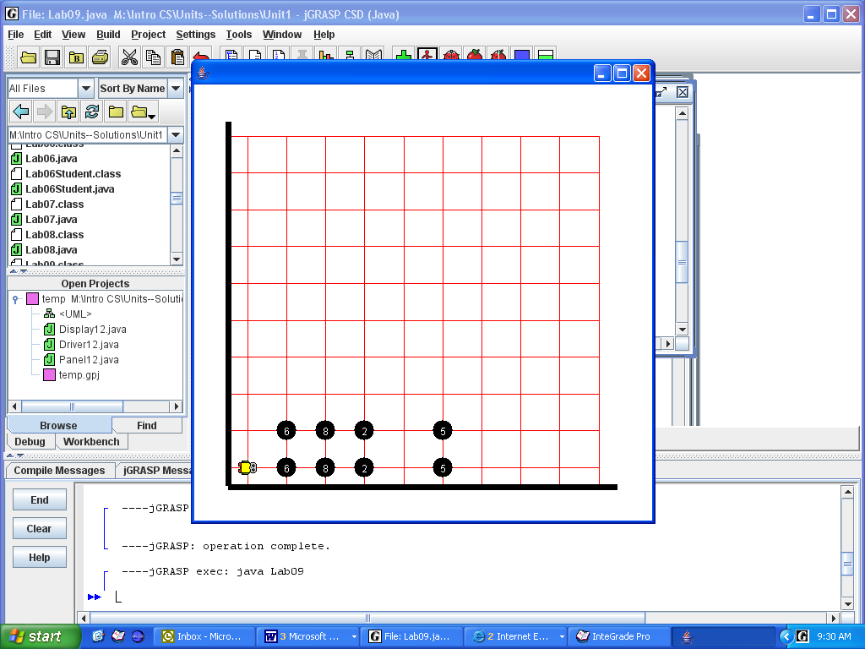  before | 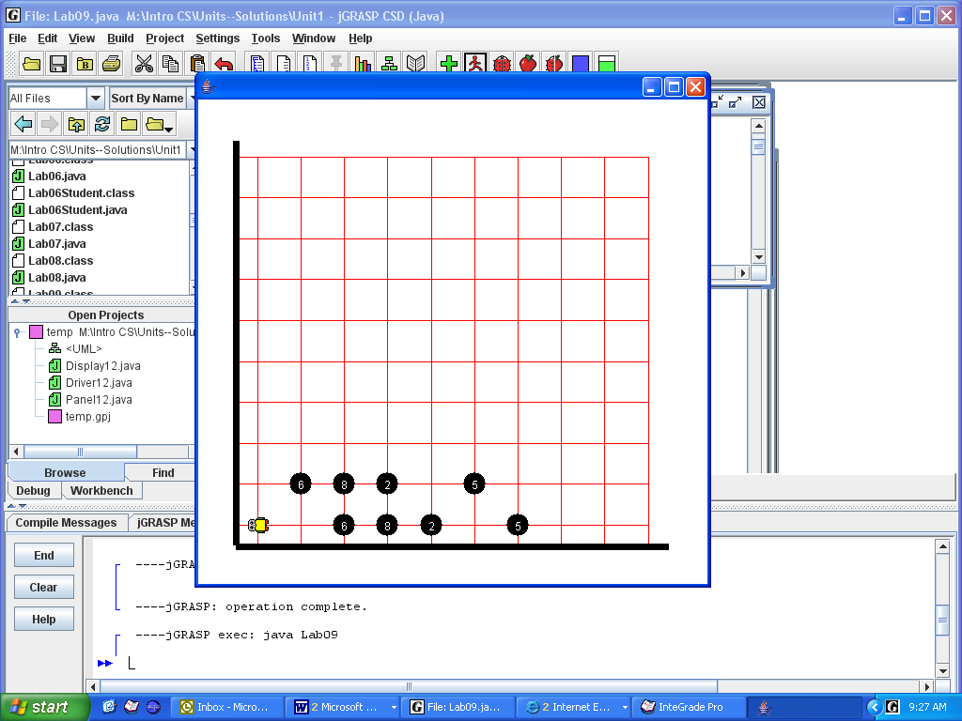  after

Exercises
Lab09
In this exercise you also have to pick up beepers, counting as you pick, then carry the beepers to another place and put them down. Change the vertical pictograph ("before") into the horizontal pictograph ("after"). There is only one beeper at each corner. There are no more than 4 columns of beepers. You do not know how tall each column is, but there are no gaps within a column.
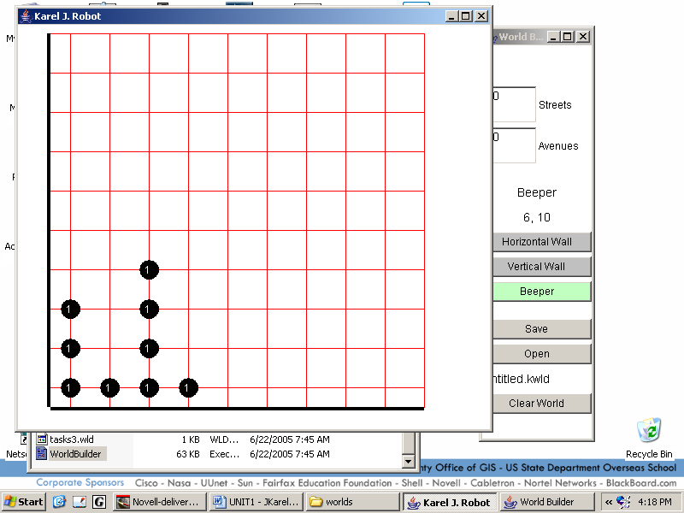
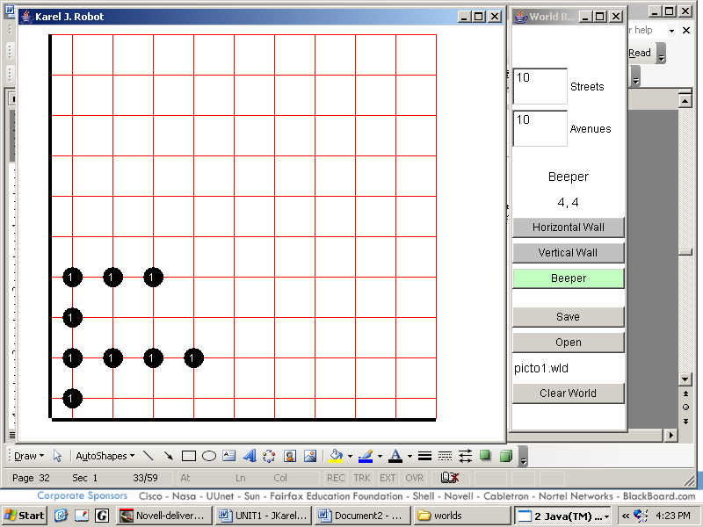

Before After

1. Plan the tasks, in English, not in code, which your Athlete must do.

2. Would it help to make a subclass of Athlete? Y/N. If so, what would you name it and what would it do?

- Here is a useful task: assume that the robot has already picked up the column and stored the number of beepers in that column in the variable rowCount2. Assume that the robot is in position, facing east. Now write the code to put down rowCount2 number of beepers in that row.

4. Your teacher may wish to turn this exercise into a lab. If so, you may use maps "picto1.map", "picto2.map", and "picto3.map".
Discussion
Decision Structures
The simplest decision structure, which you have already seen, is the if-statement.

if(karel.nextToABeeper())
karel.pickBeeper();

if(total == 0) // tests for equality, i.e. "is equal to"
{
karel.turnRight();
karel.move();
}

(Given this code fragment, we may assume that karel is an Athlete and total has previously been declared as an integer.) The if-statement is useful when we have one branch that may or may not happen. When we have two branches, only one of which will happen, we use the if-else statement.
if(karel.nextToABeeper())
karel.pickBeeper();
else
karel.putBeeper(); //only happens if !karel.nextToABeeper()

Here is an if-else example that requires curly braces:

if(total != 0) // tests for "is not equal to"
{
karel.turnLeft();
karel.move();
}
else
{
karel.turnRight(); //only happens if total == 0
karel.move();
}
In an if-else statement, exactly one of the choices will occur. It is impossible that neither will occur. It is impossible that both will occur. When three-way branching is needed, we use an else-if ladder:
if(total < 0)
karel.turnRight();
else if(total > 0)
karel.turnLeft();
else
karel.turnAround();
karel.move(); //move goes here because it will definitely move no matter what
Of course, this three-way branching can be generalized to n-way branching by using as many else-if statements as are required. Make sure you end the ladder with an else statement to ensure that exactly one of the methods will be executed—and in some cases just to keep the paranoid Java compiler happy.
Lab10
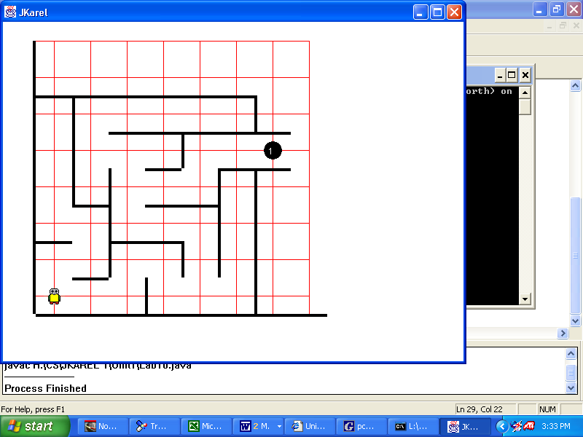
Maze Escaping
Objective
Algorithms.
Background
You’ll get very few hints on how to solve this problem. An Athlete is standing at (1, 1) facing north with an infinite number of beepers. Your robot is in a maze of unknown size. The maze has a continuous sequence of walls connecting the start of the maze to the end of the maze--that is, by keeping a wall on one hand, you will reach the end, which is a single beeper. A good problem-solving strategy is to imagine yourself in a corn maze. What do you do to exit the maze?
Ask yourself the following questions:
1. What are the initial conditions of the problem?

2. What are the terminating conditions of the problem?

3. What does an Athlete know about walls?
4. At each step, the Athlete needs to make one decision and either move, turn left, or turn right. What sorts of situations could the Athlete be in?

5. Will your answer to Question #4 get you from the initial to the terminating condition?
Good luck.
Specification
Create Unit1\Lab10.java at size 10x10. Declare one Athlete at (1, 1) facing north with an infinite number of beepers. Test your program on “maze1”, “maze2”, and “maze3”. Escape the maze.

Extension 1
Use MapBuilder.jar to create valid robot-maps to test your program.

Extension 2
Mark the path from start to end. The final path should not mark detours that were tried and then later abandoned. Hint: The last sentence was another hint.

Sample Run Unit1Lab10.jar
Exercises
Lab10
1. Given the declarations shown, circle the legal commands.
Robot karel = new Robot();
Athlete maria = new Athlete();
Climber lisa = new Climber(4);
Racer pete = new Racer(1);
Robot horatio = new Climber(8);

maria.facingEast(); | pete.pick();
karel.climbUpRight(); | pete.sprint(-10);
lisa.jumpRight(); | pete.put(5);
lisa.climbUpRight(); | pete.climbUpRight();
horatio.move(); | pete.move(10);
Lab04.takeTheField(pete); | Lab08.race(karel);
Climber ophelia = new Robot(); | Robot hamlet = new Racer(3);
Athlete kyla = (Athlete) karel; | Climber ray = (Climber) horatio;
Climber ann = (Climber) maria; | Racer jerry = (Racer) lisa;
2. What is wrong with the instantiation:
Climber ophelia = new Climber(1, 1, Display.SOUTH, 10);

3. Write a constructor for a Roofer class that extends Robot. Roofers can start anywhere, but all Roofers face SOUTH and carry 100 beepers.

4. Write the code for: if you are on top of a beeper, pick them all up, and report how many there are.

- Write the code for: move forward until there is a wall to your right and you are standing on a beeper
1 2 3 4
Discussion
Abstract Methods
An interface tells you what methods are available. An API is an interface, listing the methods that you can use. The implementation specifies how the methods work. Often, you don't know and don't care how the methods work. Other times, it will be your job to implement the interface.

An abstract method specifies an interface without its implementation. All you see is the header of the method plus the keyword abstract. For example, in Lab11 the abstract method is public abstract void display();. Notice the semicolon: there is no code in the body of an abstract method!

Since no implementation is given, an object of this class would not know how to respond when the method is called. Thus, it is not permitted to create objects of a class containing any abstract methods. A class with an abstract method is called an abstract class, labeled with the keyword abstract. The class could contain many methods with implementations, but so long as there is even one abstract method, the class must be abstract. The opposite of an abstract class is called a concrete class, but there is no keyword. All the classes we have used up till now have been concrete classes. All objects are instantiated from concrete classes.

Abstract classes are useful when designing a class hierarchy. Usually, when you are given an abstract class, you extend it. Usually, when you extend an abstract class, you make it concrete, i.e., you write the implementation code for every abstract method. The compiler checks to see that any concrete subclass actually does override the abstract method. If not, the compiler will generate an error.
Look at the code on the right. Digit is an abstract class because it has the abstract method display. Notice that display has no implementation code in its body, but only a semicolon.
Notice that the class Zero extends the abstract class Digit. Therefore, Zero inherits segment1_On, as well as the private Robot object. On the other hand, if we want to instantiate a Zero object, we must write code that implements the abstract method display.
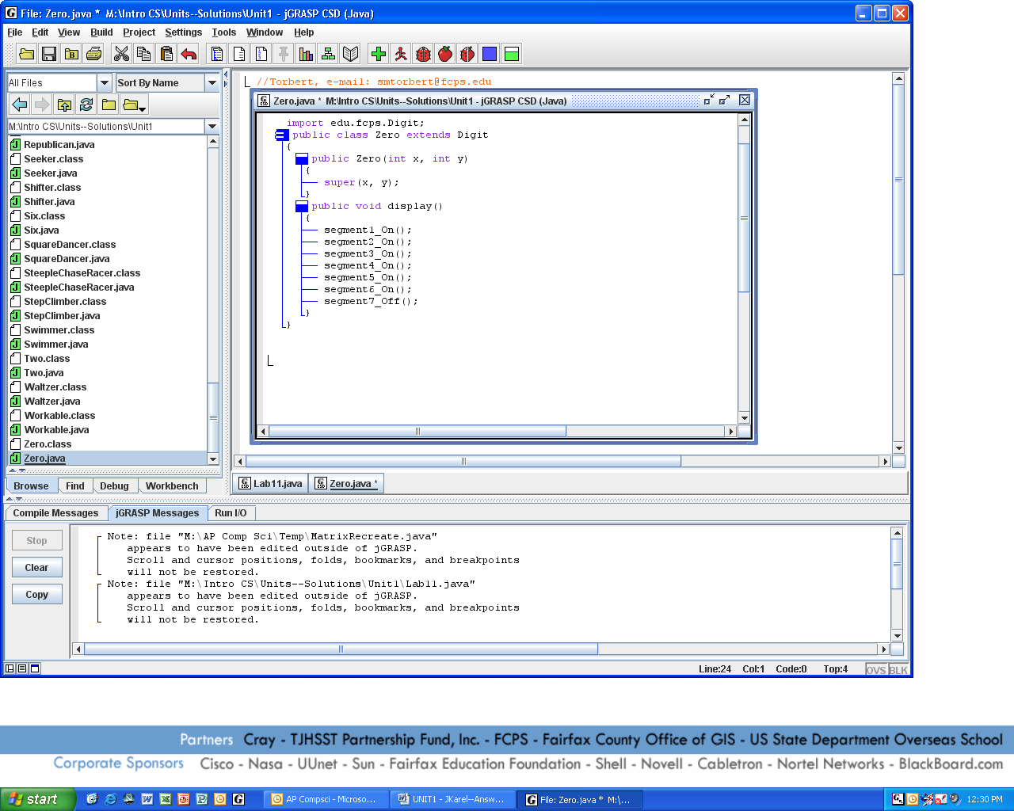
Digits are formed from beepers in seven segments, each of which is either turned on or turned off. These methods must be called in order from one to seven, as shown in Zero's code.
 |  |  |  |  | 1
 |  |  | N | 6 |  | 2
 | 7 |  |  |  | 7
 |  |  |  | 5 |  | 3
 |  |  |  |  | 4

If segments 1 to 6 are turned on, the rows of beepers will form the digit “0”. How do you display “1”?
Lab11
Your ID Number
Objective
Extending an abstract class.
Background
Digit is an abstract class. It provides code to turn on segments of beepers, but its display method is abstract. When you extend Digit, you will implement (provide the code for) display that is appropriate to each concrete class Zero, One, Two, etc.
Digit
The class hierarchy is familiar, although Digit is abstract.
Zero
One
Two
. . . etc.
Three

This hierarchy models the concept of a digit, which is a higher abstraction than your concept of, say, a five. Your concept of a five in turn is a higher abstraction than your concept of this five here—5. The various degrees of abstraction illustrated here relate precisely to the relationship between an abstract class, a concrete class, and an object.
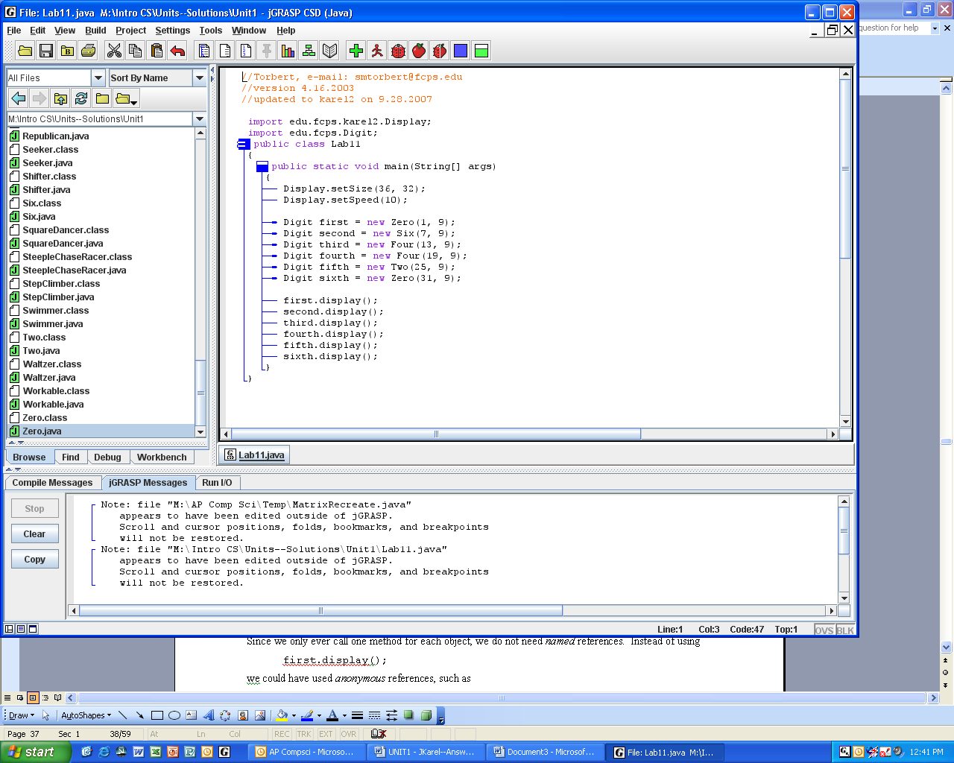
Mr. Torbert’s student ID number is 064420. He wants to display his ID number in a robot-map using Digit objects. Part of his driver program is shown at the right. The first digit in his ID is a zero, the second digit is a six, the third digit is a four, and so on. Notice that each digit is modeled by its own concrete class. Look how he instantiates each object. Notice that the arguments to the constructor somehow control the horizontal spacing of the digits. He later calls the superclass’s display method, which is abstract, but is overridden by each subclass’s concrete method. Here is another example of polymorphism at work.
Specification
Create Unit1\Lab11.java with a default-map at size 36x32 or 42x37. Import both edu.fcps.karel2.Display (why?) and edu.fcps.Digit (why?). Display your student ID number using appropriate Digit objects. For each different numeral, you will have to define a concrete subclass.
Extension 1
Since we only ever call one method for each object, we do not need named references. Instead of using
first.display();
we could have used anonymous references, such as
new Zero(1, 9).display();
Rewrite the code to use anonymous references.

Extension 2
You have quite a bit of evidence about the behavior of Digit. Reverse engineer the Digit class. Make sure your version works.

Sample Run Unit1Lab11.jar
Discussion
Interfaces
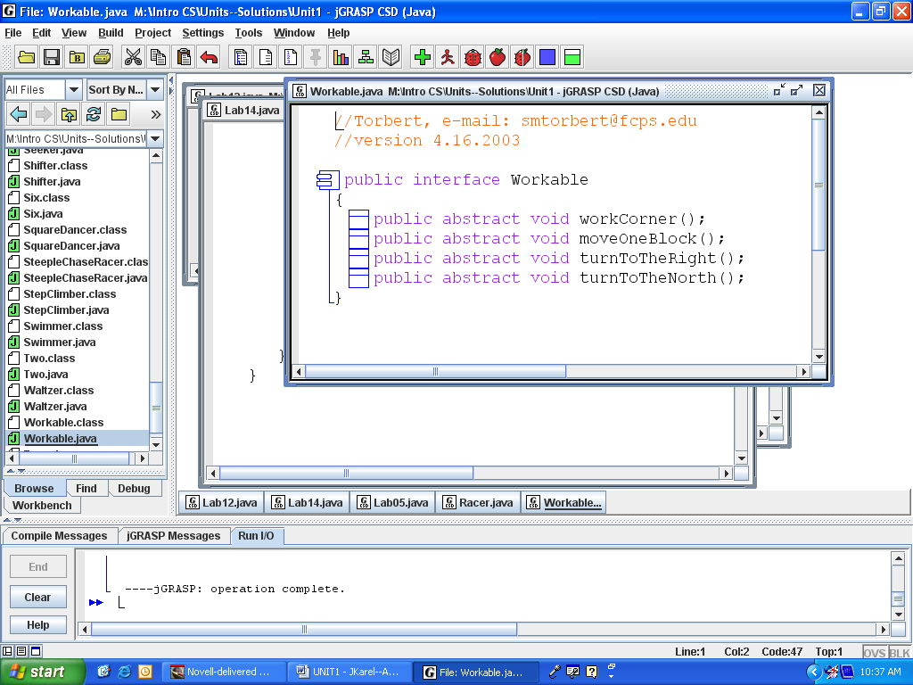
A (Java 7) interface is like an abstract class that has only abstract methods. No method in an interface actually does anything. All the methods are abstract. At the right is the Workable interface, which is in the Unit 1 folder as Workable.java.
Since there are no methods that do anything, it doesn’t make sense to extend an interface. There is nothing to extend. Thus we use a different keyword, “implements,” to indicate that our subclass is providing code for all the methods. That is, our subclass will implement the interface. For example,
public class Harvester extends Robot implements Workable
{
//private data
//constructors
//new instance methods in Harvester
//code for the four abstract methods from Workable
}
Again, the interface specifies what the methods are and our class defines how those methods work.
The power and beauty of this is that the driver application does not care about the object’s implementation. The driver calls the methods and the object does its task. Object-oriented programming is so easy!
In the next lab you will define two classes that implement the Workable interface. (Since Workable has four abstract methods, you must define all four methods.) You then instantiate an object from one of those classes and pass it to the class method work_8x8_square. The class method work_8x8_square will call work_one_row. But what does work_one_row actually do? Here is the code:
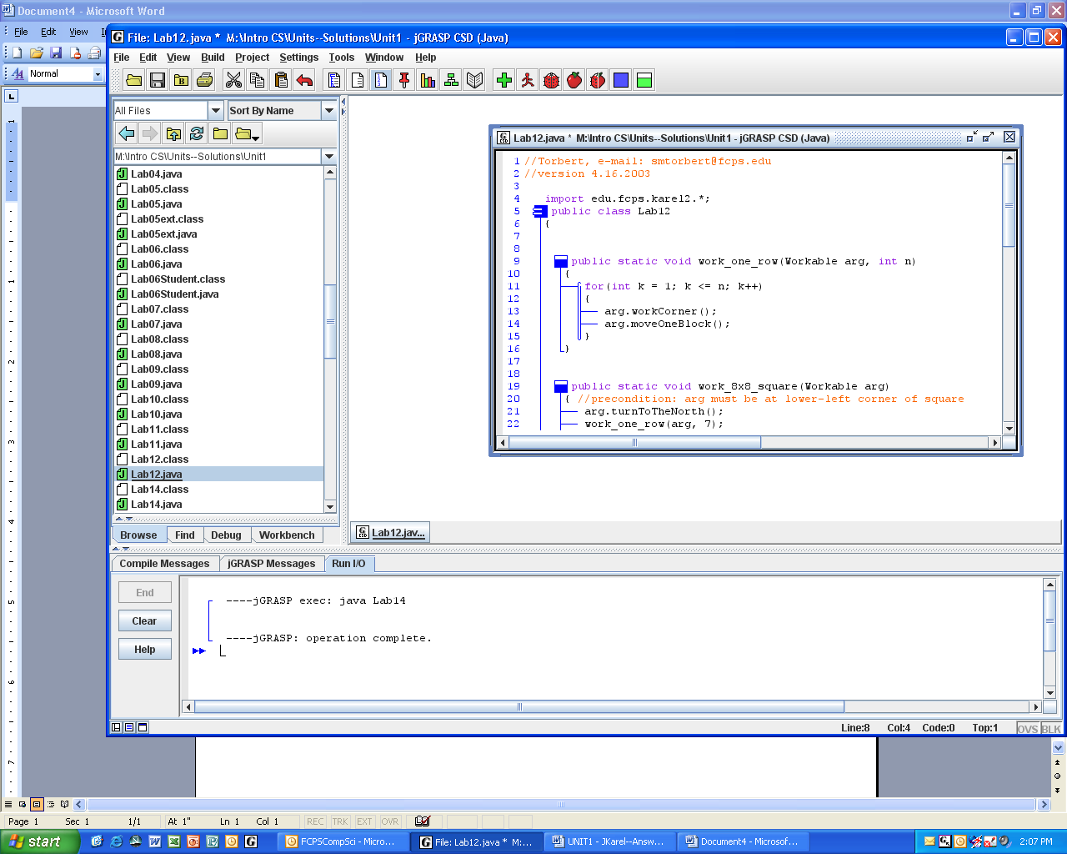

We can't tell what this code will actually do! One reason programmers use abstract classes and interfaces is to make the code more generic and re-usable, which has its good points and its bad points.

The actual behavior depends on how the methods workCorner and moveOneBlock have been defined in the subclasses. In other words, the Workable interface results in another example of polymorphic behavior.

Because Workable is generic code, we could instantiate and pass any object from any hierarchy, as long as that class also implemented Workable. The compiler guarantees that our implementing class actually has code for Workable's methods. Obtaining that guarantee is another reason that code designers think in terms of interfaces.

Lab12
Harvesting and Carpeting
Objective
Implementing an interface.
Background
You are going to write two classes named Harvester and Carpeter. Each of these classes will implement the Workable interface, but in slightly different ways. Polymorphism!
So how are harvesters different from carpeters? Harvesters pick beepers up when they find them whereas carpeters put beepers down where they find none. On any given corner with a beeper, a harvester will pick the beeper up but a carpeter will leave the beeper there. On any given corner without a beeper, a carpeter will put a beeper down but a harvester will not.
The driver class will use a class method work_one_row and pass a Workable object. Therefore, this lab is another example of a superclass reference to a subclass object.
Code in the main method, shown to the right, will create either a harvester or a carpeter with equal probability. The Math class method random generates and returns one decimal number between zero and one. It might be zero but it will not be one. Another way to say this is that Math.random returns a value from the interval [0, 1).
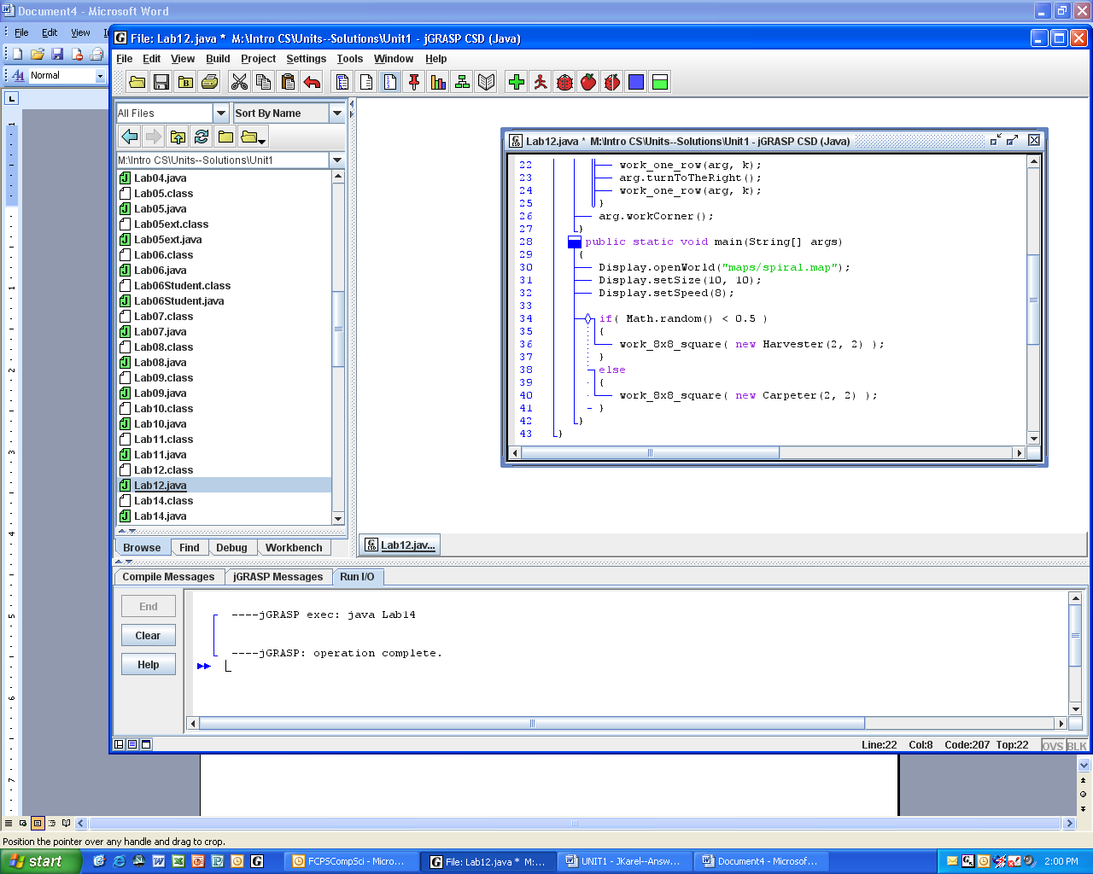
Warning. Some of the method definitions in Harvester and Carpeter may seem overly simplistic. Remember that the interface knows nothing and doesn’t want to know anything about how your class will work. For instance, it doesn’t know that the inherited classes are also Robots. So if the interface requires you to specify how to move forward one block, just use the robot’s move command. That’s it.
Lab12
main()

Fill in the UML class diagram at right. Which of Harvester methods come from Robot? Which methods come from Workable?
isa
isa
Specification
hasa
Load Unit1\Harvester.java and Unit1\Carpeter.java. Implement the required methods.

Load Unit1\Lab12.java. Study the two class methods carefully. This program walks a spiral square with either a harvester or a carpeter. Run the program over and over until you see it work successfully with both types of workers.

Sample Run Unit1Lab12.jar
Exercises
Lab12
1 public interface Swims
2 {
3 void swim();
4 }
5 public abstract class Fish implements Swims
6 {
7 public Fish()
8 { /* some code */ }
9 public void swim()
10 { /* some code */ }
11 public abstract void breed();
12 }
13 public class Catfish extends Fish
14 {
15 public Catfish()
16 { /* some code */ }
17 public void breed()
18 { /* some code */ }
19 }
20 public class Dolphin extends Mammal implements Swims
21 {
22 public void swim()
23 { /* some code */ }
24 }
- Draw the UML diagram for the classes above.
- Does Line 3 compile without error? __ Why or why not?
- Does Fish implement Swims correctly? __ Why or why not?
- Does Catfish extend Fish correctly? __ Why or why not?
- Does Dolphin implement Swims correctly? __ Why or why not?
- Fish and Catfish both have constructors (Lines ____ and ____). Does Dolphin need to have a constructor too? ___ Why or why not?
- Which of the following will compile without error?
  - Fish f = new Fish();
  - Catfish c = new Fish();
  - Fish f = new Catfish();
  - Swims s = new Catfish();
  - Catfish c = new Swims();
  - Mammal m = new Dolphin();
  - Swims s = new Dolphin();
  - Dolphin s = new Mammal();
g. Fish f = new Dolphin();
Lab13--Project
An Original fcpsKarel Lab

Use your imagination and your experience from this unit to create an original fcpsKarel problem. In formulating your own fcpsKarel problem, consider the following:
- How many robots are involved?
- What are the initial conditions?
- What is the goal?
- How many robot-maps do you need to make, and what do they look like?
- What can the programmer assume? For instance, will there always be a beeper at (5, 4) or do we have to be flexible?
- What control structures (while, for, if, if-else) are needed?
- What existing fcpsKarel class or classes may be appropriate to use in the solution?
- What extended classes may be helpful (or necessary) in solving the problem?
- What abstract classes or interfaces are helpful?
- What story can you devise to suit this lab?

You may use previous labs as guides to choosing an appropriate problem, but try to be creative as well. You should code your own solution that works before writing up the lab assignment for your peers.

Here is one possible grading rubric. Check with your teacher for sure.

Word document looks just like a fcpsKarel Lab: 0----1----2----3----4----5

lab assignment for peers is appropriate 0----1----2----3----4----5

lab is at an appropriate level of difficulty: 0----1----2----3----4----5

UML class diagram is correct: 0----1----2----3----4----5

some elements of the task require the
robot to make decisions, i.e., the program
works in different maps: 0----1----2----3----4----5

maps are appropriate: 0----1----2----3----4----5

uses a class method to solve the problem: 0----1----2----3----4----5

uses inheritance appropriately: 0----1----2----3----4----5

uses polymorphism appropriately: 0----1----2----3----4----5

uses an abstract class or implements an interface: 0----1----2----3----4----5

the solution works: 0----1----2----3----4----5

the lab is creative and original: 0----1----2----3----4----5

Discussion
Threads
In Lab14, four different robots will perform their own methods seemingly at the same time. We call this parallel processing. Java has a class Thread class that takes care of the details of parallel processing. You just have to implement the Runnable interface in your objects.
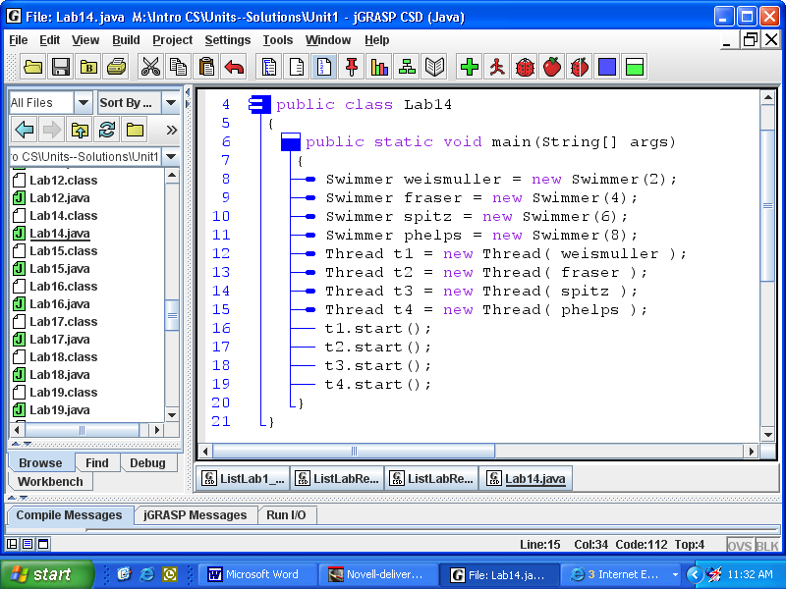
At first glance at Lab14 (shown here to the right) you may be wondering if this is really a robot lab at all. Where are the robots and the display? All we see are Thread and Swimmer objects. We have to look at the Swimmer class (or its API) to see that Swimmer extends Robot and implements Runnable. Implementing Runnable is important because a Thread constructor requires a Runnable object as an argument. In Lab14, the compiler checks to make sure that weismuller, fraser, etc., are all Runnables.

Here is another example that requires parallel processing. Suppose we are writing a Java program that shows a video with audio. Obviously, we want our video and audio to execute together, at the same time. If you understood the words in the paragraph above, then you can complete the little shell at the right.
public class Video ____________________
{ }
public class Audio ____________________
{ }
public class MyShow
{
public static void main(String[] args)
{

}
}

Here is a syntax point. We did not have to give our swimmers names. We could have started the threads with anonymous swimmer objects, as follows:

Thread t1 = new Thread( new Swimmer(2) );
t1.start();

In fact, we didn’t even have to name the threads: new Thread( new Swimmer(2) ).start();

Which do you think is the clearest and most readable? Ultimately, convention dictates how to write the most readable code.
Lab14
Synchronized Swimming
Objective
Implement an interface to achieve parallel programming.
Background
Workable was an interface that Mr. Torbert created. Unlike Workable, Runnable is a built-in interface in java.lang.Runnable. (Therefore, don't type it in!) The Runnable interface specifies a single abstract method run. Although it doesn’t look very useful, this interface is Java’s way to guarantee parallel behavior.
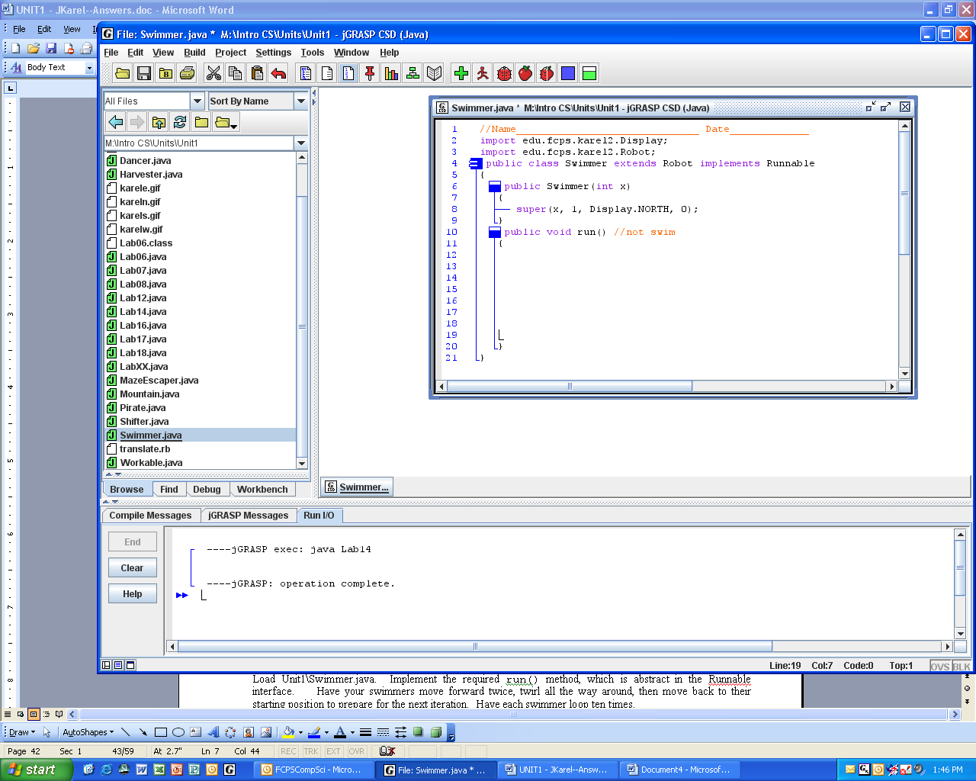
public interface Runnable
{
public abstract void run();
}

A Thread constructor requires a Runnable object as an argument. Every Thread object has a start method that runs run and takes care of all the parallel processes. In other words, all we have to do to produce parallel behavior is to implement the Runnable interface in our Swimmer object. That’s your job.
In Java, a class may implement as many interfaces as desired, but is allowed to extend only one class. This rule guarantees that there is only one definition for each method, not two or more, which would lead to conflicts.
Lab14
main

Fill in the class diagram for Lab14. Which methods in Swimmer come from Robot?
Which methods comes from Runnable?
isa
isa
Specification
Load Unit1\Swimmer.java. Implement the Runnable interface so that a swimmer moves forward eight steps, twirls around, then moves back to its starting position to prepare for the next iteration—like one lap in a pool. Make a swimmer do ten laps.
hasa

Load Unit1\Lab14.java. Notice there are four Threads and Swimmers. Compile and run.

Extension
Return to Lab05, the hurdle problem. Have the Racer class implement the Runnable interface. Modify Lab05 so that the racers run in parallel.
Sample Run Unit1Lab14.jar and Unit1Lab05ext.jar
Discussion
Concrete and Abstract Classes
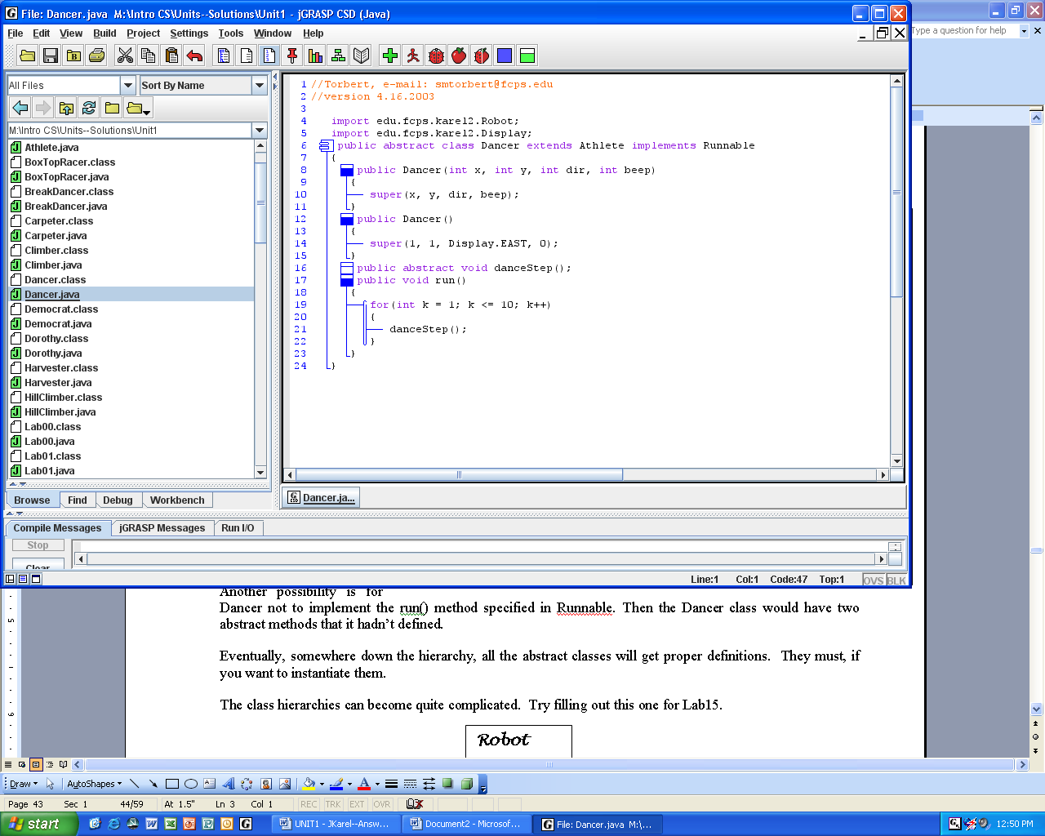
The Dancer class must be tagged abstract because it contains the abstract method danceStep on Line 16. Because Dancer is abstract, it is impossible to instantiate Dancer objects. However, we still give Dancer two constructors (lines 8-15) because it will be useful to super these from Dancer's subclasses. Somewhere in the hierarchy below Dancer, we know we are going to write a subclass class that will be instantiated.
The subclass immediately below Dancer normally contains the code that implements danceStep. It is possible, however, to write a subclass that postpones implementing danceStep. In that case, that subclass would also have to be abstract.
Because the run method (from Runnable) is implemented in Dancer, Mr. Torbert is choosing to make every subclass have the same run method. He could have made a different design decision, namely, not to implement the run method in Dancer, but to make run, as well as danceStep, abstract in Dancer. That would also work. Eventually, somewhere in the hierarchy, all the abstract methods will get properly implemented. In other words, all the abstract classes will eventually have concrete subclasses.
The class hierarchies can become quite complicated. Try filling out this one for Lab15.

Lab15
main()

Lab15
Dancing Robots
Objective
Extend an abstract class and implement an interface.
Background
The class shown here may be the world’s most boring dancer ever.
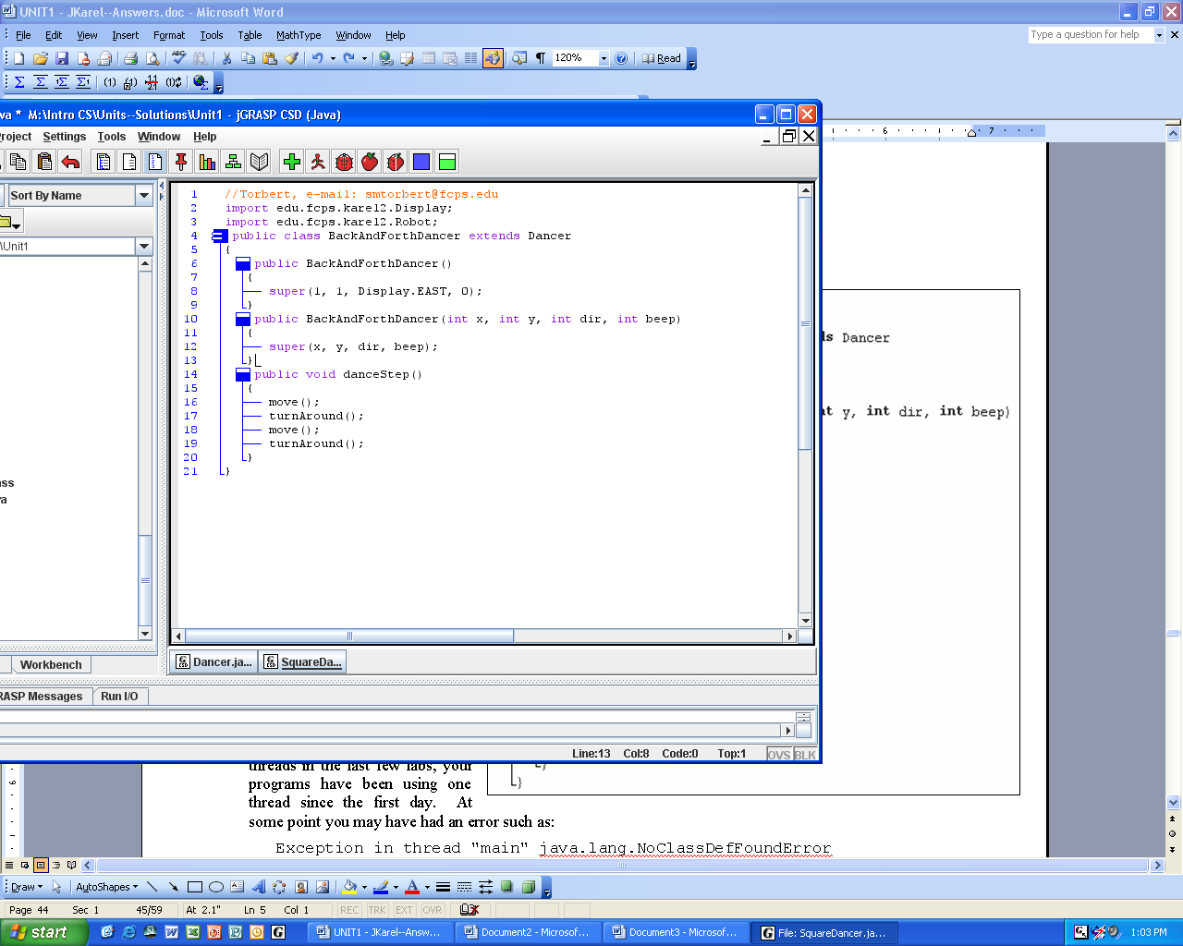
Notice that only the danceStep method, which was specified abstract in Dancer, must be defined. The run method that was defined in Dancer is simply inherited.
This means that when you create a BackAndForthDancer object and an associated thread, and when you start that thread, Java will first check here for the run method, then move up the hierarchy to Dancer’s run, then look back here for danceStep. Java at run-time always starts looking for a method’s definition at the object on which it was invoked.
You should be aware that, although you have used multiple threads in the last few labs, your programs have been using one thread since the first day. At some point you may have had an error such as:
Exception in thread "main" java.lang.NoClassDefFoundError
The main thread of any Java application exists by default. The main thread executes the commands in the public static void main(String[] args) method, which is in every Java application.
Specification
Create at least three different dancer-type classes. Create three new Java files modeled after the example shown above. But make your dancers more interesting than just back and forth. For instance, you might have a square dancer, a line dancer, a break-dancer, a waltzer.
Create Unit1\Lab15.java. Model your Lab15 main on the Lab14 main. Create objects from your three different dancer classes and have them “do their stuff” in parallel.

Sample Run
Unit1Lab15.jar

Lab16
Shifty Robots
Objective
Implementing multiple interfaces.
Background
Isn’t it amazing that your Lab14 and Lab15 programs executed in parallel, even though you don’t know how parallelization works? Some one else did all that work. It works for your code in Lab16 because the parallelization algorithms in the Thread class were written for any Runnable object. That is, when you implement the Runnable interface, then you automatically get parallelization. Oh, the power of object-oriented design.
Let’s return to the problem of shifting piles of beepers, as in Lab09. The algorithm most people used was to repeat 6 times: pick up a pile while counting the beepers, put down the previous pile, and move one block. Since we are working each corner, it might be nice to implement the Workable interface. Which methods are in the workable interface? Study Lab12, Harvester and Carpeter, especially workCorner and moveOneBlock. What does it mean in Lab16 to workCorner? What does it mean to moveOneBlock?
Since we want to shift four rows at a time, in parallel, we of course will need to implement the Runnable interface. Which method is in the Runnable interface? See Lab14, Synchronized Swimming. What do we want run to do in this lab?
One purpose of this lab is to let you implement two interfaces. The Shifter class has the header:
public class Shifter extends Robot implements Runnable, Workable
Another purpose of this lab is to show you a private variable. The Shifter class initializes a private variable (or private field) with the command:
private int myBeepers;
myBeepers stores integers. When the Shifter class is instantiated, each shifter object has its own copy of this variable—that’s why it is private. In this lab, we have four shifter objects and therefore four different myBeepers values. One shifter might be storing the number “3” while another is storing the number “1”.
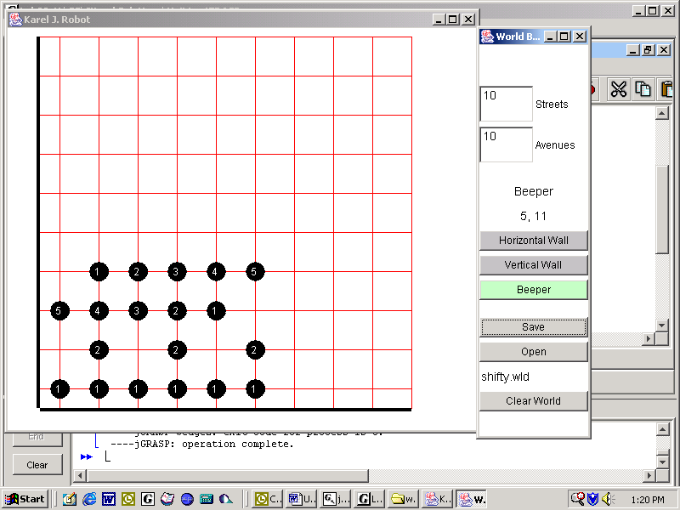
Specification
Load Unit1\Shifter.java. The problem is to shift four rows of piles of beepers, in parallel. Of course, implement all the methods from the two interfaces. Use the field myBeepers to help keep count. You may assume that the rows to be worked are always six blocks long (when you shift, of course, you will then go into the seventh block).
Load Unit1\Lab16.java. Compile and run. The application uses the “shifty” map.

Sample Run
Unit1Lab16.jar

Discussion
Abstract Classes and Interfaces
When do programmers create an abstract class and when do they create an interface? MazeEscaper, for example, contains only abstract methods.
5 public abstract class MazeEscaper extends Athlete
6 {
7 public abstract void walkDownCurrentSegment();
8 public abstract void turnToTheNextSegment();
9 }

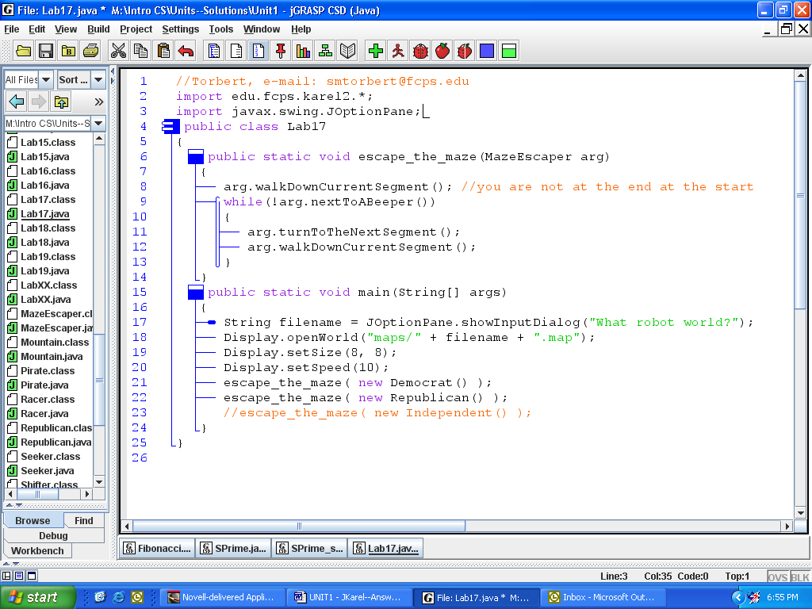
It seems like MazeEscaper might easily be an interface. Mr. Torbert chose to make it an abstract class because he wanted to guarantee that MazeEscapers were subclasses of Robots. Let's look at how the code uses MazeEscaper objects.

The class method escape_the_maze has an argument that accepts either a MazeEscaper object or a MazeEscaper-subclass object. If you try to pass something else, the code won't compile.

Now look at the code in escape_the_maze. Which arg command works only with Robot objects? _____________________ Because that command works only with Robot objects, MazeEscaper should be in the Robot hierarchy, not simply an interface. An interface would not guarantee inheritance from Robot. The rule of thumb is, if inheriting behavior is important, then make an abstract class, like MazeEscaper in Lab17 or like Digit in Lab11. On the other hand, if two behaviors are completely unrelated to each other, like Robot and Runnable, then make an interface. The UML diagram below shows MazeEscaper as an interface.
MazeEscaper
Democrat
Athlete
Robot
Republican
However, we could still get this code to work even if MazeEscaper were written as an interface. We would simply have to cast the MazeEscaper reference to an Athlete reference. If you can explain why, you understand what casting is.

Suppose you were designing Flier objects. Would it be better to make Flier an abstract class or an interface?

Suppose you were designing Mammal objects. Would it be better to make Mammal an abstract class or an interface?

Lab17
Republicans and Democrats
Objective
Extending an abstract class.
Turning the corner to the right.
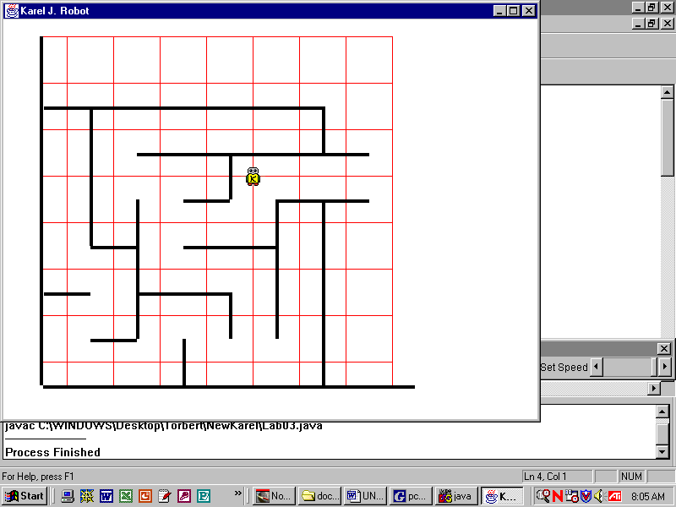 | 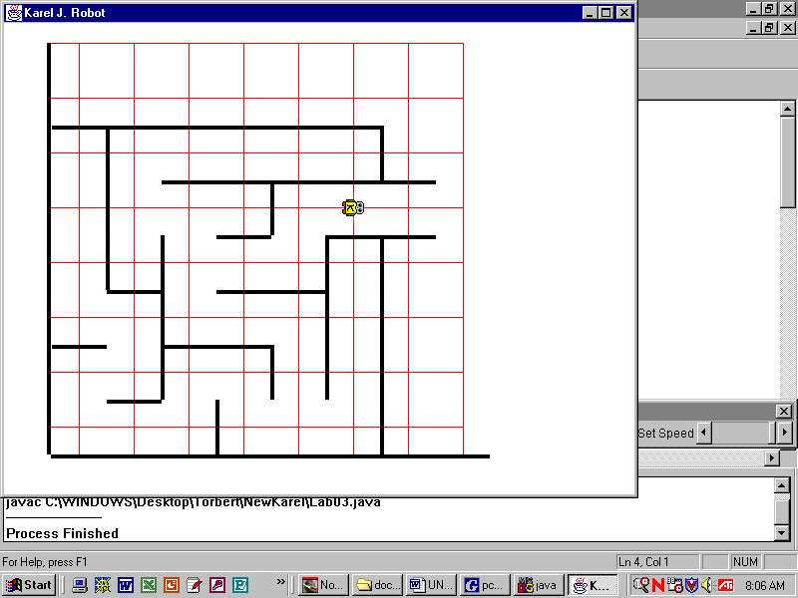
Turn left.
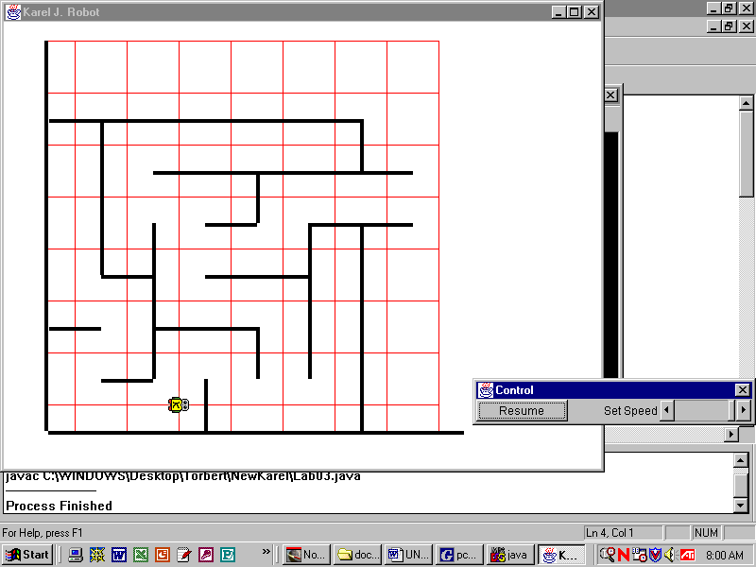 | 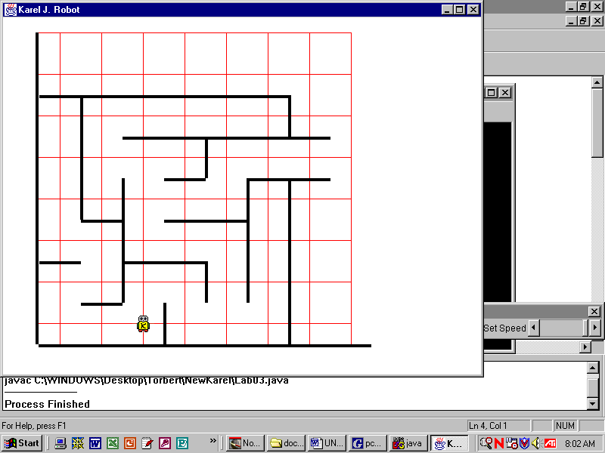
Background
A maze is a robot-map containing walls but no islands. A beeper marks the exit. A robot can escape from any maze by constantly keeping a wall to its right-hand-side. Here is the algorithm, known as “follow walls right”: it is okay to move forward one step if there is a wall to your right AND your front is clear. Then, if your right is clear, turn right and take a step; otherwise, simply turn left. The algorithm does not need a special case for getting stuck in dead ends because the robot will simply make two left turns and thus effectively turn itself around.
This time, we have abstracted the walking and the turning into two abstract methods in MazeEscaper.
5 public abstract class MazeEscaper extends Athlete
6 {
7 public abstract void walkDownCurrentSegment();
8 public abstract void turnToTheNextSegment();
9 }

Of course, you could just as easily “follow walls left” to escape the maze. The abstract class allows both Republican and Democrat objects to polymorphically use the same static class method escape_the_maze in the driver.
Lab17
main
Fill out the class hierarchy:
Specification
Create two concrete subclasses of MazeEscaper, a Republican who follows walls right and a Democrat who follows walls left, each implementing the abstract methods in MazeEscaper. You don't need to write constructors, for in this case Java automatically generates default super constructors.
Load Unit1\Lab17.java. In the main, comment out the escape_the_maze lines that you are not testing. Test the program using “maze1”, “maze2”, “maze3”, and “maze4”.

Extension 1
Start each robot in the upper left hand corner. You must write the appropriate constructor in MazeEscaper.

Extension 2
Let MazeEscaper implement Runnable, making all necessary changes. Which politician escapes first?

Sample Run Unit1Lab17.jar
Exercises
Lab17
- Why would a programmer choose to make an abstract class, such as MazeEscaper?

- Why would a programmer choose make an interface such as Runnable?

- Do MazeEscaper, Democrat, and Republican have constructors? Y/N Why or why not?

- Are constructors inherited in Java? Y/N

- Suppose we add this constructor to the abstract class MazeEscaper:
public MazeEscaper()
{
super(1, 6, Display.NORTH, 0);
}
  - Is it legal to put a constructor in an abstract class? Y/N
  - Does this count as a default constructor? Y/N
  - Does every class in the hierarchy still compile? Y/ N
  - What does super call?
  - What happens to 1, 6, Display.NORTH, 0?

- Define "polymorphism."

- Explain exactly how and where the MazeEscaper lab demonstrates polymorphic behavior. (Recall that a Thread's start command automatically calls a run method.)

Discussion
Return, Break and Continue
One way to approach the Lab17 problem is:
public void walkDownCurrentSegment()
{
while( SOMETHING && !SOMETHING_ELSE ) {
if( SOME_OTHER_THING) {
DO_SOMETHING;
return;
}
DO_SOMETHING_ELSE;
}
}
The return statement causes the method to end immediately. Control of execution is then “returned” to whatever method called walkDownCurrentSegment, namely, to the escape_the_maze method in the Lab17. The return statement is a useful tool for handling special cases in an algorithm. Two other sometimes-useful tools are the break and continue statements, which work in loops.
while(karel.frontIsClear())
{
if(karel.nextToARobot())
break;
if(karel.nextToABeeper())
{
karel.pickBeeper();
continue;
}
karel.move();
}
This while-loop will repeat so long as karel’s front is clear. If karel should ever be next to another robot, the break statement will cause the loop to end immediately. If karel should ever be next to a beeper, karel will pick up that beeper and the loop will continue back at the top; karel will not have moved forward. The continue statement ends the current iteration of the loop but then continues the loop again at the start.
By convention these statement make your code less readable then simply having methods that end appropriately, loops that stop appropriately, and decision statements that control program flow appropriately. The example shown above is probably better written as:
while(karel.frontIsClear() && !karel.nextToARobot())
{
if(karel.nextToABeeper())
karel.pickBeeper();
else
karel.move();
}
Use return, break, and continue sparingly and only for handling special cases.
Lab18
Treasure Hunt
Objective
Implement an algorithm.
Background
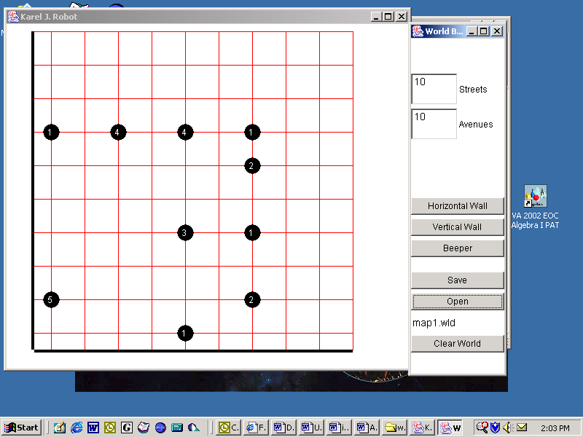
There are treasures hidden in various robot-maps. Piles of beepers will guide your robot to the treasures. The treasure your robot is searching for is marked by a pile of exactly five beepers. To read the maps, your robot must walk forward until it encounters a pile of beepers. If that pile is the treasure, then you’re done. If not, have your robot turn a certain way based on the number of beepers in the pile. Then continue searching for the treasure.
Algorithm for Reading a Map
1. Continue forward until you encounter a pile of beepers.
2. If you are at a pile with exactly five beepers, you’ve found the treasure.
3. Otherwise, if there is exactly one beeper, then turn left.
4. Otherwise, if there are exactly two beepers, then turn around.
5. Otherwise, if there are exactly three beepers, then turn right.
5. Otherwise, maintain your current heading.
6. Repeat as needed.
You must pick up the pile in order to count the beepers. Don’t put the beepers down again.

Consult the Unit 1 API for more information regarding the Pirate class.
Specification
Load Unit1\Pirate.java. Pirate extends Athlete and has only a no-arg constructor starting each pirate at (1, 1) facing east with no beepers. There are three methods in Pirate that you must implement so that Lab18 will work. The method approachPile() should give you no trouble. The method
public int numOfBeepersInPile()
has to count and return the number of beepers in that pile. Ask your teacher how to return a value from a method. The method turnAppropriately(int beepers) can be implemented with an if-else ladder, a for-loop, or a switch statement. If you want to use the switch statement, ask your teacher about its syntax.
Load Unit1\Lab18.java at size 8x8. Use maps “map1”, “map2”, and “map3”. Compile and run.
Test Data
Look in the DOS window when your program ends to make sure you followed the map correctly. There are 24 total beepers in map one, 32 total beepers in map two, and 33 total beepers in map three.

Extension
Rewrite each method recursively. See the appendix for more details on recursion.

Sample Run Unit1Lab18.jar
Lab19
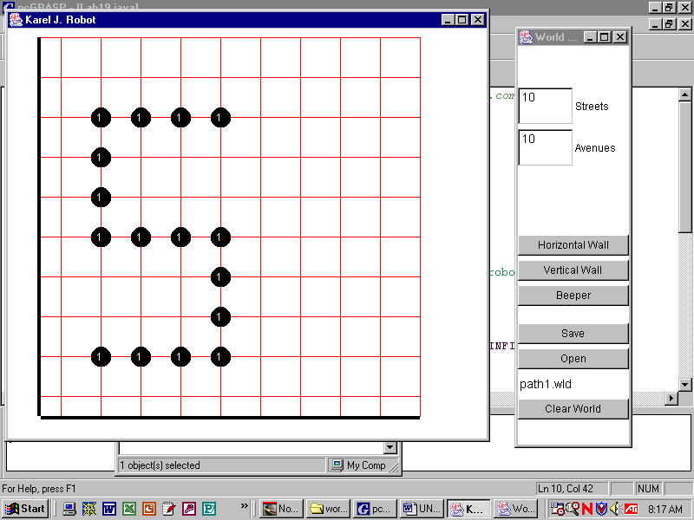
Yellow Brick Road
Objective
Implement an algorithm in a resource class.

Background
Follow, follow, follow, follow, follow the yellow brick road. Your job is to get your robot from (2, 2) to the end of the path of beepers, wherever that may be. Be careful! Your robot must stop when it gets to the end of the path.

Here is a good algorithm: while the robot is on the path, follow it. Nice!

Or: if the robot has found the path, then take a step. Repeat.

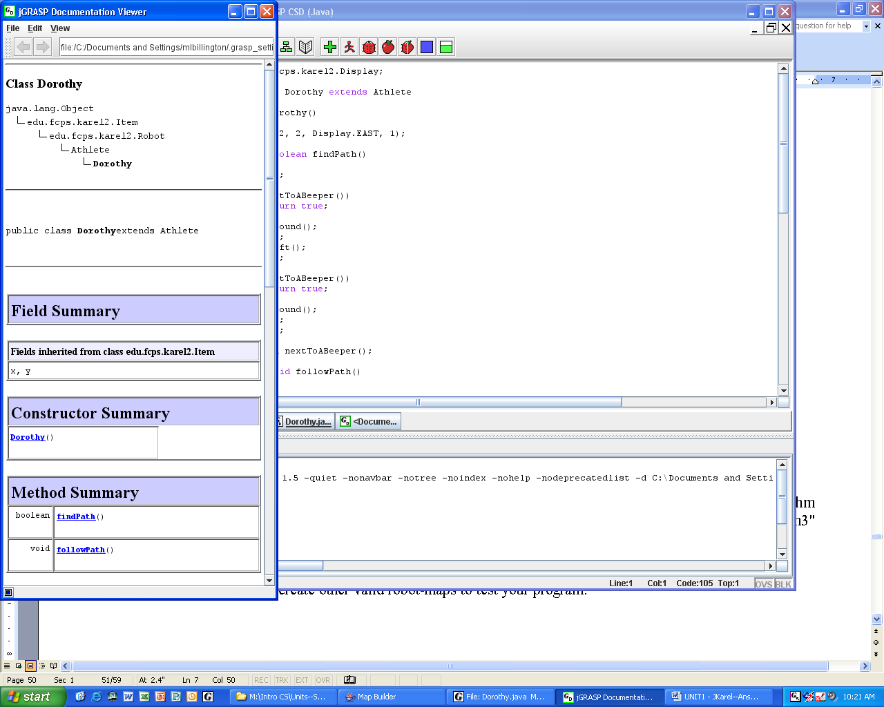
Specification
Create Unit1\Dorothy.java. The Dorothy API is shown at the right. What should go in the default constructor? What methods are in Dorothy? Notice that the findPath method returns a boolean. Use it.
Create Unit1\Lab19.java. Instantiate a Dorothy object and send her on her way. Use “path1”, “path2”, and “path3”. The map "path3" has an extra complication for you to deal with!
Extension
Use MapBuilder.jar to create other valid robot-maps to test your program.

Sample Run
Unit1Lab19.jar

Discussion
Recursion
In Racer we defined an iterative method sprint as follows:
void sprint(int n)
{
for(int k = 1; k <= n; k++)
{
move();
}
}
The following solutions are recursive because the method sprint calls the method sprint—it calls a copy of itself. The two solutions below act exactly the same, but the code on the right is often easier to read. Since the return statement forces the method to end early, the else is not required.

void sprint(int n)  {  if(n <= 0) //the base case  return;  else  {  move();  sprint(n – 1); //recursive call  }  } | void sprint(int n)  {  if(n <= 0) //the base case  return;  move();  sprint(n – 1); //recursive call  }

Let's trace the call sprint(2). It is useful to imagine the recursive calls as stacking on top of one another, as shown. Eventually, the code reaches the base case and all the calls come back out, in reverse order.
sprint(0)

sprint(1)

sprint(2)
Since n = 2, which is not equal to zero, the robot will move and then call sprint(1). In sprint(1) the value of n is 1, which is also not equal to zero, so the robot will move and call sprint(0). In sprint(0) the value of n is 0, which is equal to zero, so the robot would do nothing and the call to sprint(0) would return , thus ending the method. Then the call to sprint(1) would end, then the call to sprint(2) would end. In all, our robot moved twice.

Be careful with recursion, as infinite recursive calls are common (resulting in a "stack overflow" error). The following code has such an error:

void sprint(int n)
{
sprint(n-1); //ERROR: makes the recursive call before
if (n <= 0) // checking the base case!
return; // Keeps calling sprint "forever"
}

To avoid infinite recursive calls, it is smart to think of recursion as a two-step process: 1) check the base case first to see when the recursive calling should stop, then 2) if the base case is not met, call the recursive method again with a "one-step smaller" argument so that the base case will eventually be reached.

Assignments:
Return to Racer from Lab05. Re-write the sprint, put, and pick methods as recursive methods.
Return to Lab18's Pirate class. All three instance methods in Pirate can be written recursively.
Discussion
Stored Recursive Calls

Imagine a beeper is on the same y-coordinate as your robot, some unknown distance due east of your robot’s current location. You need to retrieve the beeper, turn left, and move north the same distance and drop the beeper. The following iterative solution counts how many blocks we travel east during the while-loop, then uses that number to control the for-loop, which travels north:
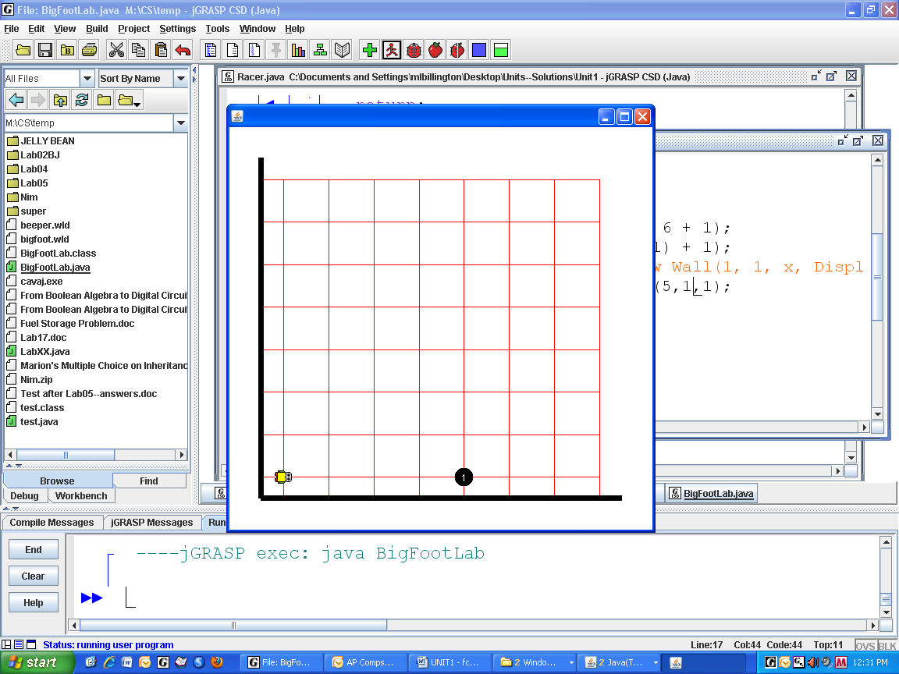
int n = 0;
while (!karel.nextToABeeper())
{
karel.move();
n = n + 1;
}
karel.pickBeeper();
karel.turnLeft();
for(int k = 1; k <= n; k++)
karel.move();
karel.putBeeper();

A more elegant solution uses a recursive method:

void recur()
{
if(nextToABeeper()) //base case
{
pickBeeper();
turnLeft();
}
else
{
move();
recur(); //recursive call
move(); //this command is stored; eventually it is executed
}
}
As long as nextToABeeper is false, we move and call recur. Each call to recur will test nextToABeeper, only one block further east. At some point nextToABeeper will be true. The robot picks the beeper up and turns left—now facing north. This call to recur, the one that found the beeper, will end. When it ends, the previous call to recur, the one that made the call to the one that found the beeper, will continue where it left off, i.e, there is a second move that has to execute.

This move will now be made north. When each call to recur ends, the one before it continues, moves one block farther north, and ends itself. Every move before the recursive call goes east and every move afterwards goes north. Since there is the same number of moves before and after the recursive call, the robot travels the same distance north as it had traveled east.

If this doesn’t make sense, imagine that the beeper was originally located only one block in front of karel and trace through the execution of the method. What if the beeper was originally located at the exact same intersection as karel?

Use the technique of stored recursive commands for the next lab.
LabXX
Seeking the Beeper
Objective
To implement stored recursion.

Background
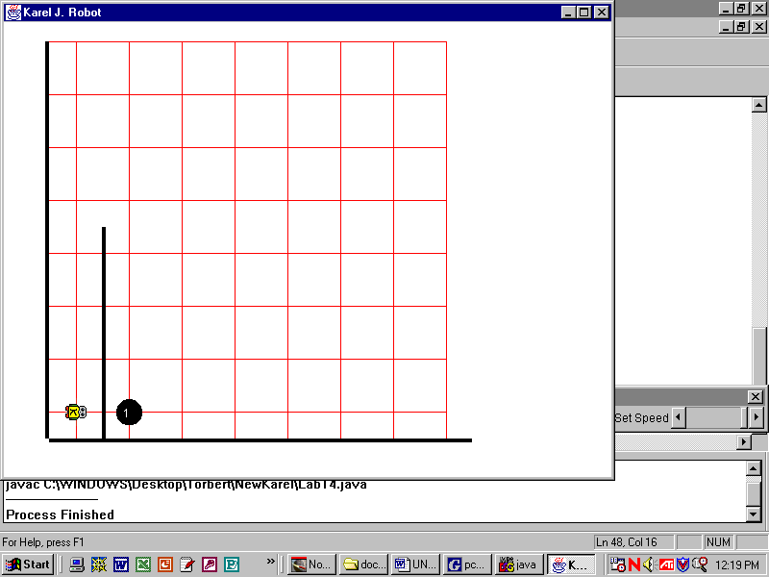
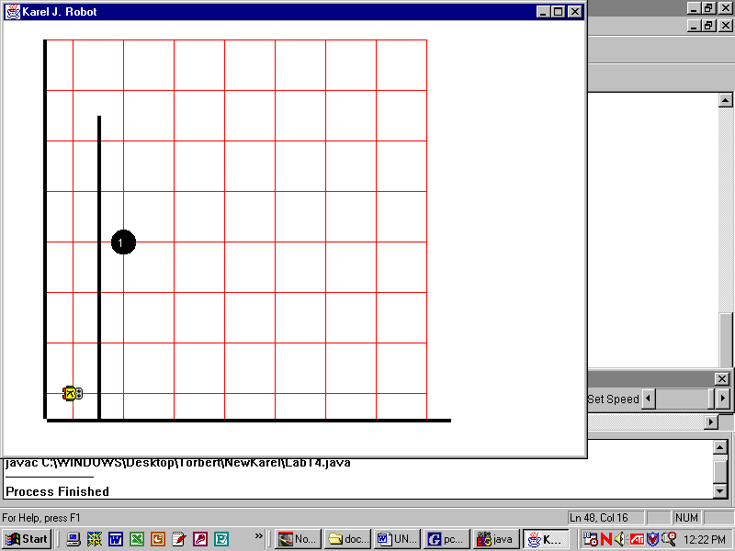
Your robot begins at (1, 1) facing east. There is a north-south wall of unknown length blocking your robot’s path. Directly on the other side of that wall, on the 2nd x-coordinate, there is a beeper. The beeper is against the wall but you do not know what y-coordinate that beeper is located on. You must retrieve the beeper, bring it back to (1, 1), and put it down.

Consult the Unit 1 API for information regarding the Seeker class.
Specification
Filename Unit1\Seeker.java. Implement the Seeker class. Compile.
Load Unit1\LabXX.java. Compile and run. You must test the LabXX program (really you are testing your fetchBeeper method) for many randomly generated maps. Run the program a few times to make sure your method always works.

Sample Run
Unit1LabXX.jar

Exercises
Recursive Solutions
1) Imagine your robot is on 1st y-coordinate. You do not know what x-coordinate the robot is on and you do not know what cardinal-direction the robot is facing. There is a beeper at (1, 1). Use loops to get the beeper and bring it back to your starting location. Put the beeper down at the end.

2) Complete the definition of a recursive method getBeeper. This method is designed to be part of a solution to Question #1. The robot should search its path to the front until it finds a beeper, then go back to its starting place.
public void getBeeper()
{
if( )
{

}
else
{

}
}

3) Write the solution to Question #1 using your recursive method from Question #2. Assume that getBeeper does what you intended, regardless of the correctness of your answer to Question #2.

Exercises
Recursive Solutions (continued)
4) Imagine the problem from Question #1 is modified so that you do not even know what y-coordinate your robot is on—it could be at any intersection! Your solution makes use of a recursive function findBeeper as follows:
karel.faceWest();
karel.findBeeper();
karel.putBeeper();
Complete the definition of the recursive method findBeeper. You may use getBeeper.
public void findBeeper()
{
if( )
{

}
else
{

}
}

5) Your maze escaping solution can be simplified to the following:
karel.followWallsRight();
karel.pickBeeper();
Complete the definition of the recursive method followWallsRight.
public void followWallsRight()
{

}
Discussion
Arrays
Multiple objects can be stored with a single identifier in an “array.” An array is a linear data structure of fixed length. For instance:
Robot[] array = new Robot[7];
 |  |  | [0] | [1] | [2] | [3] | [4] | [5] | [6]
array
This declaration creates an array of seven Robot references. Each of these references is initialized to null. To create actual robot objects use:
for(int index = 0; index <7; index++)
{
array[index] = new Robot(index + 1, 1, Display.EAST, 0);
}
Arrays are zero-indexed, which means the boxes inside an array are numbered starting from zero. Don’t start counting at one with a variable that is meant to indicate a certain cell in an array. Notice that index is part of an expression that is passed as an argument to the Robot constructor. The loop control variable can be used for more than just repetition and the access of array cells.
The basic idea is that the objects stored in an array can be manipulated with a for-loop:
for(int index = 0; index < 7; index++)
{
array[index].putBeeper();
}
Imagine you want all seven of these robots to move forward five blocks.
for(int index = 0; index < 7; index++)
{
for(int count = 1; count <= 5; count++)
{
array[index].move();
}
}
This is a very common technique—using a for-loop to access the cells of an array. Note the importance of the int-type variable index; as it changes value, the robot we are dealing with also changes, because each robot is identified by a cell-number in the array. Traversing an array with a for-loop works no matter how many objects are being stored: a hundred, a thousand, etc. Also note that the name of an array can be any valid identifier (not just array).

As shown, these robots will not all move at the same time. Rather, they will take turns as the outside for-loop repeats. In order to have parallel processes execute at the same time you must use threads.
LabYY
Seeking the Beeper, Part II
Objective
Solve a problem.

Background
Set the robot map to some large, random size, call it NxN. For instance:
final int N = (int)(Math.random()*50+25);
Display.setSize(N, N);
The keyword final indicates that the value of N will not change. As a convention, final variables are written in ALLCAPS, like Display.EAST.
Place a beeper randomly in the world.
WorldBackend.getCurrent().putBeepers(
(int)(Math.random()*N+1), (int)(Math.random()*N+1), 1);
Your job is to get the beeper.
There are a number of different ways to approach this problem. You could have a robot start at (1, 1) and search the entire map itself. You could have a bunch of robots, maybe even an array, start along 1st and march east. You could use recursion or just loops.
Specification
Create Unit1\LabYY.java. Use the commands shown above to place a beeper randomly in a large, but randomly sized, robot map. Somehow, get the beeper.

Test Data
However you decide to approach this problem, if the beeper gets picked up, then your program works.

Glossary
Abstract: A Java keyword indicating that a method does not have a definition and must be implemented either by an extending class (for an abstract class) or by an implementing class (for an interface).
Actual Argument: A data item specified in a method call. An argument can be a literal value, a variable, or an expression.
Anonymous: An object or class that is used but not named. For instance, new Robot().move();.
Body: The commands that actually get executed when a method is called.
Class: In Java, a type that defines the implementation of a particular kind of object. A class definition defines both class and instance methods, as well as specifying the interfaces the class implements and the immediate superclass of the class. If the superclass is not explicitly specified, the superclass will implicity be java.lang.Object.
Class methods: Methods that are invoked without reference to a particular object. Class methods are tagged with the keyword static and do not have an implicit argument this.
Formal Argument (parameter): The variable representation of an argument in the definition of a method.
Header: The first line of a method definition.
Inherited Method: A method defined in a superclass that is available to a subclass (keyword extends).
Instance methods: Methods that are invoked with reference to a particular object (an instance). Instance methods affect a particular instance of the class, which is passed as the implicit argument this.
Isa: A phrase to express the relationships of classes in a hierarchy.
Object: The building block of an object-oriented program. Each object consists of data and functionality.
Package: A group of classes in the same folder. Packages are declared with the keyword package.
Polymorphism: If a method defined in a superclass is overridden in a subclass, then the subclass method is invoked at runtime. Used with abstract classes and interfaces we can write code generically to be used later without modification for various other classes.

Reference to an Object: A symbolic pointer to an object.
Root: In a hierarchy, the one class from which all other classes are descended. The root has nothing above it in the hierarchy.
Signature: A method’s name and argument list, but not the method’s return type.
Subclass: A class that is derived from a particular class.
Superclass: A class from which a particular class is derived.

