Hallway Traffic Simulator
Peter Riggs
TJ Computer Systems Lab 2006-2007
Abstract
A system of hallways is theoretically designed to allow large groups of people to move fairly quickly to a nearby destination—but thanks to the modern miracle of traffic jams, this goal is often made impossible. Since most buildings with large hallway systems will generally house a population of like-minded individuals, the goal of the designer then becomes to predict how these individuals will behave, then design the halls to accommodate this behavior with minimal traffic stoppage. The purpose of this project is to provide a computer simulation to help to model this situation and more easily test the efficacy of various designs against the expected behavior of the hallway's occupants.

1 Introduction
Eventually, all hallway designs must be tested via trial and error to determine their effectiveness. A simulation can provide this sort of testing on a scale that could never be feasible in a real-world setting, because of the capability to simulate any number of layouts without having to physically remodel the building in question. Obviously, prior knowledge of a design's effectiveness would be highly beneficial to constructors, allowing them to know whether a design is going to work before they commit resources to building it. In order for the simulation's results to mimic the effectiveness of its real world counterpart, however, the calculations involved must take into account as many of the known factors that influence traffic movement as possible.

2 Background
This project being a traffic simulation, there are certain similarities between the Hallway Traffic Simulator and the various programs being used to model vehicle traffic. Simulations are often used to predict the requirements of an intersection based on a given volume of traffic from each direction, and the results gleaned from such experiments are vital in determining the number of lanes and structure of the intersection to provide optimal traffic flow. This situation is similar to the project because it ultimately aims to determine an ideal hallway width for certain sections of the layout, and models the traffic to obtain these results. In addition, some simulators are instead given average traffic volumes between certain cities and then made to evaluate the usefulness of the interstate highways, sometimes displaying the need to construct additional highways to connect certain population centers. This is also applicable to my project, because it must be able to show how functional a certain hallway layout is for the given population, and it sometimes becomes apparent that more hallways must be added in some areas.
Also of relevance to the Hallway Traffic Simulator project is the development of various pathfinding algorithms. This area has been traversed frequently by programmers for a long time, because the need for accurate and/or efficient pathfinding appears very frequently in a number of different computational situations—not least of which is modeling and simulation. The Hallway Traffic Simulator needed to have an effective pathfinding algorithm in order to achieve realistic movement, but efficiency is also paramount when running the same algorithm over a population of 1000 or more students. Valve Studios solved this problem using a node graph, which allows individuals to find their way to a destination using only the most primitive of algorithms.

3 Development Sections

3.1 Requirements
Because this program is intended to simulate reality, it has to create realistic student movement patterns in order to be deemed successful. Students should take the most practical route to their destination, they should avoid walls and other individuals whenever possible, and the overall student body should naturally form traffic jams in poorly designed hallway areas. Given the computer’s limited processing power, however, it is also necessary that these tasks be performed at minimal cost to the computer’s resources so that the program can run smoothly. During the design process, in order to meet these requirements an evolutionary prototyping model was established for the duration of the project development.

3.2 Research Theory & Design Criteria
The main body of the project is a Fortran program that handles all calculations for student movement. The program begins by reading in user-defined data on the layout of the environment in which the simulation will be run, the initial population of the students, the starting locations of the students and their destinations, and the node graph for the environment that facilitates pathfinding (it is also possible for certain of these functions to be randomized instead). Students are stored as objects in an array, with each individual containing variables on x and y coordinates, destination, current movement speed and direction, the next position the student will occupy, and the student’s current coloration. The environment is then stored in a matrix along with the students, wherein each location containing an impassable “wall” segment has value 2, each location containing a student has value 1, and each empty location has value 0. The program then iterates through a specified number of time steps, and with each step the pathfinding algorithm is executed on the entire array of students to determine their next location. Once each student has a space to move to the positions are updated, the student data is written to a text file, and the next time step begins. This process continues until the time limit has been reached, at which point the program exits.
The most comprehensive method of finding a clear path to a destination uses a recursive algorithm for each individual, but to apply such a method to 1000 or more students for each time step would be prohibitively expensive to processing resources. Thus a simplified algorithm is used, in conjunction with a node graph as demonstrated by Valve Studios. The node graph is a set of spaces (or, in this case, small areas) set at specific points to guide individuals to their eventual destination. Instead of attempting to find a path directly to the destination, a student will instead navigate to the first node and, upon reaching it, receive instructions to proceed to the next node in the series until the destination is reached. By placing the nodes in areas that are easy for students to navigate to, the need for a complex pathfinding algorithm is removed. Also, the nodes in this simulation are areas roughly the width of the hallways so that students will not be encouraged to cluster around a single point node.

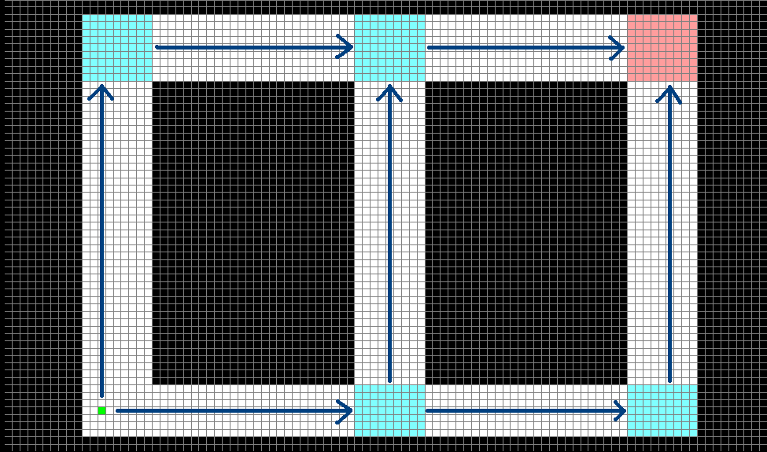

Figure 1: Node graph with area segments

With the implementation of the node graph, each successive destination can be reached via a straight line, so students are required only to navigate around other individuals and not immobile walls. With each time step a student’s movement direction is set as the direction in which the next destination lies. If the adjacent space in that direction is clear the student moves, and if not minor adjustments are made to the direction of movement and the student will attempt to move again. If the individual is completely unable to progress it will cease trying to move until the next time step, and that student’s color variable will be incremented. This variable serves as a visual cue (when displayed in graphical form by the viewer) to the user by causing students who are stuck in traffic to gradually fade from their original green to a bright red when their way is blocked, thus highlighting problem areas in the hallway layout.
The Java viewer reads all of the student location data and stores it in a three-dimensional matrix (the third dimension being time), and then reads the coloration data into an array that corresponds to the student matrix. It then iterates through the matrix, displaying each time step in succession as students (green dots) in a hallway environment (black walls), giving each student its appropriate color for the time step. The user can control this simulation playback with the keyboard, allowing them to review certain time steps at will to discover the origin of any traffic problems.

Environment generation
Creates environment data files
Viewer
Reads & stores location data
Converts location data into visual representation
Main program
Reads & stores environment data
Initializes students
Calculates all individual movement
Creates location data files

Environment data files
(coordinate data)
Bug reporting
(system output)
Environment
(user input)
Desired hallway layout
Location data files
(coordinate data)
Individual location and coloration for each time step
Keyboard playback controls
(user input)
Simulation Playback
(graphical output)

Figure 2: Program organization and layout

4 Testing and Analysis
Collision detection: Students must not be able to pass through each other if a realistic traffic simulation is to be implemented. In this test, varying numbers of students were placed in an environment and instructed to approach each other with various speeds and directions. This test was successful when none of the students passed through another.
Student avoidance: Because students cannot occupy the same space, there must be some way for them to find a path around each other. This experiment was designed to test the part of the pathfinding algorithm that introduces minor variations in the students’ direction of movement to induce them to find a clear path. This test was similar to the previous one, but was considered successful only when all students reached their destinations without failing the collision detection test.
Realism test: The student movement must be fairly realistic in order for the simulation results to have any real-world application, so this test was designed to ensure that all of the various methods were working in tandem to produce realistic pathfinding and traffic patterns similar to those found in a real hallway environment. Students were initialized in a basic hallway layout and the simulation was run several times to see that the behavior of the students and the resulting traffic situations closely mimicked those of the real world.

5 Results and Conclusion
The purpose of this project was to develop a realistic computer simulation that accurately modeled the actions of a student population in a given hallway environment. This requirement was instituted so that the simulation could be used to reliably predict the effectiveness of a specific hallway design under given traffic conditions before it is constructed. The final version of the project is capable of running the simulation under any desirable environment provided by the user, and the student population behaves with a reasonable degree of faithfulness to their real-world counterparts.

6 References
G. Newell and Valve Studios, “Efficient and Dynamic NPC Pathfinding in Game Design”.
Half-Life developer’s commentary, 2006.

