Analysis of Runner Biomechanics Through Edge Detection and Image Processing
Asa Kusuma
TJHSST Computer Systems Lab Senior Research Project
2007-2008
Abstract
The biomechanical features of a runner in an image can be analyzed by using certain image processing techniques, the primary method being edge detection. By constructing an accurate, two-dimensional model of a runner’s lower body from a rear angle, it is possible to extrapolate the underlying qualities of that runner’s biomechanics. It is only nesessary to bet a two-dimensional model, so it is only nesessary to create a mere outline of a runner's lower leg and feet. Using edge detection and image processing techniques, an outline can be construced from an image. Because you only need to analyze a few images to create a two dimensional model of the lower body, as well as the fact that the time it takes to analyze a runner does not directly affect his performace as a runner, algorithim speed is not a very relevant issue in this type of project and goal; accuracy is far more important.

Introduction
If you've ever had shin splints, you are aquainted with the most common running injury. A large proportion of shin split cases can be atributed to the wrong type of shoe in the affected runner. This problem can be traced to the fact that many runners don't have a good idea of the makeup of their biomechanical "fingerprint." The goal of this project is to determine this fingerprint from images of the runner. This fingerprint is largely determined by the degree of pronation associated with a runner's biomechanics.

Background
Pronation is one of the natural mechanisms by which humans absorb impact while running. When runners pronate, their feet roll inward after impact. All runners land on the outer edge of their feet. If a runner's foot rolls inward just enough so that their foot is parralell to the ground, then they are considered neutral, in reference to the degree of pronation. If a runner pronates past the point where their foot is parralell to the ground, than he is considered to be an overpronator. If a runner doesn't pronate enough, than he is a supernator. Modern running shoes are designed to counterbalence any imperfections in biomechanics, i.e overpronation and supernation. However, a runner must know which shoe to wear in order to properly coutnerbalence problems in his or her biomechanics. This project aims to fix that information gap.

There are many different edge detection algorithims available to use. Instead of taking one and using it, a unique edge detection algorithim will be created for the specific purpose of determining the outline of the lower human body.

Development
The product of this project will work in three steps. The first step is to create an outline of the subject's lower body. This involves mostly edge detection and some image processing. The next step is two determine the positional relationship between the foot/ankle and the leg. Once this has been determined, the last step is to evaluate the data and give a verdict for the degree of pronation and the type of recommended shoe
The meat of the development of the project involves the edge detection. Here are some samples of current edge detection algorithims.

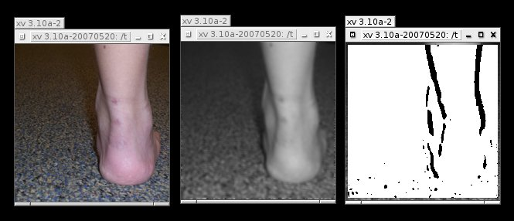
This algorithim works by converting an image to greyscale, bluring the image, and then looking for differences in pixel brightness across large pixel gaps in the X direction. The Y direction in not relevant because the human leg is a vertical pillar that should be straight. The algorithim is looking for bends in a verticaly straight object, so differences across the Y direction are not relevant and only introduce problems with innacuracies.

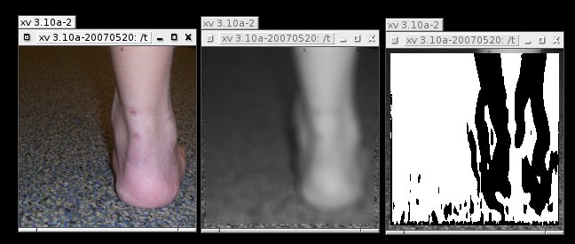
Here is another algorithim that looks for lines. Essentially, is tries to find difference gaps that are adjacent to each other.

