COMPUTER SYSTEMS RESEARCH
Code Writeup, example report form, 3rd quarter 2007-2008

- Your name: _Gregory Gates____________________, Period: __5__
- Date of this version of your program: _4/4/08_______
- Project title: _Elementary Education in a Technology Age
- Attach some sort of summary listing of your code, such as an API listing, or an outline of classes, functions, methods, with explanatory comments.
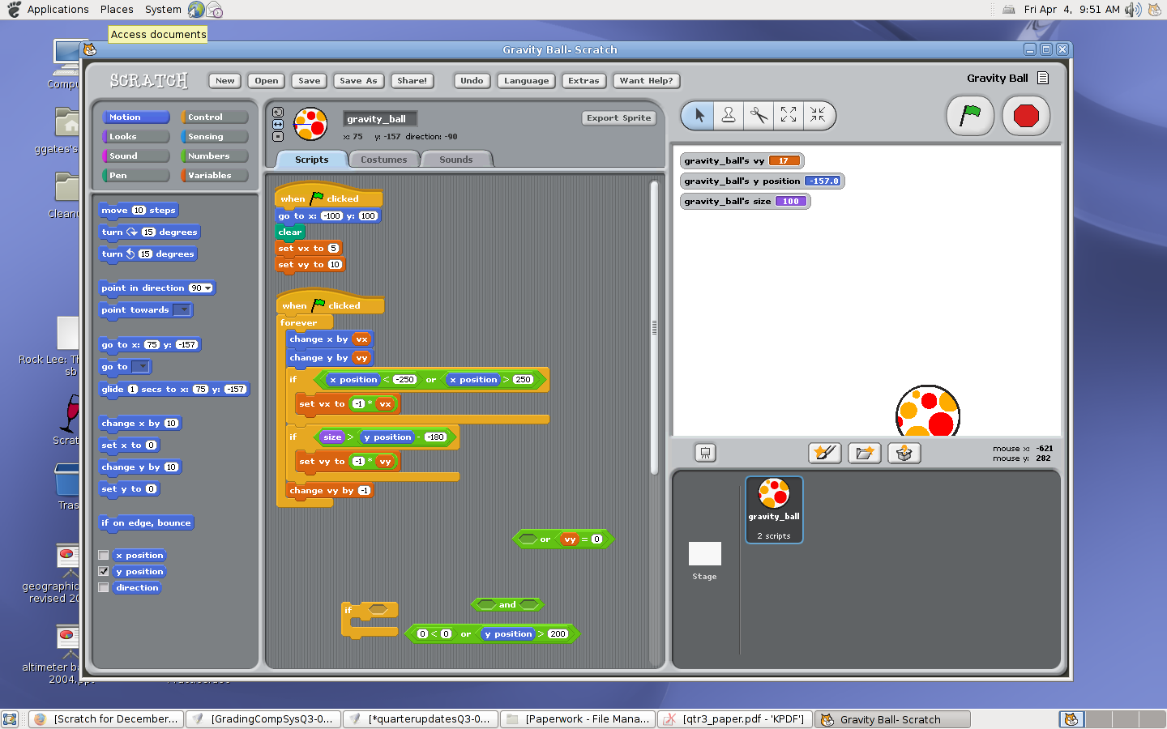
- Describe how your program runs. List test input(s) that may be used. Are there incorrect user input(s) that your program handles?
There aren't any user inputs for this program. You simply click the green flag at the top of the screen. After clicking the flag, the ball goes to the top of the screen and then starts to "realistically" bounce up and down, going from left to right.

- What is the program analyzing as far being used for your senior research project this year?
The goal was to implement some realistic (although rudimentary) physics in a Scratch program. The ball bounces well for the first few bounces, but it eventually gets stuck in an invisible boundary line which I was unable to fix even after an hour or so of fiddling with it. With this project I was trying to see what Scratch is capable of and explore any possible limitations. Apparently, realistic physics is one of those limitations. I was working on this to learn of Scratch's potential as an educational tool for other math and science topics (in this case physics) in order to better sell the program to the parents of the students involved in the activity.

7. How has your program evolved during third quarter? What do you expect to be your final version by the end of this school year, by the end of this school year, what do you hope to have as a final version of your program in relation to this current version? What will you demonstrate during your final presentation?

This program is completely new for third quarter. I doubt that I will be working on it at all in fourth quarter. It was simply a little experiment for myself in exploring Scratch a little bit more. There may be other small experiments like it during fourth quarter however. I may use this as an example of some of Scratch's capabilities in my final presentation for this project, though I will most likely reserve that honor for some of the student-made projects.

- What will be the major research points you’ll write about for the final version of your research paper?

The main research points that I will be writing about are:
- The potential for elementary school students to learn how to program
- demonstrate how programming can be used in teaching other subjects (most specifically mathematics)
- Showcase student projects/progress
- Feasibility of similar projects at other schools
- The importance of computer science, and how it's a topic that should be taught at all grade levels

