COMPUTER SYSTEMS RESEARCH
Running Version of Your Program, example report form 2007-2008
- Your name: __Michael Chen___, Period: __3__
- Date of this version of your program: ___January 22, 2008____
- Project title: ___Parallel Programming with MPI_____
- Describe specifically what files are needed and the command(s) necessary to run your program
-The necessary files are: golmpi4.c (the latest version), the hosts list (hosts.txt, the list of available computers, the makefile (Lgcc), and all the necessary files for MPI implementation
- How to run your demo:
-in a command prompt, type ./Lgcc golmpi4
-then, after it finishes compiling, type mpirun –machinefile hosts.txt –np #PROCESSORS golmpi4
-My current setup has 9 processors, each covering a 3x3 area
- Your program is running, now what? List test input(s) for the user to interact with your program. Specifically what should the user expect to happen?
-Currently, there are no inputs after the initial ones, but it will be changed to prompt the user for a max length/width (size of board), and will return an error if it does not match the areas that the specified processors can divide up.
- Input(s): expected to have one that asks for board size
- Program's expected response(s): First, the main computers will contact each other processors needed to run the program, before running each step, like in the following screenshot:
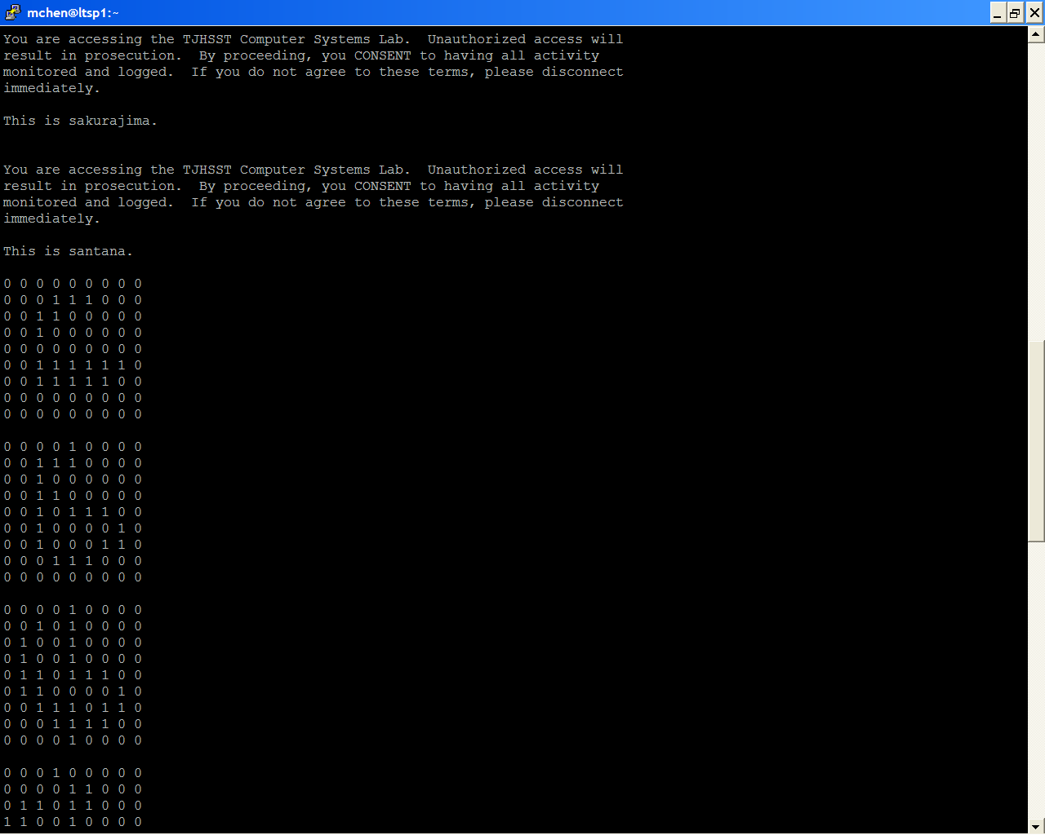

- What about user input errors? Are there incorrect user input(s) that your program handles?
-It is planned for there to be a checker so that the program will know when # of processors does not match with board size, but currently, incorrect inputs will lead to errors in exceeding array limits, or just incorrect steps
- What is the programming doing, demonstrating, or analyzing? What is the user looking for in order to understand what you've been studying and developing with this project?
-It is demonstrating the game of life as designed by Conway, and has become one of the most famous examples of a cellular automaton, using cells to roughly simulate situations in real life. The user should notice that in each step, cells with less than two surrounding live cells die (loneliness), cells with more than three cells die (overcrowding), cells with three cells around them come back to life (birth), and cells not meeting any of these stay the same.
- How has your program evolved during second quarter to now, the beginning of third quarter?
-This program, though different from my first quarter program, has evolved because it is demonstrating a more difficult form of MPI: divide-and-conquer, instead of master and slave. Whereas the master and slave has one computer communicate with each other computer (other computers do not communicate with each other), this program has each processor communicate with the necessary “surrounding” processors, and becomes much more efficient by splitting up computation time (though it still uses master-slave for the print function)
- By the end of this school year, what do you hope to have as a final version of your program in relation to this current version? What will you demonstrate during your final presentation?
-I am going to move the focus of my project from less exploration to more tests of efficiency depending on different factors. As Mr. Torbert told me, we can compare the difference between passing time and internal processing time by changing the number of times each cell has to communicate with another. Right now, each computer asks for one row or one column from surrounding computers and uses it to step once. But what if it asked for two columns or two rows? Then it could step twice accurately, reducing the amount of time needed in passing data by half, but increasing computation time. I am hoping to move my project towards finding how to attain optimum efficiency in certain situations. In this one, it would be passing time vs. computation time, whereas in the wind velocity lab from first quarter, it was a question of how many processors to use? (also a problem in this program, 9? 16? 25?)

