COMPUTER SYSTEMS RESEARCH
Portfolio Update Report 2nd Quarter 2007-2008
Research Paper, Poster, Slides, and Analysis of your program. Looking ahead – Plan for 3rd Quarter
Name: ___Madhav Nandipati____________________, Period: ___6__, Date: _1-16-08___________
Project title or subject: _Analysis of spectro-temporal receptive fields in an auditory neural network__
Computer Language: ___Matlab___________________

Describe the changes/updates you have made to your research portfolio for 2nd quarter. Also describe your plan for 3rd quarter

- Coding: attach new code that you wrote or modified 2nd quarter. Describe the purpose of this code in terms of your project's development
Stimuli training code:
warning off all
warning off all
%also try 750 for 0.1 seconsd and see if training is better
%200 ms signals. If end is 2000 higher, 0 and alpha and beta each 5
%timesteps apart. 1500=4
t1=0:1/11025:0.2;
for startfreq=10:20:2010,
y=chirp(t1,startfreq,0.2,startfreq+1500); %up by 4 timesteps
[soundmatrix,f,t]=specgram(y,256,11025,[],[]);
soundmatrix=abs(soundmatrix);
soundmatrix=soundmatrix-min(min(soundmatrix));
soundmatrix=soundmatrix/max(max(soundmatrix));
cd ..
filename=[num2str(startfreq)];
save(filename,'soundmatrix');
wavwrite(y,11025,16,filename);
cd generator
fprintf(['Done ',num2str(startfreq)]);
end
for startfreq=2030:20:3450,
y=chirp(t1,startfreq,0.2,startfreq); %tones
[soundmatrix,f,t]=specgram(y,256,11025,[],[]);
soundmatrix=abs(soundmatrix);
soundmatrix=soundmatrix-min(min(soundmatrix));
soundmatrix=soundmatrix/max(max(soundmatrix));
cd ..
filename=[num2str(startfreq)];
save(filename,'soundmatrix');
wavwrite(y,11025,16,filename);
cd generator
fprintf(['Done ',num2str(startfreq)]);
end
for startfreq=5510:-20:3470,
y=chirp(t1,startfreq,0.2,startfreq-1500); %tones
[soundmatrix,f,t]=specgram(y,256,11025,[],[]);
soundmatrix=abs(soundmatrix);
soundmatrix=soundmatrix-min(min(soundmatrix));
soundmatrix=soundmatrix/max(max(soundmatrix));
cd ..
filename=[num2str(startfreq)];
save(filename,'soundmatrix');
wavwrite(y,11025,16,filename);
cd generator
fprintf(['Done ',num2str(startfreq)]);
end
...
Although I chose not to attach the different generation codes, you can see that this code generates stimuli that are upsweeps and tones. (I also have code that would be able to generate different types of training set, or the code is easily modified to accomodate this). The frequency goes up by 1500 Hz by the end of the stimulus that lasts 0.2 seconds. This is what I am using to train my temporal coded model.

Modified training program:
for anneal=1:1, %slowly decreasing the learning rate 1:3
for iter=1:3500, %iterate multiple times through training set 1:100
for nummat=10:20:5520, %1:1141 iterate through training set
tempnum=num2str(nummat);
filename=['atset/',tempnum,'.mat'];
load(filename)

trackoutp=zeros(6,size(soundmatrix,2));

%outputing and training
for i=1:size(soundmatrix,2), %iterate through time
timestep=soundmatrix(:,i)';
if i>2,
prevtimestep=soundmatrix(:,i-2)';

end
if i>4,
prevtimestep2=soundmatrix(:,i-4)';

end
input(1,1:129)=timestep;
input(1,130:258)=prevtimestep;
input(1,259:387)=prevtimestep2;
%outputing
outp1=input*weightsTatset;
trackoutp(:,i)=outp1;

%weight update
inputtrain=input';
inputrep=inputtrain(:,ones(1,6));
outp1rep=outp1(ones(387,1),:);

weightchangeTatset=learningratesTatset.*(inputrep.*outp1rep-outp1rep.^2.*weightsTatset);
for u=1:size(weightsTatset,2)
val=dot(weightsTatset(:,u),weightsTatset(:,u)+weightchangeTatset(:,u))/(norm(weightsTatset(:,u))*norm(weightsTatset(:,u)+weightchangeTatset(:,u)));
if val>1,
val=1;
end
angle(cangle,u)=acos(val);
end
cangle=cangle+1;
weightsTatset=weightsTatset+weightchangeTatset;
end
end
end
%learningratesTatset=learningratesTatset/10;
end

The training program has also changed, to accomodate the fact of temporal coding into the model. The if...statements obtain the information from the time-delayed inputs and the neural network responds accordingly.

- Poster: Paste here new text you've added to your poster for 2nd quarter. Also describe or include new images, screenshots, or diagrams you are including for 2nd quarter. Have you reached any preliminary conclusions?

- Presentation slides: Paste here new text you've added to your presentation for 2nd quarter. Also describe or include new images, screenshots, or diagrams you are including for 2nd quarter. Have you reached any preliminary conclusions?
(see below)
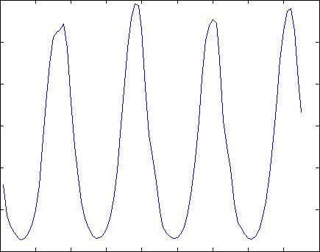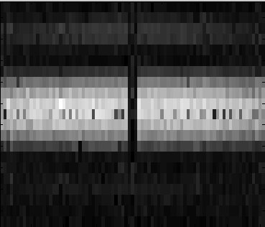

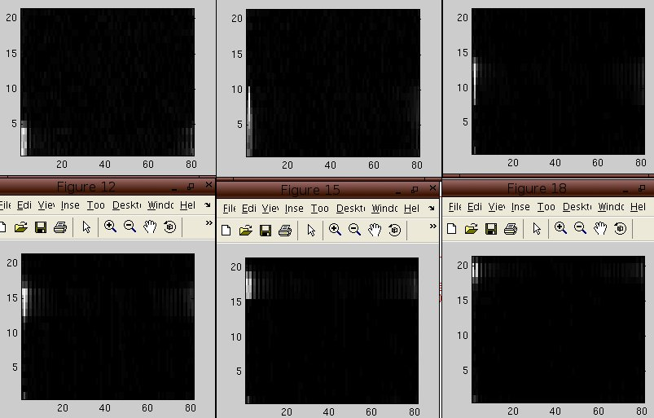

These are some new images I am including in my second quarter presentation. The first image on the top left describes the output of the neural network to the ripple stimuli. The second image describes the transfer function, which is a summary of the neural network output to all ripple stimuli. And the final bottom image are the receptive fields from each neuron. My preliminary conclusion is that STRFs are able to output the the same minimum level of information as tuning curves because the STRFs are showing the frequency information. Now I just need to see whether the STRFs are able to output the temporal information also.

- Research paper: Paste here new text you've added to your paper for 2nd quarter. Also describe or include new images, screenshots, or diagrams you are including for 2nd quarter. Have you reached any preliminary conclusions? What have you added to you bibliography?

- Running version of your project. Include new analysis, how your research has changed or evolved or grown or expanded during 2nd quarter. Specifically what have you done this quarter.

During the second quarter, my project evolved to accomodate temporal modeling. During first quarter and the beginning of second quarter, I worked on generating STRFs for only the linear model. Now I developed a whole new model that can responds to time-delayed inputs and gets trained on them also. Now, I can see how the STRFs will be able to change and conclude accordingly.

- What is your focus for 3rd quarter for your program and project?

Since I have not finished with the training procedures yet, I will finish the training during the beginning of the third quarter and generate STRFs for the rest of the third quarter with my new model. I will devise new, quantitative ways, to analyze my STRFs and I will also compare them with tuning curves, the traditional way of characterizing neural networks.

