Evolving Cutting Horse and Sheepdog Behavior
with a Simulated Flock

Chris Beacham

Computer Systems Lab, 2008-2009
Final Draft Alpha 1

The focus of this project is attempting to evolve the behavior of a single agent or small group of agents so that they can effectively direct the movement of a much larger group. This is very similar to the roles cutting horses and sheepdogs take to manage livestock. Emphasis is placed on realistic flocking behavior and evolution of a a simple set of rules to manage the herding.
Flocking behavior has been established ever since Craig Reynolds 1986 paper "Flocks, Herds, and Schools: A Distributed Behavioral Model", but it is missing a fundamental element: A way to direct the movement of the flock. The nature of the flocking model is that it is unguided - none of the three rules have a guiding mechanism in them, and one of the qualities of lifelike behavior is that it is unpredictable. There are times when controlling the motion of the flock is important. Two prominant examples would be animation - where the flock moving in a specific direction is very important as repeated renders take up valuable time, and livestock management - where a robotic sheepdog agent could reduce livestock stress. This project takes a first look at controlling the movement of a flock using an agent similar to a sheepdog.
The sheepdog and the cutting horse are two examples of animals used to manage flocks, and they were chosen as the model in order to attempt to reproduce their behavior. The sheepdog is used to herd and guard sheep. The cutting horse is used with cattle, to "cut" a single cow off from the herd, allowing farmers to access it.
This project aims to develop instructions for these specialized agents without explicitly programming it. Since the nature of different herds varies based on a variety of factors, such as the species of the animals, their health, conditions, and environmental factors, it would be helpful to have a dynamic system for creating this sheepdog behavior, to allow for a later, robotic herding agent to adapt to different conditions. There is also the possibility of discovering new techniques for controlling the movement of the herd, which could be applied to real life. Any behavior that is likely to be evolved should be easily reproducible, since it will use several vectors calculated from the sight of the sheepdog. The flocking behavior relies on three simple rules, and for the sake of symmetry the hoped for herding behavior will be just as simple.
There has not been very much research directly in this field. The main focus of past research has been on ‘flocking’, which is similar to a flock of birds flying at high speed. There have been a limited number of simulations of a stationary herd, but the flocking algorithm is flexible, and seems to cover both behaviors well. There have been a few projects dealing with manipulating the flocks, but none of them were very focused on the behavior aspect of the manipulative agent.
The Robotic Sheepdog Project experimented with two different rule-based behaviors for their sheepdog agent. They were moderately successful, but their design relies on an enclosed field o0w``ith walls to "guide" the flock towards the goal. The Robotic Sheepdog Project does serve as a proof of concept, namely that it is possible to effectively control livestock with a robotic agent. The ducks that they used responded to the robot in a consistent and predictable manner. At one point during their experimentation, a stuffed fox was mounted on the robotic agent. By their accounts, the presence of the predator visibly upset the ducks, and they did not react as well as they had to the non-predatory simple robot. This might hold in other cases, which would mean a robotic sheepdog could offer a way of controlling a herd in a way less stressful to the livestock. Using a dog to herd ducks and sheep may be inherently stressful, as a dog is a natural predator to these animals. If a robotic agent could reduce the "worrying" of the livestock, it could increase the worth of the livestock.
Flocking behavior has three components to the algorithm They are separation, cohesion and alignment. Seperation is moving to keep a minimum distance away from the nearest flockmate. Cohesion is attempting to move towards distant flockmates. Alignment is a changing direction of motion to match the direction of nearby flockmates.
A stationary herd was assumed to follow flocking behavior. The vectors were scaled down so the flock would come to a halt. It was important not to scale them down too much, otherwise the flock would loose responsiveness to the sheepdogs. By a trial and error process, the variables were hand-adjusted to be right on the cusp of having the flock spring into motion. Once the herd had been implemented, it reacted to the presense of the sheepdog in by moving in a way reminscent of a group of geese. The boids seemed to flow around a predator who approached them, and would reform into one mass after the predator had passed. This was very encouraging.

Initially, I expected to use neural networks to determine the behavior of the sheepdogs. This would have been a good approach because it would allow for many, many different kinds of behavior to emerge, including non-intuitive ones. Unfortunately, it turned out that using neural networks was not realistic, as implementing them correctly, and bug shooting them would have doubled or tripled the expected length of the project.
Instead, I choose to use a weighting system for the sheepdogs. Their genetic code determines how much weight they give to a set of pre-calculated vectors. They also have the ability to determine the exponents of the vectors, which greatly increases the possibilities for their behavior. A genetic code could make one vector be calculated on an inverse square system, while another is a linear square.
Though there are compromises in limiting the possible end behaviors, the weighting method is a good choice. Because of the way it is set up, any successful behaviors will be able to be expressed in similar language as the flocking algorithm. This makes the behavior versatile, it can be implemented anywhere, again and again, instead of relying on a specific neural network producing using cryptic methods.
Currently, the weighing method has been implemented, at least in it's first iteration. A whole 10000 separate genetic codes have been generated, comprising the gene pool for the first generation. So far, no automated trials have been programmed, but they soon will be. I should be producing my first results by the end of February.

The evolution program, and the herding simulator will be both written in python. TKinter will be the graphical display system used. Here are some preliminary screen shots.

This figure shows a very early (Q1) flock. It is chaotic, the flocks had not been stabilized to herds yet.

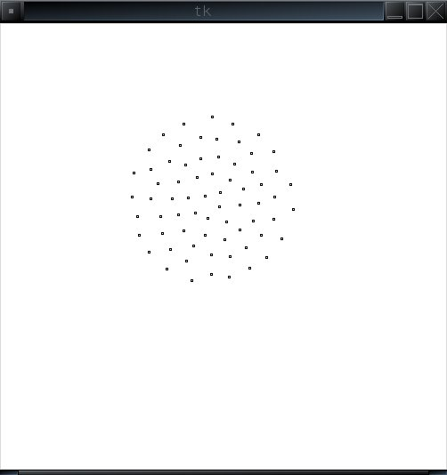
This is the correct herd behavior. Because of a bug in the code dealing with angle inversion, it wasn't until December that this behavior emerged. 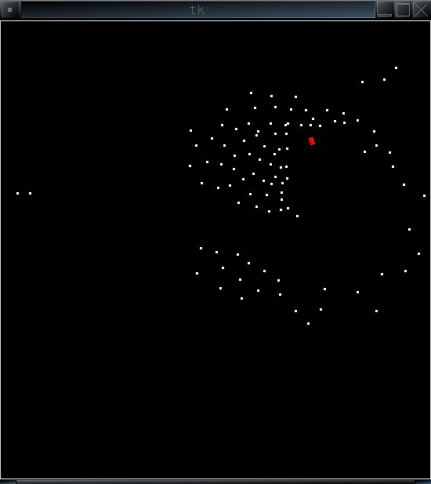
This figure shows the flock's correct response to the presence of a predator (red) in their midst. They are being herded, but they also slide around the predator, and reform the flock. This behavior was elusive due to several hidden bugs in the code.

Results
The project is by no means completed, but by halfway though the third quarter, some preliminary trends have become apparent. There were three working populations running at the same time during this stage of the project, two with the same genetic system, and the third with an extra gene that allowed the sheepdogs to set a maximum speed for themselves.
In the first population, the predominant strategy was for the sheepdogs to insert themselves into the center of the flock, and move in a spiral while slowly inching towards the goal. This was effective, though maybe an entirely realistic method for moving the sheep. The flock expands around the sheepdog, forming a formation that looks like a bubble. I have observed that this is similar to the behavior of real geese, so some variation of this method would most likely work in reality.
The second population is a little more standard behavior to what we think of as sheepdogs. These sheepdogs chase the flock down the field, moving back and forth to direct any strays back into the herd. They suffer from a problem induced by the simulation - they occasionally loose their flock and wander around aimlessly. The simulation has an artificially low barrier for sheepdog sight, which was set during testing to make the testing easier. In later populations, this barrier will be removed.
The most exciting thing about the second population's strategy is that it works even better when more dogs are added. The top 10 performing dogs from the third generation will chase the sheep down the field and into the goal in a matter of seconds, resulting in a display that is almost majestic to behold. It is possible that in later populations, this will be selected for, and that might even progress to evolving 5 or 6 populations at the same time and in the same trials. The goal would be that they could evolve complimentary behaviors, and form a very effective team to herd the sheep.
The third population is the one that has the extra gene that controls speed. This gene is taken advantage of in this population, because the dominant strategy is to move slowly behind the sheep, and gradually approach the goal. This was disappointing to see emerge as a strategy, though it is a realistic strategy for herding. Later populations might be aimed at fast solutions rather than accurate solutions. On an actual field, the faster a sheepdog can move the flock, the more useful it is.

With more evolution, more strategies developed. Some populations developed a strategy that was very simple -Southeast Movement. The location of the goals was randomly generated, but tended to fall in the southeast area. Thankfully, This behavior was out competed by more robust strategies.
The first generations’s strategy was a popular one. It was named “Bubble”, and refined until it was a quick and simple method of approaching the goal. It uses the factors that hold the flock together to it’s advantage, rather than working against them. It also keeps the flock in constant contact with the sheepdog agent.
In the first population the ‘bubble’ strategy evolved into a ‘spinning wheel’ strategy. This is a modified bubble strategy; the bubble has collapsed in front of the sheepdog, who drives it forward while spinning in small circles to keep the shape intact. These strategies are best shown in a video demonstration.
Both the bubble and the spinning wheel strategies have issues stopping once they reach the goal. They do fairly well, but because of the simple weighting system they stay near the sheep and drive them back and forth over the goal. In the imagined applications this would not occur because once you have a concrete application, the agent can have a set time to remove itself from the simulation.
The final strategy that emerged was quite simple. The sheepdog was

Many sources were consulted in the design of this project. Some of the more useful ones are listed below.
﻿, Craig Reynolds
, Temple Grandin
The robotic sheepdog project:
Robot Sheepdog Project achieves automatic flock control, in Proceedings of the International Conference on Simulation of Adaptive Behaviour, Zurich, Switzerland (1998).
Robot control of animal flocks, in Proceedings of the International Symposium on Intelligent Control, Gaithersburg, Maryland, USA (1998).
Experiments in Automatic Flock Control, Journal of Robotics and Autonomous Systems 31:109-117, April 2000, © Elsevier Science BV.

