Jack DeWeese
Project Description

Virus Simulation and Ideal
Percentages for Mass Vaccination
Computer Systems Lab 2008-09

This project is designed to expand upon the common agent-based simulation of a virus infecting a very generic population. Factors such as work, school, hospitals, age, and population size are accounted for. Different different types of existing and fictional viruses will be simulated. The effects of vaccinating parts of the population can be modeled to determine the most effective percentages of vaccination needed to best prevent the effects of a virus' spread.

After doing some research into other virus simulation programs, I found Jill Dunham's program which serves as a good base for my own simulation. While I began this quarter working on my original simulation from scratch, I moved to doing research on how other researchers worked with different variables and the differences between dynamic and agent-based modeling. It was during this research that I came upon Mrs. Dunham's model and began learning how the software works. Because of the proximity of this discovery to the end of the quarter, I have not made drastic changes to the program in terms of the code itself, but I continued my research of how to change aspects of the program. The program initially contained a basic flu virus, but I have implemented my own smallpox model and done some tweaking of her pre-done viruses.

This project is an attempt to determine the most effective methods of vaccinating a population, considering the factors of the type of population and what virus is infecting it. Different percentages of vaccination have been used to see if vaccinating certain percentages (relative to the size) of the population makes a difference and regression models have been created to attempt to create mathematical models of the simulation results.

This formula shows the number of people that should be vaccinated in a population of size n with a vaccine, which has a death rate of rv.
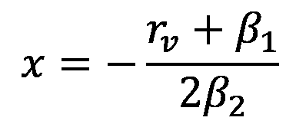

This formula is the regression model for the number of deaths as a function of percentage of the population vaccinated.
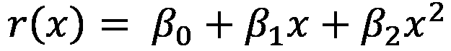

Expectations for my program included working models of past epidemics and the capability to models possible future epidemics to a fair degree of accuracy, and while this was not accomplished, I did take large steps to achieve this goal. This type of model is especially useful in today's world, where the threat of bio-terror attacks is a real fear, and precautions must be made to react to such an event. The model I have created uses regression to try to best simulate what the effect of increasing the percentage of vaccination will be on a population, and at what point it is no longer useful or even harmful to continue vaccinating. For example if there is a vaccine that has a certain death rate, the model can show at what point the risk of vaccine outweighs the benefits of preventing spread of the virus.

