Theo Gutman-Solo

Econometric simulation of global wealth flows
Computer Systems 2008-2009

The global macro economy is one of the most complicated systems in the world today. Hundreds of theories, formulas, and ideas have proliferated in attempts to explain it changes. Prior to computers attempts to integrate these theories into comprehensive models would have been impossible by the sheer complexity of the task. Even with the aid of computers analyzing the evolution of the global economy as a whole is unfeasible. However numerous advances in the theory of global trade (notably Paul Krugman’s theory on economic geography and new trade theory) have made it possible to make accurate predictions on trade and wealth flows. The aim of this study is to use these theories to create a mathematic agent-based model simulating global wealth flows.

Introduction

The global economy is an increasingly complex structure governed by myriads of daily interactions. One of the most important topics today is the value of currency. Currency values play a role in maintaining nations budgets, development, global finance among other important issues. Predicting developments of and changes due to variations in currency are critical in the greater economy.

Accomplishing this task means time evolving a world based on the integration of several theories. Agent-based modeling is a simple and elegant solution, the agents representing businesses interact on a landscape which represents the world. Their interactions cause the capital and current account surpluses and deficits that are so critical in our world. If this model correlates with empirical data it could be a powerful predictive tool in financial and economic situations.

Background

No nation or functioning political entity can survive in the modern world without inclusion in the global economy. When the world embraced fiat currency after the Second World War and moved into a landscape of complex credit derivatives and financial arrangements. Since then the fork between the real and the nominal has ever increased, resulting in great disparities in the financial markets and the economy. The survival, growth, and strength of an economy has been linked to value of its currency. But as the value of a currency is now nominal we must search for the causes for appreciation and depreciation of currency. The economic ideas behind this are simple - naturally derived from supply and demand but are very complex to model. The problem comes in the fact that supply and demand in this example ignores human action and internal markets. For this reason basic supply and demand must be supplemented by a variety of other actions: specifically user bias; and new trade theory. The assumptions made in this project are: i) minimum transportation requirements or costs; ii) bias towards dominating currency; iii) efficient markets (required for complexity issues; and iv) zero sum game. The last assumption is justified by considering all values to be indicators of relative rather than absolute wealth. Using heuristics based on these theories, agents (representing businesses) evaluate production chains based on arbitrage of CPI values between nations (classes that serve to hold data).
Three theories are key to this project. First, the “New Trade Theory”, put forth by Paul Krugman; second, Joseph Stiglitz’s theories on asymmetric information, and last, supply and demand from classical macro and micro-economics. Krugman’s theory explains, simply put, why the rule of comparative advantage breaks down in certain situations in developed economies. (E.G.. Germany buys cars from Finland and Finland buys cars from Germany.) Stiglitz’ part of contract theory which applies when one party(ies)knows less than the other(s) . Finally, the classical law of supply and demand tells us that product prices vary directly with demand and inversely with supply. These theories summarize the information which businesses will use to determine their production chains. Integrating these ideas we are left with a heuristic that evaluates combinations based on arbitrage (difference in CPI), competing agents, and country development level. Then investment procedures are evaluated by weighting all countries and selecting by probabilities. Factors include in the weighting: crowding out is detrimental,
In addition to Stiglitz’ paper “Theory of Asymmetrical Information”, and Krugman’s Vehicle Currencies and the Structure of International Exchange, The following books are of specific importance to the investment heuristic: i) Benjamin Graham’s, Security Analysis; ii) Geoffrey Poittras’, Security Analysis and Investment Strategy; iii) Jeremy J. Seigal’s, Stocks for the Long Run.
Project Structure
Nations are a class in java used solely to hold information specifically the total wealth of a country. On the basis of this information a separate class representing business entities associates itself with a pair of countries to create a production chain. Over time this production chain takes money from the country of consumption and gives it to the country of production. This is the current account balance. The capital account comes from the reinvestment of the profit the companies take and follows a complicated heuristic for reinvestment. Each time-step money is transferred according to the effects businesses have on these two accounts. The businesses then reevaluate their associated countries and if the opportunity for more profit arises reorganize structure.
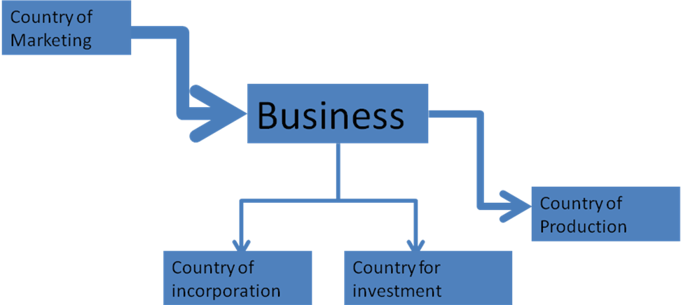
Figure 1. Model of Business Agent chain. The business is an agent and the four country are all variables that come from the landscape of the world.
Development
Java was a simple language that was completely sufficient for the required purposes. The project would be successful if it made a model consistent with economic theory and more importantly that showed some correlation with reality. In effect the project had to be able to analyze and time evolve an economic system accurately according to economic theory and then be able to display the information in an understandable form.
The project started as an agent based modeling framework. This part is the simple part of the project. It does not deal with economic theory and is solely concerned with efficiency, complexity and speed. While these are important variable the possibility of using parallel processing or other techniques if the analysis proved lengthy meant that this part was not too important.
Of far more importance is ensuring the heuristics function accurately. Because the economic model is a simplification of the global economic system critical variables need to be reset and recalibrated. Unfortunately there is no way to resolve this issue, to my knowledge, other than trial and error.
After the heuristic is calibrated display methods need to be created. The important detail is to be able to show every country at each time-step. The most aesthetically pleasing way to accomplish this is with a rectangular cartogram weighted by GDP.
Compartmental evaluation is mostly self-explanatory. The heuristic needs to change until the coefficients are recalibrated. This just comes from successive runs. The display is evaluated on the basis of whether I can assess the information from it. The agent-based modeling framework has to be assessed last. If the sample size is too small I may get inaccurate readings. This lead me to change the framework to aid efficiency.
A lot of the project’s theory has come from consistent recalibration. I realized upon reviewing the data. That it was too biased towards supply and demand and could never account for countries such as Germany and Japan which while having very high CPIs have maintained a current account surplus. These and other anomalies that appear in the real world but are inconsistent with simplistic supply and demand trade theory led me to investigate new trade theory by Paul Krugman and a couple other explanations that could be integrated into my heuristic. Due to these additions and other problems this project has rapidly hit a complexity issue that was originally unforeseen. The programming is easy, but making a good display function has become increasingly challenging.
Currently the landscape of nations is randomly generated. The aim after all the initial code testing is done is to run the program on a simulation of our world rather than a randomly generate grouping of values. I have begun calculating the necessary values for the appropriate countries in the year 1990. For complexity issues it is pretty clear that not all the nations will be used (still no one should miss Burkina Faso). The test is to see how the results correlate with the real world. Of further interest would be running congratulations on making it this far the program in simulations that it should predicted, the recent collapse of the Asian markets, Brazil’s currency flop, and other such scenarios.
Expected Results
While I have not found any simulations similar to mine in scope, theoretically is analogous to a vast array of research concerning competitive advantage in markets. The simplest case of the project in which businesses are singular non dynamic conduits between nations has a consequently simple expectation; the global gini-coefficient, which is a measure of inequity, should decrease and countries should have very small oscillations around a stable equilibrium point. In the dynamical business scenario, the change of course of the global economy will depend on the strategies of the different businesses. Based on my readings the more risk averse the businesses are the more inequitable the equilibrium point of the world’s economics will be.
Development 1st Quarter

- Creation of static agent-based model
  - Cycles through Nations
  - Nations
    - Contain
      - GDP
      - CPI
      - Population
      - Lists of associated Businesses
  - Business
    - Contain
      - Little if anything
- Basic display systems
  - Line Graphs for single country
  - Pie chart for current account position of country Eg. Balanced, negative, or positive
- Basic Heuristics
  - Reinvestment
    - All Reinvestment funds go country of incorporation
  - Arbitrage
    - Supply & Demand

Development 2nd Quarter

- Agent based-model
  - Cycles through Businesses rather than nations
  - Nations
    - Switched Hash tables for efficiency
  - Business
    - Contain
      - Country of Production
      - Country of merchandising
      - Country of incorporation
    - Forays into development of dynamic businesses agents
      - Business are constantly created and dying based
        - Open opportunities
        - Repeated sub-par performance
  - Heuristics
    - Reinvestment
      - Weighted system
        - Researched
          - Asymmetrical information
          - New Trade Theory
  - Arbitrage
    - Recalibration
    - Recalibration
    - Recalibration
Development 3rd Quarter
- Agent based-model
  - Arbitrage
    - Recalibration
    - Recalibration
    - Recalibration

Possible Future Extensions

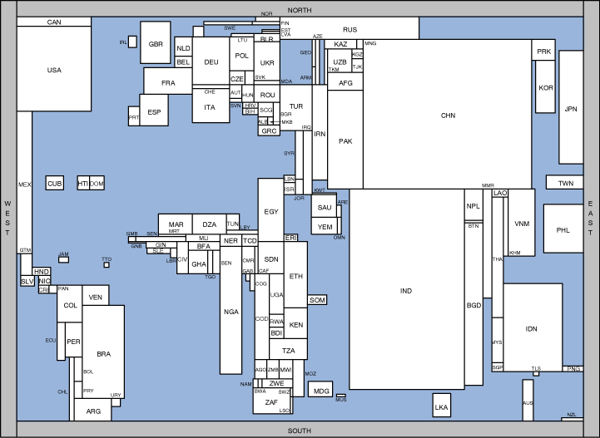
Possible extensions of this project could implement differing country economic policy in the form of protectionism. Furthermore by slowing down the speed of the simulation, by giving agents more time to change their options compared to speed of wealth transfer, in conjunction with a genetic algorithm comparable to the one used by Peter Le in his Paper Economic Policy Simulation and optimization, to find optimal government policies in the world market. Lastly display on a cartogram would be a nice addition to the current implementation. The problem with this methodology is that the speed of the economic simulation is orders of magnitude greater than the speed of calculation of frames of Cartograms (Using non-rectangular cartograms is completely unthinkable due complexity issues). While this set-up would be of extreme in extrapolating conclusions from data it would require some form of parallel programming or similar method to lower its runtime

Figure 2. Cartogram

Bibliography

Security Analysis Benjamin Graham
Security Analysis and Investment Strategy Geoffrey Poittras
Peddling Prosperity Paul Krugman
Asymmetrical Information Joseph Stiglitz
Vehicle Currencies and the Structure of International Exchange Paul Krugman
Externalities in Economies with Imperfect Information and Incomplete Markets Joseph Stiglitz

