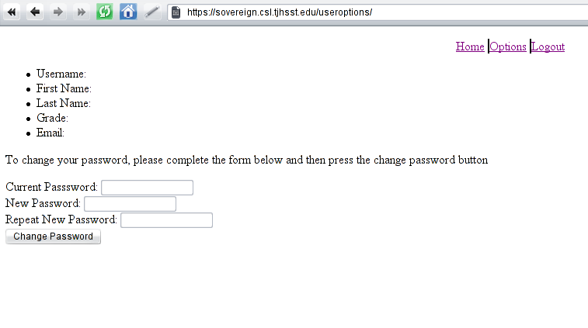
The User options page which is currently just a shell which displays but have no function

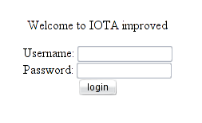

The IOTA login page.

