Traffic Model Simulation
By: Jim Kaplan
Computer Systems Lab, 2008-2009
1/23/2009

Abstract
Traffic flow is an extremely complex procedure and is near impossible to figure out equations for. The best that can be done is to have complex simulations of the traffic in order to get a semi-realistic view of the traffic that can be controlled and experimented on at will. A combination of random numbers to factor for driver’s abilities and cautions and amount of traffic flow together in a successful simulation could result in the traffic flow patterns that you see in real life.

Introduction
The problem of traffic is an apparent one: try driving in rush hour on any major road. Can the flow of traffic be improved though? If a lane is added, how much faster can cars get through a traffic jam? If a lane is blocked off, how much more is traffic backed up? How does the maximum speed limit affect the wave that is formed? What is the optimum speed limit for traffic flow? For saving gas? All of these questions will be answered through the simulation that is being developed.
The purpose of this project is to accurately model traffic situations and see how much variables such as lane changes or speed limit affect the traffic flux. The way to model the traffic will be to use a two dimensional version of the Nagel-Schreckenberg model, which will be explained later in this paper.
This experimentation is important because it could affect the highway systems throughout the world. The Wilson Bridge near the District of Columbia uses a setup where the speed limit decreases with an increase in traffic. This project is to determine exactly how much the decreased speed limit will save the cars in the traffic flow in terms of time and gas, and therefore money. The real life application is very real, and necessary, as with our busy roads, a set speed limit just is no longer appropriate for the amount of traffic that these roads are receiving, and with the increase in population of the world, these traffic jams can only get worse.

Background
This subject has been researched before in various forms. One of the papers that researched traffic flow was Simulation of Traffic Flow at a Signalised Intersection. The goal of the project was to use the Nagel-Schreckenberg model to determine the reaction of cars to a stoplight at an intersection. The Nagel-Schreckenberg model is a way to determine how much a car moves in a one dimensional cellular setup. There are 4 steps to the process (Fig. 1): Determine the previous speed, then (1) add 1 to each speed. Then find the number of cells between one car and the next and lower the speed of the car if necessary until the car has a speed of the number of cells in front of it (2). Then a random factor comes in, where a random 1/3 of the cars have their speed decreased by 1 (3). The cars then progress forward in their cells according to their speed.

Development
The project would be deemed successful if the wave patterns that appear in real life also appear in the simulation. First, In order to have successful pathing around a two dimensional environment, the car looks a certain distance in front of it, on both the left and right sides of the car (Fig 2). If one of the two spots triggers (it detects a color that isn’t road), it turns away from that spot.
Fig 2
The way that wave patterns would be achieved in a 2 dimensional environment would be to use a 2 dimensional version of the Nagel-Schreckenberg. Instead of looking ahead in the cells until you reach the first occupied cell, a 2 dimensional version would look for the first car in front of it in an arc (Fig 3). And instead of changing the speed with whole numbers, the speed would be a factor of the distance between the two cars.
To have the cars be on different lanes, they will see each lane as a road. To switch lanes, first they will have to have someone in front of them go very slowly so they have incentive to switch, then they check in an area to the side of them (also Fig. 3). If the area is clear, they will move to the other lane and see the other lane as a new road. Since the 2 lanes will be seen by the cars as a different color, the pathing will work for each individual lane.
Fig 3

Results and Discussion
A working version of this program has not been achieved yet, but once it is, these are the results that are expected. The results show that there is a speed limit that is better for the cars than the maximum speed limit, but it varies greatly depending on the flow, the lanes, and the existing state of flow. The GUI looks like figure 4, 5, and 6 in different maps.

Figure 4.
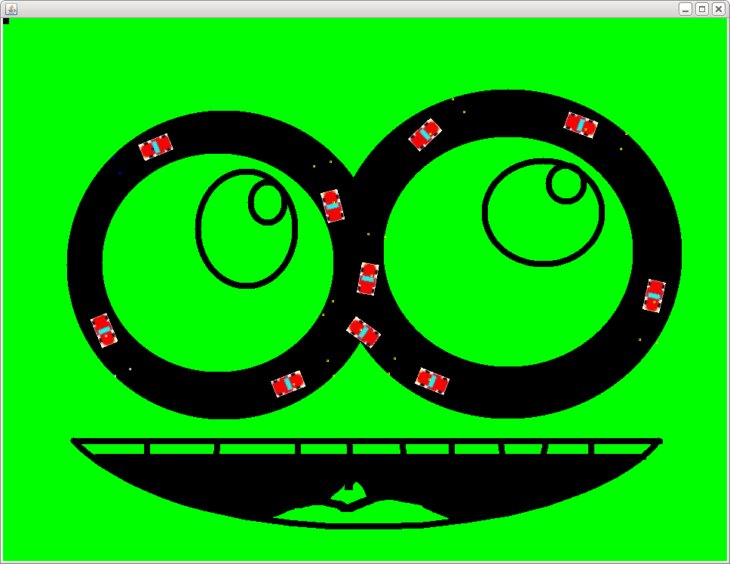
Figure 5.
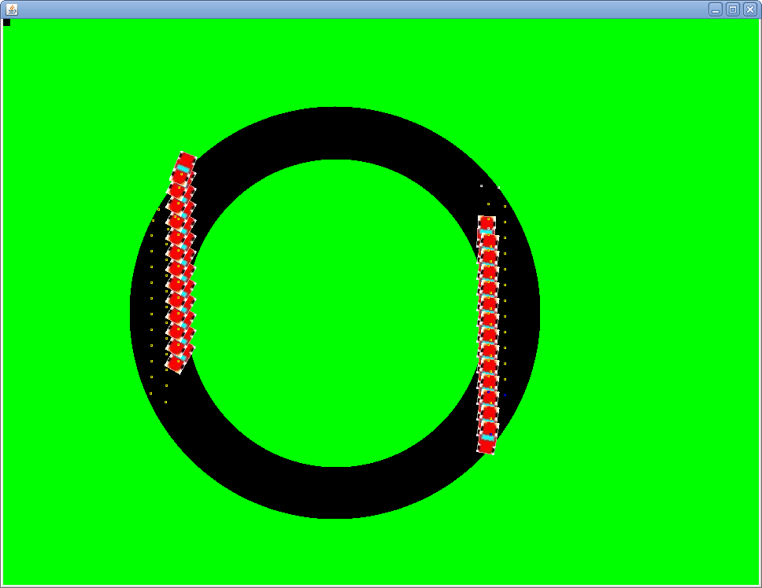
Figure 6.
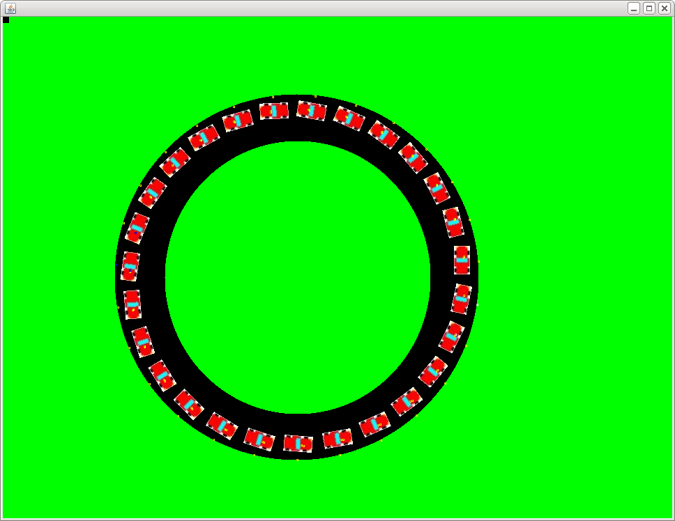
References
M. Ebrahim Foulaadvand, Sommayeh Belbaasi, Simulation of traffic flow at a signalised intersection, Journal of Statistical Mechanics, September 22, 2008. http://arxiv.org/abs/0809.3591

