Traffic Model Simulation
By: Jim Kaplan
Computer Systems Lab, 2008-2009
1/23/2009

Abstract
Traffic flow is an extremely complex procedure and is near impossible to figure out equations for. The best that can be done is to have complex simulations of the traffic in order to get a semi-realistic view of the traffic that can be controlled and experimented on at will. Simulating similar situations and behavior patterns closely results in other behaviors that can be studied and that can also be applied to real life as well.

Introduction
The problem of traffic is an apparent one: try driving in rush hour on any major road. Can traffic be improved? Is there a more optimum speed limit for the cars driving that could not only improve the overall traffic flow, but save a ton on individual and group gas prices? This simulation aims to figure this out.
The purpose of this project is to accurately model traffic situations and see how much the maximum speed limit affect traffic flux, given different numbers of starting cars. The way to model the traffic will be to use a two dimensional version of the Nagel-Schreckenberg model, which will be explained later in this paper.
This experimentation is important because it could affect the highway systems throughout the world. The Wilson Bridge near the District of Columbia uses a setup where the speed limit decreases with an increase in traffic. This project is to determine exactly how much the decreased speed limit will save the cars in the traffic flow in terms of time and gas, and therefore money. The real life application is very real, and necessary, as with our busy roads, a set speed limit just is no longer appropriate for the amount of traffic that these roads are receiving, and with the increase in population of the world, these traffic jams can only get worse.

Background
This subject has been researched before in various forms. One of the papers that researched traffic flow was Simulation of Traffic Flow at a Signalised Intersection. The goal of the project was to use the Nagel-Schreckenberg model to determine the reaction of cars to a stoplight at an intersection. The Nagel-Schreckenberg model is a way to determine how much a car moves in a one dimensional cellular setup. There are 4 steps to the process (Fig. 1): Determine the previous speed and then add 1 to each speed. Then find the number of cells between one car and the next and lower the speed of the car if necessary until the car has a speed of the number of cells in front of it. Also, a random factor comes in, where a random 1/3 of the cars have their speed decreased by 1. The cars then progress forward in their cells according to their speed. The values themselves are without units; however we can still see the developing of a wave pattern in this 1D environment.

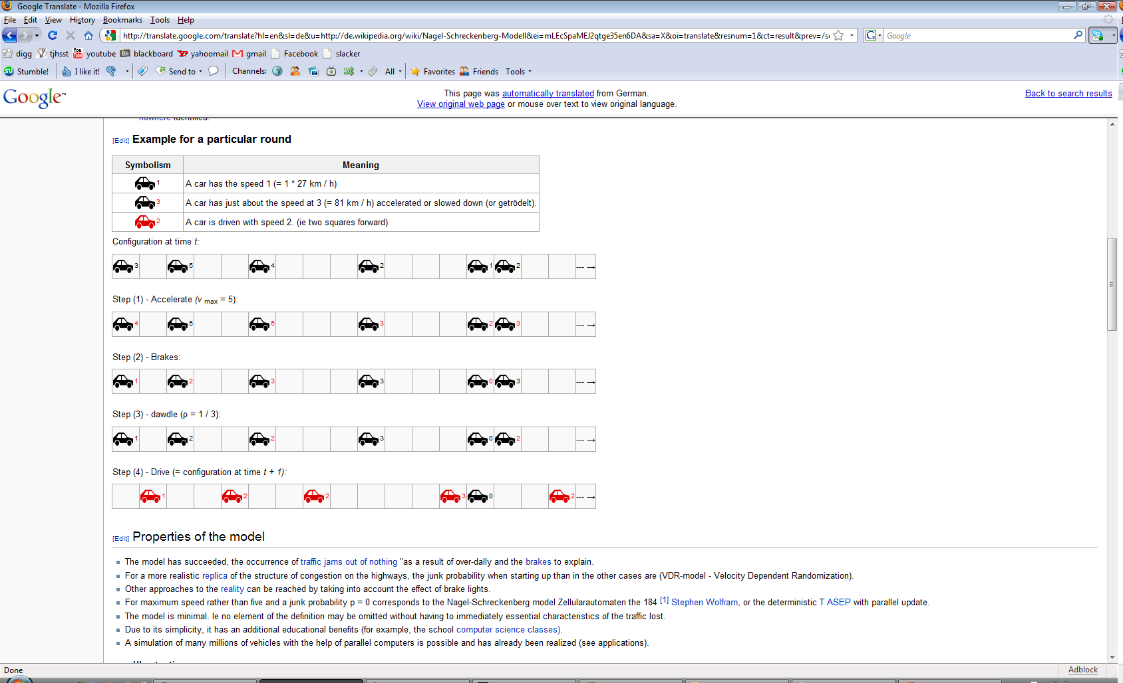
Figure 1.

Development
The project would be deemed successful if the wave patterns that appear in real life also appear in the simulation. First, In order to have successful pathing around a two dimensional environment, the car looks a certain distance in front of it, on both the left and right sides of the car (Fig 2.). If one of the two spots triggers (it detects a color that isn’t road), it turns away from that spot. In the actual simulation, these dots are shown (Fig 3.)

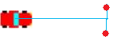

Figure 2.

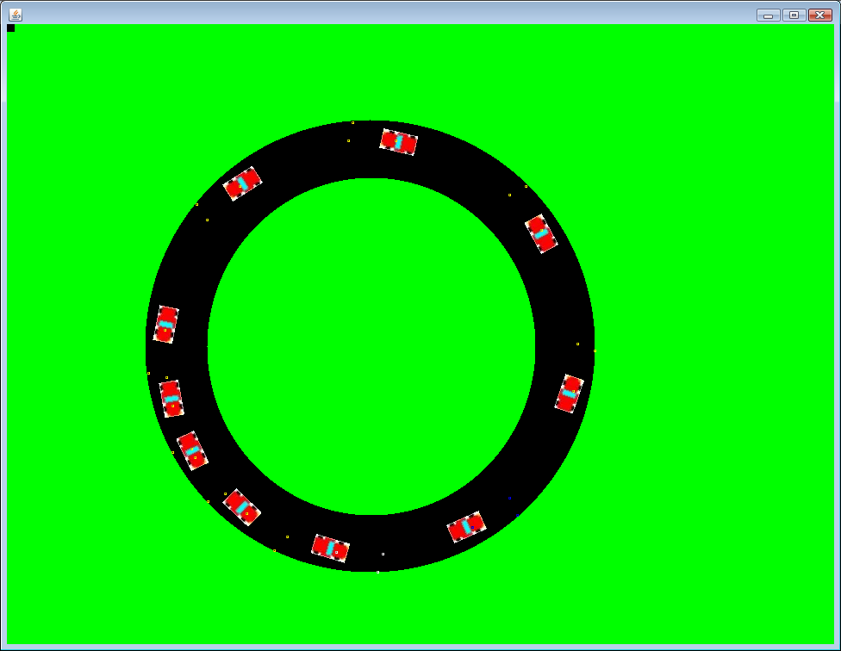

Figure 3.

The way that wave patterns would be achieved in a 2 dimensional environment would be to use a 2 dimensional version of the Nagel-Schreckenberg. Instead of looking ahead in the cells until you reach the first occupied cell, a 2 dimensional version would look for the first car in front of it in an arc. And instead of changing the speed with whole numbers, the speed would be a factor of the distance between the two cars. The idea of the Nagel-Schreckenberg, however, is that there is a time delay between the moving cars. In the simulation, this means that a car determines its speed, moves for a period of time under that speed, and after it has moved recalculates the speed. If there were no delay, the car would be calculating its new speed each step, which would represent a perfect simulation where a computer AI controlled all the cars (Figure 4.).

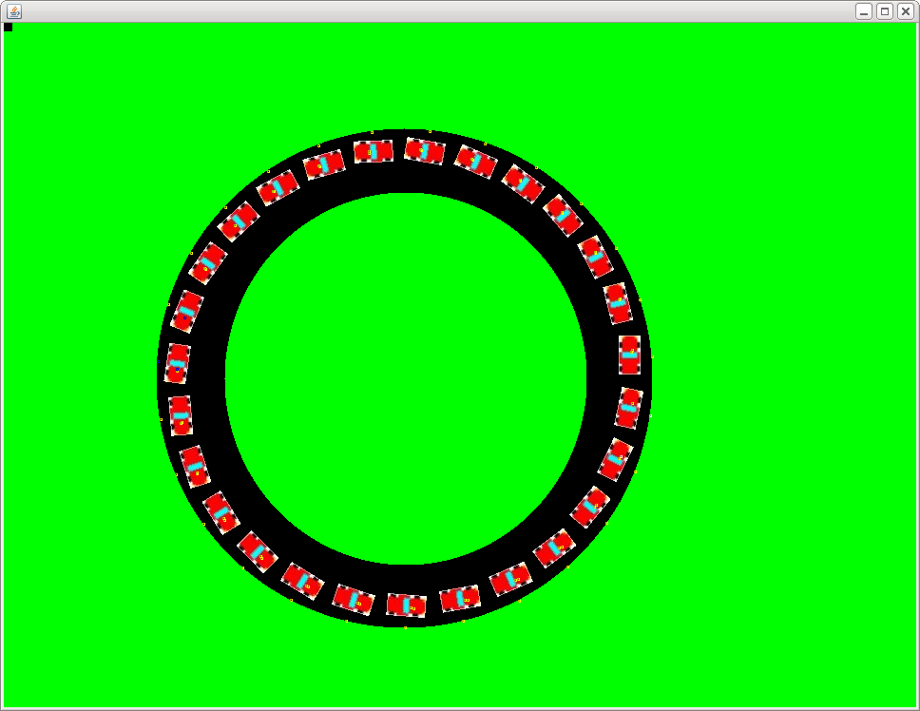
Figure 4.
To successfully detect other cars, the simulation has each car look in an arc 200 pixels in front of it, detect the closest car in that arc, and factor speed through there (Figure 5.).
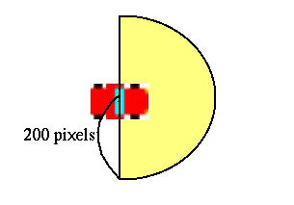
Figure 5. (Not to scale)

Finally, in order to calculate gas used, the simulation adds to a counter every time a car accelerates, thus finding the total acceleration, which is similar to how much gas is used. The amount of gas used while idling (when the car is going a flat speed) is 0 in this simulation.

Results and Discussion
The GUI (Graphical User Interface) looks like this:

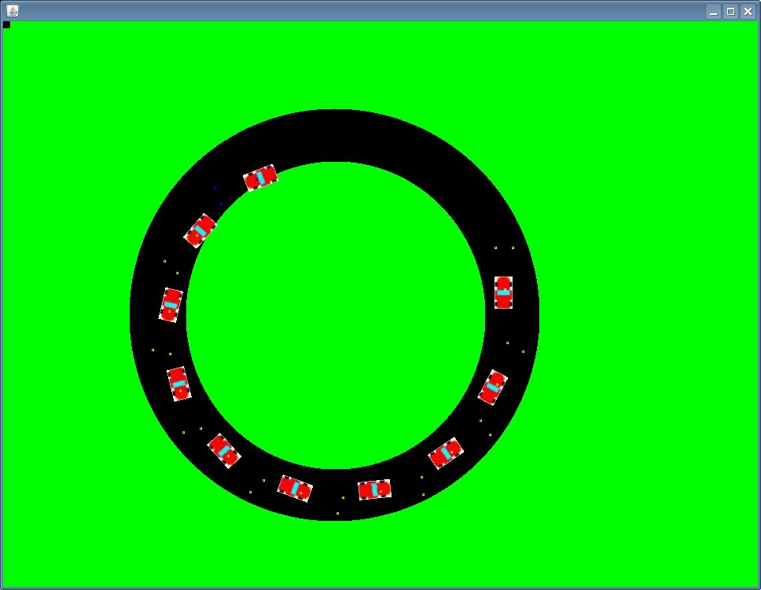
Figure 6. Starting conditions for 10 cars.

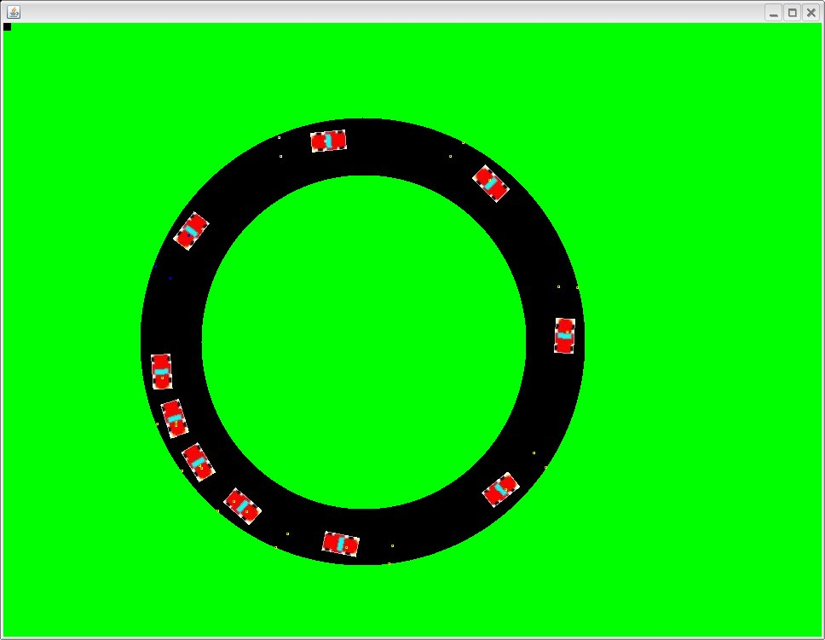
Wave Pattern
Figure 7. During the runtime for 10 cars.

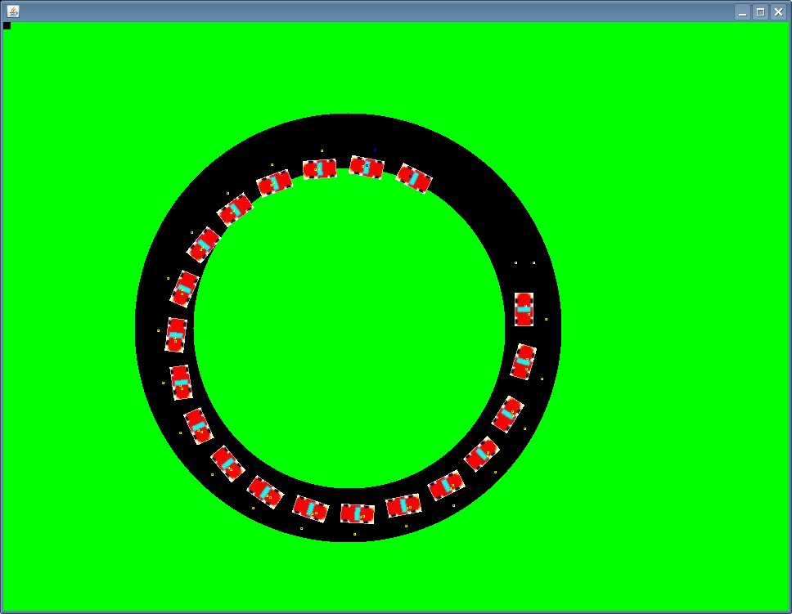
Figure 8. Starting conditions for the 20 car simulation

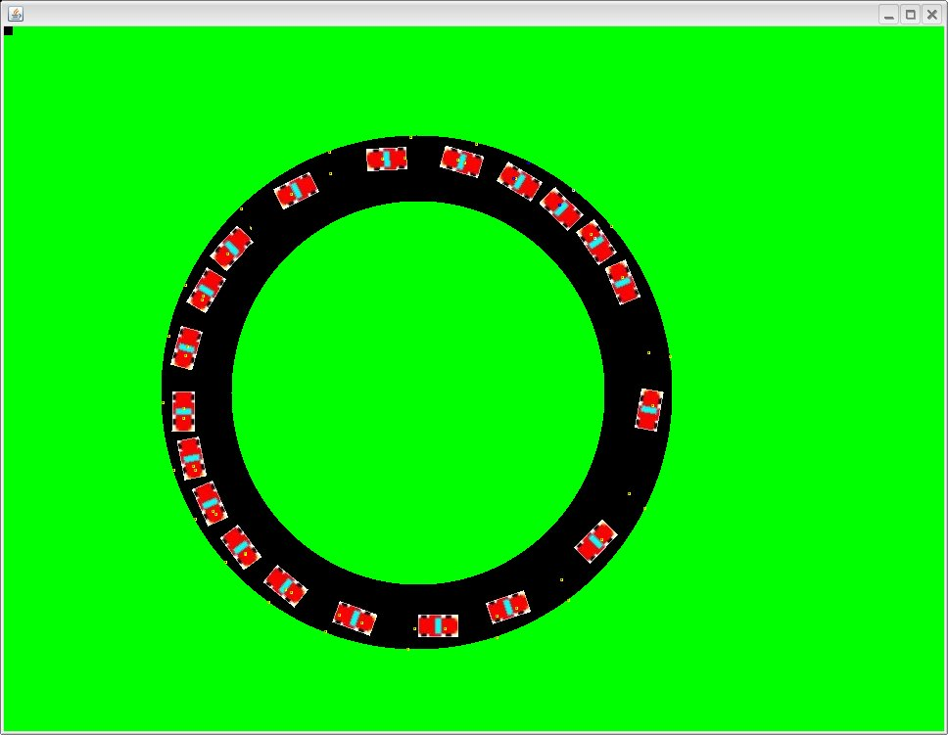
Wave Pattern
Figure 9. During the runtime of the 20 car simulation

As is apparent in the pictures, the wave patterns successfully form. You can tell by looking at the picture where the wave is by finding the clump of cars where there is a gradual acceleration in front but what would be a sudden stop behind it.
Wave patterns are bad for traffic. Not only does the stop and go traffic create more acceleration (and thus more gas) but it lowers the total flux of the traffic flow greatly, as is shown in Table 1. From this table, you could correctly conclude that the wave patterns start to appear when there are 10 cars. The maximum traffic flux for this simulation is 12 cars. What this means is that with the arbitrary value of a speed limit of 1, the most cars get through a single point per given time when there are 12 cars in the simulation.
With Table 2 there is a maximum speed limit of ½, however. As expected, the average times for low numbers of cars are doubled compared to that of Table 1, as there are no wave patterns being formed. With Table 2, however, the maximum traffic flux for this simulation is 16 cars. What this means is that with the arbitrary value of a speed limit of ½, the most cars get through a single point per given time when there are 16 cars in the simulation. Comparing this to Table 1, at 16 the time value is 198, while in Table 2 the time value is 178. What this indicates is that even though there is a lower speed limit, there are more cars getting through on average. Not only this, but because there are no wave patterns formed for the speed limit being so low, the gas saved is much greater. So with a lower speed limit there are more cars going through, as well as saving gas.
What these results indicate is that in heavily trafficked areas, if the speed limit were variable to lower with increased traffic, time and gas costs could both be saved.

Car number | average time | average gas used per car per lap | average gas used per lap
2 | 710 | 0 | 0
4 | 356 | 0 | 0
6 | 236 | 0 | 0
8 | 185 | 0 | 0
10 | 195 | 6.78 | 67.69
12 | 190 | 8.975 | 107.7
14 | 196 | 12.14 | 169.7
16 | 198 | 13.54 | 216.6
18 | 199 | 14.06 | 233.01
20 | 203 | 13.55 | 271.045
22 | 209 | 12.836 | 282.404
24 | 216 | 11.754 | 282.1
26 | 227 | 10.094 | 262.433
28 | 241 | 7.98 | 223.426
30 | 260 | 3.887 | 116.62
Table 1. Results for a Car’s Max Speed as 1.

2 | 1420 | 0 | 0
4 | 712 | 0 | 0
6 | 474 | 0 | 0
8 | 357 | 0 | 0
10 | 285 | 0 | 0
12 | 237 | 0 | 0
14 | 203 | 0 | 0
16 | 178 | 0 | 0
18 | 199 | 7.531 | 150.626
20 | 200 | 8.075 | 161.5
22 | 208 | 10.54 | 231.9
24 | 216 | 11.22 | 269.28
26 | 227 | 10.1 | 262.6
28 | 240 | 7.96 | 222.92
30 | 256 | 3.99 | 119.77
Table 2. Results for a Car’s Max Speed as ½.

Graph 1.
Graph 2. A closeup on the intersections in Graph 1.

Graph 3.
Graph 4.

References
M. Ebrahim Foulaadvand, Sommayeh Belbaasi, Simulation of traffic flow at a signalised intersection, Journal of Statistical Mechanics, September 22, 2008. http://arxiv.org/abs/0809.3591

