Modeling the Tragedy of the Commons Using Agent-Based Modeling
Computer Systems Lab, 2008-2009

Josh Lee

January 28th, 2008-2009

Abstract

The Tragedy of the Commons is an Experimental Economics social scenario wherein a number of autonomous individuals share a pool of resources. Conventional economic wisdom dictates that they should act selfishly, for their own benefit. However, the tragedy of the commons demonstrates that a community of individuals acting in this way will ultimately lead to the downfall of the community as a whole. The agent-based modeling simulations (ABMS) which can be created using the NetLogo software are an ideal means by which to model the Tragedy of the Commons.

Keywords: tragedy of the commons, agent-based modeling

1 Introduction

1.1 Rational

The Tragedy of the Commons is a real world problem which may be observed throughout the world. For example, one way America deals with its pollution is by putting its garbage in designated areas. However, space in a finite resource. When individual groups each contribute to the nation's pollution problem, it mounts into an exponentially larger issue. The Tragedy of the Commons exists in any environment consisting of autonomous individuals, who stand to benefit by taking from a shared resource pool. A practical solution to the Tragedy would have far reaching benefits.

1.2 Purpose and Goal

This project provides for a generic model of the Tragedy of the Commons. The parameters in the model are meant to reproduce those found in the original Agent-Based Modeling Simulation of the Tragedy of the Commons. This original model was based on the tragedy of the Sahel - a real world example of the Tragedy of the Commons. The model consisted of grass, cattle, and people. Cattle eat grass to gain the energy they need to survive, and people eat cattle to gain the energy they need. Grass repopulates the world at a set rate. This is not the most basic representation of the Tragedy of the Commons - if it were, it would consist only of cattle and grass. The secondary layer of people renders the model more complex and unwieldy, but also more useful and realistic. Many of the instances of the Tragedy of the Commons in the real world exist due to the patterns of human behavior. By incorporating a layer of people into the model, different types of human behavior may be incorporated and tested.

If the model's parameters are set correctly, the model should exhibit certain patterns. The grass, cattle, and people populations are graphed so that their trends may be tracked. The expected model behavior is for cattle and people populations to rise exponentially, reach a peak, and then drop off abruptly. After dropping to a certain point, the cycle will repeat, and the population will begin to rise on an exponential curve again. This pattern may be complicated by the three tier grass-cattle-people populations; for example, cattle are not only affected by the amount of available grass, but also by the number of people in the area consuming cattle. However, the basic exponential-drop off pattern should still come into effect.

The purpose of my project is to find a "solution" to the Tragedy of the Commons. As mentioned previously, the populations go through a rise-fall cycle. This cycle demonstrates the instability of the populations. When the population trends are too unstable, those populations may easily be rendered extinct by environmental perturbations. A solution to the Tragedy would stabilize the populations, so that they do not rise and fall so dramatically, but, rather, remain relatively constant. However, consistent population sizes are difficult to reconcile with the inherent desire to raise population productivity and growth to as high a level as possible. Herein lies the difficulty of solving the Tragedy. The ideal solution would alter human behavior, so that they take into consideration certain factors - namely, the expected behaviors of others in the area.

2 Background

2.1 Similar Projects

"Understanding the Tragedy of the Sahel" provides the foundation for this project. This paper documents the original modeling of the Tragedy of the Commons using ABMS. My project aims to duplicate that project, use it as a foundation, and then extend it.
"The Tragedy of the Commons as a Result of Root Competition" used ABMS to model root competition - that is, plants competing for space and nutrients. This resulted in a Tragedy of the Commons.
"Modeling the 'El Farol Bar Problem' in NetLogo" models - not the Tragedy of the Commons, but a somewhat similar Experimental Economics scenario - using NetLogo. The scenario it models involves a resource shared by a group of autonomous individuals. Their ability to utilize the resource depends on there being a low number of other individuals using the resource. The model programs the individuals so that they base their decisions, on whether to attempt to take from the resource pool , on whether they expect others to do so.

2.2 Relevant Theory

- "Understanding the Tragedy of the Sahel," Corey L. Lofdahl

The Sahel is an arid region in Africa. During the 1980's, its inhabitants (people and animals) suffered from drought, desertification, and famine. Lack of rain in this region limited the availability of resources, such as forage area for animals and the quality of the soil. The limited nature of these resources, and the fact that both people and animals in the region depended on them to survive were both characteristic of the Tragedy of the Commons.

This project examined the Tragedy of the Sahel using systems dynamics. The goal was to examine the issue using a more comprehensive and realistic method than had been used in the past, and, hopefully, to illuminate the root problems in the system and discover potential solutions. The initial model took into account three different types of "agents" - people, cattle, and grass. Cattle would eat grass to sustain themselves, and people ate cattle to sustain themselves. This scenario essentially regulated itself - for example, high populations of human or cattle caused grass levels to fall, which would cause famine, thus "correcting" the population.

To curb the cruel nature of this self-correcting environment, outside influences introduced the Sahel to modern technology. This had the unintended affect of overpopulating the Sahel - limited amounts of grass could no longer have as strong a stabilizing effect on cattle (and, thus, people) populations. Then, when a drought occurred, the now-higher population had, essentially, farther to fall. In other words, the populations still fluctuated as before, but with higher peaks and valleys.

This Sahel representation illustrates the complexity of the Tragedy of the Commons. With so many factors, something as apparently beneficial as technology ended up merely exacerbating the issues and destabilizing the environment.

- "The Tragedy of the Commons," Garrett Hardin

The paper establishes the Tragedy in basic, human-related terms: people undergo work to survive, and require energy to do this work. Ideally, the environment would include the maximum amount of goods possible for the maximum amount of people possible. However, these two goals are at direct odds with one another. A perfectly efficient, non-wasteful human would do nothing for pleasure, doing only the work required to live and taking in no more energy than necessary. A society with the maximum number of people - ie one consisting only of these perfectly efficient individuals - will not meet the "maximum goods for each person" requirement. The ideal situation an impossibility.

Determining the optimum for a Tragedy of the Commons scenario is complicated. Whatever the optimum, however, it will not include the maximum population possible. The ideal society would grow until it reaches the optimum; then, no individual in the society would take a greater cut than necessary to sustain the society at the same population level. Taking a greater cut would result in a Tragedy of the Commons. Obviously, this is a "moral" issue for societies to deal with, and not one which can be solved simply through the implementation of technology.
- "﻿Empirically Based, Agent-based Models," Marco Janssen and Elinor Ostrom
This project outlined the recent growth ABMS has seen and some of the findings this work has produced in the field of economics. Then the project discussed how these findings have been demonstrated non-empirically, suggesting that the next step, now that agent-based modeling has been proven to be a legitimate and useful method of study, is to find methods to generalize the findings and make them useful for further studies/applications.
- "Tragedy of the commons as a result of root competition," ﻿Mordechai Gersani, Joel Brown, Erin O'Brien, Godfrey M. Maina and Zvika Abramsky
This study dealt with competition between plants and the effects on root proliferation and seed yield. Two types of plant competition were studied: intraplant and interplant. Intraplant competition deals with multiple plants sharing a space, but where the space is divided into equal shares, and each plant is prohibited from accessing the resources in another plant’s share. In interplant competition, plants share the same amount of space as in intraplant, but now are free to use the resources of the entire region. Greater root proliferation leads to greater uptake of nutrients/resources. Greater seed yield leads to more productive plants.
What was determined here was the importance for individuals in a Tragedy of the commons to focus on defending their own “share” of the common resource pool. The paper suggests that the best way to defend one’s resources might simply be to acquire those resources for oneself, before anyone else has a chance to.
- "Modeling the 'El Farol Bar Problem' In NetLogo," Mark Garofalo
The purpose of this project was to model the El Farol Bar Problem using ABMS in NetLogo. This problem involves a member of autonomous agents who must decide whether to take from a common resource pool, based on their explanation that the other agents will take from the pool.

3 Development

3.1 Overview
This model is written using the NetLogo software. NetLogo's agent-based modeling simulations are ideal for this type of project as they allows for groups of autonomous agents and the programming of prescribed behaviors for each type of agents. NetLogo displays graphically and in real time the agents and the environment , and can easily chart aspects of the environment. Thus, the simulation may be easily modified, and observations may be made and conclusions drawn with ease.

The parameters of this model are based on an existing study which modeled the Tragedy of the Sahel. If the model is functioning correctly, the populations should oscillate regularly, rising exponentially and then falling abruptly. The ultimate aim of my project is to modify the environment so that the populations become and remain stable. Modifications to the environment, ie the means by which stabilization may be reached, include direct modification of the behavior of the agents, and the introduction of external environmental factors, such as technology, perhaps in the form of water wells.

3.2 Limitations
There is a conflict in setting up the model, between specificity and generality. That is, if the model is made to fit more accurately a specific data set or example of the Tragedy of the Commons, then the results from the experiment may not be useful for other applications.

3.2 Research Theory
The parameters are based on an existing Tragedy of the Sahel model. There are certain patterns to be expected, if those parameters are correctly replicated.
Grass - the foundation of the energy cycle within the model - grow at random with each time step. They do this indefinitely. Cattle and people are created within the environment at set up but, thereafter, may be created only through reproduction. Cattle and people undergo the same procedure at each time step: move at random, consume any available resources, reproduce if the appropriate energy requirements are met, and then die if they have failed to consume enough energy to sustain themselves in that turn.
There are certain, crucial factors which may be modified in real time as the model is running. These are grass growth rate, the amount of energy the consumption of grass provides, and the amount of energy the consumption of a cow provides. The survival and strength of the populations are most dependent on the likelihood that any specific individual in the population will find enough energy to sustain itself. As an example, raising grass-growth-rates will, logically, cause an increase in population. This limits the likelihood that any specific cow will be able to find food. Thus, the grass-growth-rate change will actually negatively impact cattle populations in the long term. Furthermore, increasing the amount of energy available makes the population oscillation cycles more dramatic. Larger oscillations increases the likelihood that a an environment perturbation will be exaggerated and lead to population extinction. This happens when the population's death rate is so steep that the population can not recover before every unit dies out.

3.3 Testing and Analysis

If the program incorporates reasonably realistic behavior, certain expected growth patterns should occur. Namely, the exponential growth-fall population cycle already mentioned. Furthermore, the populations should vary directly and inversely with one another. Once the model is advanced enough, different behaviors may be programmed into the people. These modifications may result in some emergent behavior in the people over a long period of time. One particular type of people, behaving differently from others, may emerge as the dominant class (for example, selfish people over altruistic people).

3.4 Visual Recognition
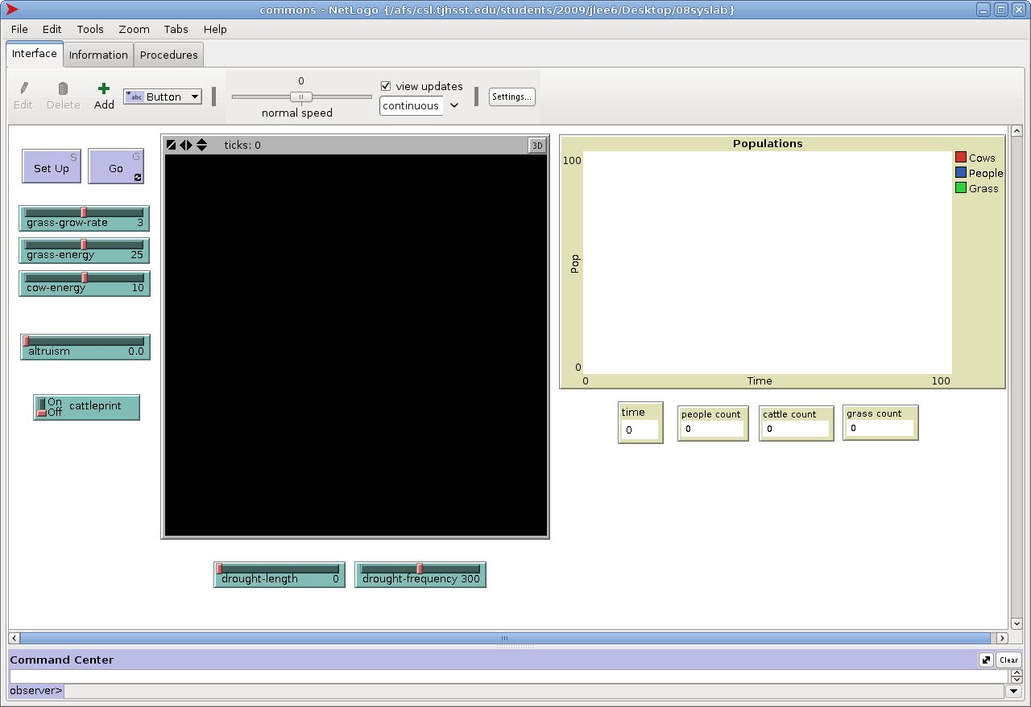
The program, at startup.
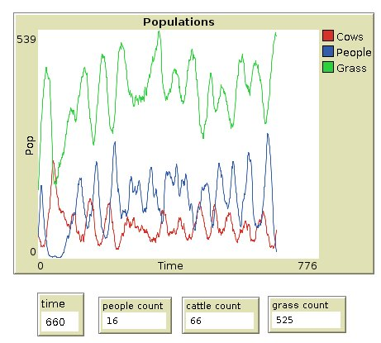
An example of the oscillating populations. These do not yet demonstrate the exponential pattern.

