Creation of Algorithms and Software For Use With a “Foosbot”
By: Michael Meadows
June 2008
Computer Systems Lab, 2008-2009

1-Abstract:

The purpose of the project is to create a functional AI to be physically integrated with a full sized foosball table. The project will involve two group members that will divide responsibilities between the physical automation and the “intelligence” behind the automation. The following will deal with the AI aspect of the project and how it relates to the physical constraints.
The Project was to be dealt with in three stages. The tracking was to be developed first. The defense and physical movement will come into play second. The offensive algorithms will be the third and final aspect of the project to be implemented. The idea behind all aspects of the project was to create an AI that will grow in skill the more it plays by analyzing past experiences. Some specific scenarios will be hard coded into the bot, but that is not the purpose of the project. The actual results and findings revolved almost entirely around the creation of the tracking algorithm and its operation.

Introduction:
Simple scenarios such as tic-tac-toe can be hard coded into systems because of the limited supply of possibilities. In more complex games such as chess the number of options grows extremely quickly and the ability to code for specific scenarios declines, however the computer can still have code written for types of scenarios. In the game of foosball we run into a different problem. Not all movements work in the same way. Just because the bot hits the ball at a certain angle at a certain time does not mean it will behave exactly as it did the time before. The reason for this is that there are far to many tiny errors we can not account for. The ball is not shaped perfectly, nor is the table’s surface. Due to imperfections in our control methods we are also unable to perfectly replicate a shot from instance to instance. We cannot account for spin or other similar factors. In order to meet the challenges of an environment that is not constant we seek to program an AI that will constantly adapt to the imperfect and changing environment. We aim to give the AI the tools that it needs to “evolve” to best fit the situation by teaching itself what we may be unable to perfectly teach.

Statement of Problem:
In order to allow AI's to continue to expand there areas of expertise we need to create a more effective method of programming them. Human beings are not coded from birth for every challenge that they will face, instead they are given a set of tools to adapt to new challenges. To replicate that effect we will strive to create a self taught AI only given guidelines for how it should develop. Perhaps the largest part of the problem is designing a mechanism that it can use to make sense of its environment. For the AI to have any hope of evolving it needs a set of tools to convert raw data from the world around it into something it can work with. This was largely the focus of the project, turning raw visual data into something that an AI can work with.

Statement again of the Purpose/Goal:

The problem set before the group is an integration of motion tracking with predictive algorithms and using these variables, to create a useful output to manifest in the movements of pneumatic reel control devices. The topic has many potential beneficial outcomes. Assuming that the end product is competitive and costs less than $32,00 USD there is potential to take the project to the market. Should the project fail to play on a highly competitive level then it shall serve a demonstration to future students and may serve as an educational resource by providing insight as to the integration of our three components.
The purpose of the project is to create a functional AI to be physically integrated with a full sized foosball table. The project will involve two group members that will divide responsibilities between the physical automation and the “intelligence” behind the automation. This paper will deal with the AI aspect of the project, with a chief emphasis on the tracking aspect, of the making sense of the environment.

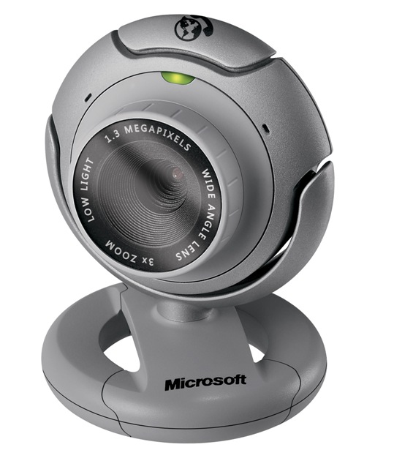
Background:

The concept of self teaching AI is definitely not new. Evolutionary AI’s are seen in basic form via simple on line equivalents to 20 questions. They are seen in more complex forms such as voice recognition and similar programs. It is not even new in the application of a "foosbot". German scientists have created a commercial table for sale, and several universities have created full projects on the creation of these tables, though most have met limited or no success. The University of Illinois has also created a functional table using the same cam we plan to use, the MS Lifecam. Taking university student’s success as motivation we decided to move ahead.

Development Sections:﻿
Creating a functional program to manage the movements of Foosball robot is a multistage process with several large obstacles. The fundamental difference between the play style of the robot and the human, is that while the robot may have better reaction time (.05 seconds and up in our case as compared to a humans .1), the human has a much better innate ability to recognize patterns and predict actions then does a computer.
To counter this discrepancy the team will attempt to improve on two fronts at the same time. The team will attempt to increase the frame rate (Reaction time of the bot) as well as the precision and speed of movement of the mechanical system. Secondly the team will attempt to improve the computers ability to predict ball's movement to compensate for imperfect reaction time.
In order for the bot's AI to function it will need a method to determine the balls position in real-time. To solve this issue the group determined to use software from “Processing.org” and a Video Digitizer. This software working together converts a video stream into a 2-D array the values of which will contain the colors of the pixels. Using a preselected ball color that is significantly different from the rest of the objects on the table, we should be able to determine the balls position in real time by examining the values in the video array. We require and expect to have at least .35in resolution from the camera. If this is not achieved then the table will not be able t respond to ball movements because it will lose the motion amidst the poor resolution issues.
Once the balls position on the table can be determined we can begin the construction of the defensive algorithm. At every frame the balls position will be recorded, the position will also be recorded in the subsequent frame. The first and second frame position will be used as keys in a map where the contained value will be the coordinates where the ball should cross the subsequent reels. The contained value will be determined simply by an average of past experiences. The defense will not so much anticipate the ball movement as it will remember previous scenarios that were identical. Over time the program will create a map of nearly all unique ball paths (Not all paths will be recorded, only the ones that are significantly different from previous paths.)
The offensive algorithm will come in second and will utilize a different approach. The offense will record 50 algorithms to describe 50 different shots. Every time the program takes a shot that is not described by one of the 50 algorithms(it will shoot randomly with only a few guidelines about 10% of the time), it will create a new algorithm to describe that shot (initial position of ball and foosmen (Objects along the reels), as well as amount of power). As each algorithm is used it will be awarded points for weather or not it went into the goal, or if not then how close it came to going in. If the newly generated shot's point score is higher than any of the previous 50 shots, the lowest rated algorithm is forgotten and the new shot is adopted into the shot table. Over time, and by taking new shots randomly the machine should acquire 50 accurate and hard to block shots.

Developmental Procedures:
The next areas can be prefaced by the fact that only the tracking methods and algorithms were ever fully completed and tested. Desite that the general original program flow was kept in mind. The constantly tracking program would store the current data which would move to control the reels. The results of each instance would then be evaluated and the process would repeat. The visual tracking aspect had to tackle a few problems. First off and perhaps most importantly were the hardware limitations that had to be kept in mind. The resolution of the camera was quite limited but what was worse is the fact that the computer would not be able to stay anywhere near real-time if the resolution exceeded 320x320 Pixels (Determined by experimentation). Because of this, a lot of work needed to be done with the tracking methods. What was decided on was not constantly writing the paths but have a separate learning and playing mode. Additionally we scaled back the resolution even further and learned to live with a little lag. Also by limiting our search for the correct color to the last known frame location area we could speed up the search algorithm. Many of these modifications were made easy because of the extensive libraries that come standard with Processing. Processing allows many of the needed operations in searching through video streams to be done in a standard format which truly helped.
Although the actual playing of the table was never truly developed this is largely because the task chosen to complete was simply to gigantic. What was accomplished was quite effective at what it was meant to do. In that the program developed can track specific user selected colors in real time, in a fairly high resolution video feed. This program allows the tables “future” AI to be able to “see” the ball in a manner similar to how a human player would. The table can now perceive certain patters and then search for them again in a fashion similar to humans.
A lot of our modification work was actually done at the start of the code:
void setup() {
size( 320, 240 );
video = new Capture( x, y, z, 10 );
image = loadImage(Some Image file (foosballtable))
We spent some time playing around with different resolution configurations to attempt to maximize the speed of the tracking while still having the accuracy of the tracker be sufficient to keep its “eye” on the ball. Not everything was successful, but eventually we did in fact develop a program that could keep track of the ball to within ½ the diameter and maxed out at around .3 seconds of delay during intense motion.

Conclusion:
In conclusion the project was a success taken for what it is. Taken in terms of the original scope it was miserable failure. This is more do to a poor appraisal of what a fully functional AI controlled table really takes. There is a reason that the German table costs several thousand Euro. Regardless the code generated would be incredibly useful in the creation of future projects that need a similar base for their construction. What was accomplished was an incredibly powerful learning experience and the creation of a tool for interesting use in future projects. On a more technical level the limitations of hardware over software were explored in an interestingly realistic manner and while the results were saddening, they were incredibly educational.

Acknowledgments
I would like to thank Dynamo Toys for their donation. I would also like to thank my partner James Heard for inspiration. A special thanks to Mr. Latimer for putting up with my rather nasty combination of procrastination and disorganization.

