COMPUTER SYSTEMS RESEARCH
Code Writeup of your program, example report form 2008-2009
- Your name: Brendan Greenley, Period: 3
- Date of this version of your program: Oct. 28, 2008
- Project title: Epidemic Modeling in NetLogo
- Describe how your program runs as of this version. Include
-- files that may be needed
Open up NetLogo 4.0.3.
File…
Open..
avianflu.nlogo/avianflurework.nlogo (I currently have two versions of my model, the first uses System Dynamics, the second primarily uses arrays in the non SD procedures window)
-- algorithms, specific procedures or methods you wrote
-avianflu.nlogo uses System Dynamics, and thus I did not write any code, per se, but did create an original system with flows and stocks, as seen in screenshot below. I also added sliders and buttons to the GUI, which is seen in later screenshots.
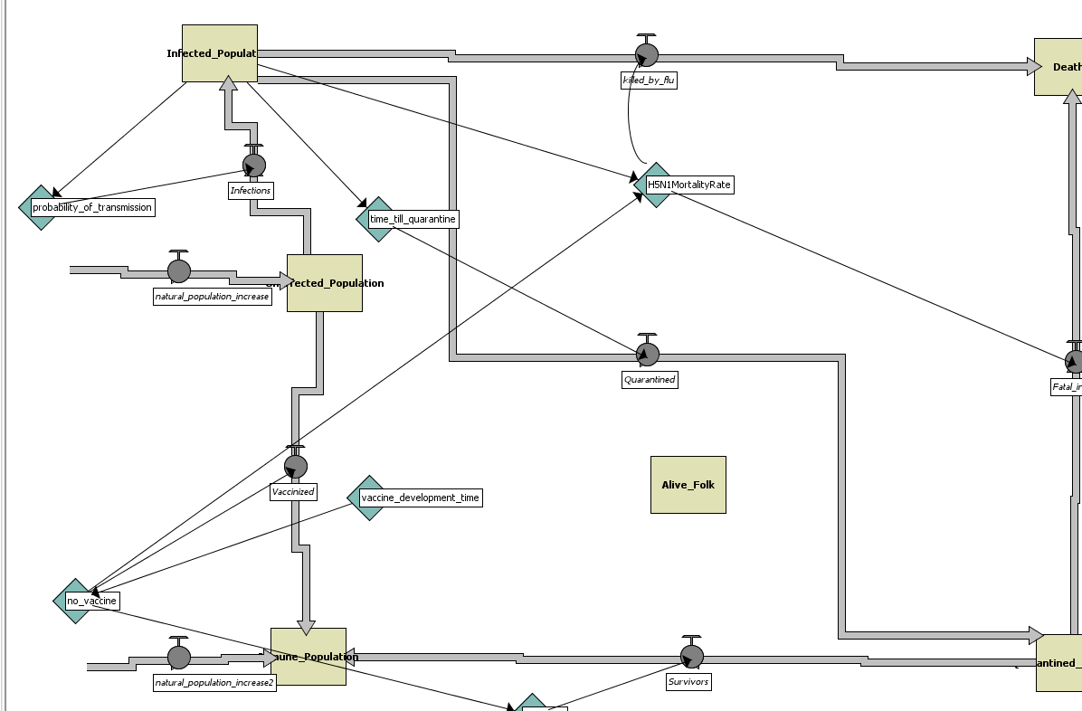
Figure 1. System Dynamics setup in avianflu.logo
-avianflurework.nlogo uses primarily non-System Dynamic code, and has actual chunks of code I put in that use arrays to cycle populations between alive, infected, quarantine, and dead. Such code appears below.
;;Cycle through qurantined array, move qurantined population to deaths/surviviors, set first index of qurantined array equal to last index of infected array
let deathsthisstep (array:item q (array:length q - 1) * H5N1MortalityRate * no_vaccine)
let survivors (array:item q (array:length q - 1) * (1 - (H5N1MortalityRate * no_vaccine)))
set Deaths (Deaths + deathsthisstep)
show " Deaths (after) " type Deaths type "\n"
let z ((array:length q) - 1)
while [z > 0]
[
array:set q z (array:item q (z - 1) )
set z z - 1
]
array:set q 0 (array:item i (array:length i - 1))
;;
;; Cycle through infected array; set first index equal to the number of people who have been infected for more than one day
set z ((array:length i) - 1)
while [z > 0]
[
array:set i z (array:item i (z - 1) )
set z z - 1
]
set z ((array:length i) - 1)
set Infected_Population 0
set z ((array:length i) - 1)
while [z > 0]
[
set Infected_Population (Infected_Population + (array:item i (z - 1) ))
set z z - 1
]
array:set i 0 (Unaffected_Population * probability_of_transmission)
set z ((array:length q) - 1)
set Infected_Population Infected_Population + array:item i 0
while [z > 0]
[
set Quarantined_Population (Quarantined_Population + (array:item q (z - 1) ))
set z z - 1
]
set Unaffected_Population (Alive_Folk - Infected_Population - Quarantined_Population + survivors)
set Alive_Folk (Alive_Folk - deathsthisstep)

-- kinds of input your program uses
-NetLogo GUI
-Sliders (currently taken out because of error with “Already defined” variables)
-Mouse clicks (buttons)
-- screenshots, what kinds of output does your program have
--Graph of stock values
--Monitor of stock values
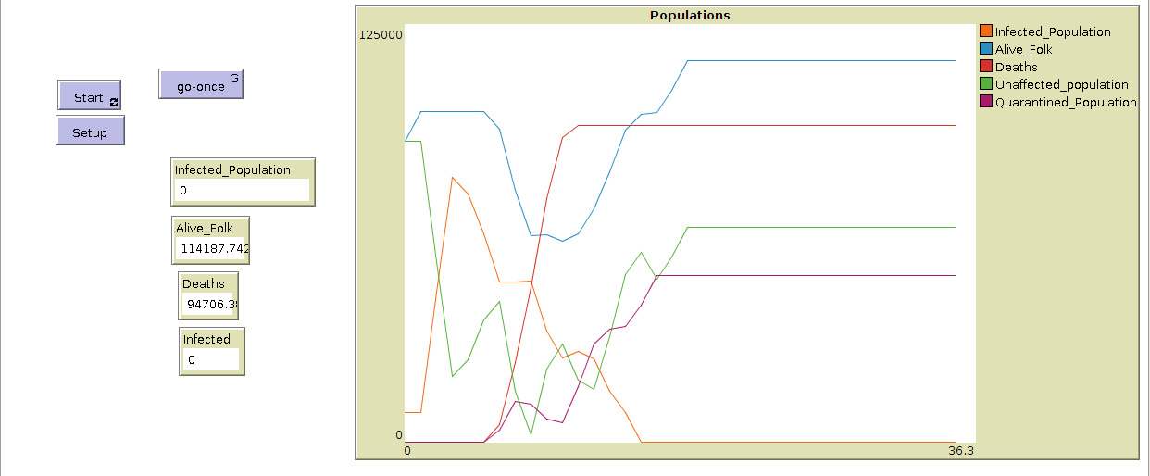
-- does your program handle errors, or does it crash on errors of input?
If there are errors in the code, it refuses to run, as NetLogo debugs the code on the fly and refers the user where the code is invalid.
-- tests: summarize the basic analysis and testing of this version of your program
- The most basic way to test my code is to watch the graph of the stocks and see if they make sense, which is primarily what I have been doing. Currently, I feel my stocks are all updating correctly, except for the deaths stock, which looks to be approximately twice what it should be. In terms of analysis, I have started changing variable values and seeing how the shape/slope of the graph changes. By doing so I can get a basic idea of how to create a virus with a specific characteristic and see how a population is affected.

- What do you expect to work on next quarter, in relation to the goal of your project for the year?
-I plan on expanding my System Dynamic model further, and leave my array-based model to be revisited at the end of the year if I have time. I want to make my flows more complicated and try to implement variables that change over time (proportional to ticks) or that change when a certain trigger is met (vaccine when x% of total population infected.) Basically I want my project to have greater flexibility in what a user can change and also have it be more realistic.

