COMPUTER SYSTEMS RESEARCH
Code Writeup of your program, example report form 2008-2009
- Your name: Chris Beacham Period: 5
- Date of this version of your program: Oct 22
- Project title: Evolving Sheepdog and Cutting Horse Behavior in Simulated Herds
- Describe how your program runs as of this version. Include
-- files that may be needed
swarm.avi
it has no dependencies other than tkinter, which comes standard,
-- algorithms, specific procedures or methods you wrote
Flocking algorithm, with the three components : cohesion, separation, alignment,
as well as a mouse seeker, and a random direction.
-- kinds of input your program uses
The program takes continuous mouse movement to run, as a function of tKinter.
-- screenshots, what kinds of output does your program have
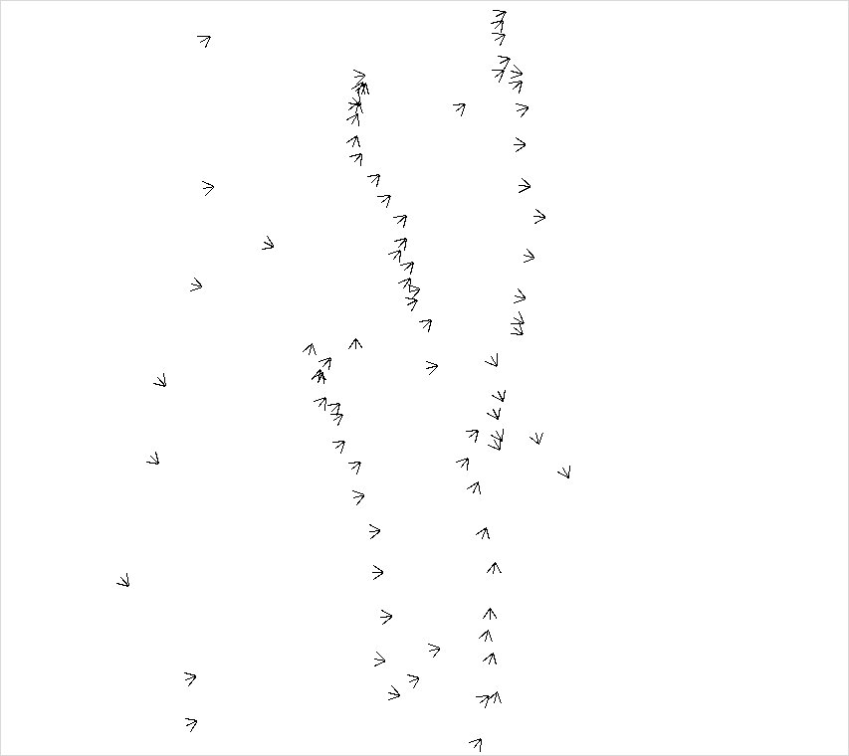
As of right now, the program is pretty simple. It takes in continuous mouse movement, and outputs an image of boids flocking around the screen. I've removed the mouse seeking aspect of the boids behavior, but in the past they have followed the mouse around.
-- does your program handle errors, or does it crash on errors of input?
There are no errors of input. They cannot occur. If the mouse moves inside of the program area, the birds move, otherwise the do not.
-- tests: summarize the basic analysis and testing of this version of your program
This version of the program shows good flocking behavior. They approach the V shapes of migrating geese, without having that ever been programmed in. They show strong emergent behavior, acting complexly without any human input.

- What do you expect to work on next quarter, in relation to the goal of your project for the year?

Next quarter, I expect to perfect this flocking algorithm, then slow it down and fine tune it to make it simulate a herd of livestock. Then I expect to make a herding agent, and perhaps create a gene pool to determine it's behavior. After that, it should be a simple matter to evolve sheepdog behavior from the herding agents.

