COMPUTER SYSTEMS RESEARCH
Running Version of Your Program, example report form 2008-2009

Your name: _Josh Lee_________________________, Period: _3___

Date of this version of your program: _10/30/08______

Project title: Modeling the Tragedy of the Commons through Agent-Based Modeling

Describe specifically what files are needed and the command(s) necessary to run your program
How to run your demo:

1) Use the terminal to navigate to the NetLogo folder.
2) Run NetLogo with the terminal command:
java -jar NetLogo.jar
3) Once NetLogo is open, access the File menu, select Open, and open the "commons.nlogo" file.

Your program is running, now what? List test input(s) for the user to interact with your program. Specifically what should the user expect to happen?
Input(s):

-"Set Up" resets the environment to its starting conditions.
-"Go" begins running the model. Once this button is depressed, clicking it again will turn it off and stop the model.
-The key inputs are sliders for: "grass-growth-rate," "grass-energy," and "cow-energy."

Program's expected response(s):

The survival and strength of the populations depends on the likelihood that any specific individual in the population will find enough energy to sustain himself. As an example, raising grass-growth-rates or grass-energy will essentially increase the amount of energy available to cows, which will cause cows to first decrease and then increase in population. Increasing the amount of energy available makes this effect more dramatic - the oscillations in population will be of a greater magnitude. Larger oscillations increases the likelihood that a population will go extinct. This happens when the population's death rate is so steep that the population can not recover before every unit dies out.

There is a row of inputs below the model window. These seem to have no major affect on the way the model runs, as the environment balances them out automatically.

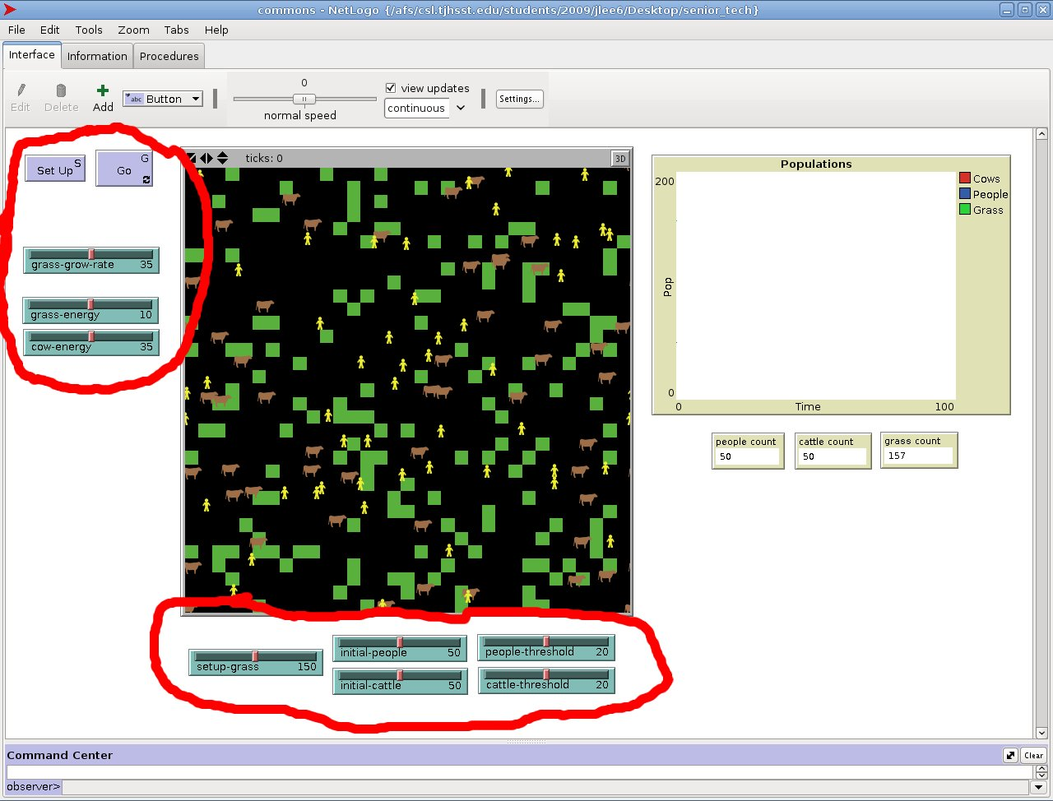

What about user input errors? Are there incorrect user input(s) that your program handles?

The GUI I have created through NetLogo allows virtually no opportunities user input errors.

What is the programming doing, demonstrating, or analyzing? What is the user looking for in order to understand what you've been studying and developing with this project?

The population trends are displayed on a graph. This graph demonstrates the inverse-proportionality trend the different populations possess between one another. When a population is too large, the environment "fixes" the situation naturally - the pool of resources available to the too large population is too limited, so the population size falls. Changing how the pool of resources functions has direct consequences on the magnitude of the population trends. This demonstrates the basic concept of the tragedy of the commons.

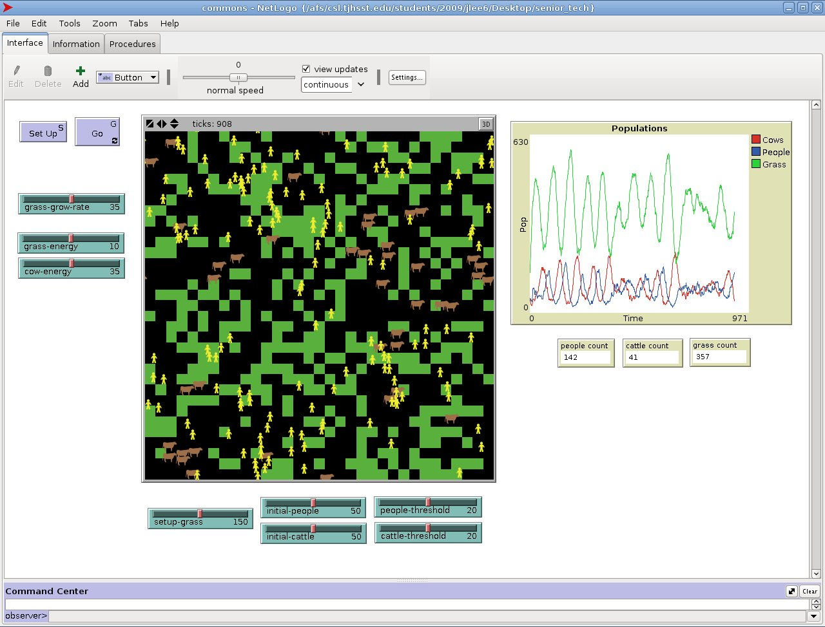

By the end of this school year, what do you hope to have as a final version of your program in relation to this current version? What will you demonstrate during your final presentation?

A program which demonstrates similar trends to what I have now. However, by modifying the environment in some way - eg altering the behavior of my populations or adding another factor/agent to my environment - the population trends should remain stable (ie not oscillate).

