COMPUTER SYSTEMS RESEARCH
Code Summary First Quarter 2008-2009
- Name: John Walsh Period: 1
- Code version and date: Seven - 10/30/08
- Title: Artificial Intelligence in Multi-Agent Modeling
- Describe how your program runs as of this version.
  - L.java, Simulation.java, Predator.java, Prey.java, Agent.java are used to run it.
  - This version approaches a basic level of an agent-based model, with a basic environment in which each agent moves and interacts according to methods that are defined separately. So far, only the interaction between predator and prey has been defined, as the predator growing and the prey dying. Also, the program can be set to have a predetermined seed for the simulation, allowing simulations to be repeated, but this is set inside the code, meaning no user input is allowed.
  - Run with two instances of the simulation and random seeds:
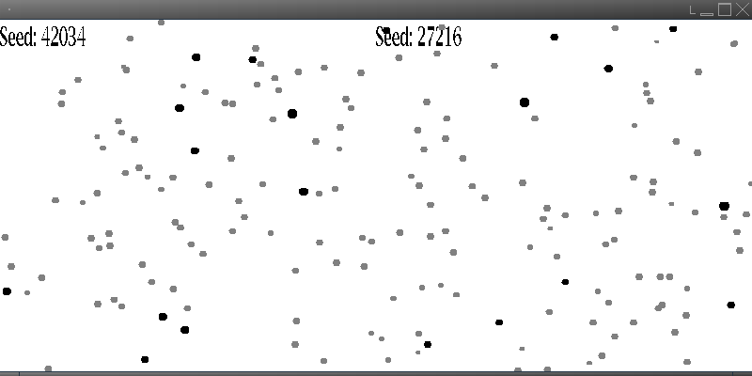
  - Run with two instances and the same seed:
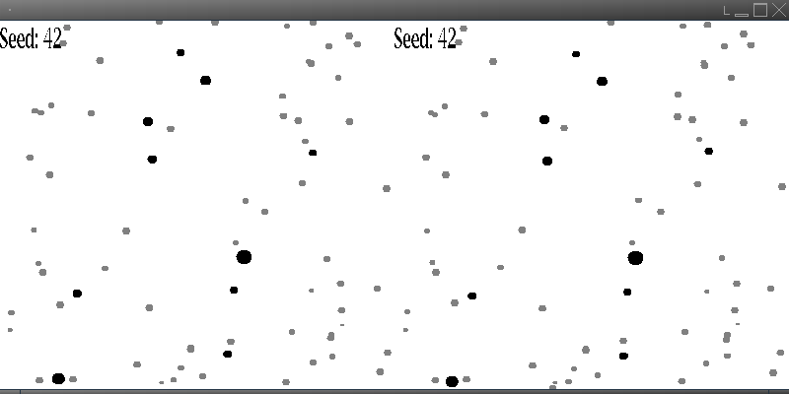

- What do you expect to work on next quarter, in relation to the goal of your project for the year?
Next quarter I intend to implement adjustable user input, to allow for simple testing of the program with different initial variables. I plan on displaying graphs as the program runs of the populations of each kind of agent, to assist in making initial observations. I also intend to implement a method of outputting the data for each run to a file, for further analysis. I plan on beginning work on artificial intelligence for the agents, to complete my project

