COMPUTER SYSTEMS RESEARCH
Code Writeup of your program, example report form 2008-2009
- Your name: _Joshua Yoon______________________, Period: _2___
- Date of this version of your program: __10/30/08____
- Project title: __Modeling the Effects of Disasters on a Human Population_____
- Describe how your program runs as of this version.
My program can be shown as a diagram, so I'll go through each piece of the diagram and how they fit together.
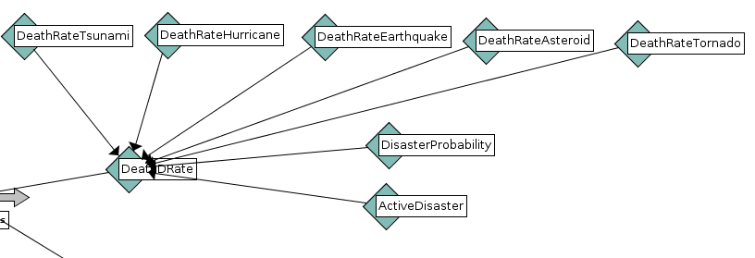
This portion of the code handles everything there is to handle about disasters. The death rates are made by the different converters (blue diamonds), and each death rate is set to a constant. The DisasterProbability converter handles the frequency of a disaster. The converter creates a random integer from 0 to 400 and if that random integer is equal to 1, then the disaster(s) is turned on. The ActiveDisaster converter calculates new death rates if more than one disaster is turned on at once. All of these converters connect to DeathDRate, which is the final death rate due to disaster after all the disaster related death rates have been accounted for.
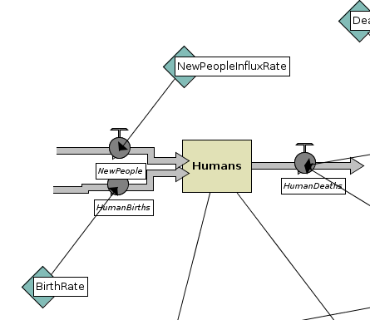
This diagram controls the actual human population signified by the stock (tan box). There is an inflow (gray arrows going into stock) of people, which are new people added to the already existing population, and then there is the outflow (gray arrow going out of stock) which signifies the death of individuals in the population. The inflows are controlled by converters such as BirthRate and NewPeopleInfluxRate, whereas the outflow is controlled by the DeathDRate and DeathNDRate.

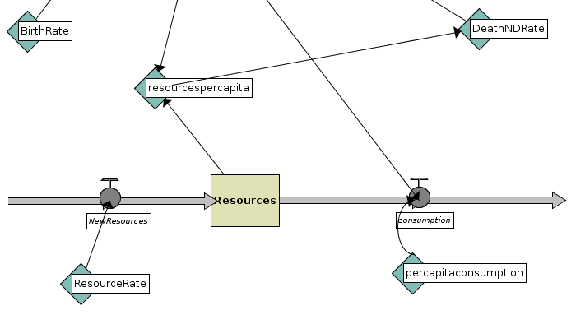

This is another stock called resources. This stock represents the resources, which are available to the population and this in turn keeps the population in check. I made this class originally to create a carrying capacity, but now I'm implementing it so that resources can also be affects by disasters. The DeathNDRate stock stands for the non-disaster death rate, and basically it is controlled by the resources and how abundant the resources are compared to the size of the population.

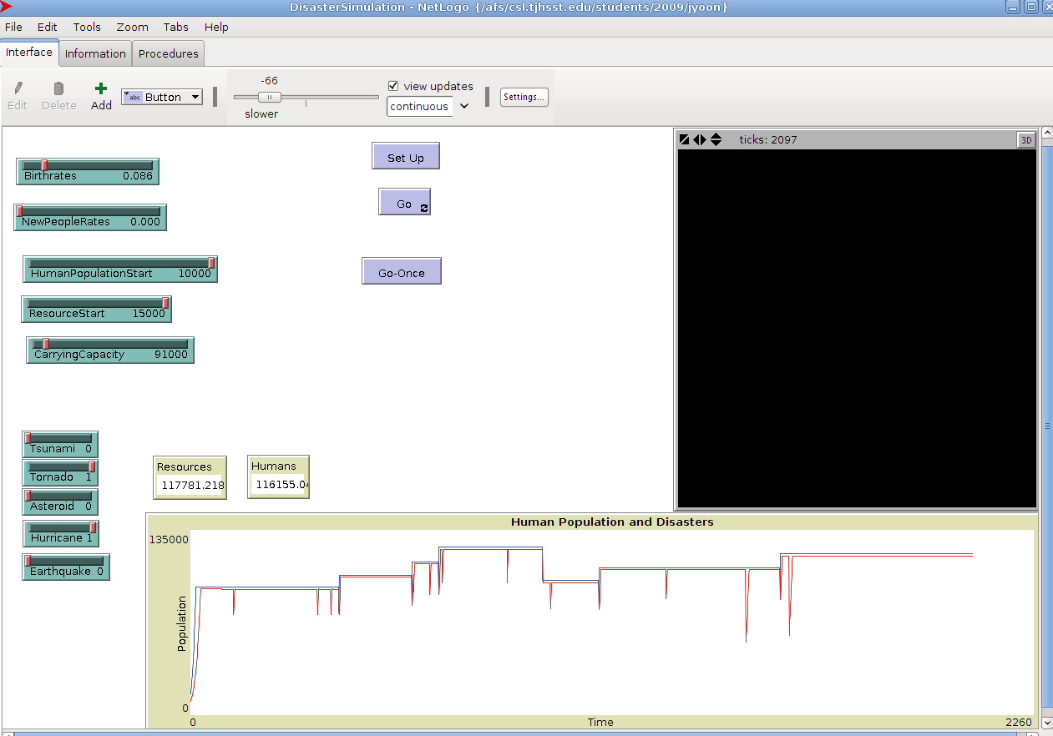
This is the test run of the code itself. The population seems to stay in check with the resources, and the disasters are occurring (represented by the sharp drops), but the graph is much to straight and flat.
- What do you expect to work on next quarter, in relation to the goal of your project for the year?
As shown above, the graph of my test run is too flat, sharp, and unnatural. I need to figure out a way to make the graph smooth, less erratic, and make it function better. At the moment, there is no recovery curve, nor a significant lag time. Those are the things that I need to fix first, before I start looking and comparing my simulations to actual data.

