COMPUTER SYSTEMS RESEARCH
Code Writeup of your program, example report form 2008-2009
- Your name: _____Maya Wei_________, Period: __5__
Date of this version of your program: ___October 24, 2008__
Project title: ___Analysis of Graphs: Identifying Points on Scatterplots_____
Describe how your program runs as of this version.
The input files (images in png in order to ensure cleaner pictures) needed in this version were for the purpose of color recognition:
Using this image, it was possible to identify that the BufferedImage’s color identification was properly used. Originally, this was more complex when using PixelGrabber instead of BufferedImage. However, both correctly identify the transition between black and white.

The graph that is being utilized for current tests is the following:
This is a simple graph created by OpenOffice’s Calc, it’s version of Excel. Guidelines have been eliminated, the points are squared – all edges are easily detectable. There is no background color – rather, the background color is the same color as the pixel at (0, 0). All extraneous graph details have been eliminated. The points are at the graph’s (0,0), (1,1), (2,2), (3,3), (4,4), and (5,5).

All images are in png in order to ensure clearer images.
Algorithms used include a very simplistic form of edge detection. Given a point, check its surroundings to the left (x-1, y), right (x+1, y), up(x, y+1), and down (x, y-1). Is there at least one point in those four that is the same color as the background? If there is, then this is defined as an “edge.” This will be an algorithm that shall be consistently updated throughout the year.
Other methods used involve making the following panel:
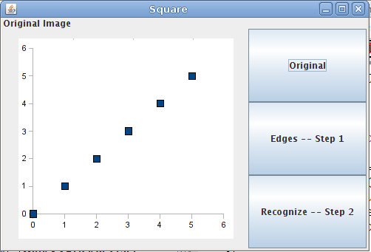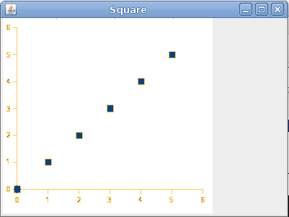
This image on the left is when one clicks on the “original” button. Step 1, edges, utilizes the algorithm described above.
The image on the right (screenshot taken pre-GUI) is identification of the “edges.” The edges are in orange. Interestingly, the numbers are defined as edges, which provides an obstacle in identifying the individual points.
The program doesn’t handle programs too well – while the GUI still runs, there is a mass of errors. As of right now, however, the errors are at minimum.
This version is very primitive – the edge detection, if anything, is lacking. At the very least, it should check the points diagonal to the point given (in order to accommodate the diamond / circle points that some graphing programs used).
- What do you expect to work on next quarter, in relation to the goal of your project for the year?
I expect to be working on being separating the “axis edges” from the “point edges” from the “numbers on axis edges.” From there, it would involve taking the location of the center of each of the point edges, finding its location relative to the axis. The axis will be defined (most likely) from user input – for example, we’d have to give the computer the fact that the axis is, in the graph, six units long. Text recognition is a little advanced at this point in time.

Ideally, by the end of second quarter, the program will be able to read the graph, at least in a primitive fashion.

Code -- drawingImages.java

import java.awt.*;
import java.util.List;
import java.util.ArrayList;
import java.util.Iterator;
import javax.swing.*;
import java.applet.*;
import java.awt.image.BufferedImage;
import java.awt.image.PixelGrabber;
import java.awt.image.MemoryImageSource;
import java.awt.*;
import java.awt.event.*;

public class drawingImages extends JPanel {
Image i, j;
Image mem_img, our_img;
JLabel label;
JLabel title;
int step = 0;

public drawingImages(){

setLayout(new BorderLayout());
ImageIcon q = new ImageIcon("graph.png");
label = new JLabel(q);
title = new JLabel("Original Image");

i = q.getImage();
BufferedImage bimage = new BufferedImage(i.getWidth(null), i.getHeight(null), BufferedImage.TYPE_INT_RGB);
Graphics temp = bimage.createGraphics();
temp.drawImage(i, 0, 0, null);
temp.dispose();

JButton orig = new JButton();
orig.setText("Original");
orig.setEnabled(true);
orig.addActionListener( new ListenerOrig(q));

JButton button = new JButton();
button.setText("Edges -- Step 1");
button.setEnabled(true);
button.addActionListener( new Listener(bimage) );

JButton button2 = new JButton();
button2.setText("Recognize -- Step 2");
button2.setEnabled(true);
button2.addActionListener( new Listener1(bimage) );

JPanel buttonHolder = new JPanel();
buttonHolder.setLayout(new GridLayout(3, 1));
buttonHolder.add(orig);
buttonHolder.add(button);
buttonHolder.add(button2);

add(title, BorderLayout.NORTH);
add(buttonHolder, BorderLayout.EAST);
add(label, BorderLayout.CENTER);}

public void makePanel(ImageIcon ic, String name){
label.setIcon(ic);
title.setText(name);
}

public class ListenerOrig implements ActionListener
{
private ImageIcon ic;

public ListenerOrig(ImageIcon q){
ic = q;}

public void actionPerformed(ActionEvent e){
makePanel(ic, "Original Image");}
}

public class Listener implements ActionListener
{
private BufferedImage bimage;

public Listener(BufferedImage q){
bimage = q;
}
public void actionPerformed(ActionEvent e){
edges(bimage);
ImageIcon ic = new ImageIcon(bimage);
makePanel(ic, "Step 1: Edge Recognitions");
}
}

public class Listener1 implements ActionListener
{
private BufferedImage bimage;

public Listener1(BufferedImage q){
bimage = q;
}
public void actionPerformed(ActionEvent e){
recognize(bimage);
}
}

public void paintComponent (Graphics g) {
super.paintComponent(g);
i = new ImageIcon( "graph.png" ).getImage();
ImageIcon q = new ImageIcon("graph.png");

BufferedImage bimage = null;
bimage = new BufferedImage(i.getWidth(null), i.getHeight(null), BufferedImage.TYPE_INT_RGB);
Graphics temp = bimage.createGraphics();
temp.drawImage(i, 0, 0, null);
temp.dispose();

edges(bimage);

JLabel label = new JLabel(q);
add(label, BorderLayout.CENTER);
//g.drawImage(bimage, 0, 0, null);

//int[] modifiable = testMethod(i);
//our_img = createImage(new MemoryImageSource(400, 300, modifiable, 0, 0));
//g.drawImage(our_img, 0, 0, null);
}

public void edges(BufferedImage bimage) {

int color = (bimage.getRGB(0,0));
int[] list = new int[1000000];
int marker = 0;
for(int x = 1; x < bimage.getWidth(); x++)
for(int y = 1; y < bimage.getHeight(); y++)
{
if(Math.abs(color - bimage.getRGB(x, y)) != 0)
{
int edges = testEdges(bimage, x, y, color);
if(edges != 4)
{
list[marker] = x;
list[marker + 1] = y;
marker += 2;
}
}
}

for(int i = 0; i < marker - 2; i+=2)
{int x = list[i];
int y = list[i + 1];
//System.out.println(x + " " + y);
bimage.setRGB(x, y, -14000); }

}

public int testEdges(BufferedImage bimage, int x, int y, int back)
{
int count = 0;
if(back - bimage.getRGB(x+1, y) != 0)
count++;
if(back - bimage.getRGB(x, y+1) != 0)
count++;
if(back - bimage.getRGB(x-1, y) != 0)
count++;
if(back - bimage.getRGB(x, y-1) != 0)
count++;
return count;

}

public void recognize(BufferedImage bimage)
{
}

}

