COMPUTER SYSTEMS RESEARCH
Code Writeup of your program, example report form 2008-2009
- Your name: Timmy Galvin, Period: 2
- Date of this version of your program: October 30, 2008
- Project title: A Traffic Simulation Model Allowing For Wide-ranged Vehicle Communication
- Describe how your program runs as of this version. Include
-- files that may be needed
-- algorithms, specific procedures or methods you wrote
-- kinds of input your program uses
-- screenshots, what kinds of output does your program have
-- does your program handle errors, or does it crash on errors of input?
-- tests: summarize the basic analysis and testing of this version of your program
In its current stage, my program requires the following files to run: World.java, WorldFrame.java, Car.java, Vehicle.java, and Driver.java. Other files not yet involved but that have been created include: Truck.java and Road.java (if a class based structure is later implemented).
My program is a World environment that has road data hard coded into it at the moment. It keeps an ArrayList of Vehicles that it draws onto the World. On every timestep the World traverses the ArrayList and calls the Vehicles update method. The Vehicles hold their own x and y locations each in a array 4 long, one for each corner. The Vehicles also have their velocity, acceleration, and angle stored. The Vehicles alter their velocity in accordance to their situation in the World, they use this algorithm to react to the nearest Vehicle in front of themselves:
if(min <40)
if(velocity > v.get_Veloc() && velocity < speedlimit)
{
velocity=(Math.pow((min-10.0)/3.0,2)*velocity + (-Math.pow (((min-10)/3.0),2)+100)*v.get_Veloc())/100.0;
}
}
This algorithm uses the two velocities and 2 parabolic functions to create a ratio between the two to calculate the velocity for the car that is behind the other. Also, the Vehicles calculate their x and y velocities and accelerations based on their angle using this code:
double radians = angle_from_west*Math.PI/180.0;
x_velocity=velocity*Math.cos(radians);
y_velocity=-velocity*Math.sin(radians);
x_acceleration=acceleration*Math.cos(radians);
y_acceleration=-acceleration*Math.sin(radians);
This makes all of their movement based solely on their angle so only that variable has to be changed for turning.
In its current stage my program only has the output of drawing the model which appears like this:
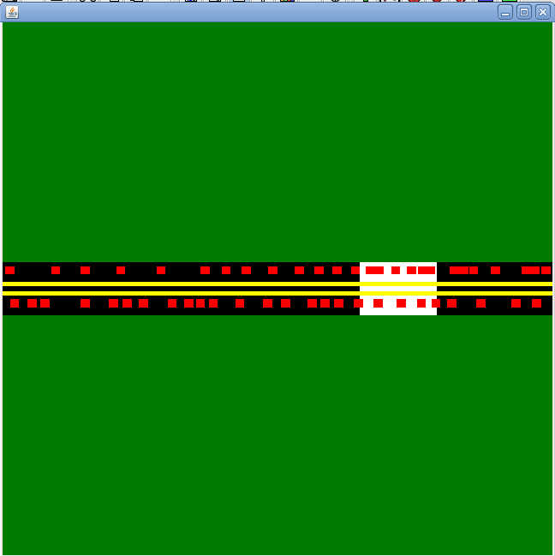
The Cars are the red rectangles and the white area represents the speed trap which initiates the traffic jam.
At the moment there is no availability for user input, so no my program does not crash with invalid input, but it does run into problems of speed as the ArrayList continually grows larger and larger.
The basic test for this program was to see if it could visually show the know and proven trend of a traffic jam moving backwards, which it is able to do. The other tests were to see if the Vehicles would stay within the range of maximum speed and if the Vehicles would not run up on and over each other, both which were successfully done.

- What do you expect to work on next quarter, in relation to the goal of your project for the year?
Next quarter I hope to allow for a good amount of user defined input so that they can control the program as to better model some behavior. I also want to create a basic graphical analysis for my program so I can do a better test of whether my agent based system is modeling traffic correctly. These will be very high up on my list for goals.

