Data Compression through Duplicate Elimination and Tagging

Jeffrey Thomas, 10/23/2008
Computer Systems Lab
First Quarter Research Paper

I. Abstract

Data compression is a valuable tool to save memory and time when sending data between computers. Although many different methods exist, I believe to have created a new method to compress data based on simple probability and the concept of effective infinite data. This algorithm will also potentially work with any kind of data, and will always compress a significant amount of data. I intend to test the effectiveness of this algorithm in terms of both time saved when sending large amounts of data and the proportion of data compressed, and find the optimal case of the inner variables.

II. Introduction

In order for a data compression algorithm to be valid for use, it must reach its optimal case a majority of time it is run on different data files. An algorithm is useless if it cannot reach its optimal case very often. Effective methods of data compression are vital in the current progress of computing. As file sizes grow exponentially, methods must be used to save space as well as time when sending data over networks.

In this paper, we will explore fully a completely original data compression method. This method relies on two inner variables, and can be run multiple times on compressed data. The main will be to find the optimal state in one iteration, if one exists. It is possible that the algorithm will have no optimal state, as increasing the variables to infinity will infinitely enhance the performance.

The algorithm will be tested on how much data the algorithm compresses. The data files it compresses will be randomly generated to simulate large files. In theory, the algorithm should be able to compress large data files to an optimal proportion any time it runs. This paper will test that claim.

If the algorithm is a success, it has the potential to be exceptionally useful in the world of computing, as it can perform on any type of file, and should be able to optimally perform every time it runs.

III. Background

The main purpose of data compression is to replace larger patterns of data with smaller representations. In doing so, there are two main methods; lossless, and lossy compression. Lossless compression does not lose any data in the compression/decompression process. It is used for data that requires accuracy, such as program and text files. Lossy compression allows for some data to be lost in the process, and is used in compressing images and other visual mediums (Data-Compression.com).

A common method of data compression is Huffman coding. This takes repeating symbols or patterns and replaces them with a smaller pattern or number that represents that pattern (McGeoch).

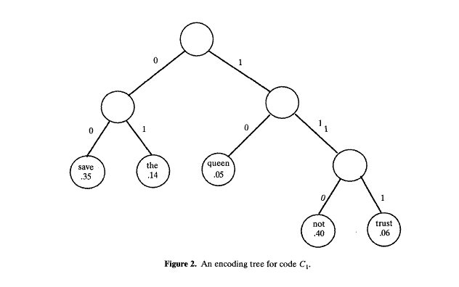
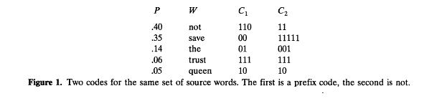
Pictures taken from reference #1, Page 494-495

This is valuable when compressing large files with repetitious data, such as text files. The downside is that if the probability of each word or pattern is equal, then the efficiency drops dramatically (Lelewer and Hirschberg).

Lossy compression is utilized in various image compression. If certain colors are reduced in quality or removed altogether, the human eye cannot tell the difference between the compressed version and the original version.

IV. Development

4.1 The Algorithm

The algorithm I have developed works on the concept of data large enough to be effectively infinite and basic probability. Reading in four bits, there are sixteen different bit combinations that can be read. Of these sixteen, four are duplicates, in that the first two bits are identical to the last two in both order and value. Thus, one-fourth of the possible combinations are duplicates. This ratio holds true for any group of 2^n bits, provided n is greater than one.

For clarification, G is the number of groups analyzed at once, and B is the number of bits each group has.

G groups of size B are analyzed. Each individual group is checked for duplicity. If it is not a duplicate, nothing is done, and the next group is analyzed. If it is, than only half of the group is retained, and a marker is placed before the entire stream denoting which group, numerically, is a duplicate. The marker is of size log(G)/log(2), rounded up. After all of the groups are processed in this manner, then one final marker is added in front of all the data so far denoting how many groups were duplicates. The entire data stream is processed in this manner.

4.2 Data Storage

A large problem confronting this project was how to store the data that was being processed. Currently, 2^30 elements of data are being processed. With an inefficient method of storage, code runtime can easily exceed several hours. By using an ArrayList, I was able to cut runtime down to minutes. However, the amount of data exceeded the maximum size of the ArrayList. To remedy this problem, I placed the data in an ArrayList of ArrayLists, with each individual ArrayList holding one hundred thousand elements.

VIII. Literature Cited

1. McGeoch, Catherine C. "Data Compression." The American Mathematical Monthly 100:
493-497. 31 Oct. 2008 <http://www.jstor.org/stable/
2324310?seq=1&Search=yes&term=data&term=compression&list=hide&searchUri=%2Faction
%2FdoBasicSearch%3FQuery%3Ddata%2Bcompression%26x%3D1%26y%3D10%26wc%3Don&item=15&ttl=16184&returnArticleService=showArticle&resultsServiceName=doBasicResultsFromArticle>.

2. Data-Compression.com. EEF. 31 Oct. 2008 <http://www.data-compression.com/
index.shtml>

3. Lelewer, Debra A, and Daniel S Hirschberg. "Data Compression." Data Compression.
University of California. 31 Oct. 2008 <http://www.ics.uci.edu/~dan/pubs/
DataCompression.html>. Research Paper

