COMPUTER SYSTEMS RESEARCH
Code Writeup of your program, example report form 2009-2010
- Your name: _Raghav Bashyal_, Period: _04_
- Date of this version of your program: _October 29, 2009_
- Project title: _Statistical Machine Translation (Spanish to English)_
- Describe how your program runs as of this version.
This project requires that I go through the NLTK book found at the link below, since I need to become familiar with the toolkit before I start working on the code. Once I feel like I have covered enough material to write a part of the code, I will jump off the book and return later. Below I have documented my progress through the tutorial, which began a little more than a week ago after we finally were able to install NLTK in my system. The comments under the pieces of code note the uses of the functions and ways that they could be implemented.
http://nltk.googlecode.com/svn/trunk/doc/book/ch01.html

>>> import nltk
//sets up the nltk package for usage
>>> from nltk.book import *
//imports the texts in the “book” corpora
//////Searching Text
>>> text1.concordance("monstrous")
//finds the word “monstrous” in text1
>>> text1.similar("monstrous")
//this finds the words that are surrounded by the words that also surround “monstrous” in text1.
//the ability to find words with a similar context may be of particular use – like, for example, when you need to check if a word is the same part of speech as another
>>> text2.common_contexts(["monstrous", "very"])
//returns the surrounding words mentioned above
>>> text4.dispersion_plot(["citizens", "democracy", "freedom", "duties", "America"])
//makes a chart that looks like this
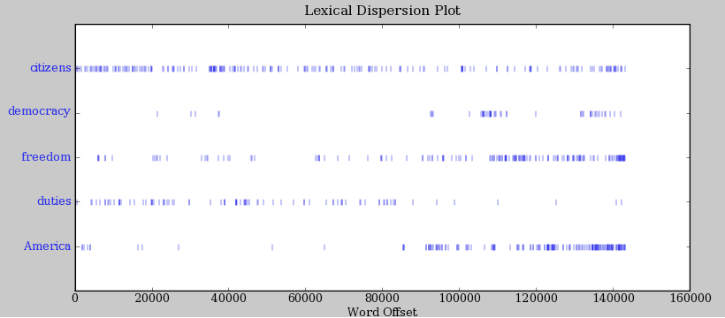
>>> text3.generate()
//generates a random sampling of the words in text3
///////Counting Vocabulary
>>> len(text3)
//return the length of the tokens in text 3. Tokens are series of characters – words, punctuation marks, symbols
>>> len(set(text3))
//returns the length of the set of tokens in text3. This probably how the program will start off
>>> len(text3) / len(set(text3))
//how many times each word is used, on average
>>> text3.count(“word”)
//counts the number of times “word” appears in text3
>>> 100 text4.count('a') / len(text4)
//percentage of text that has the word “a”
>>> def lexical_diversity(text):
//the book tries to teach new Python users how to start functions
>>> def percentage(a, text4):
text4.count('a') / len(text4)
// a useful function
Lists
>>> sentence1 = ['Hello','world','.']
//to be used as a sentence in the NTLK environment
>>> len(sent1)
//other NLTK functions can be used on this list, since NLTK deals with text in lists like these
>>> percentage('.', sentence1)
//our self-made works as well
>>> sent4 + sent1
// Lists in python can be concatenated like this
>>> sent1.append(“something”)
//appending to a list

