COMPUTER SYSTEMS RESEARCH
Code Writeup of your program, example report form 2009-2010
- Your name: Vincent DeVito, Period: 2
- Date of this version of your program:
- Project title: 10/8/09
- Describe how your program runs as of this version.
As of this time my coding is as a bunch of smaller program segments that cover various basic concepts of image processing. I have, for the most part, been using a single image (Fig.1) as an input in the .gif image format. Some of the concepts I have coded include image rotation, image resizing/skewing, contrast stretching (Fig. 1), and other, basic pointwise operations. These were all outputted as .gif files as well of the same size (except for the resized image). These processes will probably help me in the long run with other concepts I will be learning when attempting image deblurring and especially during the final noise reduction phase.

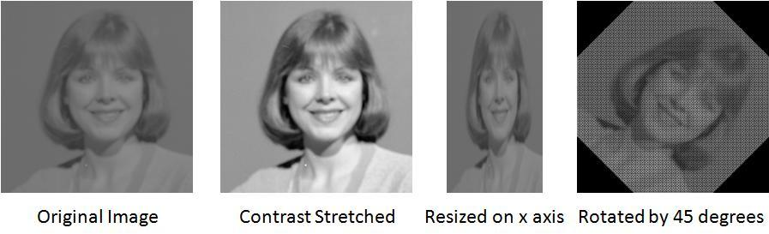
Figure 1.
- What do you expect to work on next quarter, in relation to the goal of your project for the year?
I expect to begin coding the algorithm that will take the known blur kernel and blur my input image, and then I will begin writing the deconvolution algorithm that will “undo” the blur and restore the image.

