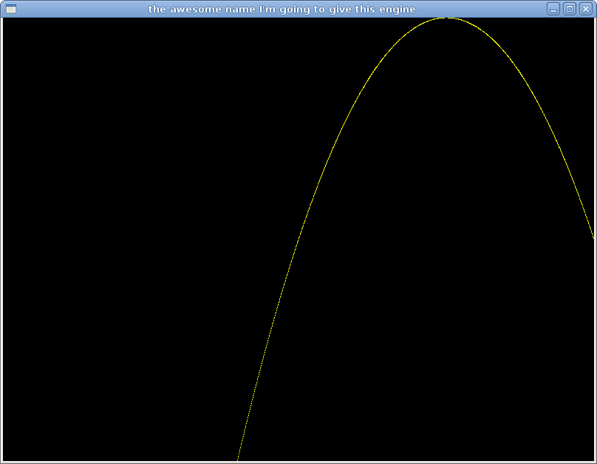
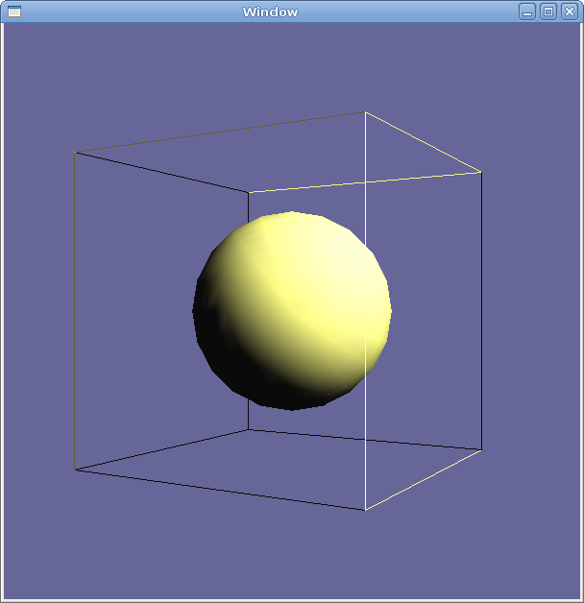

COMPUTER SYSTEMS RESEARCH
Code Writeup of your program, report form 2009-2010
- Your name: Joseph Hallahan, Period: 5
Date of this version of your program: 10/26/09
Project title: Design of a 3D Graphics Engine for use in Various Applications
Describe how your program runs as of this version. Include
-- files that may be needed
-- algorithms, specific procedures or methods you wrote
-- kinds of input your program uses
-- screenshots, what kinds of output does your program have
-- does your program handle errors, or does it crash on errors of input?
-- tests: summarize the basic analysis and testing of this version of your program

My program currently displays a sphere inside a wireframe cube and can be moved around using the keyboard. The only file needed is the actual program file – GLTest. The source is in GLTest.cpp and is compiled using a program called Lg++, which is a variation of g++ that also includes OpenGL support within a program. My program uses the W, A, S, and D keys to move left and right, and to move forward and backward. The spacebar is used to move up, and the delete key returns it to its original height. The escape key returns it to its original position, regardless of whichever direction it had moved in previously. Any other key quits the program. Also, in a console window, the keys that have been inputted are shown.
Screenshots…

I have not encountered any errors in my program so far in its current stage. It really is not attempting to do anything to the extent that I would need to put in extra code to handle special errors yet. Since all the input does is move shapes around, the only thing that could go wrong is if their positions go beyond the area that can be drawn in, in which case the user can either try to retrace his steps, hit the escape key to return them to their default positions, or simply quit. Basically, the testing of this program has consisted of running it, making sure that all the input works correctly, and then fixing anything that doesn’t work right. I had to revise my input code because I made the mistake of trying to use variables to store the positions of the shapes, but when I moved them, I kept on moving them even after the keys had been released. This gave it a pretty cool and smooth motion, but also made it very hard to control.

- What do you expect to work on next quarter, in relation to the goal of your project for the year?
Next quarter I hope to be able to concentrate more on creating an actual engine. This will require me to use what I have learned about OpenGL from my test programs in order to encapsulate it in its own program. This will only have very limited functionality at first, but I will soon make it more complicated toward the end of the quarter. If time permits, I will most likely create a simple program to test the engine, such as Pong, in order to see if it works. If so, this will become the basis for my final engine at the end of the year.

Code:
#include <iostream>

#include <string.h>

#include <stdlib.h>

#include <stdio.h>

#include <stdarg.h>

#include <ctype.h>

#include <math.h>

#include <GL/glut.h>

const int WINDOWX=600,WINDOWY=600;

int winX=100,winY=100;

GLfloat light_diffuse[] = {2.0,2.0,1.0,1.0};

GLfloat light_position[] = {5.0,5.0,5.0,0.0};

GLUquadricObj *qobj;

int list = 1;

int win1;

//Coordinates of sphere/box thing

float x = 0;

float y = 0;

float z = 0;

//Velocity components

int xv = 0;

int yv = 0;

int zv = 0;

//String s = "Text"

using namespace std;

void draw()//This is where all drawing things will be actually drawn

{

glClearColor(0.4,0.4,0.6,1.0);

glClear(GL_COLOR_BUFFER_BIT | GL_DEPTH_BUFFER_BIT);

glPushMatrix();

int len, i;

glRasterPos3f(0,0,0);

len = (int)strlen("Joe");

for(i=0; i<len; i++)

glutBitmapCharacter(GLUT_BITMAP_TIMES_ROMAN_24,'J');

glPopMatrix();

glColor3f(1.0,0.0,0.0);

glPushMatrix();

//glTranslatef(x,y,z);

glRotatef(60.0,0.0,1.0,0.0);

glutWireCube(3.0);

glPopMatrix();

glCallList(list);

glutSwapBuffers();

glFlush();

}

void idle()

{

}

void keyFunc(unsigned char key, int x1, int y1 )

{

if(isprint(key))

printf("key: %c,%d,%d\n",key,x1,y1);

else

printf("key: 0x%c,%d,%d\n",key,x1,y1);

switch(key)

{

case 119:{//'W'

z+=.1;

break;

}

case 115:{//'S'

z-=.1;

break;

}

case 97:{//'A'

x-=.1;

break;

}

case 100:{//'D'

x+=.1;

break;

}

case 32:{//Spacebar

y-=.1;

break;

}

case 127:{//Delete key

y=0;

break;

}

case 27:{//Escape

x=y=z=0;

break;

}

default:{//anything else

exit(0);//quit

break;

}

}

glTranslatef(x,y,z);

glutPostRedisplay();

//exit(0);

}

void mouseFunc(int button, int state, int x, int y)

{

printf("button: %d %s %d, %d\n",button,state==GLUT_UP ? "UP" : "down", x, y);

}

void display()

{

draw();

}

void display_window()

{

glPushMatrix();

//glTranslatef(0.0,0.0,-3.0);

display();

glPopMatrix();

}

/*void display()

{

//glClear(GL_COLOR_BUFFER_BIT);

draw();//this is my custom drawing method

//glFlush();//force everything to be drawn

}*/

void init()

{

//Define object

gluQuadricDrawStyle(qobj, GLU_FILL);

glNewList(1,GL_COMPILE);//create display list for object

gluSphere(qobj, 1.0, 20, 20);

//gluSphere(qobj,x,y,z);

glEndList();

glLightfv(GL_LIGHT0, GL_DIFFUSE, light_diffuse);

glLightfv(GL_LIGHT0, GL_POSITION, light_position);

glEnable(GL_LIGHTING);

glEnable(GL_LIGHT0);

glEnable(GL_DEPTH_TEST);

//glClearColor(0,0,0,0);//clears to black screen

glMatrixMode(GL_PROJECTION);

gluPerspective(40.0,1.0,1.0,20.0);

glMatrixMode(GL_MODELVIEW);

gluLookAt(0.0,0.0,5.0, 0.0,0.0,0.0, 0.0,1.0,0.0);

//glTranslatef(0.0,0.0,-1.0);

glTranslatef(x,y,z);//TAKE THIS LINE OUT ITS BREAKING EVERYTHING

//glLoadIdentity();

//glOrtho(0.0,1.0,0.0,1.0,-1.0,1.0);

}

int main(int argc, char* argv[])

{

qobj = gluNewQuadric();

glutInit(&argc,argv);

glutInitDisplayMode(GLUT_SINGLE|GLUT_RGB|GLUT_DEPTH);

glutInitWindowSize(WINDOWX,WINDOWY);

glutInitWindowPosition(winX,winY);

win1 = glutCreateWindow("Window");

init();

glutDisplayFunc(display_window);

glutMouseFunc(mouseFunc);

glutKeyboardFunc(keyFunc);

//glutInitWindowSize(WINDOWX,WINDOWY);

//glutInitWindowPosition(winX,winY);

//glutIdleFunc(idle);

//glutKeyboardFunc(keyFunc);

//I'll need to change this name eventually

//glutCreateWindow("the awesome name I'm going to give this engine");

//glutDisplayFunc(display);

glutMainLoop();

return 0;//end

}

