COMPUTER SYSTEMS RESEARCH
Code Writeup of your program, example report form 2009-2010
- Your name: Jennifer Lee, Period: 05
- Date of this version of your program: Oct. 26, 2009
- Project title: Automated Detection of Human Emotion
- Describe how your program runs as of this version.
The files used currently are the basic tracking file and the webcam integration file. A GUI still needs to be developed to integrate these two smoothly, but at the moment, running one after another seems to suffice. The webcam integration file was found online and only has a few minor tweaks to make it function correctly.
The basic tracking, utilizes PIL to detect the markers (based on color) and write the tracking results to a new file. Basically, it functions by reading the stopmotion images and detecting the markers. It then writes the position of the markers to the tracking file. After reading all images, a path of the markers is left on the tracking image.
At the moment, the program does not catch errors. However, as this experiment can't distinguish what an error of input is, it will never crash. Rather it will result in no tracking data. The plan is to have a very versatile GUI that will allow users to fine tune the program according to their surroundings.
Tests have been run using initially, static test images for marker recognition, and then sample webcam data.
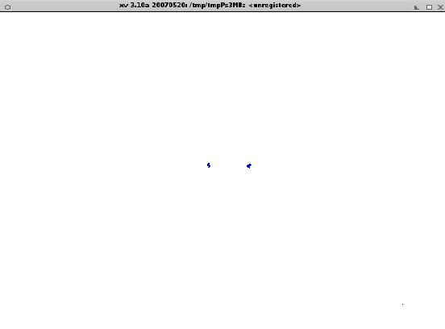
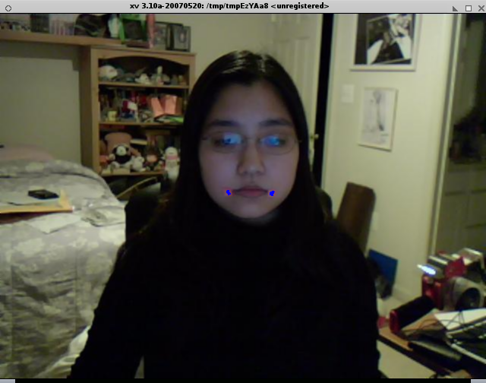

- What do you expect to work on next quarter, in relation to the goal of your project for the year?
The next step is detailed tracking which includes facial tilt and feature specific tracking images. This will allow a more detailed look at each feature, making their movement more obvious. Account for facial tilt will limit chances for error.

